Appendix
Table of content:
Supplementary Materials and Methods
Appendix Figure 1.
Appendix Figure 2.
Appendix Figure 3.
Appendix Table 1.
Appendix Table 2.

Operatory and equipment setup.
All dental procedures were conducted in an enclosed dental operatory equipped with a dental unit (KaVo INTRAmatic LUX 3 25 LHA, KaVo Dental), including an HSH with water spray (T3 SIROBoost, Sirona Dental Systems GmbH), an US (Suprasson P5 Newtron, SATELEC) with a Dentsply 30K slimline scaling tip, an HVE and LVE, and an SAP (AeroVac Pro Dental, E-Maxdent Co., Ltd.). To prevent the airflow from affecting the splatter pattern, we turned off air conditioning and ventilating fans in the operatory operation. The experiments were performed at a relative humidity of 25% and a temperature of 25°C.
The mannequin head with a typodont was placed on dental chair to simulate dental preparation. The mandibular plane was parallel to the ground (60 cm above the ground). To simulate an oral cavity, we positioned the rubber dam on the typodont to expose teeth and prewetted them with water.
We placed a fixed stand with a clamp next to the mannequin. A piece of dental equipment (an HSH or a US) is fixed in 6-o’clock operation mode by the clamp. The power settings and the water dispenser (100% power and 100% flow rate) on the dental equipment were identical throughout the experiment. We operated the HSH (400,000 revolutions per minute) and the US (30 kHz) for 20 seconds. The water flow was set at 60.0 milliliters/minute.
We oriented the HVE and LVE 1 cm from the experimental tooth. We measured the suction rate of the two kinds of evacuations. The time of emptying 1,000 ml water was 12.70 seconds and 38.64 seconds, equating to rates of 78.74 mL/second and 25.88 mL/second for HVE and LVE, respectively. We oriented the suction air purifier 10 cm from the manikin head. The diameter of the suction port is 120 mm. The corresponding clean air delivery rate is 440 m3 h-1.
As shown in Appendix Figure 1, we set the oral outlet as the origin of the spatial coordinates and defined the corresponding x-, y-, and z-axes. The splatter pattern was recorded at two observation positions, the xz-plane on the back and the yz-plane on the side, by high-speed videography (Phantom VEO 410 L, Vision Research Inc). The position of the LED video light was manually adjusted at each camera site. The diameter of smaller droplets that appeared in the frame was recorded as a pixel.
Before any measurements were performed, the conditions were re-established in all cases, with 10 independent repeats per condition on average.
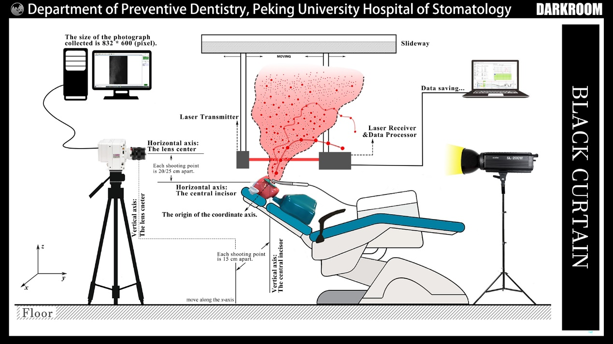
Appendix Figure 1. Operatory and equipment setup. Experimental set-up for the visualization of dental splatters by high-speed cameras and the measurement of particle size distributions by laser diffraction.
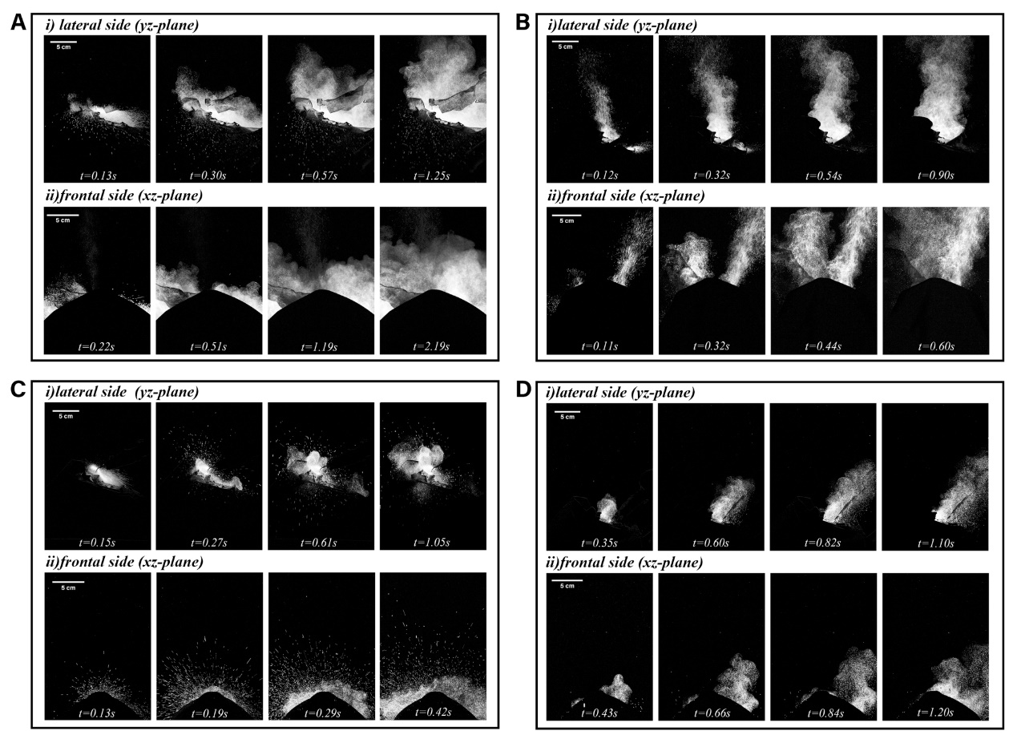
Appendix Figure 2. The high-speed image of the splatter spatial-temporal distribution in dental procedures (A) The image of the central incisor preparation with HSH. The splatter pattern was a relatively dense flow that expands in all directions under the reaction force exerted by the teeth. The time of the dental splatter to a fully developed state was 1.25s(yz-plane) and 2.19s(xz-plane). (B) The image of the first molar preparation with HSH. The splatters bifurcating from the mouth at the beginning tended to approach in the following time and successfully gathered. The time of the dental splatter to a fully developed state was 0.90s(yz-plane) and 0.60s(xz-plane). (C) The image of the central incisor preparation with US. More droplets were produced than other working conditions, and the aerosol cloud was more localized to the vicinity of the head. The time of the dental splatter to a fully developed state was 1.05s(yz-plane) and 0.42s(xz-plane). (D) The image of the first molar preparation with US. The direction of the aerosol cloud becomes more concentrated. The time of the dental splatter to a fully developed state was 1.10s(yz-plane) and 1.20s(xz-plane).
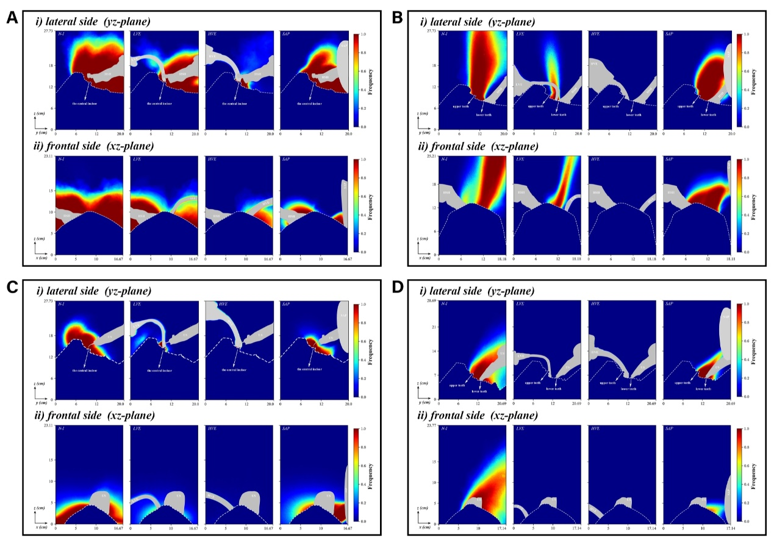
Appendix Figure 3. Heat map of splatters produced under different working conditions. A red pixel shows a 100% probability of a drop at any time, whereas a blue pixel points to a zero probability. (A) HSH operates in OM1 without intervention (N-I) or with LVE, HVE and SAP intervention. The contamination scope diverges, with none of the interventions clearing all the contaminants. (B) HSH operates in OM2 without intervention (N-I) or with LVE, HVE and SAP intervention. The contamination scope is concentrated, and almost all interventions work well with the exception of the LVE. (C) US operates in OM1 without intervention (N-I) or with LVE, HVE and SAP intervention. Despite the map result looks good, droplets still exist in the form of radial sputtering no matter what intervention is used. (D) US operates in OM2 without intervention (N-I) or with LVE, HVE and SAP intervention. All of the interventions give good performance. The LVE and HVE evacuate water from the mouth while the SAP sucks all the splatters under negative pressure.

Appendix Table 1. The size distribution of the dental splatters under different working condition.
Equipment | Operating mode | Control | D_{4,3} (μm) |  |  | Number (%) |  |  |  |  | Volume (%)
 |  |  | Mean | S.D. |  | <10μm | 10-50μm | 50-100μm | >100μm |  | <10μm | 10-50μm | 50-100μm | >100μm
HSH | Direct | - | 34.44 | 3.13 |  | 77.46 | 22.48 | 0.06 | 0.00 |  | 9.56 | 74.28 | 10.69 | 5.47
US | Direct | - | 101.38 | 8.69 |  | 0.00 | 78.04 | 19.37 | 2.59 |  | 0.00 | 23.51 | 34.88 | 41.62
 |  |  | *
HSH | OM1 | - | 30.67 | 4.98 |  | 71.30 | 28.67 | 0.03 | 0.01 |  | 10.34 | 76.12 | 5.98 | 7.56
 | OM2 | - | 14.32 | 0.30 |  | 87.03 | 12.97 | 0.00 | 0.00 |  | 23.59 | 76.40 | 0.01 | 0.00
 |  |  | *
HSH | OM1 | HVE | 28.62 | 4.32 |  | 29.59 | 70.25 | 0.16 | 0.00 |  | 2.66 | 91.29 | 6.05 | 0.00
 | OM1 | LVE | 18.48 | 1.37 |  | 65.94 | 34.06 | 0.00 | 0.00 |  | 15.38 | 84.38 | 0.24 | 0.00
 | OM2 | HVE | - |  |  | - | - | - | - |  | - | - | - | -
 | OM2 | LVE | 12.45 | 1.15 |  | 88.27 | 11.73 | 0.00 | 0.00 |  | 35.39 | 64.61 | 0.00 | 0.00
US | OM1 | - | 40.05 | 2.63 |  | 5.15 | 93.80 | 1.03 | 0.03 |  | 0.24 | 80.70 | 16.26 | 2.79
 | OM2 | - | 32.75 | 1.58 |  | 21.61 | 78.02 | 0.37 | 0.00 |  | 1.23 | 90.95 | 7.79 | 0.03
 |  |  | *
US | OM1 | HVE | -
 | OM1 | LVE | 35.75 | 1.69 |  | 0.47 | 98.60 | 0.92 | 0.00 |  | 0.02 | 88.34 | 11.37 | 0.17
 | OM2 | HVE | - |  |  | - | - | - | - |  | - | - | - | -
 | OM2 | LVE | - |  |  | - | - | - | - |  | - | - | - | -
* Wilcoxon signed-rank test, p < 0.05
- The number of particles is too low to be detected
OM1: Operation mode 1, the simulated preparation of the central incisor. OM2: Operation mode 2, the simulated preparation of the first molar. HSH: high-speed air turbine handpiece. US: ultrasonic scaler. HVE: high-volume evacuation. LVE: low-volume evacuation. SAP: suction air purifier. D_{4,3}: volume mean diameter.

Appendix Table 2. The quantity distribution and volume distribution of particles in each average particle size section
HSH |  |  |  |  |  |  |  |  |  |  |  | US
Direct |  |  |  | OM1 |  |  |  | OM2 |  |  |  | Direct |  |  |  | OM1 |  |  |  | OM2
D(μm) | Q(%) | V(%) |  | D(μm) | Q(%) | V(%) |  | D(μm) | Q(%) | V(%) |  | D(μm) | Q(%) | V(%) |  | D(μm) | Q(%) | V(%) |  | D(μm) | Q(%) | V(%)
2.80 | 0.00 | 0.00 |  | 2.66 | 0.00 | 0.00 |  | 2.41 | 0.00 | 0.00 |  | 17.60 | 0.00 | 0.00 |  | 7.94 | 0.00 | 0.00 |  | 6.19 | 0.42 | 0.01
3.09 | 2.81 | 0.05 |  | 2.80 | 0.70 | 0.01 |  | 2.53 | 2.88 | 0.09 |  | 18.49 | 0.79 | 0.03 |  | 8.35 | 1.35 | 0.05 |  | 6.84 | 2.81 | 0.09
3.41 | 7.09 | 0.17 |  | 3.09 | 2.60 | 0.05 |  | 2.80 | 6.89 | 0.29 |  | 20.43 | 3.13 | 0.16 |  | 9.22 | 3.80 | 0.19 |  | 7.56 | 5.10 | 0.22
3.77 | 8.98 | 0.29 |  | 3.41 | 5.40 | 0.14 |  | 3.09 | 9.70 | 0.55 |  | 22.56 | 4.94 | 0.34 |  | 10.18 | 5.49 | 0.37 |  | 8.35 | 6.37 | 0.37
4.16 | 9.42 | 0.41 |  | 3.77 | 7.45 | 0.26 |  | 3.41 | 10.99 | 0.84 |  | 24.92 | 6.58 | 0.61 |  | 11.25 | 6.72 | 0.61 |  | 9.22 | 6.90 | 0.54
4.60 | 8.87 | 0.52 |  | 4.16 | 8.07 | 0.38 |  | 3.77 | 10.68 | 1.10 |  | 27.52 | 7.85 | 0.98 |  | 12.42 | 7.52 | 0.92 |  | 10.18 | 7.11 | 0.75
5.08 | 7.97 | 0.63 |  | 4.60 | 7.88 | 0.50 |  | 4.16 | 9.37 | 1.30 |  | 30.40 | 8.91 | 1.50 |  | 13.72 | 8.01 | 1.32 |  | 11.25 | 7.18 | 1.02
5.61 | 7.04 | 0.75 |  | 5.08 | 7.14 | 0.61 |  | 4.60 | 7.76 | 1.45 |  | 33.58 | 9.61 | 2.18 |  | 15.16 | 8.28 | 1.84 |  | 12.42 | 7.10 | 1.36
6.19 | 6.27 | 0.90 |  | 5.61 | 6.43 | 0.74 |  | 5.08 | 6.31 | 1.59 |  | 37.09 | 9.95 | 3.04 |  | 16.74 | 8.35 | 2.50 |  | 13.72 | 6.98 | 1.80
6.84 | 5.53 | 1.07 |  | 6.19 | 5.80 | 0.90 |  | 5.61 | 5.21 | 1.77 |  | 40.97 | 9.69 | 3.99 |  | 18.49 | 8.18 | 3.30 |  | 15.16 | 6.79 | 2.36
7.56 | 4.95 | 1.29 |  | 6.84 | 5.31 | 1.11 |  | 6.19 | 4.37 | 2.00 |  | 45.25 | 8.90 | 4.94 |  | 20.43 | 7.78 | 4.23 |  | 16.74 | 6.55 | 3.07
8.35 | 4.47 | 1.57 |  | 7.56 | 5.00 | 1.41 |  | 6.84 | 3.76 | 2.32 |  | 49.98 | 7.68 | 5.74 |  | 22.56 | 7.17 | 5.25 |  | 18.49 | 6.21 | 3.92
9.22 | 4.04 | 1.91 |  | 8.35 | 4.82 | 1.83 |  | 7.56 | 3.32 | 2.76 |  | 55.20 | 6.20 | 6.25 |  | 24.92 | 6.37 | 6.29 |  | 20.43 | 5.79 | 4.93
10.18 | 3.67 | 2.34 |  | 9.22 | 4.69 | 2.40 |  | 8.35 | 3.01 | 3.37 |  | 60.98 | 4.72 | 6.41 |  | 27.52 | 5.44 | 7.24 |  | 22.56 | 5.29 | 6.07
11.25 | 3.34 | 2.87 |  | 10.18 | 4.58 | 3.16 |  | 9.22 | 2.76 | 4.16 |  | 67.35 | 3.40 | 6.23 |  | 30.40 | 4.46 | 8.00 |  | 24.92 | 4.71 | 7.28
12.42 | 3.01 | 3.49 |  | 11.25 | 4.47 | 4.15 |  | 10.18 | 2.55 | 5.18 |  | 74.39 | 2.36 | 5.82 |  | 33.58 | 3.50 | 8.45 |  | 27.52 | 4.05 | 8.43
13.72 | 2.68 | 4.18 |  | 12.42 | 4.26 | 5.33 |  | 11.25 | 2.34 | 6.41 |  | 82.17 | 1.60 | 5.32 |  | 37.09 | 2.62 | 8.52 |  | 30.40 | 3.33 | 9.33
15.16 | 2.33 | 4.89 |  | 13.72 | 3.90 | 6.58 |  | 12.42 | 2.11 | 7.77 |  | 90.76 | 1.08 | 4.85 |  | 40.97 | 1.86 | 8.15 |  | 33.58 | 2.59 | 9.78
16.74 | 1.95 | 5.53 |  | 15.16 | 3.37 | 7.66 |  | 13.72 | 1.81 | 9.02 |  | 100.24 | 0.74 | 4.48 |  | 45.25 | 1.25 | 7.39 |  | 37.09 | 1.88 | 9.59
18.49 | 1.57 | 6.00 |  | 16.74 | 2.72 | 8.32 |  | 15.16 | 1.46 | 9.81 |  | 110.72 | 0.52 | 4.23 |  | 49.98 | 0.79 | 6.32 |  | 40.97 | 1.26 | 8.68
20.43 | 1.21 | 6.23 |  | 18.49 | 2.02 | 8.34 |  | 16.74 | 1.09 | 9.83 |  | 122.30 | 0.37 | 4.09 |  | 55.20 | 0.48 | 5.10 |  | 45.25 | 0.78 | 7.19
22.56 | 0.89 | 6.19 |  | 20.43 | 1.38 | 7.66 |  | 18.49 | 0.74 | 8.97 |  | 135.08 | 0.28 | 4.08 |  | 60.98 | 0.27 | 3.89 |  | 49.98 | 0.43 | 5.39
24.92 | 0.63 | 5.91 |  | 22.56 | 0.86 | 6.48 |  | 20.43 | 0.45 | 7.34 |  | 149.20 | 0.21 | 4.19 |  | 67.35 | 0.15 | 2.83 |  | 55.20 | 0.22 | 3.63
27.52 | 0.43 | 5.44 |  | 24.92 | 0.50 | 5.09 |  | 22.56 | 0.24 | 5.37 |  | 164.80 | 0.16 | 4.40 |  | 74.39 | 0.08 | 2.01 |  | 60.98 | 0.10 | 2.18
30.40 | 0.29 | 4.88 |  | 27.52 | 0.28 | 3.77 |  | 24.92 | 0.12 | 3.46 |  | 182.03 | 0.12 | 4.51 |  | 82.17 | 0.04 | 1.42 |  | 67.35 | 0.04 | 1.15
33.58 | 0.19 | 4.29 |  | 30.40 | 0.15 | 2.72 |  | 27.52 | 0.05 | 1.93 |  | 201.06 | 0.09 | 4.21 |  | 90.76 | 0.02 | 1.01 |  | 74.39 | 0.01 | 0.54
37.09 | 0.12 | 3.72 |  | 33.58 | 0.08 | 2.00 |  | 30.40 | 0.02 | 0.91 |  | 222.08 | 0.05 | 3.43 |  | 100.24 | 0.01 | 0.73 |  | 82.17 | 0.00 | 0.21
40.97 | 0.08 | 3.20 |  | 37.09 | 0.05 | 1.54 |  | 33.58 | 0.00 | 0.33 |  | 245.29 | 0.03 | 2.33 |  | 110.72 | 0.01 | 0.53 |  | 90.76 | 0.00 | 0.07
45.25 | 0.05 | 2.75 |  | 40.97 | 0.03 | 1.26 |  | 37.09 | 0.00 | 0.07 |  | 270.93 | 0.01 | 1.22 |  | 122.30 | 0.00 | 0.39 |  | 100.24 | 0.00 | 0.01
49.98 | 0.03 | 2.37 |  | 45.25 | 0.02 | 1.08 |  |  |  |  |  | 299.25 | 0.00 | 0.41 |  | 135.08 | 0.00 | 0.28
55.20 | 0.02 | 2.06 |  | 49.98 | 0.01 | 0.98 |  |  |  |  |  | 330.54 | 0.00 | 0.04 |  | 149.20 | 0.00 | 0.21
60.98 | 0.01 | 1.81 |  | 55.20 | 0.01 | 0.94 |  |  |  |  |  |  |  |  |  | 164.80 | 0.00 | 0.17
67.35 | 0.01 | 1.62 |  | 60.98 | 0.01 | 0.93 |  |  |  |  |  |  |  |  |  | 182.03 | 0.00 | 0.15
74.39 | 0.01 | 1.46 |  | 67.35 | 0.00 | 0.95 |  |  |  |  |  |  |  |  |  | 201.06 | 0.00 | 0.13
82.17 | 0.00 | 1.34 |  | 74.39 | 0.00 | 0.99 |  |  |  |  |  |  |  |  |  | 222.08 | 0.00 | 0.11
90.76 | 0.00 | 1.24 |  | 82.17 | 0.00 | 1.05 |  |  |  |  |  |  |  |  |  | 245.29 | 0.00 | 0.07
100.24 | 0.00 | 1.15 |  | 90.76 | 0.00 | 1.12 |  |  |  |  |  |  |  |  |  | 270.93 | 0.00 | 0.02
110.72 | 0.00 | 1.07 |  | 100.24 | 0.00 | 1.17
122.30 | 0.00 | 0.99 |  | 110.72 | 0.00 | 1.19
135.08 | 0.00 | 0.90 |  | 122.30 | 0.00 | 1.17
149.20 | 0.00 | 0.80 |  | 135.08 | 0.00 | 1.10
164.80 | 0.00 | 0.67 |  | 149.20 | 0.00 | 0.96
182.03 | 0.00 | 0.51 |  | 164.80 | 0.00 | 0.77
201.06 | 0.00 | 0.33 |  | 182.03 | 0.00 | 0.56
222.08 | 0.00 | 0.16 |  | 201.06 | 0.00 | 0.35
245.29 | 0.00 | 0.04 |  | 222.08 | 0.00 | 0.18
 |  |  |  | 245.29 | 0.00 | 0.08
 |  |  |  | 270.93 | 0.00 | 0.03
D: Particle diameter. Q: Quantity distribution. V: Volume distribution. OM1: Operation mode 1, the simulated preparation of the central incisor. OM2: Operation mode 1, the simulated preparation of the first molar. HSH: high-speed air turbine handpiece. US: ultrasonic scaler.

