Supplemental Table 1. Clinical Characteristics of Participants (N = 14) with SARS-CoV-2 Infection in a Nursing Home Cohort — Arkansas, June–August 2020
 | N=14
Age, median (range) in years | 80 (58-93)
Sex | No. | %
Female | 8 | 57
Male | 6 | 43
Race
White | 14 | 100
Symptoms at diagnosisª
None | 8 | 57
Cough | 6 | 43
Shortness of Breath | 4 | 29
Diarrhea^{b} | 4 | 29
Fatigue | 3 | 21
Myalgias | 3 | 21
Sore throat | 3 | 21
Nausea/vomiting | 3 | 21
Abdominal pain | 2 | 14
Rhinorrhea | 2 | 14
Loss of Taste | 2 | 14
Fever (≥100ºF)^{c} | 1 | 7
Underlying conditions^{d}
≥3 underlying conditions | 14 | 100
Cardiovascular disease | 13 | 93
Hypertension | 11 | 79
Coronary artery disease | 6 | 43
Heart failure | 5 | 36
Cerebrovascular accident | 3 | 21
Neurologic disorder | 6 | 43
Non-asthmatic chronic lung disease | 6 | 43
Chronic obstructive pulmonary disease | 5 | 36
Diabetes mellitus | 5 | 36
Obesity | 2 | 14
Cancer (current or recent) | 2 | 14
In active treatment, immunosuppressed | 1 | 7
Chronic kidney disease | 1 | 7
Mild or moderate COVID-19 illness | 12 | 86
Severe COVID-19 illness^{e} | 2 | 14
Hospitalized | 2 | 14
Died | 0 | n/a

Abbreviations: COVID-19, coronavirus disease 2019; SARS-CoV-2, severe acute respiratory syndrome coronavirus 2; n/a, not applicable
ªDiagnosis defined as first SARS-CoV-2 RT-PCR–positive test result. Subjective fever, loss of smell, and chest pain were not reported by any participant.
^{b}Diarrhea was defined as ≥3 loose stools in 24 hours.
^{c}The highest temperature recorded in the nursing home cohort was 101.6ºF.
^{d}Liver disease was not reported as an underlying condition by any participant.
^{e}Severe COVID-19 illness was defined as a decrease from baseline of >3% in oxygen saturation (SpO2) regardless of whether the participant was on room air or supplemental oxygen.
Supplemental Table 2. Plasma Antibody Responses of Participants (N = 14) with SARS-CoV-2 Infection in a Nursing Home Cohort — Arkansas, June–August 2020

 | Plasma Antibody Responses (Geometric Mean Titer)ª
 | Pan-Ig | IgG | IgA | IgM | Neutralizing
 | N=45 | N=45 | N=35 | N=32 | N=34
All | 3187 | 3807 | 479 | 497 | 213
Week Since First RT-PCR–Positive Result^{b}
1 | 216 | 245 | - | - | -
2 | 2265 | 1693 | 558 | 476 | 263
3 | 5013 | 5376 | 684 | 668 | 293
4 | 4141 | 6872 | 585 | 570 | 187
5 | - | - | - | - | -
6 | - | - | - | - | -
7 | 4692 | 5866 | 246 | 266 | 160
8 | 4300 | 6325 | - | 471 | 113
ªGeometric mean titer calculations for pan-Ig, IgG, IgA, and IgM antibodies included all titers ≥1:100. Geometric mean titer calculations for neutralizing antibodies included titers ≥1:80. Neutralizing titers reported as >1:640 were included in calculations as 1:640.
^{b}Data were not included by week when ≤1 observation was made.

Supplemental Figure 1. Timeline of evaluation and activities conducted at each visit, including questionnaire administration and specimen collection. Diagnosis defined as first SARS-CoV-2 RT-PCR‒positive test result. Day 0 defined as day of enrollment (4–13 days after the first RT-PCR‒positive result).

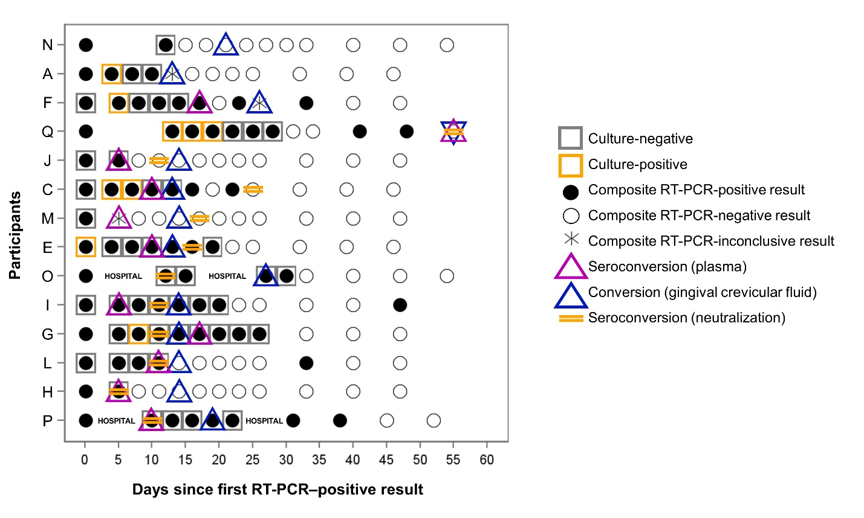
Supplemental Figure 2. Plasma and Gingival Crevicular Fluid Antibody Conversion in Relation to RT-PCR and Viral Culture Results in Participants with SARS-CoV-2 Infection in a Nursing Home Cohort — Arkansas, June–August 2020. Abbreviations: COVID-19, coronavirus disease 19; RT-PCR, real-time reverse-transcription polymerase chain reaction. RT-PCR–positive result at day 0 represents initial diagnosis. Composite RT-PCR results are determined from all oropharyngeal, anterior nasal, and saliva specimens collected at each visit. Oropharyngeal and anterior nasal specimens with a cycle threshold (Ct) ≤34 were submitted for viral culture. Due to challenges with specimen collection, transport, and processing, RT-PCR results for each specimen type were not always available for each visit. Plasma seroconversion (purple triangles) was determined by detection of the first pan-Ig titer ≥1:100. Crevicular conversion (blue triangles) was determined by detection of the first IgA or IgG SARS-CoV-2–specific antibodies in crevicular fluid. Neutralizing antibody seroconversion (gold bars) was determined by detection of the first neutralizing antibody titer ≥1:80.

