**Distribution of oxygen saturation and respiratory rate across groups**

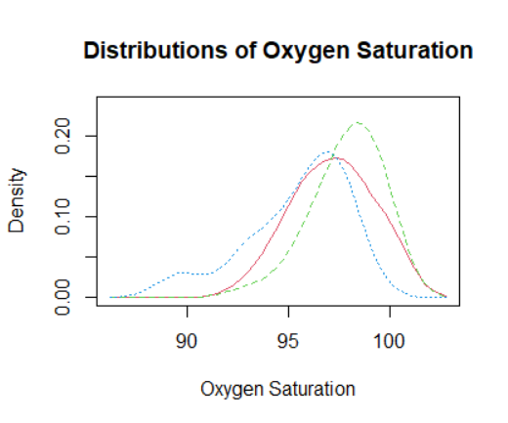 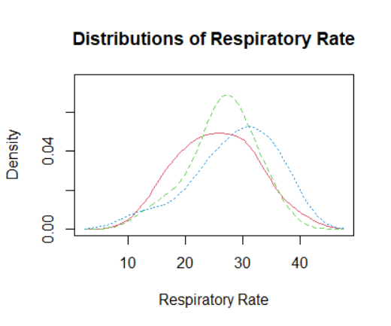

Baseline Intervention 1 Intervention 2