Supplementary material for:
Association Between Antibiotic Resistance in ICU-Acquired Infections and Excess Resource Utilization: Evidence from Spain, Italy, and Portugal
Miquel Serra-Burriel^{1,2*}, Carlos Campillo-Artero^{3,1}, Antonella Agodi^{4,5}, Martina Barchitta^{3,4}, Guillem López-Casasnovas¹
¹ Centre for Research in Health and Economics, Pompeu Fabra University, Barcelona, Spain. ² Epidemiology, Biostatistics and Prevention Institute, University of Zurich ³ Balearic Islands Health Service, Palma de Mallorca, Balearic Islands, Spain. ⁴ Department of Medical and Surgical Sciences and Advanced Technologies “GF Ingrassia”, University of Catania, Catania, Italy ⁵ GISIO-SItI: Italian Study Group of Hospital Hygiene - Italian Society of Hygiene, Preventive Medicine and Public Health, Italy
*Corresponding author:
Miquel Serra-Burriel, PhD
Hirschengraben 84, Zurich, Switzerland.
miquel.serraburriel@uzh.ch
Figure S1. Propensity score Kernel density distributions, before and after matching.
Notes: panel a) presents the full sample propensity score distribution before matching. Panel b) presents the propensity score distribution after 1:1 genetic matching.
Figure S2. Quantitative balance plots.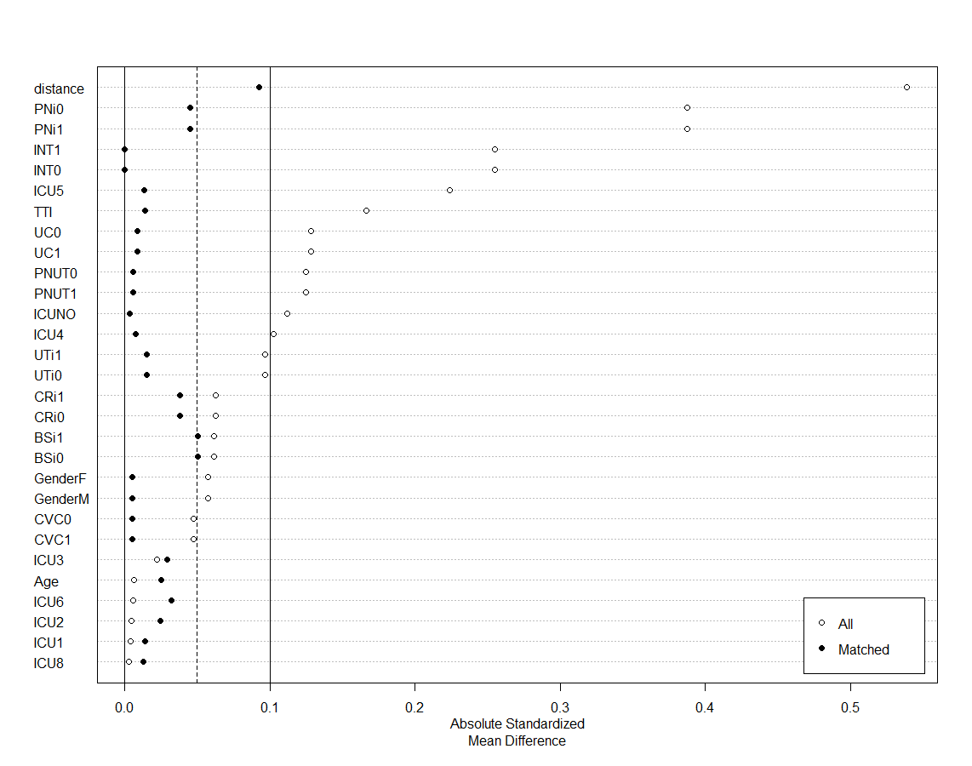
Notes: The figure presents the absolute standardized mean difference before and after matching. The full sample presents a mean standardized distance around 0.55, while after matching this distance has been reduced below 0.1.

Figure S3. Unobservable selection and
Notes: panel a) presents gamma’s values as a function of maximum R² that would be required to drive the estimates towards the null. Panel b) presents the estimate (beta) values that would result from a maximum R² with a gamma value of 1.

Table S1. Regression results by number of resistant organisms present at infection.
N of resistant organisms | a) | b) | c) | d) | e)
1 | 2.920*** | 2.933*** | 2.838*** | 2.689*** | 2.222***
 | (1.946, 3.895) | (1.959, 3.908) | (1.743, 3.934) | (1.578, 3.800) | (1.447, 2.997)
2 | 13.337*** | 13.339*** | 12.307*** | 8.095*** | 5.787***
 | (11.918, 14.755) | (11.920, 14.758) | (10.750, 13.864) | (6.509, 9.681) | (4.548, 7.025)
3 or more | 26.212*** | 26.191*** | 25.247*** | 17.140*** | 15.249***
 | (23.381, 29.042) | (23.361, 29.021) | (22.300, 28.195) | (14.144, 20.136) | (12.911, 17.587)
Control variables
Age |  | ● | ● | ● | ●
Gender |  | ● | ● | ● | ●
Bacteria FE |  |  | ● | ● | ●
Hospital-ICU FE |  |  |  | ● | ●
Infection Site |  |  |  | ● | ●
Procedures |  |  |  | ● | ●
Time to Infection |  |  |  |  | ●
Significance: *** 1%, ** 5%, *10%. Abbreviations: 95%CI: 95% confidence interval, FE: fixed effects.

