Statistical analyses
Quantitative variables are described as mean ± standard deviation, and categorical variables as number and percentage. The Student t, chi-square or Fisher’s exact tests were used as appropriate. To identify factors potentially associated with positive serology, multilevel logistic models were fitted. Multivariate analysis included variables which were significant at a p value <0.10 by univariate analysis, as well as factors known or suspected to be associated with a positive serology. Only department with more than 100 serologies carried out were considered for analysis. The following variables were therefore selected: presence of ageusia and anosmia and the working department. Statistical significance was set at p < 0.05. Analyses were performed using R® software version 4.0.4.
Hospital departments were grouped together according to staff exposure risk for multivariate analysis. The “Administrative group” includes administration, medical affairs, general management, logistics, finance and human resources. The “Pharma / lab / operating group” includes biology, pharmacy, public health, operating rooms, radiology. The “Oncology group” includes supportive care, oncology and hematology. The “Mother-child group” includes gynecology and pediatrics. The “Medicine group” includes cardiology, thoracic pathology, internal medicine and infectious diseases. The “Medico-surgery group” includes visceral and transplantation medicine, surgery, dental care, urology and dermatology. The “Psychatry group” contains psychiatry. The “Geriatry group” includes geriatrics and rehabilitation. The “Emergency-intensive care group” contains the emergency department, anesthesia and intensive care units.

Supplementary Figure 1 – Study flowchart
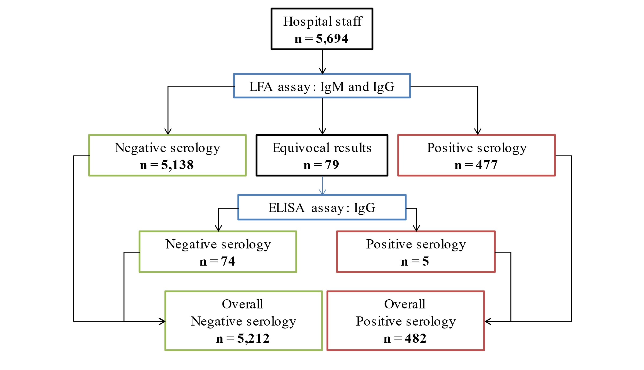

LFA: Lateral flow assay
All serum samples were tested using the immunochromatographic lateral flow assay (LFA), Biosynex® COVID-19 BSS (Biosynex, Switerland, Fribourg), detecting IgM and IgG directed against the Receptor Binding domain (RBD) of the SARS-CoV-2 spike protein. Serum samples from seronegative subjects in LFA test and reporting COVID-19 suggestive chest scanner or symptoms or positive SARS-CoV-2 RT-PCR were tested with a second assay to confirm their serological status, namely the ELISA anti-SARS-CoV-2 IgG kit (Euroimmun, Lübeck, Germay). This assay uses the recombinant S1 domain of the SARS-CoV-2 spike protein as antigenic source.

Supplementary Table 1 – Participants characteristics
 |  |  | Total  N= 5,694 | Positive serology  N= 482 | Negative serology  N= 5,212 | p-value
Gender |  | Female, n (%) | 4,633 (81.4) | 396 (82.2) | 4,237 (81.3) | 0.64
 |  | Males, n (%) | 1,061 (18.6) | 86 (17.8) | 975 (18.7)
Age (+/- SD) |  |  | 40.4 (± 11.7) | 40.0 (±12.1) | 40.5 (±11.8) | 0.42
Data collected about COVID-19 symptoms onset (N= 5,003)*
Participants who fill out this part of the questionnaire |  |  | Total  N= 5,003 | Positive serology  N= 422 | Negative serology  N= 4,581 | p-value
Asymptomatic, n (%) |  |  | 3,943 (78.8) | 201 (47.6) | 3,742 (81.7) | < 0,05
COVID-19 symptoms, n (%) |  |  | 1,060 (21.2) | 221 (52.4) | 839 (18.3)
Time symptoms** | <1 week, n (%) |  | 134/1,060 (12.6) | 44/221 (19.9) | 90/839 (10.7) | < 0,05
 | 2 to 4 weeks, n (%) |  | 64/1,060 (6.0) | 6/221 (2.7) | 58/839 (6.9)
 | > 4 weeks, n (%) |  | 862/1,060 (81.3) | 171/221 (77.4) | 691/839 (82.3)
Data collected about type of COVID-19 symptoms (N= 4,934)***
Participants who fill out this part of the questionnaire |  |  | Total  N= 4,934 | Positive serology  N= 404 | Negative serology  N= 4,530 | p-value  OR (95%CI)
Type of symptoms | Fever, n (%) |  | 434 (8.8) | 110 (27.2) | 324 (7.15) | < 0,05  4.9 (3.8-6.3)
 | Asthenia, n (%) |  | 705 (14.3) | 161 (39.85) | 544 (12.0) | < 0,05  4.9 (3.9-6.1)
 | Myalgia/arthralgia, n (%) |  | 463 (9.4) | 110 (27.2) | 353 (7.8) | < 0,05  4.4 (3.4-5.7)
 | Digestive signs, n (%) |  | 293 (5.9) | 56 (13.9) | 237 (5.2) | < 0,05  2.9 (2.1-4.0)
 | Respiratory signs, n (%) |  | 216 (4.4) | 55 (13.6) | 161 (3.6) | < 0,05  4.3 (3.0-6.0)
 | Cough, n (%) |  | 459 (9.3) | 93 (23.0) | 366 (8.1) | < 0,05  3.4 (2.6-4.4)
 | Anosmia, n (%) |  | 186 (3.8) | 118 (29.2) | 68 (1.5) | < 0,05  OR: 27.0 (19.4-37.9)
 | Agueusia, n (%) |  | 181 (3.7) | 110 (27.2) | 71 (1.6) | < 0,05  OR: 22.7 (16.3-31.7)
 | Headache, n (%) |  | 446 (9.0) | 98 (24.3) | 348 (7.7) | < 0,05  OR: 3.9 (3.0-5.0)
SD: Standard deviation
*691 participants did not fill out this part of the questionnaire (60 seropositive subjects and 631 seronegative subjects)
** The delay between symptoms onset and the SARS-CoV-2 serological testing was estimated and participants were asked to quote this information as: less than a week, between 2 and 4 weeks, and more than 4 weeks.
***760 participants did not fill out this part of the questionnaire (78 seropositive subjects and 682 seronegative subjects)
Supplementary Figure 2- Distribution of SARS-CoV-2 seropositive subjects among the cohort and according to the presence of symptoms

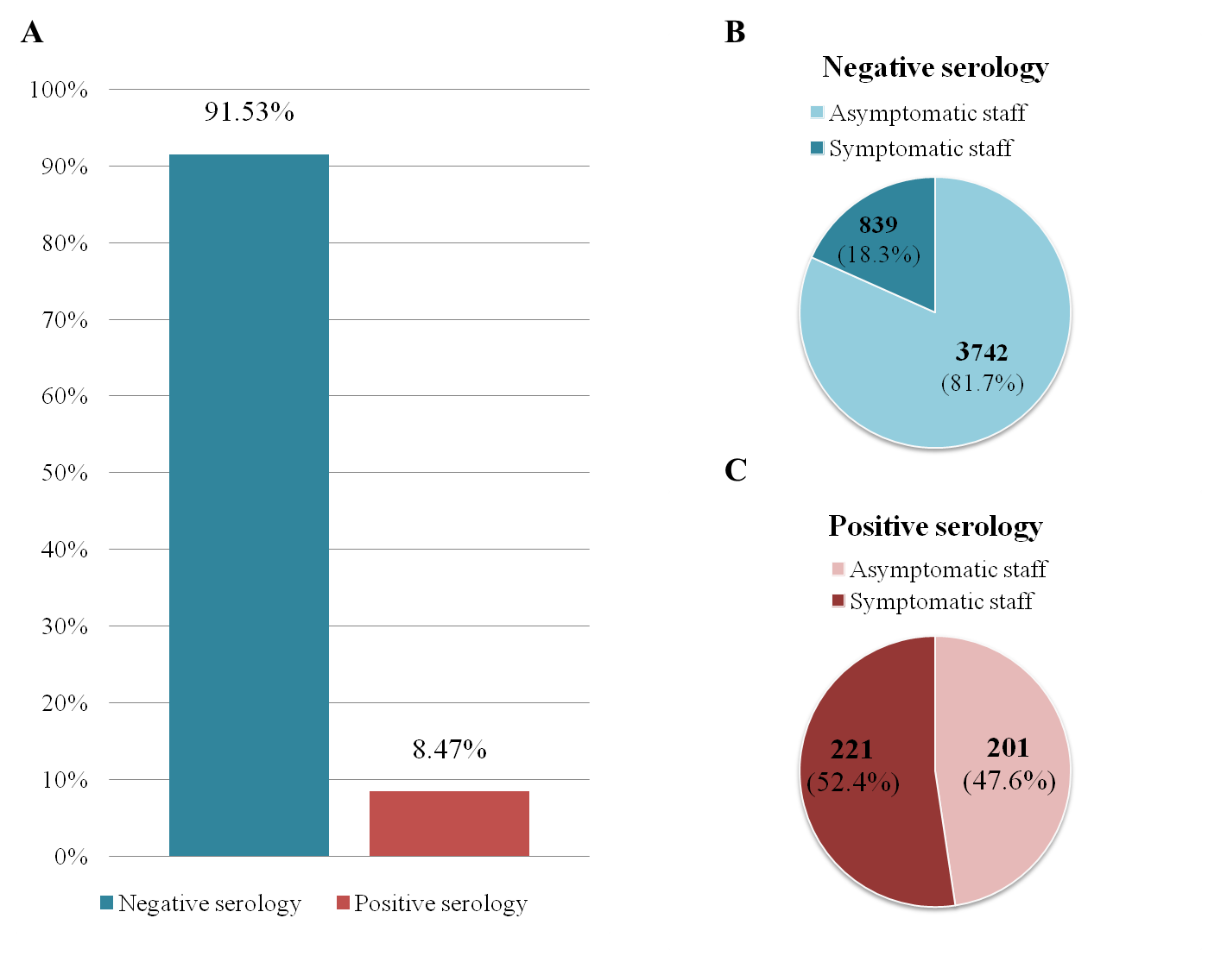
Proportion of negative and positive SARS-CoV-2 serology in tested personnel (A) and crossover between seroprevalence and asymptomatic (B) or symptomatic (C) professionals. Negative serologies include results with negative IgM and IgG. Positive serologies include results with positive IgM and/or IgG.

Supplementary Table 2 - Distribution of seropositive subjects and symptoms by department
 | Positive serology |  |  | Symptoms
Department | No n (%) | Yes n (%) | Total | No n (%) | Yes n (%) | Total
Anesthesia reanimation | 352 (92.1) | 30 (7.9) | 382 | 281 (81.4) | 64 (18.6) | 345
Biology | 404 (95.5) | 19 (4.5) | 423 | 285 (78.5) | 78 (21.5) | 363
Cardiology | 247 (91.5) | 23 (8.5) | 270 | 191 (82.3) | 41 (17.7) | 232
Executive management | 97 (86.6) | 15 (13.4) | 112 | 74 (78.7) | 20 (21.3) | 94
Finance management | 110 (95.7) | 5 (4.3) | 115 | 77 (79.4) | 20 (20.6) | 97
Gynecology | 264 (91.7) | 24 (8.3) | 288 | 204 (75.8) | 65 (24.2) | 269
Logistics management | 211 (94.2) | 13 (5.8) | 224 | 135 (80.4) | 33 (19.6) | 168
Digestive pathologies | 160 (94.7) | 9 (5.3) | 169 | 123 (83.7) | 24 (16.3) | 147
Internal medicine | 130 (85.0) | 23 (15.0) | 153 | 99 (73.3) | 36 (26.7) | 135
Dental care | 110 (88.0) | 15 (12.0) | 125 | 75 (67.6) | 36 (32.4) | 111
Thoracic pathology | 167 (88.4) | 22 (11.6) | 189 | 113 (77.4) | 33 (22.6) | 146
Pharmacy | 181 (97.3) | 5 (2.7) | 186 | 152 (88.9) | 19 (11.1) | 171
Geriatry | 141 (72.3) | 54 (27.7) | 195 | 117 (72.7) | 44 (27.3) | 161
Musculoskeletal system | 173 (87.8) | 24 (12.2) | 197 | 144 (82.3) | 31 (17.7) | 175
Pediatrics | 378 (94.7) | 21 (5.3) | 399 | 297 (80.7) | 71 (19.3) | 368
Medical specialties | 254 (90.7) | 26 (9.3) | 280 | 195 (76.8) | 59 (23.2) | 254
Psychiatry | 142 (91.0) | 14 (9.0) | 156 | 93 (76.9) | 28 (23.1) | 121
Imagery | 259 (92.5) | 21 (7.5) | 280 | 197 (75.5) | 64 (24.5) | 261
Head-Neck | 244 (96.4) | 9 (3.6) | 253 | 176 (80.4) | 43 (19.6) | 219
Emergencies | 388 (91.9) | 34 (8.1) | 422 | 275 (73.7) | 98 (26.3) | 373

Supplementary Table 3 - Odds ratio of SARS-CoV-2 seroprevalence according to a history of anosmia and/or agueusia and the type of hospital department.

Variables | OR | p-value | 95%CI
Anosmia and/or agueusia | 16.6 | < 0,05 | 12.5 – 22.0
Administrative group | 1.4 | 0.16 | 0.9 - 2.1
Medicine group | 2.2 | < 0,05 | 1.5 - 3.1
Medico-surgery group | 1.4 | 0.07 | 0.97-2.10
Mother-child group | 1.3 | 0.18 | 0.87 – 2.03
Emergency-intensive care group | 1.7 | < 0.05 | 1.16 – 2.51
Geriatry group | 5.3 | < 0,05 | 3.48 - 8.16
Oncology group | 2.8 | < 0,05 | 1.60 - 4.69
Psychatry group | 1.9 | 0.05 | 0.96 - 3.50

