SUPPLEMENTAL DATA
Methods
Three different SARS-CoV-2 tests were available for COVID-19 diagnosis and monitoring during the study period. Availability of the Xpert Xpress SARS-CoV-2 was limited. The majority of testing was performed using the LDT based on CDC test followed by the Roche COBAS SARS-CoV-2. Head-to-head comparison of 5 positive samples over range of Ct values showed small differences (< 2) in Ct values between the LDT CDC PCR and the Cobas SARS-CoV-2 tests (Table 1), particularly for N2 and ORF.
 | LDT CDC COVID-19 PCR |  | Cobas 6800 SARS-CoV-2
Sample ID | N1 (Ct) | N2 (Ct) | ORF (Ct) | E (Ct)
1 | 15.88 | 15.59 | 15.61 | 16.17
2 | 17.169 | 15.25 | 14.6 | 14.93
3 | 17.169 | 15.25 | 14.75 | 15.14
4 | 31.57 | 30.5 | 29.87 | 30.8
5 | 32.307 | 31.516 | 30.69 | 31.94
Table 1. Head-to-head comparison of Ct values between LDT and Cobas SARS-CoV-2

Meant Ct values for all positive samples during the study period are summarized by platforms in
SARS-CoV-2 Test | Total positive tests | Target | Mean Ct (SD)
LDT CDC PCR | 1344 | N2 | 26.7 (±7.45)
Cobas 6800 SARS-CoV | 321 | ORF | 25.6 (±11.4)
Table 2. Mean Ct values of Positive samples during study period.

While small differences exist between Ct values obtained using different tests, the Ct values were used interchangeably in the study (target 1: N2, N, or ORF).

Supplemental Table 1. Characteristics of patients with cancer and COVID-19 by tumor type
 | Patients with solid tumors | Patients with hematologic tumors | p-value
N | 70 | 35
Demographic characteristics
Age | 63 (4, 91) | 57 (4, 86) | 0.26
Male sex | 37 (53) | 22 (63) | 0.33
Race |  |  | 0.052
White | 42 (60) | 22 (63)
Black | 7 (10) | 8 (23)
Asian | 10 (14) | 0
Other | 11 (16) | 5 (15)
Hispanic/Latinx ethnicity | 16 (25) | 4 (13) | 0.16
Health and treatment history
Current or former smoker | 27 (40) | 13 (41) | 0.89
Neutropenia | 0 | 1 (3) | 0.33
Lymphopenia∫ | 1 (1) | 2 (6) | 0.22
Diabetes | 14 (20) | 6 (17) | 0.73
Cardiac disease | 15 (21) | 9 (26) | 0.62
Chronic kidney disease | 4 (6) | 5 (14) | 0.10
Asthma | 6 (9) | 0 | 0.08
Chronic obstructive pulmonary disease | 8 (11) | 1 (3) | 0.14
Hypertension | 38 (54) | 16 (46) | 0.41
Chemotherapy (30 days) | 32 (46) | 17 (49) | 0.78
PD1 inhibitor (90 days) | 10 (14) | 0 | 0.14
Steroids~ | 15 (21) | 7 (20) | 0.87
Rituximab (six months) | 1 (1) | 7 (20) | 0.002
COVID-19 clinical course
Symptomatic (any signs or symptoms) | 64 (91) | 35 (100) | 0.08
Fever | 42 (60) | 28 (80) | 0.04
Cough | 43 (61) | 28 (80) | 0.06
Shortness of breath | 28 (40) | 17 (50) | 0.33
Other* | 12 (17) | 7 (20) | 0.72
Hypoxia | 39 (56) | 18 (51) | 0.68
Required hospitalization | 24 (34) | 16 (46) | 0.26
Required critical care** | 18 (26) | 5 (15) | 0.23
Died | 12 (17) | 9 (26) | 0.30
Days from first positive test to death*** | 33 (11, 124) | 33 (19, 133) | 0.58
Resolved during observation period
Defined as negative test | 28 (40) | 15 (43) | 0.78
Defined as cycle threshold >30 | 58 (83) | 24 (69) | 0.10

Continuous data are median (range) and categorical data are no. (%) yes. Differences between groups were assessed using Wilcoxon signed rank sum test for continuous data and Fisher’s exact test for categorical data.
∫ Absolute lymphocyte count <500 per microliter over five previous consecutive measurements
~ Corticosteroids use was defined by equivalent of prednisone ≥20 mg for at least 10 days
*Other symptoms included anosmia, chest pain, delirium, diarrhea, fatigue, headache, myalgia, sore throat.
**Defined as admission to intensive care unit.
***Among patients who died.

Supplemental Figure 1. Scatterplot of cycle threshold by days from first positive test for patients with solid and hematologic tumors. All positive tests and the first sustained negative test (i.e., a negative test that was not followed by a positive test), if applicable, are included for each patient. Patients with positive results after 50 days (all hematologic tumors) are plotted individually and identified with different marker shapes. Linear trend lines are shown for solid and hematologic tumors.

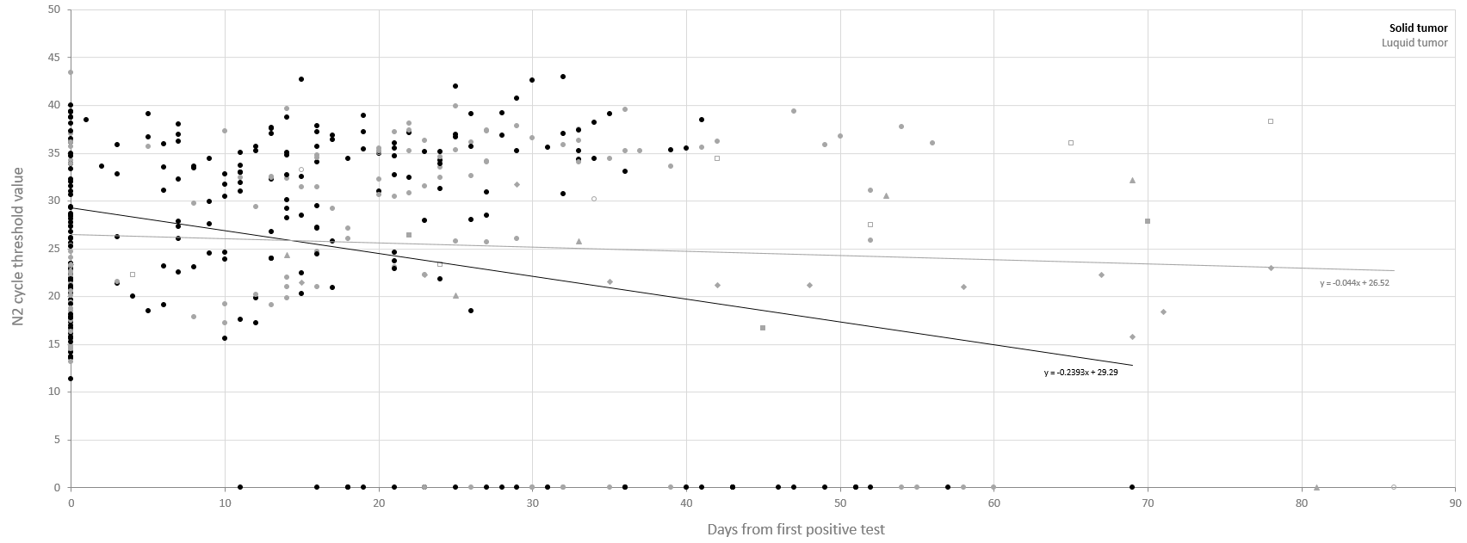
Supplemental Figure 1

