Supplement 1: Timeline for Healthcare Personnel Infected with COVID-19 During Feb 12 – Jul 13, 2021
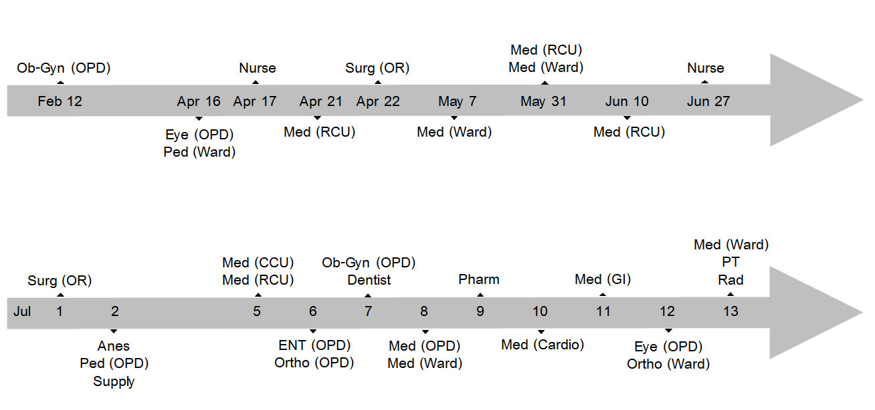

Note: Ob-Gyn = Department of Obstetrics and Gynecology, OPD = Outpatient Department, Eye = Department of Ophthalmology, Ped = Department of Pediatrics, Nurse = Nursing Department, Med = Department of Medicine, RCU = Respiratory Care Unit, Surg = Department of Surgery, OR = Operating Room, Anes = Department of Anesthesiology, Supply = Supply Unit, CCU = Cardiac Care Unit, ENT = Department of Otolaryngology, Ortho = Department of Orthopedics, Dentist = Department of Dentistry, Pharm = Department of Pharmacology, Cardio = Division of Cardiology, GI = Division of Gastroenterology, PT = Physical Therapy, Rad = Department of Radiology

Exposure Risk
High-risk exposure | A high-risk exposure corresponds generally to a person who has been in sustained physical contact with the person who tested positive without wearing a procedure** mask: for example someone living under the same roof, someone who is an intimate or sexual partner or someone who has had direct contact with infectious biological fluids such as saliva.
Medium-risk exposure | A medium-risk exposure is someone who has been in close contact (less than two metres away for 15 minutes**) with a person who tested positive, IF one or both people were not properly wearing*** a procedural mask.
Low-risk exposure | A low-risk exposure is someone who:  - Was in close contact (less than two metres away for at least 15 minutes*) with a person who tested positive, but both people properly wore a procedural mask during the entire exposure; OR  - Remained more than 2 m away at all times from the person who tested positive; OR  - Was less than 2 m away, but for less than 15 minutes*
Severity of Symptoms
Asymptomatic | Individuals who test positive for SARS-CoV-2 using a virologic test (i.e., a nucleic acid amplification test [NAAT] or an antigen test) but who have no symptoms that are consistent with COVID-19.
Mild Illness | Individuals who have any of the various signs and symptoms of COVID-19 (e.g., fever, cough, sore throat, malaise, headache, muscle pain, nausea, vomiting, diarrhea, loss of taste and smell) but who do not have shortness of breath, dyspnea, or abnormal chest imaging.
Moderate Illness | Individuals who show evidence of lower respiratory disease during clinical assessment or imaging and who have an oxygen saturation (SpO2) ≥94% on room air at sea level.
Severe Illness | Individuals who have SpO2 <94% on room air at sea level, a ratio of arterial partial pressure of oxygen to fraction of inspired oxygen (PaO2/FiO2) <300 mm Hg, respiratory frequency >30 breaths/min, or lung infiltrates >50%.
Critical Illness | Individuals who have respiratory failure, septic shock, and/or multiple organ dysfunction.
Definitions of Exposure Risk and Severity of Symptoms

