Appendices
48hr Antibiotic Timeout List Column and Workspace
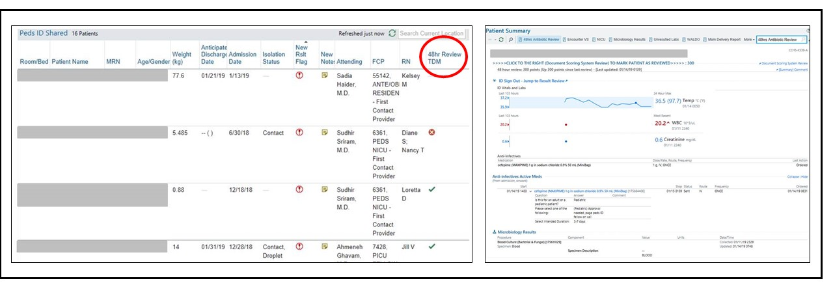
© 2021 Epic Systems
Multi-ATO Nursing Algorithm
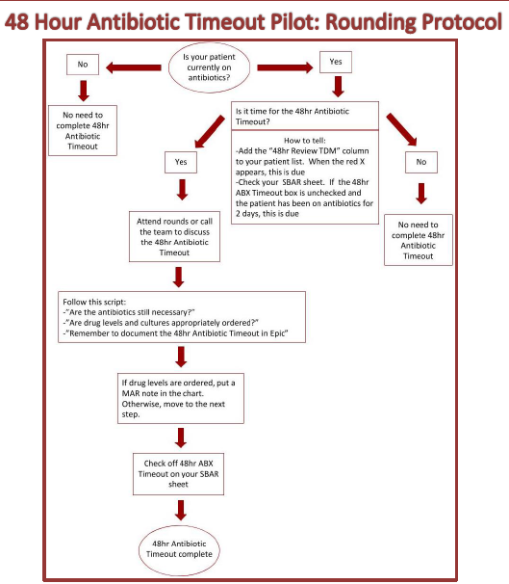

Multi-ATO Resident Algorithm
