Supplementary Table 1: List of antibiotics that patients were allergic to
Antibiotic | # Patients
AMOXICILLIN | 176
AMPICILLIN | 5
CEFAZOLIN | 12
CEFDINIR | 1
CEFOTAXIME | 1
CEFTRIAXONE | 4
CEFUROXIME | 1
CEPHALEXIN | 44
“CEPHALOSPORINS” | 14
DICLOXACILLIN | 2
ERTAPENEM | 1
MEROPENEM | 1
OXACILLIN | 2
PENICILLIN G | 4
PENICILLIN G BENZATHINE | 9
PENICILLIN G SODIUM | 1
PENICILLIN V | 6
“PENICILLINS” | 543
Total Patients | 827

Supplementary Figure 1a-b
- Antibiotic selection algorithm for GBS prophylaxis
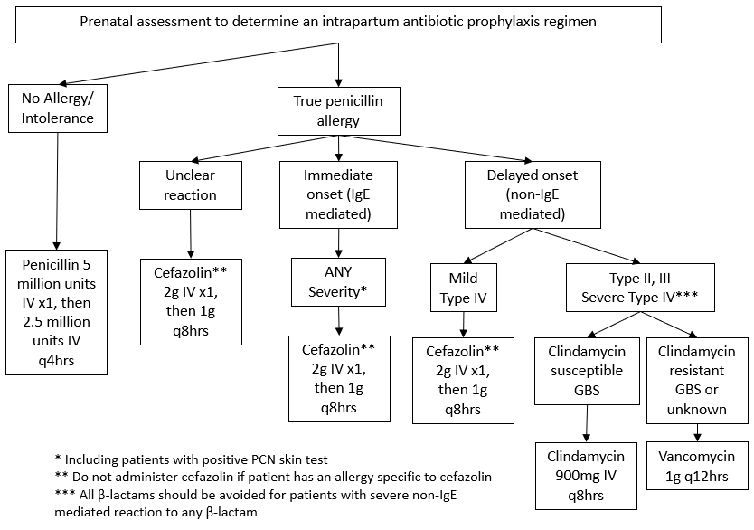
- Antibiotic selection algorithm for Cesarean section
