Supplementary figures

Figure S1: Isometric view of a computer rendering of the single patient room. Room entry would be from the lower left hand corner of the image.
The white air cleaner (or portable HEPA filter) is the one on the patient bedside and the red air cleaner (portable HEPA filter) is flush with the wall

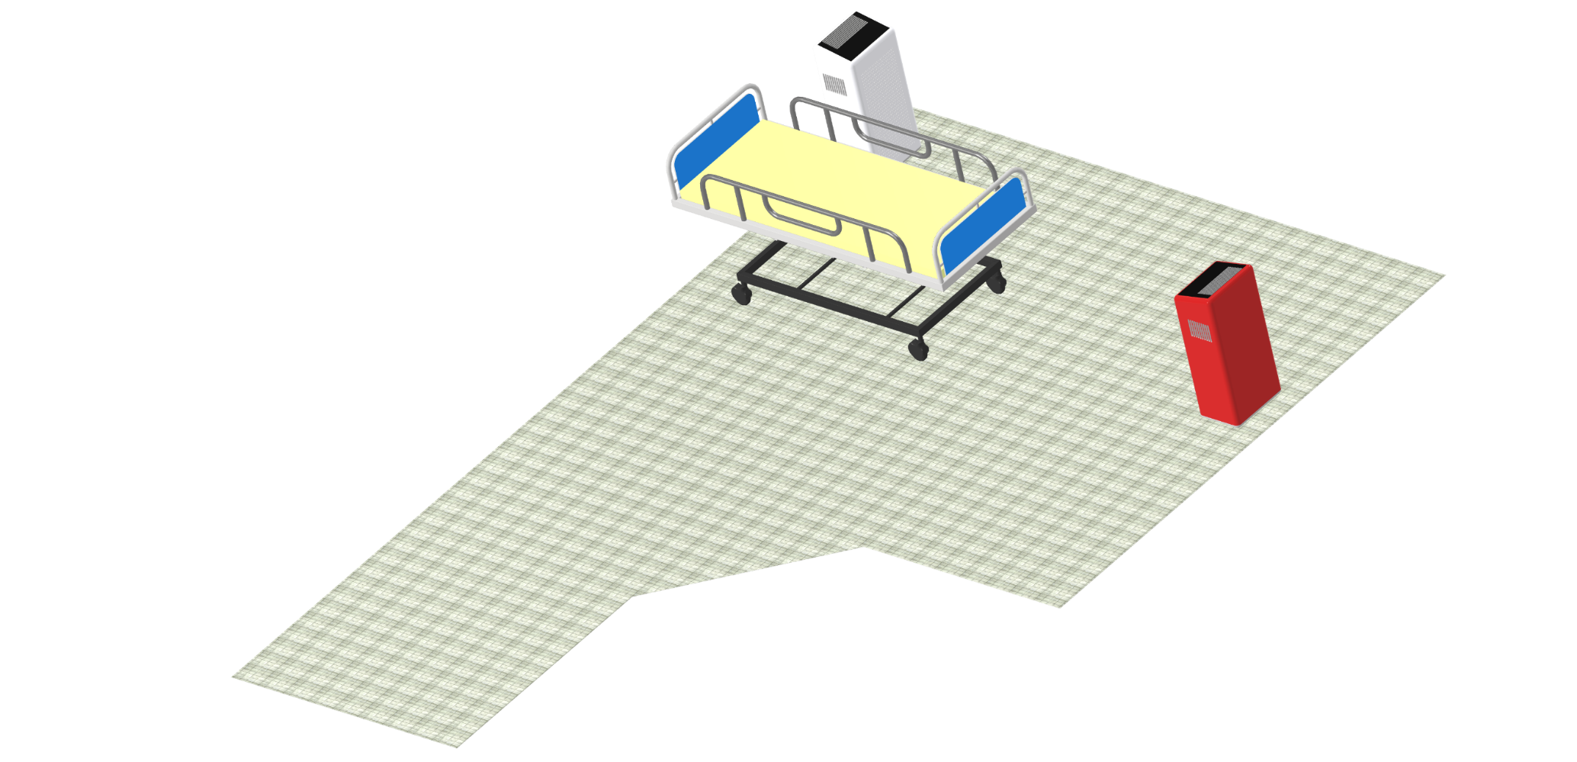

Figure S2: Isometric view of a computer rendering of the air cleaner barrier in front of the nurses’ station table.

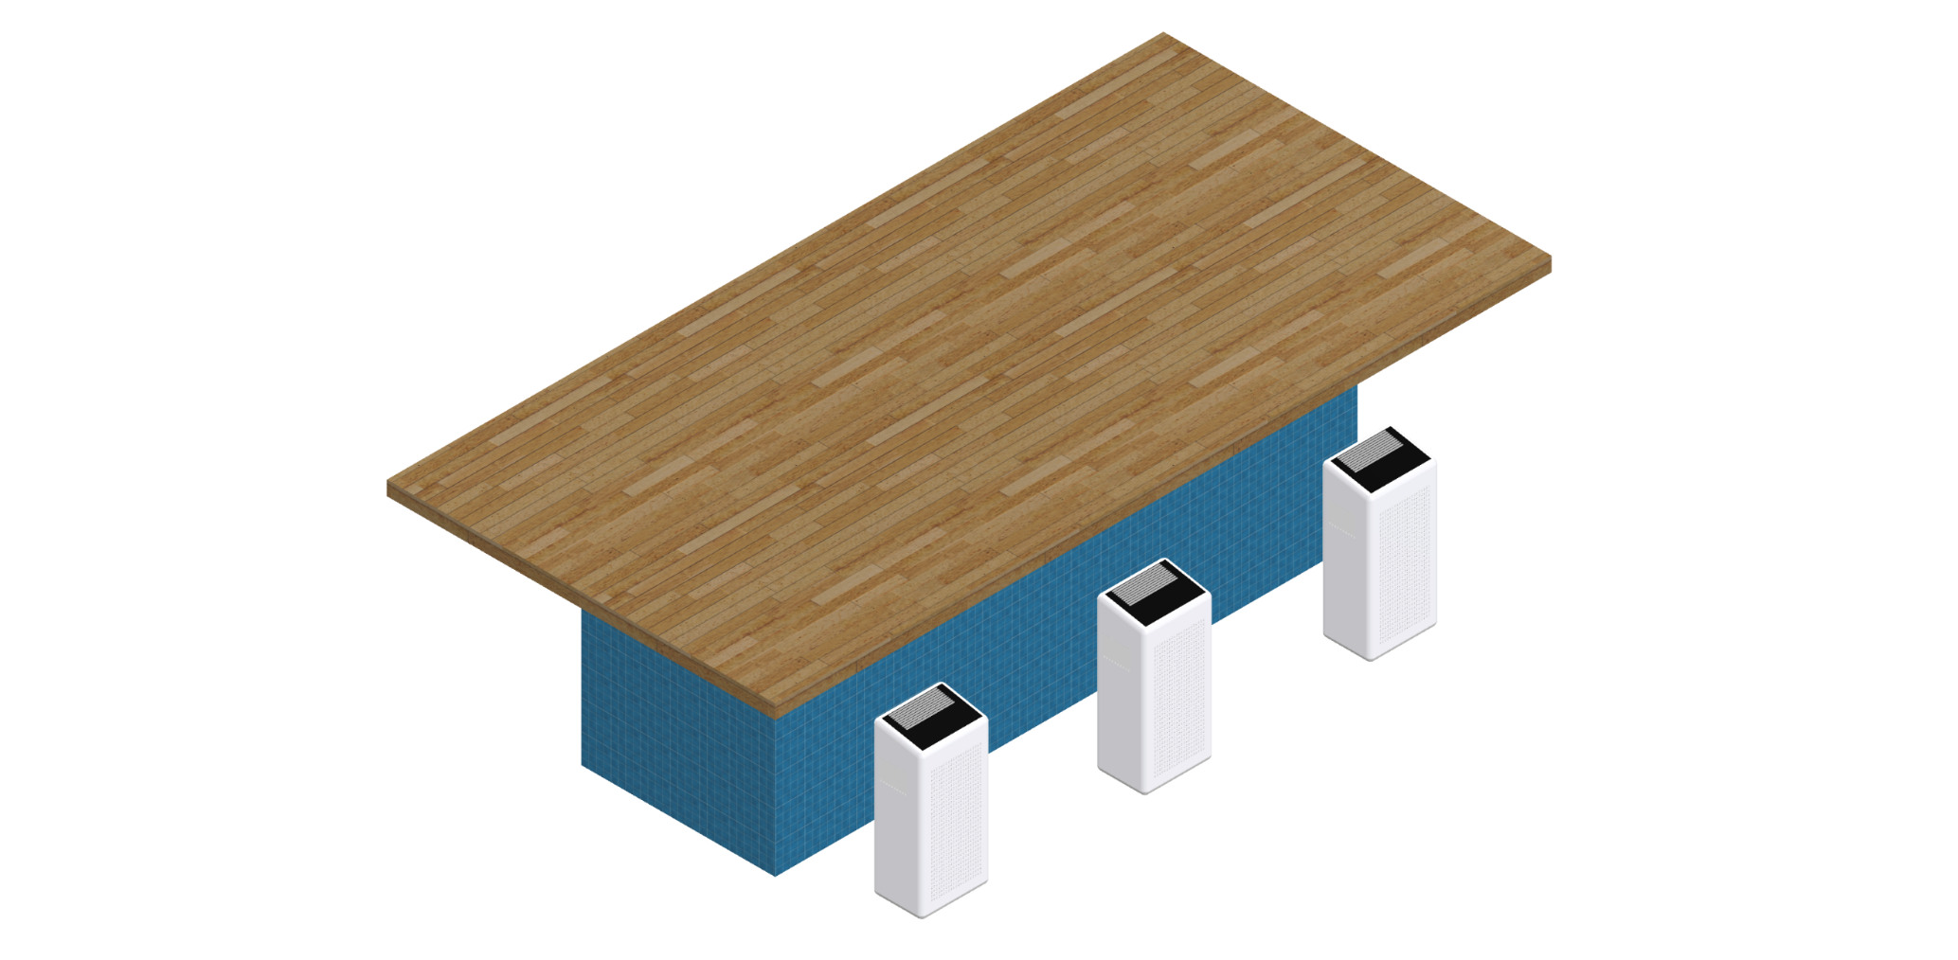

Figure S3: Photo of installed ZipWallTM at nurses’ station

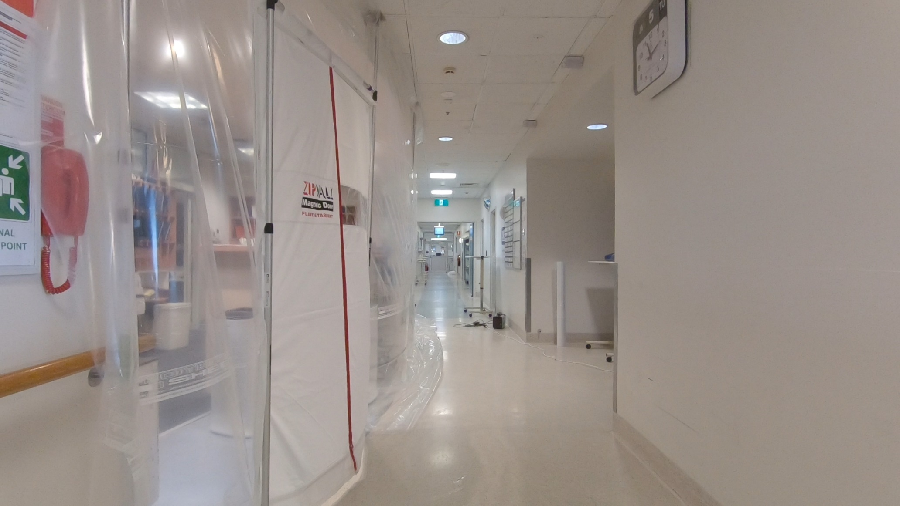

Figure S4: Comparison of smoke exiting the patient room with the door closed (left) and open (right).
Note that the figures were taken at approximately the same time after the room was flooded with smoke.

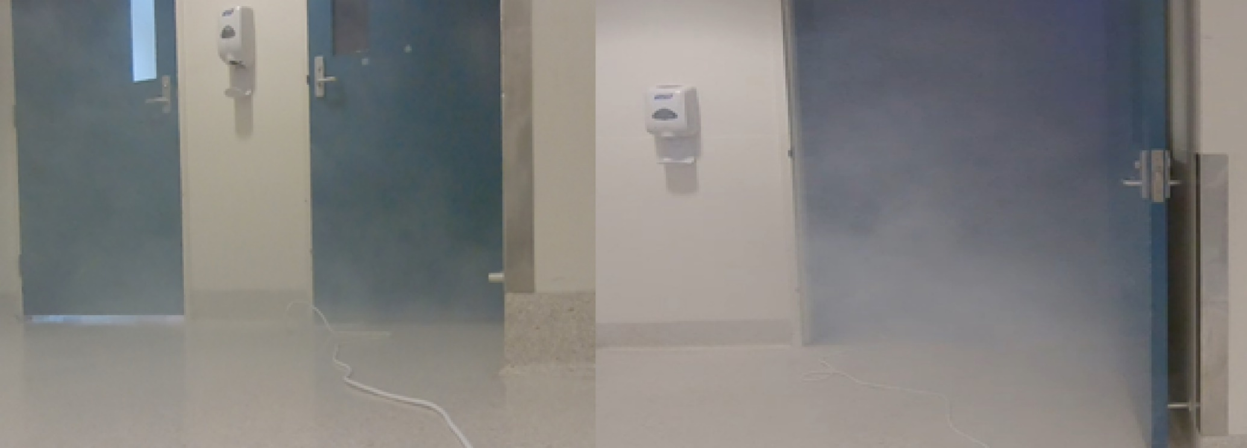

Figure S5: Aerodynamic Particle Sizer™ (APS) particle number size distribution observations for the variable number of air cleaners during corridor clearance experiment.
S5a is the same as 4b but showing the APS observed number concentrations
S5b shows the APS observed size number concentrations.

S5a S5b
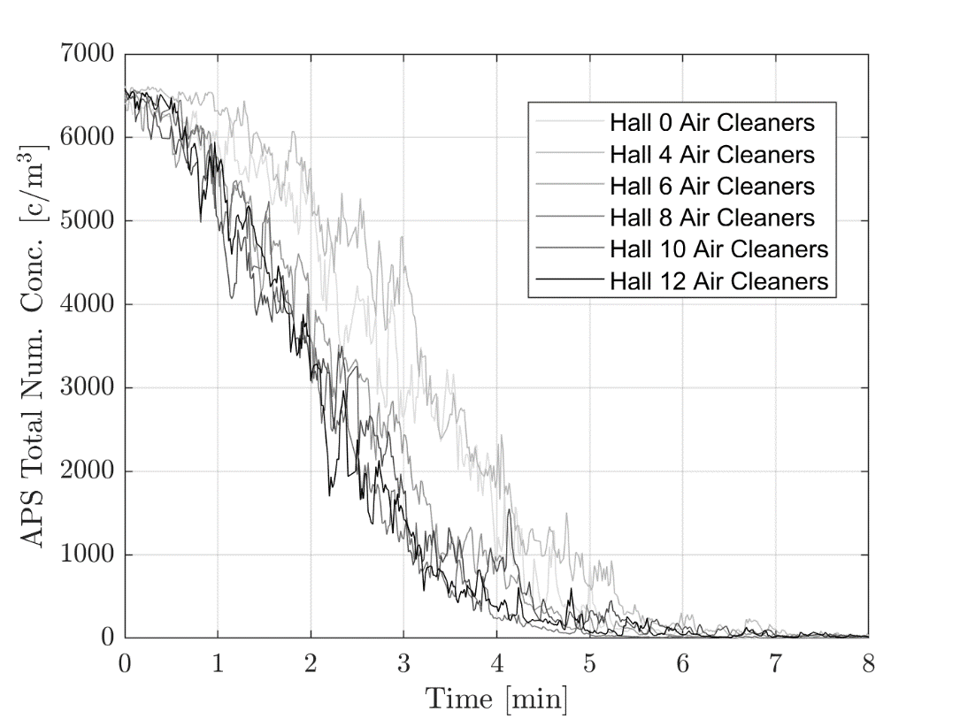 | 