Supplementary Table 1. International Classification of Diseases (ICD) Codes for Bacterial Pneumonia and Current Procedural Terminology (CPT) Codes for Chest Imaging
Inclusion Criteria
ICD-9 Codes | 481-486, 997.31
ICD-10 Codes | J13-J18, J95.851
CPT Codes for Chest X-rays (2018 and prior) | 71010
 | 71015
 | 71020
 | 71021
 | 71022
 | 71023
 | 71030
 | 71034
 | 71035
CPT Codes for Chest X-rays (≥ 2019) | 71045
 | 71046
 | 71047
 | 71048
CPT Codes for chest CT scans | 71250
 | 71260
 | 71270

Exclusion Criteria
ICD-9 Codes | 480, 487, 488
ICD-10 Codes | J09-12

Supplementary Figure 1.
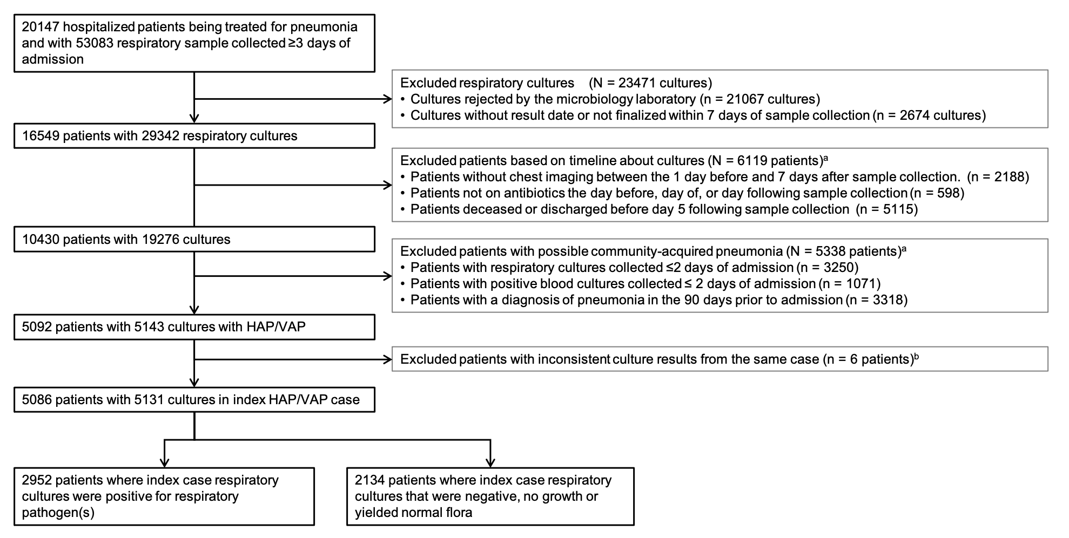
Flow diagram of the application of inclusion and exclusion criteria to identify patients with hospital-acquired pneumonia (HAP) or ventilator-associated pneumonia (VAP) that comprised the cohort that was stratified by microbiological culture results and then analyzed. ª Represents the total number of patients excluded in each exclusion step. For each major exclusion criteria, patients may have met multiple sub-criteria for exclusion. ^{b}Six patients were excluded from the final analysis because they had both respiratory pathogens and normal flora/negative growth recovered from the same case.

Supplementary Figure 2.

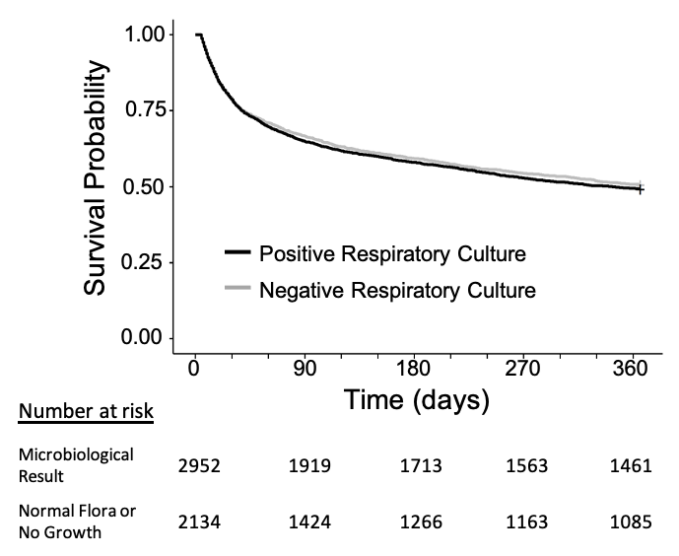

Kaplan Meier curves of time to death following hospital-acquired pneumonia and ventilatory-associated pneumonia comparing among patients with respiratory cultures that yielded microbiological results (black line) compared to those with culture results that were reported as normal respiratory flora or no growth (grey line).

Supplementary Figure 3.

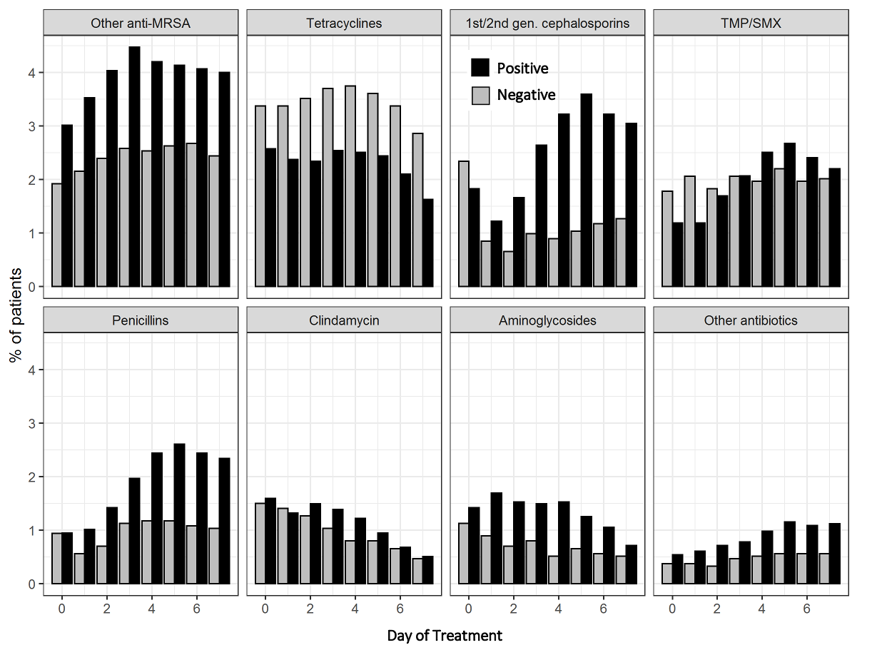
Changes in antibiotic classes prescribed to patients with hospital-acquired or ventilator-associated pneumonia. The y-axis indicates the proportion of patients receiving different classes of antibiotics on day of sample collection (Day 0) through Day 7 after sample collection. Black bars indicate patients with cultures positive for a respiratory pathogen; grey bays indicate patients with respiratory cultures recorded as normal flora, no growth, or negative. Due to the small percentage of patients on any of these agents, we did not assess for statistically significant difference between those with positive and negative respiratory cultures. MRSA, methicillin-resistant Staphylococcus aureus; TMP/SMX, trimethoprim/sulfamethoxazole.

Supplementary Table 2.
Antibiotic Classª | Respiratory Culture Results |  | Day 0 |  | Day 1 |  | Day 2 |  | Day 3 |  | Day 4 |  | Day 5 |  | Day 6 |  | Day 7
Vancomycin | Positive | 1740 (59%) |  | 1746 (59%) |  | 1539 (52%) |  | 1228 (42%) |  | 955 (32%) |  | 835 (28%) |  | 744 (25%) |  | 673 (23%)
 | Negative | 1249 (59%) |  | 1252 (59%) |  | 1122 (53%) |  | 960 (45%) |  | 820 (38%) |  | 707 (33%) |  | 590 (28%) |  | 476 (22%)
Beta-Lactam/Beta-Lactamase Inhibitors | Positive | 1528 (52%) |  | 1632 (55%) |  | 1558 (53%) |  | 1357 (46%) |  | 1116 (38%) |  | 956 (32%) |  | 831 (28%) |  | 686 (23%)
 | Negative | 949 (44%) |  | 986 (46%) |  | 964 (45%) |  | 910 (43%) |  | 829 (39%) |  | 744 (35%) |  | 618 (29%) |  | 484 (23%)
Extended Spectrum Cephalosporins | Positive | 726 (25%) |  | 785 (27%) |  | 831 (28%) |  | 862 (29%) |  | 830 (28%) |  | 786 (27%) |  | 674 (23%) |  | 572 (19%)
 | Negative | 691 (32%) |  | 682 (32%) |  | 647 (30%) |  | 575 (27%) |  | 523 (25%) |  | 426 (20%) |  | 367 (17%) |  | 301 (14%)
No Antibiotics | Positive | 394 (13%) |  | 209 (7%) |  | 239 (8%) |  | 290 (10%) |  | 354 (12%) |  | 446 (15%) |  | 653 (22%) |  | 919 (31%)
 | Negative | 250 (12%) |  | 179 (8%) |  | 221 (10%) |  | 291 (14%) |  | 350 (16%) |  | 477 (22%) |  | 672 (31%) |  | 885 (41%)
Fluoroquinolones | Positive | 316 (11%) |  | 321 (11%) |  | 344 (12%) |  | 381 (13%) |  | 402 (14%) |  | 414 (14%) |  | 398 (13%) |  | 351 (12%)
 | Negative | 342 (16%) |  | 320 (15%) |  | 334 (16%) |  | 312 (15%) |  | 309 (14%) |  | 300 (14%) |  | 272 (13%) |  | 206 (10%)
Carbapenems | Positive | 278 (9%) |  | 331 (11%) |  | 380 (13%) |  | 408 (14%) |  | 389 (13%) |  | 379 (13%) |  | 359 (12%) |  | 342 (12%)
 | Negative | 198 (9%) |  | 224 (10%) |  | 250 (12%) |  | 262 (12%) |  | 273 (13%) |  | 270 (13%) |  | 269 (13%) |  | 242 (11%)
Metronidazole | Positive | 289 (10%) |  | 331 (11%) |  | 316 (11%) |  | 297 (10%) |  | 279 (9%) |  | 251 (9%) |  | 236 (8%) |  | 217 (7%)
 | Negative | 207 (10%) |  | 226 (11%) |  | 235 (11%) |  | 225 (11%) |  | 219 (10%) |  | 193 (9%) |  | 170 (8%) |  | 152 (7%)
Macrolides | Positive | 254 (9%) |  | 239 (8%) |  | 198 (7%) |  | 152 (5%) |  | 116 (4%) |  | 91 (3%) |  | 69 (2%) |  | 64 (2%)
 | Negative | 259 (12%) |  | 235 (11%) |  | 200 (9%) |  | 163 (8%) |  | 124 (6%) |  | 100 (5%) |  | 85 (4%) |  | 66 (3%)
Other anti-MRSA agents | Positive | 89 (3%) |  | 104 (4%) |  | 119 (4%) |  | 132 (4%) |  | 124 (4%) |  | 122 (4%) |  | 120 (4%) |  | 118 (4%)
 | Negative | 41 (2%) |  | 46 (2%) |  | 51 (2%) |  | 55 (3%) |  | 54 (3%) |  | 56 (3%) |  | 57 (3%) |  | 52 (2%)
Tetracyclines | Positive | 76 (3%) |  | 70 (2%) |  | 69 (2%) |  | 75 (3%) |  | 74 (3%) |  | 72 (2%) |  | 62 (2%) |  | 48 (2%)
 | Negative | 72 (3%) |  | 72 (3%) |  | 75 (4%) |  | 79 (4%) |  | 80 (4%) |  | 77 (4%) |  | 72 (3%) |  | 61 (3%)
1st/2nd Generation Cephalosporins | Positive | 54 (2%) |  | 36 (1%) |  | 49 (2%) |  | 78 (3%) |  | 95 (3%) |  | 106 (4%) |  | 95 (3%) |  | 90 (3%)
 | Negative | 50 (2%) |  | 18 (1%) |  | 14 (1%) |  | 21 (1%) |  | 19 (1%) |  | 22 (1%) |  | 25 (1%) |  | 27 (1%)
Sulfamethoxazole/Trimethoprim | Positive | 35 (1%) |  | 35 (1%) |  | 50 (2%) |  | 61 (2%) |  | 74 (3%) |  | 79 (3%) |  | 71 (2%) |  | 65 (2%)
 | Negative | 38 (2%) |  | 44 (2%) |  | 39 (2%) |  | 44 (2%) |  | 42 (2%) |  | 47 (2%) |  | 42 (2%) |  | 43 (2%)
Penicillins | Positive | 28 (1%) |  | 30 (1%) |  | 42 (1%) |  | 58 (2%) |  | 72 (2%) |  | 77 (3%) |  | 72 (2%) |  | 69 (2%)
 | Negative | 20 (1%) |  | 12 (1%) |  | 15 (1%) |  | 24 (1%) |  | 25 (1%) |  | 25 (1%) |  | 23 (1%) |  | 22 (1%)
Clindamycin | Positive | 47 (2%) |  | 39 (1%) |  | 44 (1%) |  | 41 (1%) |  | 36 (1%) |  | 28 (1%) |  | 20 (1%) |  | 15 (1%)
 | Negative | 32 (1%) |  | 30 (1%) |  | 27 (1%) |  | 22 (1%) |  | 17 (1%) |  | 17 (1%) |  | 14 (1%) |  | 10 (0%)
Aminoglycosides | Positive | 42 (1%) |  | 50 (2%) |  | 45 (2%) |  | 44 (1%) |  | 45 (2%) |  | 37 (1%) |  | 31 (1%) |  | 21 (1%)
 | Negative | 24 (1%) |  | 19 (1%) |  | 15 (1%) |  | 17 (1%) |  | 11 (1%) |  | 14 (1%) |  | 12 (1%) |  | 11 (1%)
Other Antibiotics | Positive | 16 (1%) |  | 18 (1%) |  | 21 (1%) |  | 23 (1%) |  | 29 (1%) |  | 34 (1%) |  | 32 (1%) |  | 33 (1%)
 | Negative | 8 (0%) |  | 8 (0%) |  | 7 (0%) |  | 10 (0%) |  | 11 (1%) |  | 12 (1%) |  | 12 (1%) |  | 12 (1%)
ªBL/BLI (beta-lactam/beta-lactamase inhibitors) includes piperacillin/tazobactam, ampicillin/sulbactam, and amoxicillin/clavulanate. Extended Spectrum Cephalosporins includes cefdinir, cefepime, cefotaxime, cefpoxodime, ceftaroline, ceftazidime, ceftriaxone, aztreonam, and ceftaroline. Other anti-MRSA (methicillin-resistant Staphylococcus aureus) agents include daptomycin, dalbavancin, and linezolid. Other Antibiotics includes ceftazidime/avibactam, ceftolozane/tazobactam, colistin, dapsone, polymyxin, rifampin, rifaximin and nitrofurantoin.

