Supplementary Figure 1: Probability of N95 maintaining a good fit after incremental donnings.

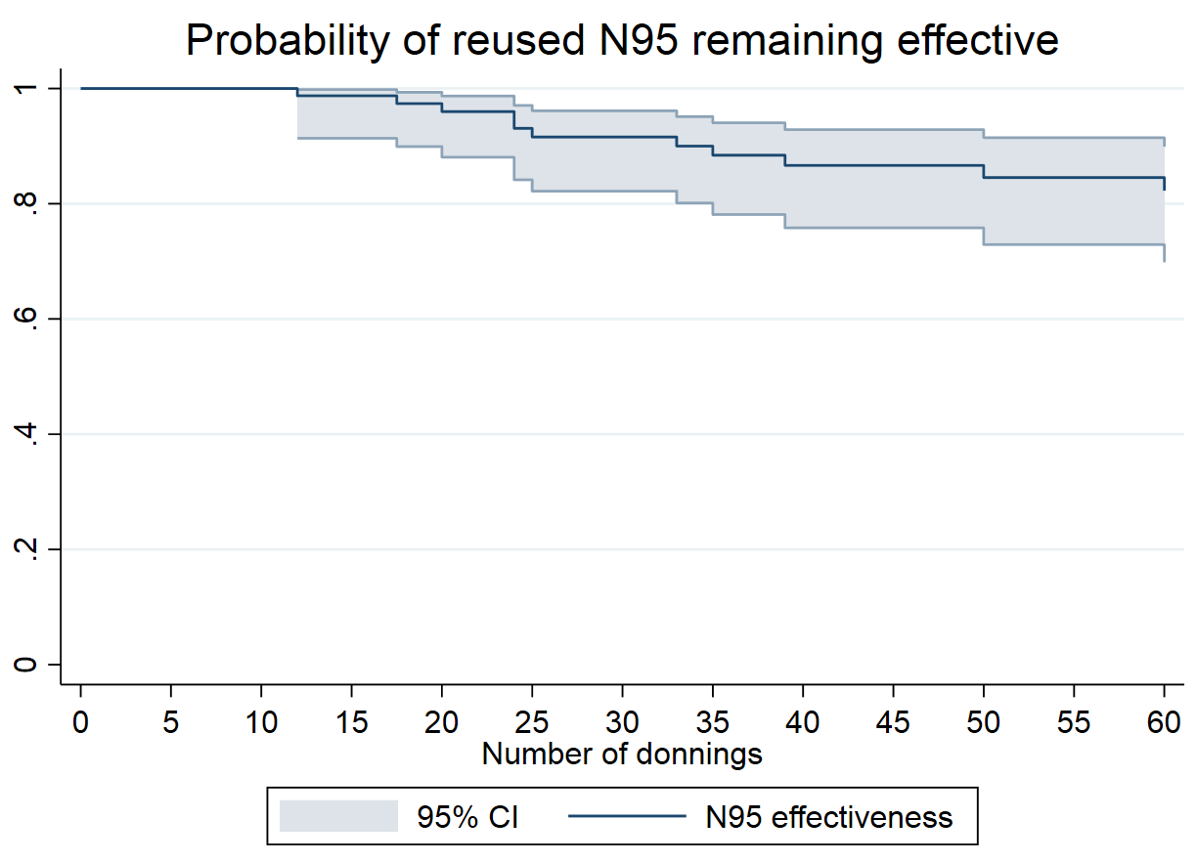

Supplementray Table 1. Donning and doffing instructions of personal protective equipment during COVID-19 pandemic.
Donning steps | Doffing steps
Purell hands | Purell outer gloves and remove
Don N95 and perform seal check | Remove gown
Don inner gloves | Purell inner gloves and leave patient room
Don gown | Purell inner gloves again
Don face shiled | Remove face shiled and clean
Don outer gloves | Remove inner gloves
 | Purell hands
 | Doff N95 and store until next use

Supplementary Table 2: Probability of N95 maintaining a good fit with incremental donnings.

Interval | Total | Failures per donning interval | Pass with no subsequent follow up | Passing | Error | 95% Confidence Interval
1 2 | 92 | 0 | 3 | 1 | 0 | . .
3 4 | 89 | 0 | 1 | 1 | 0 | . .
4 5 | 88 | 0 | 1 | 1 | 0 | . .
5 6 | 87 | 0 | 1 | 1 | 0 | . .
7 8 | 86 | 0 | 1 | 1 | 0 | . .
10 11 | 85 | 0 | 6 | 1 | 0 | . .
12 13 | 79 | 1 | 4 | 1 | 0.0129 | 0.9114 0.9982
15 16 | 74 | 0 | 1 | 0.9870 | 0.0129 | 0.9114 0.9982
17 18 | 73 | 1 | 2 | 0.9733 | 0.0186 | 0.8974 0.9933
20 21 | 70 | 1 | 2 | 0.9592 | 0.0231 | 0.8787 0.9867
22 23 | 67 | 0 | 1 | 0.9592 | 0.0231 | 0.8787 0.9867
24 25 | 66 | 2 | 2 | 0.9297 | 0.0304 | 0.8390 0.9702
25 26 | 62 | 1 | 0 | 0.9147 | 0.0334 | 0.8196 0.9608
28 29 | 61 | 0 | 1 | 0.9147 | 0.0334 | 0.8196 0.9608
30 31 | 60 | 0 | 2 | 0.9147 | 0.0334 | 0.8196 0.9608
33 34 | 58 | 1 | 0 | 0.8989 | 0.0363 | 0.7992 0.9506
35 36 | 57 | 1 | 2 | 0.8829 | 0.0391 | 0.7788 0.9398
36 37 | 54 | 0 | 3 | 0.8829 | 0.0391 | 0.7788 0.9398
37 38 | 51 | 0 | 1 | 0.8829 | 0.0391 | 0.7788 0.9398
39 40 | 50 | 1 | 0 | 0.8652 | 0.0421 | 0.7560 0.9278
40 41 | 49 | 0 | 2 | 0.8652 | 0.0421 | 0.7560 0.9278
42 43 | 47 | 0 | 1 | 0.8652 | 0.0421 | 0.7560 0.9278
45 46 | 46 | 0 | 3 | 0.8652 | 0.0421 | 0.7560 0.9278
48 49 | 43 | 0 | 1 | 0.8652 | 0.0421 | 0.7560 0.9278
49 50 | 42 | 0 | 1 | 0.8652 | 0.0421 | 0.7560 0.9278
50 51 | 41 | 1 | 2 | 0.8436 | 0.0463 | 0.7261 0.9136
52 53 | 38 | 0 | 1 | 0.8436 | 0.0463 | 0.7261 0.9136
60 61 | 37 | 1 | 1 | 0.8205 | 0.0504 | 0.6950 0.8980
63 64 | 35 | 0 | 2 | 0.8205 | 0.0504 | 0.6950 0.8980
66 67 | 33 | 0 | 1 | 0.8205 | 0.0504 | 0.6950 0.8980
70 71 | 32 | 0 | 2 | 0.8205 | 0.0504 | 0.6950 0.8980
73 74 | 30 | 0 | 1 | 0.8205 | 0.0504 | 0.6950 0.8980
75 76 | 29 | 0 | 1 | 0.8205 | 0.0504 | 0.6950 0.8980
80 81 | 28 | 0 | 2 | 0.8205 | 0.0504 | 0.6950 0.8980
84 85 | 26 | 0 | 1 | 0.8205 | 0.0504 | 0.6950 0.8980
100 101 | 25 | 1 | 0 | 0.7876 | 0.0581 | 0.6456 0.8779

Supplementary Table 3. Participant characteristics and fit pass rate on a sensitivity analysis where the seven healthcare workers who failed the seal check or the saccharin fit-test and had missing confirmatory PortaCount data are considered failures.
Cohort characteristics | All, n=99 | Pass, n = 76 | Failure, n=23 | P value
Gender, n (%)
Female | 82 | 62 (82) | 20 (87) | 0.54
Male | 17 | 14 (18) | 3 (13)
Role, n (%)
Physician/Advanced practitioner | 24 | 21 (28) | 3 (13) | 0.10
Nurse | 56 | 44 (58) | 12 (53)
Technician | 10 | 5 (50) | 5 (50)
Other | 9 | 6 (8) | 3 (13)
Mask type, n (%)
3M 1860 | 74 | 59 (78) | 15 (65) | 0.23
3M 1870 | 25 | 17 (22) | 8 (35)
N95 use characteristics
Fold N95 for storage, n (%)
No | 68 | 56 (82) | 12(18) | 0.25
Yes | 31 | 26 (34) | 5 (22)
User seal check, n (%)
Fail | 9 | 0 | 9 (39) | <0.01
Pass | 90 | 76 (100) | 14 (61)
Duration N95 reuse, n (%)
< 1 week | 9 | 7 (9) | 2 (9) | 0.38
1-2 weeks | 18 | 11 (14) | 7 (30)
>2-4 weeks | 16 | 13 (17) | 3 (13)
> 4 weeks | 56 | 45 (59) | 11 (45)
Number of repeated donnings, median (IQR) | 43.5 (20-102) | 45 (20−115) | 33 (17.5−60) | 0.28
Longest hours N95 worn after donning, median (IQR) | 2.5 (1-2.5) | 2.5 (1−2.5) | 2.5 (1−2.5) | 0.51

IQR: interquartile range.

Supplementary Table 4: Probability of passing the fit-test based on 23 failures (in this sensitivity analysis, the seven N95s that failed either the seal check or the saccharin test and that were not confirmed with PortaCount fit-test are considered failures).
Interval | Total | Failures per donning interval | Pass with no subsequent follow up | Passing | Error | 95% Confidence Interval
1 2 | 99 | 0 | 3 | 1.0000 | 0.0000 | . .
3 4 | 96 | 0 | 1 | 1.0000 | 0.0000 | . .
4 5 | 95 | 0 | 1 | 1.0000 | 0.0000 | . .
5 6 | 94 | 0 | 1 | 1.0000 | 0.0000 | . .
7 8 | 93 | 1 | 1 | 0.9892 | 0.0108 | 0.9257 0.9985
10 11 | 91 | 0 | 6 | 0.9892 | 0.0108 | 0.9257 0.9985
11 12 | 85 | 1 | 0 | 0.9776 | 0.0157 | 0.9131 0.9943
12 13 | 84 | 1 | 4 | 0.9656 | 0.0195 | 0.8971 0.9888
14 15 | 79 | 1 | 0 | 0.9534 | 0.0228 | 0.8804 0.9823
15 16 | 78 | 0 | 1 | 0.9534 | 0.0228 | 0.8804 0.9823
17 18 | 77 | 2 | 2 | 0.9283 | 0.0283 | 0.8471 0.9672
20 21 | 73 | 1 | 2 | 0.9154 | 0.0307 | 0.8305 0.9588
21 22 | 70 | 1 | 0 | 0.9023 | 0.0329 | 0.8138 0.9500
22 23 | 69 | 0 | 1 | 0.9023 | 0.0329 | 0.8138 0.9500
24 25 | 68 | 2 | 2 | 0.8754 | 0.0370 | 0.7803 0.9311
25 26 | 64 | 1 | 0 | 0.8617 | 0.0389 | 0.7637 0.9212
28 29 | 63 | 0 | 1 | 0.8617 | 0.0389 | 0.7637 0.9212
30 31 | 62 | 0 | 2 | 0.8617 | 0.0389 | 0.7637 0.9212
33 34 | 60 | 1 | 0 | 0.8474 | 0.0408 | 0.7462 0.9106
35 36 | 59 | 1 | 2 | 0.8328 | 0.0426 | 0.7286 0.8996
36 37 | 56 | 0 | 3 | 0.8328 | 0.0426 | 0.7286 0.8996
37 38 | 53 | 0 | 1 | 0.8328 | 0.0426 | 0.7286 0.8996
39 40 | 52 | 1 | 0 | 0.8167 | 0.0447 | 0.7089 0.8877
40 41 | 51 | 0 | 2 | 0.8167 | 0.0447 | 0.7089 0.8877
42 43 | 49 | 0 | 1 | 0.8167 | 0.0447 | 0.7089 0.8877
45 46 | 48 | 0 | 3 | 0.8167 | 0.0447 | 0.7089 0.8877
48 49 | 45 | 0 | 1 | 0.8167 | 0.0447 | 0.7089 0.8877
49 50 | 44 | 0 | 1 | 0.8167 | 0.0447 | 0.7089 0.8877
50 51 | 43 | 2 | 2 | 0.7779 | 0.0503 | 0.6595 0.8593
52 53 | 39 | 0 | 1 | 0.7779 | 0.0503 | 0.6595 0.8593
56 57 | 38 | 1 | 0 | 0.7574 | 0.0530 | 0.6343 0.8440
60 61 | 37 | 1 | 1 | 0.7366 | 0.0555 | 0.6093 0.8281
63 64 | 35 | 0 | 2 | 0.7366 | 0.0555 | 0.6093 0.8281
66 67 | 33 | 0 | 1 | 0.7366 | 0.0555 | 0.6093 0.8281
70 71 | 32 | 0 | 2 | 0.7366 | 0.0555 | 0.6093 0.8281
73 74 | 30 | 0 | 1 | 0.7366 | 0.0555 | 0.6093 0.8281
75 76 | 29 | 0 | 1 | 0.7366 | 0.0555 | 0.6093 0.8281
80 81 | 28 | 0 | 2 | 0.7366 | 0.0555 | 0.6093 0.8281
84 85 | 26 | 0 | 1 | 0.7366 | 0.0555 | 0.6093 0.8281
100 101 | 25 | 1 | 0 | 0.7072 | 0.0606 | 0.5698 0.8078
105 106 | 24 | 0 | 1 | 0.7072 | 0.0606 | 0.5698 0.8078
115 116 | 23 | 0 | 1 | 0.7072 | 0.0606 | 0.5698 0.8078
120 121 | 22 | 1 | 2 | 0.6735 | 0.0664 | 0.5249 0.7847
122 123 | 19 | 1 | 1 | 0.6371 | 0.0721 | 0.4784 0.7591
133 134 | 17 | 0 | 1 | 0.6371 | 0.0721 | 0.4784 0.7591
156 157 | 16 | 0 | 1 | 0.6371 | 0.0721 | 0.4784 0.7591
162 163 | 15 | 0 | 1 | 0.6371 | 0.0721 | 0.4784 0.7591
180 181 | 14 | 1 | 1 | 0.5899 | 0.0807 | 0.4158 0.7280

