Supplementary material
Table 3. Relevant characteristics among groups with high prevalence of asymtpomatic/pauci-symptomatic carrier state
 | All PCR +  111 (%) | Nursing staff  PCR +  44 (60.3%) | Medical staff  PCR +  24 (32.9%) | Other staff  PCR +  43 (38.7%) | p
Any face mask | 98 (88.3) | 41 (93.2) | 22 (91.7) | 35 (81.4) | 0.19
Direct care of COVID-19 patients | 63 (56.8) | 39 (88.6) | 18 (75) | 6 (13.9) | 0.000
Workplace  COVID-19 critical areas  COVID-19 general ward  Non COVID-19 outpatient clinic  Laboratory  Hospital staff triage  Staff kitchen  Other | 38 (34.3)  34 (30.6)  7 (6.3)  6 (5.4)  2 (1.8)  6 (5.4)  4 (3.6) | 27 (61.4)  15 (34.1)  0  0  0  0  0 | 8 (33.3)  9 (37.5)  3 (12.5)  1 (4.2)  2 (8.3)  0  1 (4.2) | 3 (6.9)  10 (23.2)  4 (9.3)  5 (11.6)  0  6 (13.9)  3 (6.9) | 0.000  0.39  0.04  0.05  0.03  0.007  0.22
Aerosol-generating procedures | 47 (42.3) | 32 (72.7) | 13 (54.2) | 2 (4.7) | 0.000

Figure 1. Distribution of cases based on current personal address
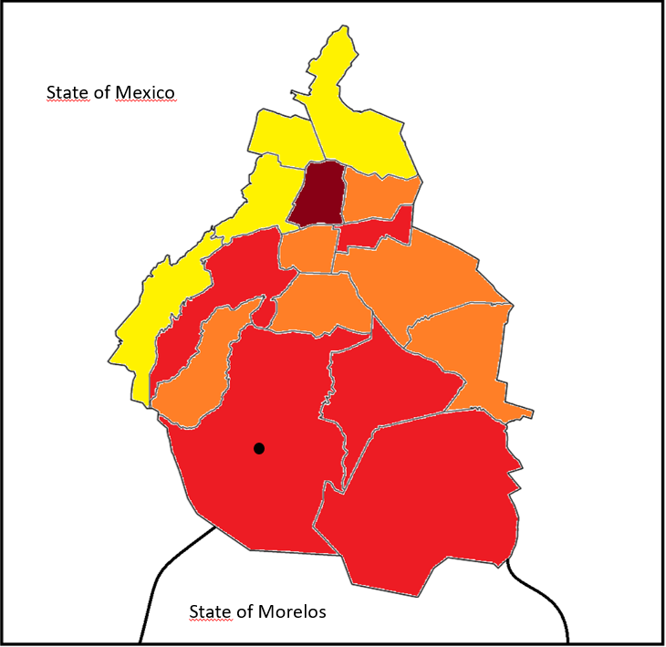
Mexico City is divided into 16 counties. Percentage of PCR positivity among HCWs from our study is marked on the map as follows: dark red >10%, red >5-10%, orange 1-5%, yellow <1%. Two hundred healtchare workers lived outside Mexico City. Sate of Mexico PCR positivity percentage was 8.3% and State of Morelos 6.3%. This distribution is consistent with Mexico´s City community transmission hot spots during the months of May through mid July²⁶.
*Black dot indicates location of our Institution

