**Methods**

**Real-time quantitative PCR (qPCR) reactions**

qPCR reactions containing final concentration of SYBR Green 1x Master Mix (Qiagen, UK), 0.6 μM primers (Table I) and 25 ng of DNA template were prepared to a final volume of 20 μL. Reactions were analysed in a Rotor-gene Q (Qiagen, UK) using the following conditions: 95 ºC for 5 min, and 95 ºC for 10s, 58 ºC for 15s, 72 ºC for 20s, repeated for 40 cycles. Standard curves of viral DNA ranging from 5x109 copies/µL to 500 copies/µL, in a 10-fold dilution series and prepared as previously described1, were included in triplicate on each qPCR run. Each DNA extract was run in duplicate.

The standard curves were used to convert threshold cycle values to copies per µL of template. The limit of detection was established at 500 copies (2.7 log10 copies/µL).

**References**

**1.** Moura IB, Normington C, Ewin D, et al. Method comparison for the direct enumeration of bacterial species using a chemostat model of the human colon. *BMC Microbiol* 2020;20:2.

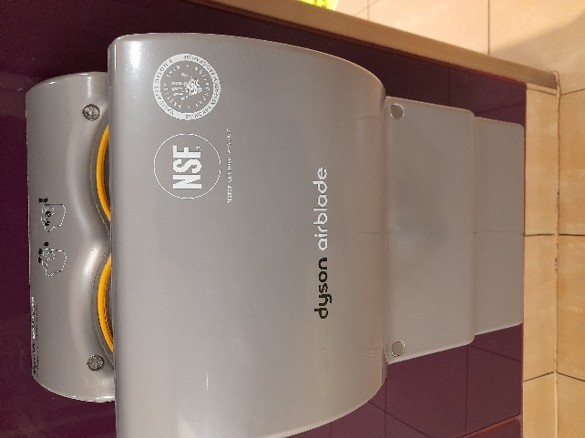

**Figure S1.** Jet air dryer available in the toilet where hand drying assays performed. Instead of heat, this electric hand dryer uses high speed air jets to remove moisture from hands.

**Table S1.** Primer sequences used for amplification of P3 and P12 gene of PR772 by standard and qPCR reactions.

|  |  |  |  |
| --- | --- | --- | --- |
| **Primer** | **Sequence** | **Amplicon size (bp)** | **Reference** |
| P3 Forward | 5′-CCCATTAAGTACGGCGATGTTATG-3′ | 102 | 2 |
| P3 Reverse | 5′-GGCAAGCGGAACCCAATAG-3′ |
| P12 Forward | 5′-AATCCACCTTTGGCGACTTC-3′ | 108 | 2 |
| P12 Reverse | 5′-CCAGTACCTTTGGCAGAATCAG-3′ |

**Results**



**Figure S2.** Box plot in log10 copies/µL of gene P3 results from assays performed with and without gloves for all samples (top), and for each hand drying method used (bottom). There was no significant difference in bacteriophage recovery between assays performed with and without gloves. Similarly, bacteriophage dispersion and recovery was not significantly affected by the use of gloves when either JAD or PT was used. Statistical analysis was performed using the Mann-Whitney U test, *p*<0.05 is considered statistically significant.

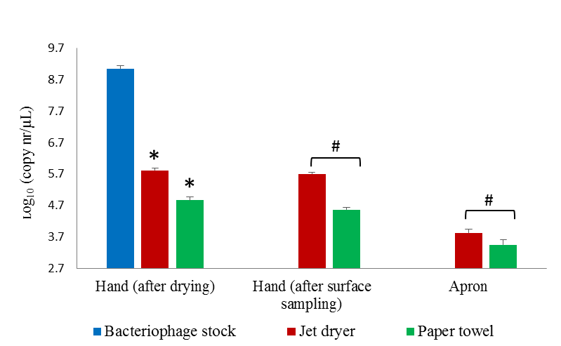

**Figure S3.** qPCR results for detection of the gene P12 of bacteriophage PR772 from surfaces exposed to bacteriophage following hand contact. * *p*<0.05 on the Wilcoxon Signed Rank; # *p*<0.05, Mann-Whitney U test.

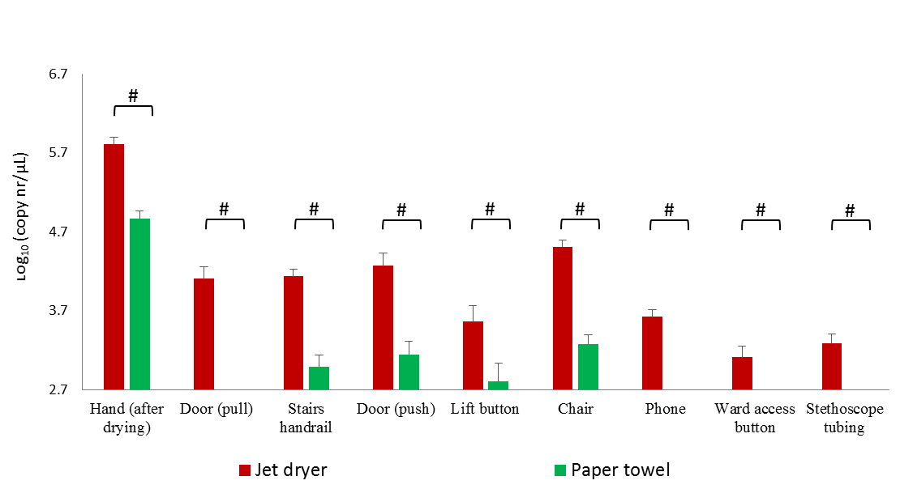

**Figure S4.** qPCR results for detection of gene P12 of the bacteriophage PR772 from environmental samples following contact with contaminated hand. # *p*<0.05, Mann-Whitney U test.

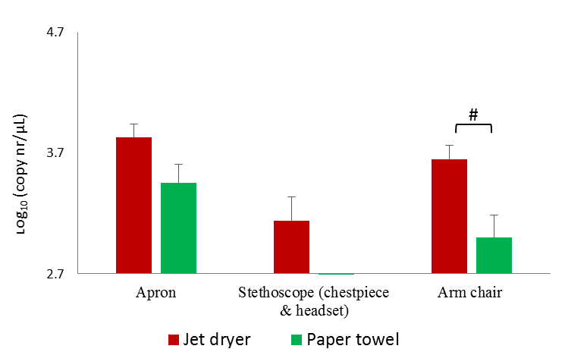

**Figure S5.** qPCR results for detection of gene P12 of the bacteriophage PR772 from environmental samples obtained after contact with contaminated apron. # *p*<0.05, Mann-Whitney U test.