Figure S1. Direct transfer test (left) and indirect transfer test with latex glove (right)

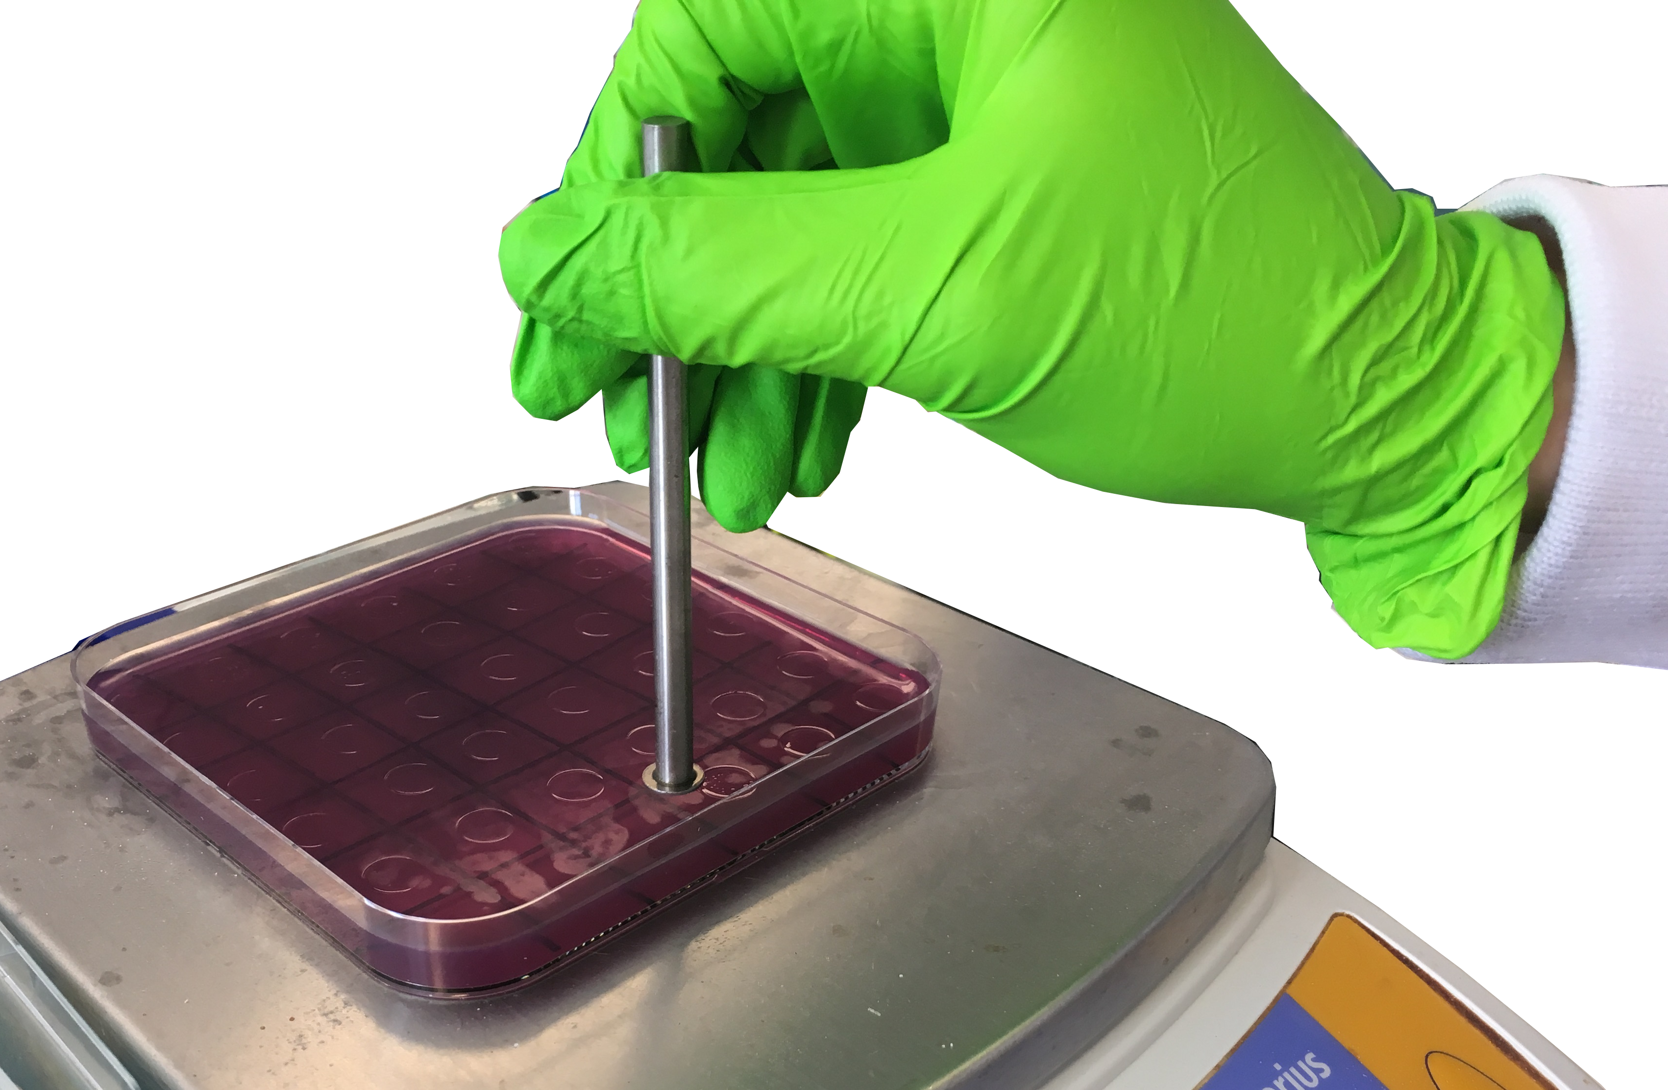

Figure S2. Surface transfer of S. aureus DSB after the treatment. Example of no bacterial transfer (left), and all adpressions resulting in bacterial transfer (right)

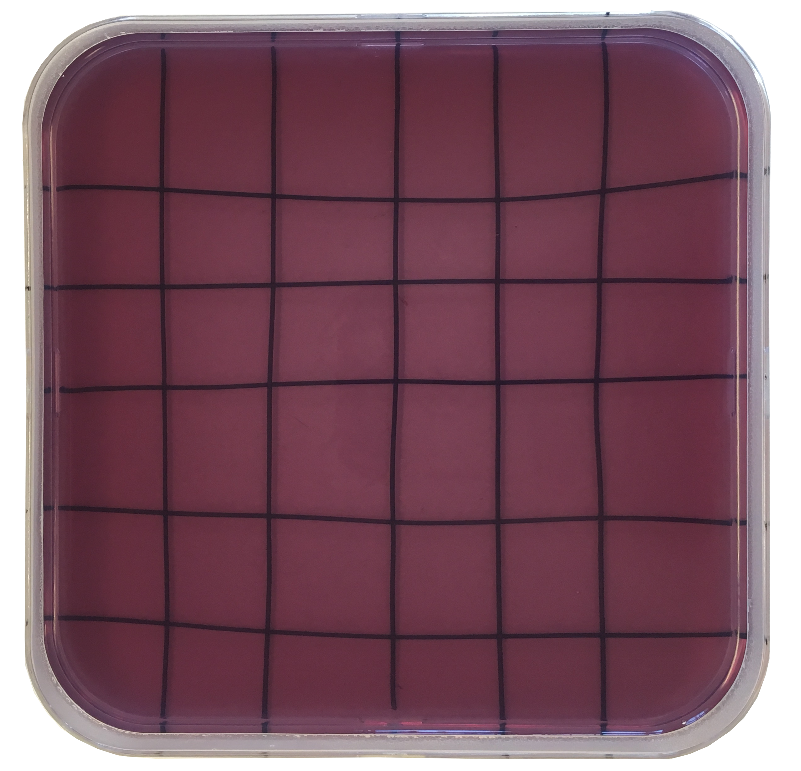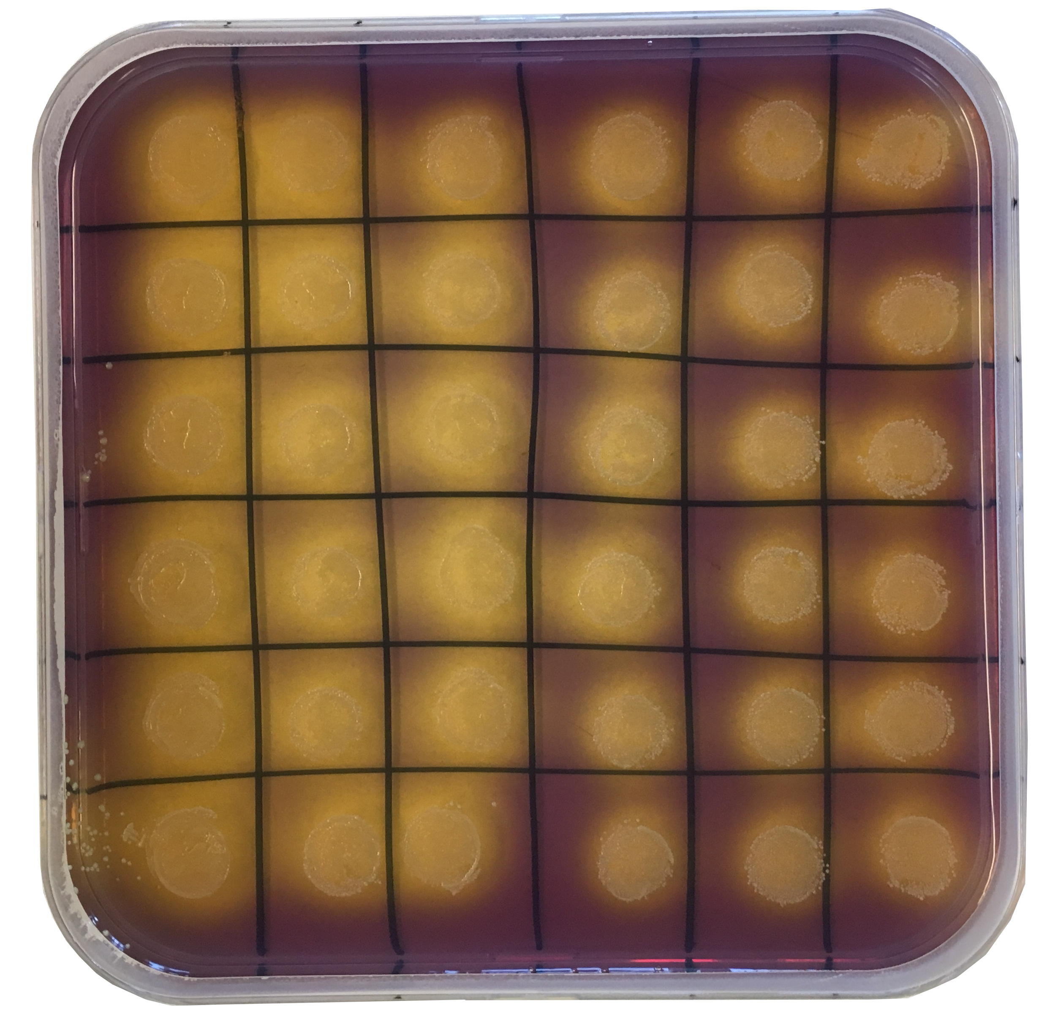

Figure S3. Transfer of S. aureus DSB with gloves after the treatment. Examples of no bacteria transferred by the glove after single touch of treated surface (left) and visible growth of S. aureus colonies after subsequent touches of contaminated glove (right)

