Supplementary Table 1. Codes to identify patients with potentially complicated urinary tract infections for exclusion.
Conditions | ICD-9-CM diagnosis codes
Urologic abnormalities | 188.0, 188.1, 188.2, 188.3, 188.4, 188.5, 188.6, 188.7, 188.8, 188.9, , 594.8, 594.9, 599.60, 599.69, V13.00, V13.01, 198.1, 233.9, 236.90, 236.99, 592.9, 599.9, 619.0, 753.5, 753.9, V10.50, V10.59, V13.09, V44.6, V45.74
Spinal injury | 344.00, 344.01, 344.02, 344.03, 344.04, 344.09, 344.1, 344.2, 344.30, 344.31, 344.32, 344.40, 344.41, 344.42, 344.5, 344.60, 344.61, 344.81, 344.89, 344.9, 805.0, 805.1, 805.2, 805.3, 805.4, 805.5, 805.6, 805.7, 805.8, 805.9, 806.00, 806.01, 806.02, 806.03, 806.04, 806.05, 806.06, 806.07, 806.08, 806.09, 952.00, 952.01, 952.02, 952.03, 952.04, 952.05, 952.06, 952.07, 952.08, 952.09, 952.10, 952.11, 952.12, 952.13, 952.14, 952.15, 952.16, 952.17, 952.18, 952.19, 952.2, 952.3, 952.4, 952.8, 952.9, 907.2
Malignancy | 140.0-209.79, 233.7, 238.4, 238.5, 238.6, 238.7, , , V10.0-V10.91
Pressure ulcers | 707.00, 707.01, 707.02, 707.03, 707.04, 707.05, 707.06, 707.09, 707.20, 707.21, 707.22, 707.23, 707.24, 707.25
Multiple sclerosis | 340
Inflammatory bowel disease | 555.1, 555.2, 555.9, 556.0, 556.1, 556.2, 556.3, 556.4, 556.4, 556.5, 556.6, 556.8, 556.9
Organ transplant | , V42.0, V42.1, V42.6, V42.7, V42.81, V42.82, V42.83, V42.84, V42.89
HIV/AIDS | 042
Stroke | 433.xx-438.xx, V12.54
Chemotherapy or radiation | V58.0, V58.11, V58.12, V66.1, V66.2, V67.1, V67.2, V15.3
Interstitial cystitis, other urologic problems, and other urologic infections | 595.1, 595.2, 595.3, 595.4, 595.81, 595.82, 595.89, 596.0, 596.1, 596.2, 596.3, 596.4, 596.5, 596.51, 596.52, 596.53, 596.54, 596.55, 596.59, 596.6, 596.7, 596.8, 596.9, , , ,
Pyelonephritis | 590.00, 590.01, 590.10, 590.11, 590.2, 590.3, 590.80, 590.81, 590.9
Kidney stones | 592.0, 592.1, 592.9
Renal failure | 403.01, 403.11-403.91, 404.02, 404.03, 404.12, 404.13, 404.92, 404.93, 584.5-584.9, 585.3, 585.4, 585.5, 585.6, 585.9, 586, V45.11, V45.12, V56.0, V56.1, V56.2, V56.3, V56.8
Rheumatologic conditions | 714.0, 714.1, 714.2, 714.30, 714.31, 714.32, 714.33, 714.81, 714.9, 720.0, 710.2, 710.3, 710.8, 710.9, 710.0
Sarcoidosis | 135
Cystic fibrosis | 277.00, 277.01, 277.02, 277.03, 277.09
Parkinson’s | 332.0, 332.1
Diabetes | 249.xx-250.xx
Tuberculosis | 010.xx-018.xx
Viral hepatitis B | 070.30
Sickle cell disease | 282.xx
Seizures | 345.xx

Supplementary Table 2. Medications to identify patients with potentially complicated urinary tract infections for exclusion.
Conditions | Medication Names
Autoimmune conditions, steroids, or other immunosuppressants | Abatacept, adalimumab, alefacept, ambrisentan, aminocaproic acid, azathioprine, balsalazide disodium, belimumab, bosentan, canakinumab, certolizumab pegol, cevimeline, ciprofloxacin/dexamethasone*, cyclophosphamide, cyclosporine, dapsone, dexamethasone*, dexamethasone acetate*, dexamethasone sodium phosphate*, dexamethasone, micronized*, dexamethasone/neomycin sulfate/polymyxin B sulfate*, dexamethasone/tobramycin*, efalizumab, etanercept, febuxostat, gentamicin sulfate/prednisolone acetate*, golimumab, immune globulin, infliximab, leflunomide, mercaptopurine, mesalamine, methotrexate, methylprednisolone*, methylprednisolone acetate*, methylprednisolone sodium succinate*, methylPREDNISolone, micronized*, mycophenolate mofetil, mycophenolate sodium, neomycin/polymyxin B /prednisolone acetate*, omalizumab, prednisolone*, prednisolone acetate*, prednisolone acetate/sulfacetamide sodium*, prednisolone sodium phosphate*, prednisolone sodium phosphate/sulfacetamide Sodium*, prednisone*, rituximab, sildenafil, sirolimus, sulfasalazine, tacrolimus, tocilizumab, tofacitinib, ustekinumab
Diabetes medications and testing supplies | Acarbose, exenatide, glimepiride, glipizide, glipizide/metformin, glucose meter, glucose meter test control, glucose meter test control strips, glucose blood test, glyburide, glyburide, micronized, glyburide/metformin hydrochloride, insulin aspart, insulin detemir, insulin glargine, insulin glulisine, insulin human isophane (NPH), NPH/insulin human regular, insulin human regular, insulin lispro, insulin syringe, linagliptin, liraglutide, metformin, metformin/pioglitazone, metformin/repaglinide, metformin/rosiglitazone, metformin/saxagliptin, metformin/sitagliptin, pioglitazone hydrochloride, rosiglitazone maleate, sitagliptin phosphate
HIV/AIDS | Abacavir, abacavir/lamivudine, abacavir/lamivudine/zidovudine, cobicistat/elvitegravir/emtricitabine/tenofovir, dapsone, darunavir, efavirenz, efavirenz/emtricitabine/tenofovir, emtricitabine/rilpivirine/tenofovir, etravirine, lamivudine, lamivudine/zidovudine, lopinavir/ritonavir, raltegravir, ritonavir, tenofovir, zidovudine
Underlying urologic problems (including medications that can contribute to and treat bladder retention, bladder pain, or recurrent urinary tract infections) | Atropine/chlorpheniramine/hyoscyamine, benzoic acid, hyoscyamine, methenamine, methylene blue, carbidopa, carbidopa/entacapone/levodopa, carbidopa/levodopa, darifenacin hydrobromide, fesoterodine fumarate, flavoxate hydrochloride, hyoscyamine/methenamine/methylene blue, hyoscyamine sulfate, hyoscyamine sulfate/phenyltoloxamine citrate, methenamine hippurate, methenamine mandelate, mirabegron, oxybutynin, oxybutynin chloride, pentosan polysulfate sodium, phenazopyridine hydrochloride, solifenacin succinate, tolterodine tartrate, trihexyphenidyl, trospium chloride
Malignancy or myelodysplastic syndromes | Apixaban, Aprepitant, cyclophosphamide, cyclosporine, dabigatran, darbepoetin alfa, deferasirox, enoxaparin, epoetin alfa, filgrastim, fluorouracil, fondaparinux, immune globulin, letrozole, leucovorin, octreotide acetate, pegfilgrastim, raloxifene hydrochloride, tacrolimus, tamoxifen citrate
Long-term systemic anti-infectives | Amphotericin B, amphotericin B liposome, ethambutol, flucytosine, isoniazid, itraconazole, posaconazole, rifabutin, rifampin, rifapentine, voriconazole
Other (includes medications for pregnancy, stroke, seizures, erectile dysfunction, cystic fibrosis, and chronic kidney disease) | Clopidogrel, darbepoetin alfa, dutasteride, dornase alfa, enoxaparin, epoetin alfa, felbamate, hydrochlorothiazide/methyldopa, lamotrigine, methyldopa, phenytoin, prasugrel, ranolazine, rho(D) immune globulin, rivaroxaban, roflumilast, sildenafil, tadalafil, tiagabine, ticagrelor, tranexamic acid

Supplementary Table 3. Codes to identify pregnant patients for exclusion.
Codes | ICD-9-CM diagnosis codes
ICD-9-CM diagnosis codes | 630-679.14, V22.X-V24.X, V27.X, V28.XX, V72.42
ICD-9-CM procedure codes | 69.01, 69.02, 69.51, 69.52, 72.0-75.99
CPT codes | 59000-59899, 36460, 76941, 85460, 85461, 76801-76828, 83030-83033, 83661-83664
UB-04 Revenue codes | 0720-0729

Supplementary Table 4. Codes to Identify Patients with Non-UTI Bacterial Infections for Exclusion
Infection | ICD-9-CM diagnosis codes
Septicemia | 003.1, 020.2, 022.3, 036.2, 036.42, 038.0, 038.1, 038.10, 038.11, 038.12, 038.19, 038.2, 038.3, 038.4, 038.40, 038.41, 038.42, 038.43, 038.44, 038.49, 038.8, 038.9, 040.82, 449, 421.0, 421.1, 421.9, 422.92, 790.7
Clinical sepsis | 995.91, 995.92, 785.52
Pneumonia | 003.22, 020.3, 020.4, 020.5, 021.2, 022.1, 039.1, 073.0, 073.7, 073.8, 073.9, 083.0, 480.0, 480.1, 480.2, 480.3, 480.8, 480.9, 481, 482.0, 482.1, 482.2, 482.3, 482.30, 482.31, 482.32, 482.39, 482.4, 482.40, 482.41, 482.42, 482.49, 482.8, 482.81, 482.82, 482.83, 482.84, 482.89, 482.9, 483, 483.0, 483.1, 483.8, 484, 484.1, 484.3, 484.5, 484.6, 484.7, 484.8,  485, 486, 510.0, 510.9, 513.0, 997.31
Skin and soft tissue infection (SSTI) | 020.1, 021.0, 022.0, 032.85, 035, 039.0, 039.3, 039.4, 039.8, 039.9, 040.0, 040.1, 040.2, 040.3, 040.42, 040.81, 078.3, 082.0, 082.1, 082.2, 082.3, 082.40, 082.41, 082.49, 082.8, 082.9, 083.0, 083.1, 083.2, 083.8, 083.9, 087.0, 087.1, 087.9, 088.0, 088.81, 088.82, 088.89, 088.9, 098.50, 567.31, 680.0, 680.1, 680.2, 680.3, 680.4, 680.5, 680.6, 680.7, 680.8, 680.9, 681.00, 681.01, 681.02, 681.10, 681.11, 681.9, 682.0, 682.1, 682.2, 682.3, 682.4, 682.5, 682.6, 682.7, 682.8, 682.9, 683, 684, 685.0, 686.0, 686.00, 686.01, 686.09, 686.1, 686.8, 686.9, 675.00, 675.01, 675.02, 675.03, 675.04, 675.10, 675.11, 675.12, 675.13, 675.14, 675.80, 675.81, 675.82, 675.83, 675.84, 675.90, 675.91, 675.92, 675.93, 675.94, 705.83, 727.89, 7280, 728.86
Surgical site infection (SSI) | 9985, 998.51, 998.59, 996.60, 996.61, 996.62, 996.63, 996.65, 996.66, 996.67, 996.68, 996.69
Bone infection | 003.23, 003.24, 0261, 036.82, 098.50, 098.51, 098.52, 098.53, 098.59, 376.03, 513.1, 519.2, 711.00, 711.01, 711.02, 711.03, 711.04, 711.05, 711.06, 711.07, 711.08, 711.09, 711.90, 711.91, 711.91, 711.92, 711.93, 711.94, 711.95, 711.96, 711.97, 711.98, 711.99, 730.00, 730.01, 730.02, 730.03, 730.04, 730.05, 730.06, 730.07, 730.08, 730.09, 730.10, 730.11, 730.12, 730.13, 730.14, 730.15, 730.16, 730.17, 730.18, 730.19, 730.20, 730.21, 730.22, 730.23, 730.24, 730.25, 730.26, 730.27, 730.28, 730.29, 730.30, 730.31, 730.32, 730.33, 730.34, 730.35, 730.36, 730.37, 730.38, 730.39, 730.80, 730.81, 730.82, 730.83, 730.84, 730.85, 730.86, 730.87, 730.88, 730.89, 730.90, 730.91, 730.92, 730.93, 730.94, 730.95, 730.96, 730.97, 730.98, 730.99
Organ infection | 003.21, 032.82, 036.0, 036.1, 036.3, 036.40, 036.41, 036.43, 036.89, 091.81, 100.81, 245.0, 253.8, 254.1, 289.59, 320.0, 320.1, 320.2, 320.3, 320.7, 320.8, 320.81, 320.82, 320.89, 320.9, 322.9, 323.1, 323.4, 323.41, 323.42, 324.0, 324.1, 324.9, 420, 420.0, 420.90, 420.99
Female pelvic infection | 091.0, 091.1, 091.2, 091.3, 091.4, 091.50, 091.51, 091.52, 091.61, 091.62, 091.69, 091.7, 091.82, 091.89, 091.9, 092.0, 092.9, 098.0, 098.10, 098.11, 098.12, 098.13, 098.14, 098.15, 098.16, 098.17, 098.19, 0982, 098.30, 098.31, 098.32, 098.33, 098.34, 098.35, 098.36, 098.37, 098.39, 098.40, 098.41, 098.42, 098.43, 098.49, 098.7, 098.81, 098.82, 098.83, 098.84, 098.85, 098.86, 098.89, 099.0, 099.1, 099.2, 099.3, 099.4, 099.40, 099.41, 099.49, 099.50, 099.51, 099.52, 099.53, 099.54, 099.55, 099.56, 099.59, 099.8, 099.9, 597.80, 597.81, 597.89, 614.0, 614.1, 614.2, 614.3, 614.4, 614.5, 614.7, 614.9, 615.0, 615.1, 615.9, 616.0, 616.10, 616.3, 616.4, 634.00, 634.01, 634.02, 635.00, 635.01, 635.02, 636.00, 636.01, 636.02, 637.00, 637.01, 637.02, 638.00, 638.01, 638.02, 639.0, 646.60, 646.61, 646.62, 646.63, 646.64, 647.00, 647.01, 647.02, 647.03, 647.04, 647.10, 647.11, 647.12, 647.13, 647.14, 647.20, 647.21, 647.22, 647.23, 647.24, 647.80, 647.81, 647.82, 647.83, 647.84, 658.40, 658.41, 658.43, 659.30, 659.31, 659.33, 670.00, 670.02, 670.04, 670.10, 670.12, 670.14, 670.20, 670.22, 670.24, 670.30, 670.32, 670.34, 670.80, 670.82, 670.84
Gastroenteritis | 001.0, 001.1, 001.9, 002.0, 002.1, 002.2, 002.3, 002.9, 003.0, 003.20, 003.29, 003.8, 003.9, 004.0, 004.1, 004.2, 004.3, 004.8, 004.9, 005.0, 005.1, 005.2, 005.3, 005.4, 005.8, 005.81, 005.89, 005.9, 008.0, 008.00, 008.01, 008.02, 008.03, 008.04, 008.09, 008.1, 008.2, 008.3, 008.41, 008.42, 008.43, 008.44, 008.46, 008.47, 008.49, 008.5, 009.0, 009.1, 009.2, 009.3, 021.1, 022.2
Intraabdominal abscess / peritonitis | 032.83, 039.2, 530.19, 530.86, 536.41, 540.0, 540.1, 540.9, 562.00, 562.01, 562.02, 562.03, 562.10, 562.11, 562.12, 562.13, 566, 567.0, 567.1, 567.2, 567.21, 567.22, 567.23, 567.29, 567.38, 567.39, 567.9, 569.5, 569.61, 572.0, 574.00, 574.01, 574.30, 574.31, 574.60, 574.61, 574.80, 574.81, 575.0, 575.12, 577.0
Upper respiratory tract infection | 460, 461.0, 461.1, 461.2, 461.3, 461.8, 461.9, 462, 464.0, 464.00, 464.01, 464.10, 464.11, 464.20, 464.21, 464.30, 464.31, 464.4, 464.50, 464.51, 465.0, 465.8, 465.9, 466.0, 466.11, 466.19, 473.0, 473.1, 473.2, 473.3, 473.8, 473.9, 476.0, 476.1
Tonsillitis | 032.0, 032.1, 032.2, 032.3, 032.81, 032.89, 032.9, 033.0, 033.1, 033.8, 033.9, 034.0,  034.1, 076.0, 076.1, 076.9, 098.6, 370.55, 376.01, 376.02, 376.03, 383.20, 383.21, 383.22, 463, 474.0, 474.00, 474.01, 474.02, 475, 478.19, 478.21, 478.22, 478.24, 478.29, 4785, 478.71, 478.79, 4789, 519.01
Otitis | 380.10, 380.11, 380.13, 380.14, 380.16, 381.00, 381.01, 381.02, 381.03, 381.10, 381.19,  381.20, 381.29, 381.3, 381.4, 381.50, 381.51, 381.52, 382.0, 382.00, 382.01, 382.02, 382.3, 382.4, 382.9, 383.00, 383.01, 383.02, 383.1, 384.00, 384.01, 384.09, 384.1
Oral infections | 522.0, 522.5, 522.6, 522.7, 523.00, 523.01, 523.10, 523.11, 523.30, 523.31, 523.32, 523.33, 523.40, 523.41, 523.42, 526.4, 527.3, 528.3, 528.5, 529.0

Supplementary Table 5. Inappropriate antibiotic therapy by agent for UTI as defined by IDSA Clinical Practice Guidelines, by rural-urban status. Note: TMP-SMX, trimethoprim-sulfamethoxazole. *286 (0.3%) rural and 1985 (0.3%) urban patients received an appropriate agent as well as another non-first-line agent on the same date. The results presented in the table represent the first-line agents but do not display the numbers for the non-first-line agents. **The women in this category are not included in another agent-related category.
 | No. (%)
 | Urban  (N=578,117) | Rural  (N=92,333) | Total  (N=670,450)
Appropriate agent* | 307,220 (53.1) | 49,942 (54.1) | 357,162 (53.3)
Nitrofurantoin | 154,362 (26.7) | 19,227 (20.8) | 173,589 (25.9)
TMP-SMX | 152,773 (26.4) | 30,706 (33.3) | 183,479 (27.4)
Fosfomycin | 85 (0.0) | 9 (0.0) | 94 (0.0)
Inappropriate agent | 270,897 (46.9) | 42,391 (45.9) | 313,288 (46.7)
Fluoroquinolones | 240,982 (41.7) | 37,854 (41.0) | 278,836 (41.6)
β-lactams | 29,023 (5) | 4,411 (4.8) | 33,434 (5)
Multiple (0 first-line agent) | 403 (0.1) | 58 (0.1) | 461 (0.1)
Multiple (≥2 first-line agent)** | 489 (0.1) | 68 (0.1) | 557 (0.1)

Supplementary Table 6. Inappropriate antibiotic therapy by duration for UTI as defined by IDSA Clinical Practice Guidelines, by rural-urban status. Note: TMP-SMX, trimethoprim-sulfamethoxazole. *286 (0.3%) rural and 1985 (0.3%) urban patients received an appropriate agent as well as another non-first-line agent on the same date. The results presented in the table represent the first-line agents but do not display the numbers for the non-first-line agents. **The women in this category are not included in another agent-related category.
 | No. (%)
 | Urban  (N=575,240) | Rural  (N=91,921) | Total  (N=667,161)
Appropriate duration | 144,604 (25.1) | 14,820 (16.1) | 159,424 (23.9)
Nitrofurantoin (5 day regimen) | 29,532 (19.3) | 2,780 (14.6) | 32,312 (18.8)
TMP-SMX (3 day regimen) | 45,035 (29.6) | 4,762 (15.6) | 49,797 (27.3)
Fosfomycin (1 day regimen) | 79 (94.0) | 9 (100.0) | 88 (94.6)
Fluoroquinolones (3 day regimen) | 51,793 (21.5) | 4,879 (12.9) | 56,672 (20.3)
β-lactams (3-7 day regimen) | 18,165 (62.6) | 2,390 (54.2) | 20,555 (61.5)
Inappropriate duration – shorter or longer than recommended duration | 430,636 (74.9) | 77,101 (83.9) | 507,737 (76.1)
Nitrofurantoin (non-5 day regimen) | 123,566 (80.7) | 16,299 (85.4) | 139,865 (81.2)
TMP-SMX (non-3 day regimen) | 107,018 (70.4) | 25,806 (84.4) | 132,824 (72.7)
Fosfomycin (non-1 day regimen) | 5 (6.0) | 0 (0.0) | 5 (5.4)
Fluoroquinolones (non-3 day regimen) | 189,189 (78.5) | 32,975 (87.1) | 222,164 (79.7)
β-lactams (non-3-7 day regimen) | 10,858 (37.4) | 2,021 (45.8) | 12,879 (38.5)
Inappropriate duration – shorter than recommended duration | 5,545 (1.0) | 696 (0.8) | 6,241 (0.9)
Nitrofurantoin (<5 day regimen) | 4,557 (3.0) | 546 (2.9) | 5,103 (3.0)
TMP-SMX (<3 day regimen) | 358 (0.2) | 57 (0.2) | 415 (0.2)
Fosfomycin (<1 day regimen) | 0 (0.0) | 0 (0.0) | 0 (0.0)
Fluoroquinolones (<3 day regimen) | 537 (0.2) | 82 (0.2) | 619 (0.2)
β-lactams (<3-7 day regimen) | 93 (0.3) | 11 (0.2) | 104 (0.3)
Inappropriate duration – longer than recommended duration | 425,091 (73.9) | 76,405 (83.1) | 501,496 (75.2)
Nitrofurantoin (>5 day regimen) | 119,009 (77.7) | 15,753 (82.6) | 134,762 (78.3)
TMP-SMX (>3 day regimen) | 106,660 (70.1) | 25,749 (84.2) | 132,409 (72.5)
Fosfomycin (>1 day regimen) | 5 (6.0) | 0 (0.0) | 5 (5.4)
Fluoroquinolones (>3 day regimen) | 188,652 (78.3) | 32,893 (86.9) | 221,545 (79.5)
β-lactams (>3-7 day regimen) | 10,765 (37.1) | 2,010 (45.6) | 12,775 (38.2)

Supplementary Figure 1. Flow chart of of study population derivation.
Premenopausal women age 18-44 who received an outpatient diagnosis of uncomplicated UTI with an accompanying oral antibiotic from
April 1, 2011 and June 30, 2015 (N = 1,349,276)

Index date on and after April 1st 2011 (n=604,398)

No recent antibiotics (n=670,450)

No recent history of UTI (n=710,466)

No recent infections (n=739,051)

No chronic health conditions (N = 844,769)

No recent hospital admission (N = 952,685)

Excluded women without continuous insurance enrollment and prescription drug coverage in the 180 days prior to index antibiotic prescription (N = 285,942)

Continuous insurance enrollment and prescription drug coverage (N=1,060,334)

Excluded pregnant women (N = 92,781)

Non-pregnant women (N = 967,553)

Excluded women with inpatient hospital admission in the 90 days
prior to the index antibiotic prescription (N = 14,868)

Excluded women with chronic health conditions in the 180 days
prior to the index antibiotic prescription (N = 107,916)

Excluded women with infections in the 30 days
prior to and on date of index antibiotic prescription (N = 105,718)

Excluded women with a history of UTI (N = 28,585)

Excluded women who received antibiotics in the 30 days
prior to the index antibiotic prescription (N=40,016)

Supplementary Figure 2. Mean quarterly use of inappropriate agents among women diagnosed with uncomplicated urinary tract infection by rural-urban status and geographic region.
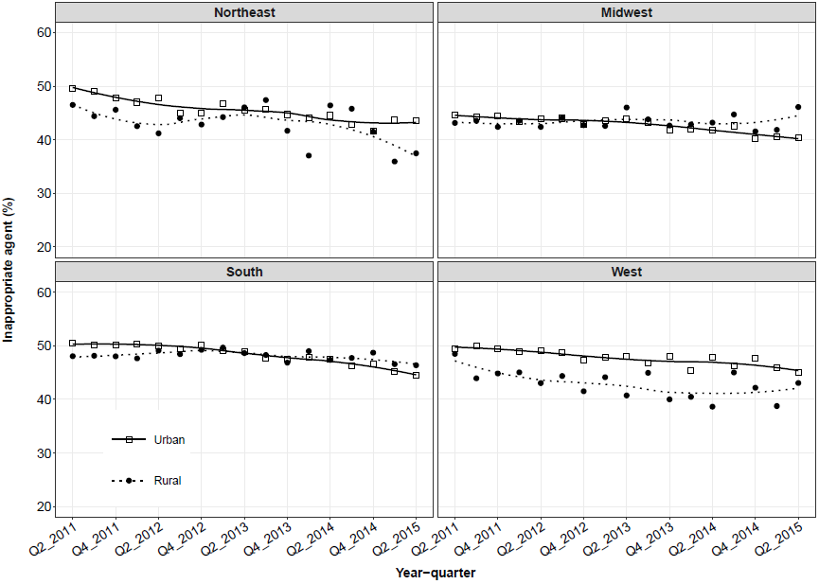

Supplementary Figure 3. Mean quarterly use of inappropriate agents by rural-urban status and provider specialty.
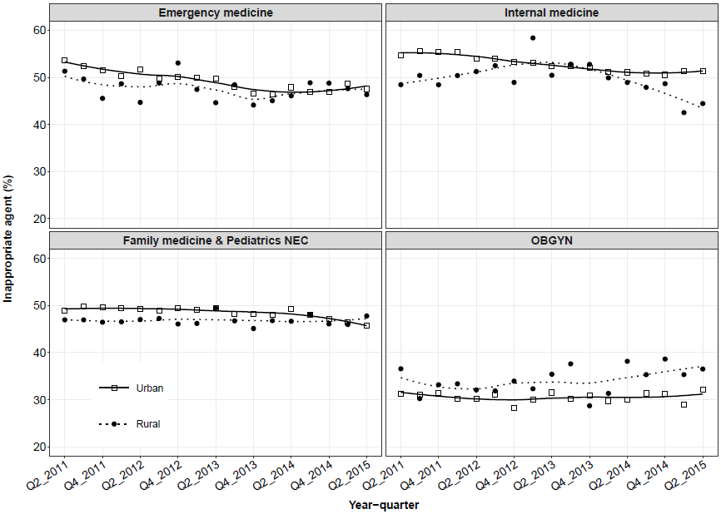

Supplementary Figure 4. Risk ratio estimates for receipt of inappropriate antibiotic agent, stratified by geographic region and provider specialty.
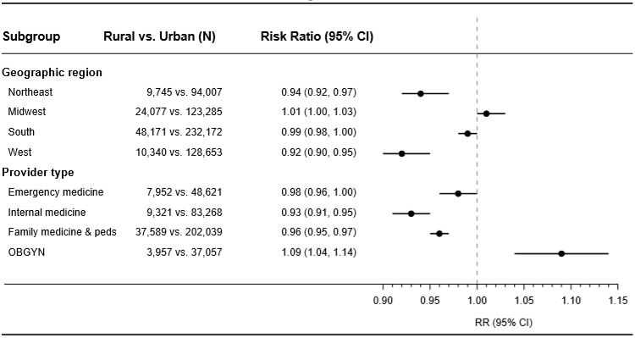

Supplementary Figure 5. Mean quarterly use of antibiotic prescriptions with inappropriate duration rural-urban status and antibiotic agent.
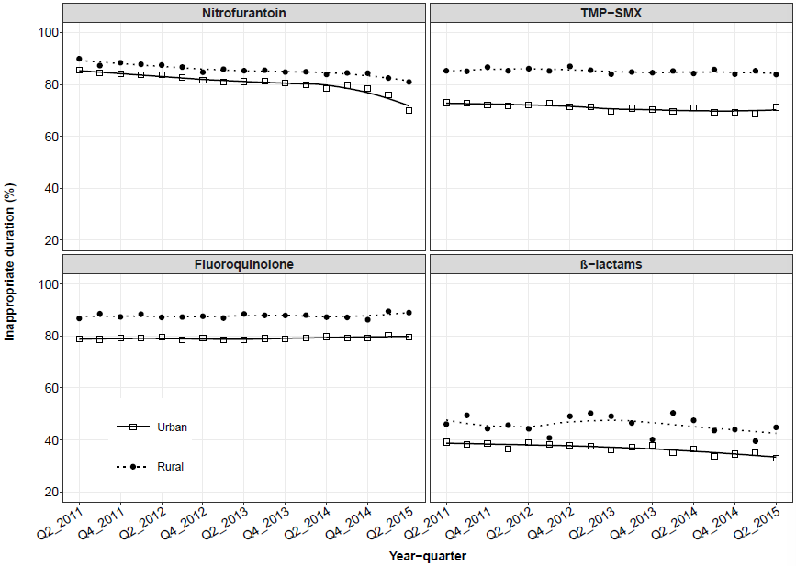

Supplementary Figure 6. Mean quarterly use of antibiotic prescriptions with inappropriate duration by rural-urban status and geographic region.
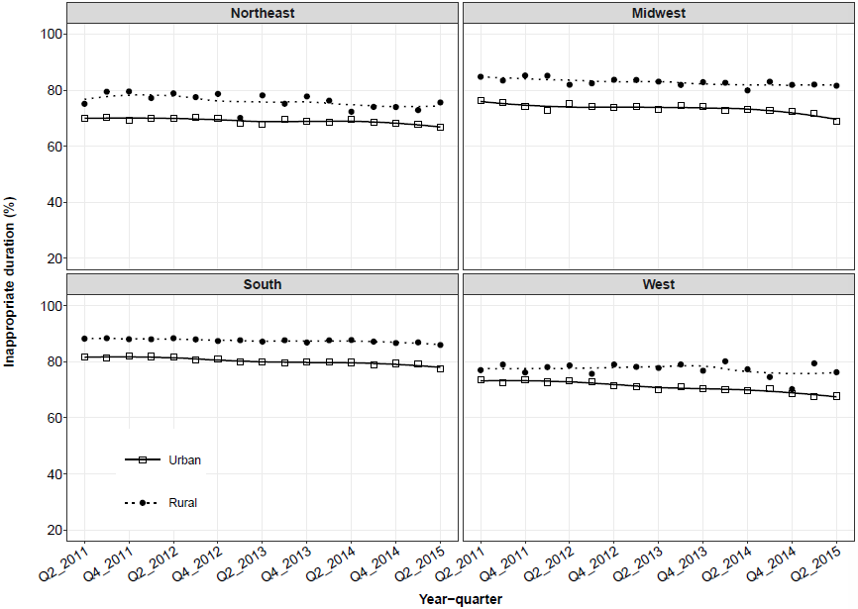

Supplementary Figure 7. Mean quarterly use of antibiotic prescriptions with inappropriate duration by rural-urban status and provider specialty.
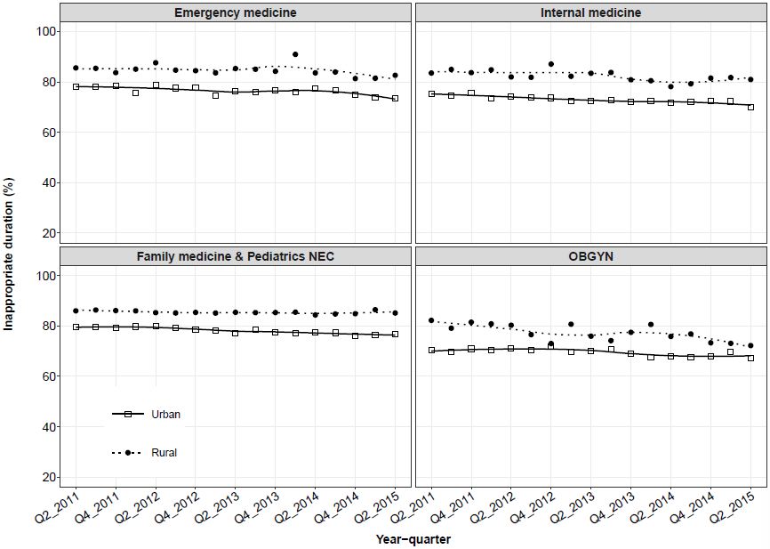

Supplementary Figure 8. Risk ratio estimates for receipt of inappropriate antibiotic duration, stratified by geographic region and provider specialty.
