Supplementary material
Supplementary Fig. S1. Patient selection for hip and knee (left) and colorectal surgeries (right).
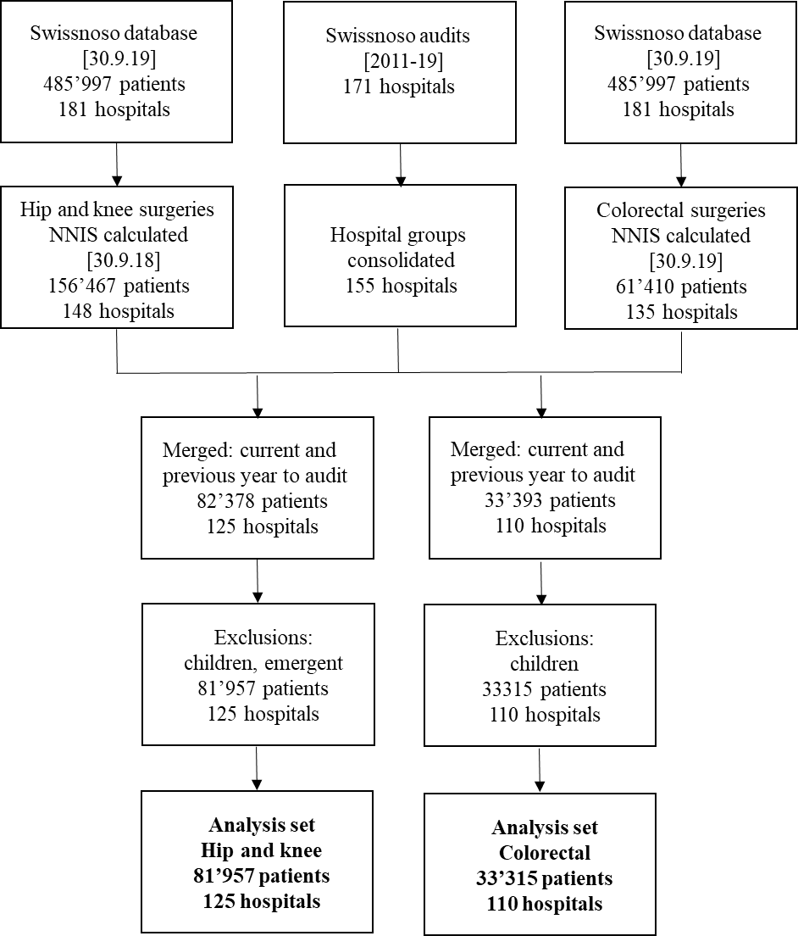

Supplementary Table S1. Patient Characteristics of Those in the Year Before the Audit and the Year of the Audit, Compared to Those From All Surgeries
A. Knee and Hip Arthroplasty
Characteristic | Audited | Not Audited | P Value
Surgeries, no. (%) | 81,957 (52.3) | 74,510 | …
Hospitals, no. (%) | 125 (84.5) | 147 | …
Surgical site infection, no. (%) | 927 (1.1) | 892 (1.2) | .23
Hospital size, beds, no. (%)  <200  200–499  500+ | 54,108 (66.0)  20,377 (24.9)  7,472 (9.1) | 42,373 (56.9)  26,042 (29.7)  605 (8.2) | <.001
Procedure type, knee, no. (%) | 32,579 (39.8) | 28,689 (38.5) | <.001
Timing of first antibiotic, median min [IQR] | −40 [−51 to −30] | −41 [−54 to −30] | <.001
Duration of procedure, median min [IQR] | 86 [68–109] | 87 [70–110] | <.001
Age, median y [IQR] | 69 [62–76] | 69 [61–76] | <.001
Sex, female, no. (%) | 44,883 (54.8) | 40,580 (54.5) | .23
Overlong operation (ScoreT), no. (%) | 12,101 (14.8) | 9,435 (12.7) | <.001
ASA levels 3, 4, and 5, no. (%) | 23,202 (28.2) | 20,488 (27.4) | .001
Minimal invasive, no. (%) | 20,258 (24.7) | 10,965 (14.7) | <.001
Repeat surgery, no. (%) | 1,684 (2.1) | 1,429 (1.9) | .002
Destination after discharge, no. (%)  Home/Nursing home  Other acute facility  Rehabilitation clinic  Patient died  Other | 53,402 (65.2)  634 (0.8)  26,748 (32.6)  643(0.1)  1,110 (1.4) | 49,113 (65.9)  692 (0.9)  23,318 (31.3)  74 (0.1)  1,312 (1.8) | <.001

B. Colorectal Procedures
Characteristic | Audited | Not audited | P Value
Surgeries, no. (%) | 33,315 (54.3) | 28,095 | …
Hospitals, no. (%) | 110 (82.7) | 133 | …
Surgical site infection, no. (%) | 4,642 (13.9) | 3,945 (14.0) | .71
Hospital size (beds), no. (%)  <200  200–499  500+ | 13,659 (41.0)  11,481 (34.5)  8,175 (24.5) | 10,438 (37.2)  11,070 (39.4)  6,587 (23.4) | <.001
Procedure Type - rectal |  | 1,381 (4.9) | <.001
Timing of first antibiotic, median min [IQR] | −45 [−66 to −30] | −45 [−67 to −29] | .005
Duration of procedure, median min [IQR] | 169 [122–227] | 167 [120–224] | <.001
Age, median y [IQR] | 68 [58–77] | 68 [57–77] | <.00
Sex, female, no. (%) | 16,877 (50.7) | 14,200 (50.5) | .78
Overlong operation (ScoreT), no. (%) | 14,518 (43.6) | 11,977 (42.6) | .02
ASA levels 3/4/5, no. (%) | 13,764 (41.3) | 11,938 (42.5) | .007
Endoscopic, no. (%) | 16,282 (48.9) | 12,894 (45.9) | <.001
Planned, no. (%) | 24,196 (72.6) | 20,951 (74.6) | <.001
Repeat surgery, no. (%) | 2,056 (7.5) | 1,995 (7.1) | .07
Destination after discharge, no. (%)  Home/old peoples home  Other acute facility  Rehabilitation clinic  Patient died  Other | 26,690 (80.1)  663 (2.0)  4’192 (12.6  1,295 (3.9)  259 (1.1) | 22,515 (80.1)  676 (2.4)  3,397 (12.1)  1,083 (3.9)  424 (1.5) | .003

Supplementary Fig. S2. Trajectory of audit scores per hospital for knee and hip arthroplasty hospital type: private in pink, public in blue; linear model (solid line) with 95% confidence intervals (shaded grey) and loess nonparametric smoother (dashed)

Supplementary Material
Multiple imputation of hospitals with low audit and infection rate
We considered only the complete cases for this analysis (79,575 of 81,957, 97.0%), excluding patients with missing data for the ASA score (343, 0.4%) and the indicator variable for repeat surgery (2,057, 2.5%).
As imputation model, we fitted a multivariable logistic model with an indicator variable for infection as dependent variable and the following independent variables that significant at the 5% level in adjusted models with the observed data: sex, ASA score, hospital size (in number of beds), and indicator variables for overly long surgery (“ScoreT”), repeat surgery and hospital type (public/private). We imputed 50 data sets using a joint modelling approach with the jomo package in R.²⁵
Multiply imputing such a large data set fitting a (mixed effects) logistic regression model proved to be both resource intensive and on the limits of the software used in terms of model convergence. Both the jomo and mice packages in R were used to multiply impute data to provide a basis for comparison.
Using the joint modeling approach with jomo, the model did not converge when fitting a logistic mixed effects model with hospital random effect as imputation model. We suspect that the size of the data set, combined with the number of hospitals, particularly imputing hospitals with few patients, was rather complex. (The software is declared as being in a beta testing phase). However, fitting a logistic model with fixed effect for the hospital provided results considered to be consistent with the expected infection rate (column “hospital fixed effect (jomo)” in Table S2).
In a further step, we also used method “2l.bin” in mice to impute the endpoint using a logistic mixed effects model with hospital random effect. Methodologically, this was a sounder approach since it explicitly took into account potential hospital cluster effects. However, the number of imputed infections is lower than might be expected (column hospital random effect (mice)”. The results in the main body of the document reflect those from the fixed effects only model using jomo.
Multiply imputing at the patient level was considered the “gold standard” for estimating a hypothetical infection rate for potentially under-reporting hospitals. In a further step, the infection rate was multiply imputed using hospital level information only, since patient level information is sometimes not always available for those reporting such data. As imputation model, the infection rate was fitted as dependent variable, and only the audit score, the number of patients in the analysis, hospital type (public/private) and number of beds included as independent variables. The results from imputing at the hospital level only (column “multiply imputed at hospital level”) compared favorably with those from both the patient level approaches (0.7%), with the rate being approximately the same as that for the random effects model (mice, 0.7%), but lower than that from the fixed effects model (jomo, 1.2%). The rates refer to those for the subgroup of patients with both low infection and audit rates. As expected, all three methods increase the infection rate in the subgroup of patients from that observed (0.3%).
This is encouraging because imputing at the hospital level is less complex and does not require the reporting organization to have all patient level data, which might be the case where functions are operationally or organizationally separated.

Supplementary Table S2. Hospital Characteristics for Those With Low Infections and Low Audit Score Compared to All Hospitals Audited, Along With Hypothetical Infection Rates Multiply Imputed at the Patient Level and Hospital Level
Hospital Characteristic | Audited Hospitals | Low Infection and Audit Rate | Multiply Imputed at  Patient Level (50 Data Sets) |  | Multiply Imputed at Hospital Level (50 Data Sets)
 |  |  | Hospital Fixed Effect (jomo) | Hospital Random Effect  (mice) | Imputing NHSN Adjusted Rate (mice)
Hospitals, no. (%) | 125 | 9 (7.2) | 9 (7.2) | 9 (7.2) | 9 (7.2)
Patients, no. (%) | 81,957 | 4,488 (5.5) | 4,488 (5.5) | 4,488 (5.5) | 4,488 (5.5)
Audit score, median [IQR] | 37 [33–42] | 29 [24–20] | 29 [24–20] | 29 [24–20] | 29 [24–20]
Infections, no. (%) | 892 (1.2) | 15 (0.3) | 53 (1.2) | 32 (0.7) | 40 (0.7)
NHSN adjusted infection rate, median % [IQR] | 1.0 [0.6–1.5] | 0.0 [0.0–0.0] | 0.8 [0.7–1.6] | 0.7 [0.7–0.7] | 0.7 [0.6–1.0]
Hospital size (beds), no. (%)  <50  50–100  100–200  200–300  400–500  500–1,000  >1,000 | 25 (20)  34 (27.2)  36 (28.8)  17 (13.6)  6 (4.8)  3 (2.4)  4 (3.2) | 7 (77.8)  2 (22.2)  0 (0)  0 (0)  0 (0)  0 (0)  0 (0) | 7 (77.8)  2 (22.2)  0 (0)  0 (0)  0 (0)  0 (0)  0 (0) | 7 (77.8)  2 (22.2)  0 (0)  0 (0)  0 (0)  0 (0)  0 (0) | 7 (77.8)  2 (22.2)  0 (0)  0 (0)  0 (0)  0 (0)  0 (0)
Public hospitals | 78 (62.4) | 2 (22.2) | 2 (22.2) | 2 (22.2) | 2 (22.2)

