SUPPLEMENTAL MATERIAL for “Detection of SARS-CoV-2 in Outpatients: A Multi-Centre Validation of Self-Collected Saline Gargle, Oral Swab and Combined Oral-Nasal Swab”

APPENDIX 1. Instructions for self-collected saline gargle.
- Use the orange specimen cup provided to collect your specimen.
- Open the pink bottle by twisting off the top.
- Squeeze the bottle so all the salt water goes into your mouth.
- Rinse your mouth by swishing the liquid back and forth for 5 seconds then gargle like you are using mouthwash for 5 seconds. Repeat this two additional times then spit all the liquid into the orange cup.
- When finished, replace the orange cap on the container and screw back on tightly.
- Give bottle to the nurse.

APPENDIX 2. Instructions for the self-collected oral swab.
- Spend 30-60 seconds pretending to chew and rubbing your cheeks like you are sucking on a hard candy to stimulate production of saliva
- Remove the top of the collection tube and discard it
- Remove the swab from its wrapper and grasp the handle
- Insert the swab into your mouth and rub the swab on the back of your tongue (as far back as you can comfortably reach) in a circular fashion for a few seconds. Then rub the inside of each cheek.
- Finally, suck on the swab for 5 seconds, swishing saliva around your mouth.
- Insert the swab into the collection tube and break off the end by bending until it snaps
- Recap the tube with the red cap and give to the nurse
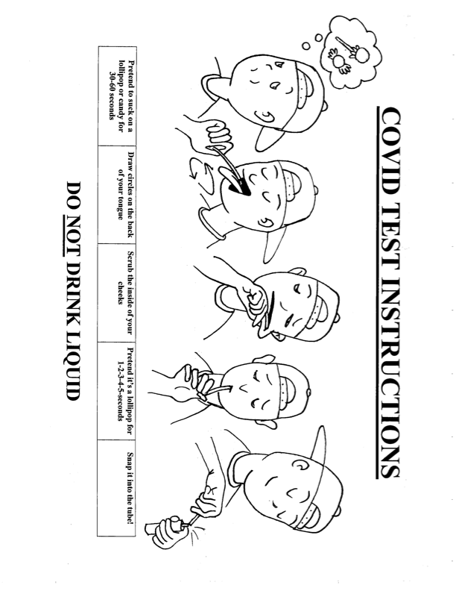
*Courtesy of James Callahan
APPENDIX 3. Instructions for the self-collected oral-nasal swab.
- Remove swab from wrapper and grasp handle
- Insert swab into your mouth and rub the back of your tongue (as far back as you can comfortably reach) in a circular fashion for 5 seconds. Then rub the inside of each cheek for 5 seconds.
- With the same swab insert into the front of one nostril and rub all around three times
- Repeat in the other nostril
- Insert swab into collection tube and break off the end by bending until it snaps
- Put the cap back on the tube and screw it on tightly and return to provider
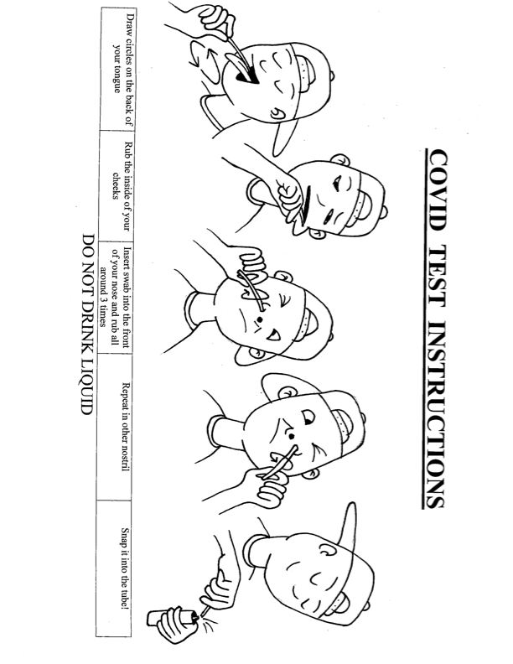
*Courtesy of James Callahan

