Supplementary Material

Figure S1 Photographs from the first wall (A) and from the agar strips of air measurements (1) adjacent to the wall, (2) 10 meters away of the wall, (3) control measurement in a separate room.
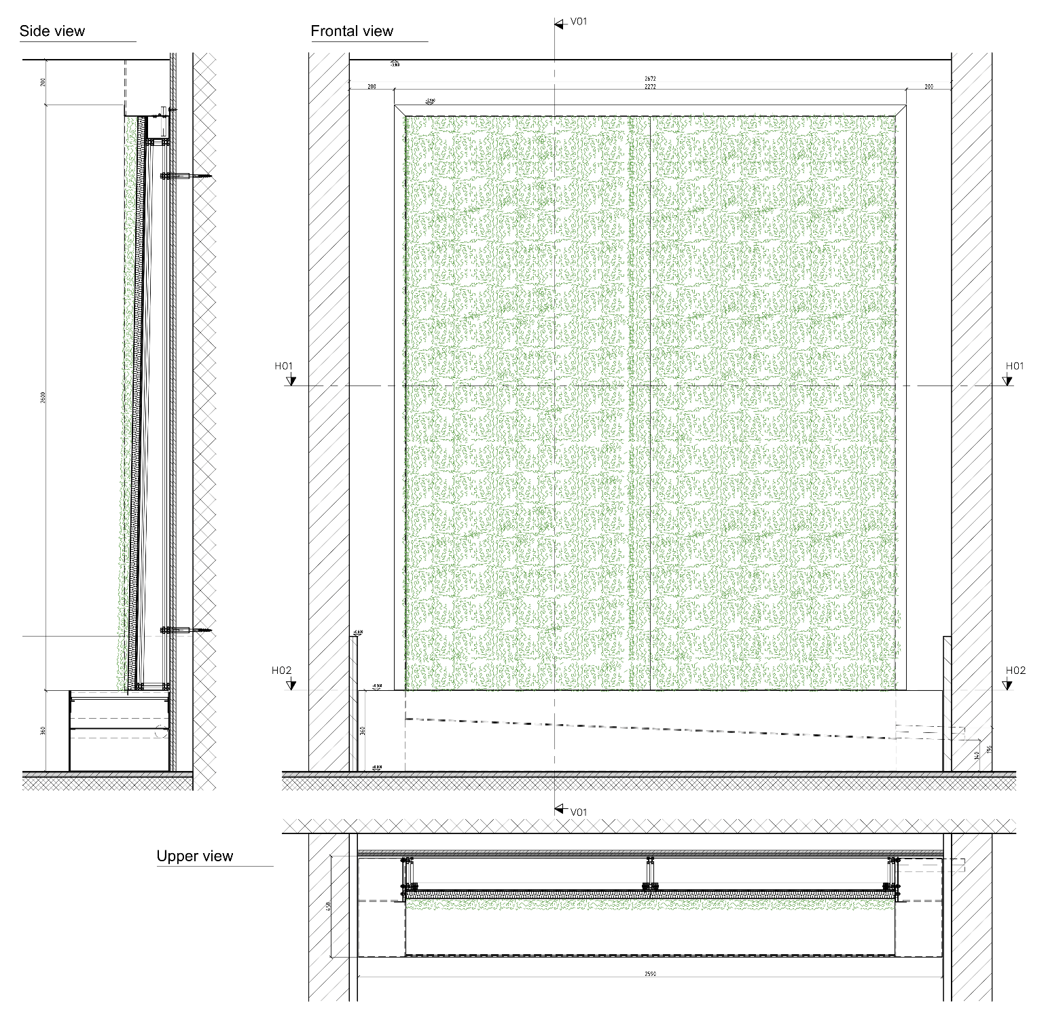

Figure S2 Construction plan

