Appendices

Appendix 1. Staff/Resident Counts by Facility
Facility | A | B | C | D | E | F | G
Population (n)  Total  Residents  Staff | 318  204  114 | 406  154  252 | 401  210  191 | 388  151  237 | 448  189  259 | 237  129  108 | 244  107  137

Appendix 2. Details of Model
Mixed-effect Segmented Regression Analysis
Segmented regression analysis of the interrupted time series was used to identify the effect of public health restrictions in LTCF. This modelling technique was used to evaluate the impact of public health measures after 14 days from implementation in LTCFs. Random intercept models (facility as a random effect) were used to account for variation by facility in COVID-19 rates and for the non-independence of cases within a facility arising from the infectious spread of COVID-19. Mixed-effects were used to account for facility level factors that may influence the extent of COVID-19 outbreaks such as for-profit status and facility characteristics^{1,2}. A Poisson model was utilized based on case counts and included as an offset term the (log transformed) total population size of staff and residents for each facility. The offset term varied over time as new cases were removed from the underlying at-risk population.
A time variable was constructed as the sequential count in days from the start of the study period to the end of the study or facility’s outbreak period. This time variable was then segmented into two periods using a level variable with the early outbreak period (from first case until 14 days following implementation of measures) set to zero and post-intervention period (after 14 days) set to one. A post-intervention trend variable was constructed as the sequential count in days from the beginning of the post intervention period (and otherwise set to zero). The details of the variables included in the model can be found in Appendix E. Model 2 was constructed to examine if case type (resident vs staff) was an effect modifier, and included three effect modification terms (summarized in Appendix E).
An analysis of deviance table for the final model is included (Appendix F). The mixed-effects model was fit using the “lme4” package in R using the Laplace Approximation. 95% confidence intervals were constructed using the “Wald” method. Standard errors for summed coefficient terms were calculated using the delta method. Model fit and assumptions was assessed using “DHARMa” package³ which demonstrated good model fit (Appendix G). Assumptions were tested and met, with residuals demonstrating no significant over/under dispersion, outliers or zero inflation for Model 2. Correlation between observations within a facility was accounted for through a ‘facility’ random-effect term. The Durbin-Watson tests and autocorrelation function graphs were non-significant for autocorrelation (Model 1: DW= 2.09, p=0.291, Model 2: DW=1.90, p=0.280) in our time series of case counts. Given the short time period of our study, no additional adjustments for seasonality were done.
Sensitivity Analysis
Given that a facility's rate of COVID-19 may be affected both by its own epidemic trajectory (e.g., transmission within the facility) and background community rates (e.g., new introductions over time), we considered a model with time specified both as days since the first case within a facility (facility specific timeline) and days since start of the study (calendar time across all facilities), respectively. However, our results did not change appreciably with using a facility specific timeline (Appendix H) so we presented the final using calendar time since it accounts for background secular trends that affect all facilities.
References
1. Stall NM, Jones A, Brown KA, Rochon PA, Costa AP. For-profit long-term care homes and the risk of COVID-19 outbreaks and resident deaths. CMAJ. 2020. doi:10.1503/cmaj.201197
2. Sun CLF, Zuccarelli E, Zerhouni EGA, et al. Predicting COVID-19 infection risk and related risk drivers in nursing homes: A machine learning approach. J Am Med Dir Assoc. 2020.
3. Florian Hartig. DHARMa: Residual Diagnostics for Hierarchical (Multi-Level / Mixed) Regression Models. 020.

Appendix 3. Results from the Descriptive Analysis
Appendix 3.1

Appendix 3.2. Characteristics of Coronavirus Disease 2019 cases by LTCF (>2 subsequent cases)
 | Facility
 |  | A | B | C | D | E | F | G
Cases n  (%) | All Cases | 78 | 88 | ** | 37 | 25 | ** | **
 | Staff | 33% | 38% | 86% | 30% | 52% | 44% | 48%
Age mean(SD) | All Cases | 73.0 (21.1) | 69.4 (20.7) | 51.4 (18.4) | 75.6 (21.6) | 67.7 (23.7) | 68.9 (22.5) | 70.8 (18.2)
 | Resident | 86.4 (8.4) | 83.1 (9.5) | 88.0 (4.2) | 87.8 (8.6) | 90.5 (5.5) | 86.3 (8.9) | 85.3 (11.7)
 | Staff | 46.2 (10.3) | 46.4 (12.0) | 46.4 (12.0) | 46.8 (13.8) | 46.7 (9.8) | 46.6 (10.9) | 54.5  (5.0)
Female (%) | All Cases | 67% | 63% | 79% | 70% | 84% | 63% | 82%
 | Resident | 69% | 73% | 50% | 65% | 67% | 67% | 78%
 | Staff | 81% | 76% | 83% | 67% | 100% | 57% | 88%
AR (%) | All Cases | 25% | 22% | <4%* | 10% | 6% | 7% | 7%
 | Resident | 25% | 36% | <3%* | 17% | 6% | 7% | 8%
 | Staff | 23% | 13% | 6% | 5% | 5% | 7% | 6%
CFR (%)*** | Resident | 38% | 24% | 50% | 46% | 42% | 33% | 22%
*calculated per <5 cases; **suppressed to prevent back-calculations of CFR with <5 deaths; ***staff CFR=0%
SD= Standard Deviation; AR: Attack Rate = Cases/Population (See Appendix A for Population Values) ; CFR: Resident Case Fatality Rate= Resident Deaths/ Resident Cases;

Appendix 3.3. Characteristics of COVID-19 asymptomatic cases by LTCF (>2 subsequent cases)
 | Facility
 |  | A | B | C | D | E | F | G
Cases n  (%) | Asymptomatic Cases | 0 | 9 | 0 | 6 | 0 | <5* | <5*
 | Staff | - | 44% | - | 50% | - | 100% | 0%
Age mean(SD) | Asymptomatic Cases | - | 67.9 (20.7) | - | 61.2 (28.1) | - | 42.0 (14.1) | 77.0 (15.6)
 | Resident | - | 84.6 (5.7) | - | 84.0 (18.1) | - | - | 77.0 (15.6)
 | Staff | - | 47.0 (7.0) | - | 38.3 (9.3) | - | 42.0 (14.1) | -
Female (%) | Asymptomatic Cases | - | 67% | - | 50% | - | 50% | 100%
 | Resident | - | 80% | - | 33% | - | - | 100%
 | Staff | - | 50% | - | 67% | - | 50% | -
Ever Hospitalized or ICU (%) | Asymptomatic Cases | - | 0% | - | 0% | - | 0% | 0%
 | Resident | - | 0% | - | 0% | - | 0% | 0%
 | Staff | - | 0% | - | 0% | - | 0% | 0%
Died (%) | Asymptomatic Cases | - | 0% | - | 17% | - | 0% | 0%
 | Resident | - | 0% | - | 33% | - | 0% | 0%
 | Staff | - | 0% | - | 0% | - | 0% | 0%
*Calculated per <5 cases; SD= Standard Deviation; - not applicable

Appendix 3.4. Characteristics of Coronavirus Disease 2019 cases by Case Type (Residents vs. Staff)
Case Demographics | Residents |  | Staff |  | Total
 | n | % | n | % | n | %
Total Cases | 165 | 60 | 110 | 40 | 275 | 100%
Age (years)
Mean (SD) | 86 (9) | . | 47 (11) | . | 70 (21) | .
Sex
Female | 115 | 70% | 87 | 79% | 202 | 73%
Male | 50 | 30% | 23 | 21% | 73 | 27%
Ever Hospitalized or Ever ICU
Yes | 13 | 11% | <5 | <5%* | 16 | 6%
No | 152 | 89% | ** | 97% | 259 | 94%
Died
Yes | 56 | 34% | 0 | 0% | 56 | 20%
No | 109 | 66% | 110 | 100% | 220 | 80%
*Calculated per <5 cases **- suppressed to prevent back calculation, . – not applicable; SD: standard deviation; n: case count

Appendix 3.5. Characteristics of Coronavirus Disease 2019 of asymptomatic cases
Case Demographics | Staff | Residents | Total
Age (years) | Mean (SD) | Mean (SD) | Mean (SD)
 | 83 (11) | 43 (9) | 64 (23)
 | % | % | N (%)
Total Cases | ** | ** | 19 (100)
Sex
Female | 70 | 56 | 12 (63)
Ever Hospitalized or Ever ICU
No | 100 | 100 | 19 (100)
Died
No | 90 | 100 | 18 (95)
**Suppressed since counts <5; SD, standard deviation.

Appendix 4. Models Output Summary
Variable | Parameter Estimate | Standard Error | Z-test | p-value*
Model 1
Early outbreak trend in COVID-19 rate | 0.070 | 0.019 | 3.746 | <0.001*
Level change after interventionª | -0.179 | 0.247 | -0.725 | 0.468
Trend change after intervention^{b} | -0.384 | 0.049 | -7.778 | <0.001*
Post-intervention trend in COVID-19 rate^{c} | -0.313 | 0.046 | N/A | N/A
Case Type^{d} | -0.451 | 0.127 | -3.548 | <0.001*
Model 2
Early outbreak trend (among residents) | 0.072 | 0.021 | 3.505 | <0.001 *
Level change after interventionª (among residents) | 0.184 | 0.283 | 0.085 | 0.514
Trend change after intervention^{b} (among residents) | -0.401 | 0.058 | -6.942 | <0.001*
Post-intervention trend in COVID-19 rate^{c} (among residents) | -0.329 | 0.054 | N/A | N/A
Case Type^{d} | -0.237 | 0.277 | -0.858 | 0.390
Pre-intervention trend x Case Type | -0.0035 | 0.019 | -0.858 | 0.852
Level change after intervention x Case Type | -1.21 | 0.552 | -2.189 | 0.029 *
Trend change after intervention x Case Type | 0.067 | 0.102 | 0.660 | 0.509
* p < 0.05 considered statistically significant; N/A: not applicable because sum of two coefficients, chi-square test reported for these parameters in Appendix E
ª Difference in the average COVID-19 rate between the early outbreak and post intervention period (level shift), ^{b} Change in trend from public health measures implementation (slope change), ^{c} Sustained effect (trend) after 14 days from public health measures implementation, ^{d}Case type refers to staff or resident(reference is resident).

Appendix 5: Model Predictor Variable and Definition
Predictor Variable | Definition | Interpretation
Model 1
Early outbreak trend in COVID-19 rate | Continuous variable indicating time in days from start of study period. The time variable concluded either on the day the outbreak was declared over or when the study period finished. | This variable captures/controls for the overall secular trend in rates of COVID-19 over the entire study period.  The regression coefficient of this variable represents the average two day change (slope) in the rate of COVID-19 during the early outbreak period (prior to public health measures, plus 14 days).
Level change after intervention | Intervention is defined as fourteen days from public health measures being implemented in a LTCF on outbreak.  This is a binary variable that indicates the time periods in which the intervention was hypothesized to be in effect in each facility (0 = within 14 days from implementation of measures, 1 = after 14 days from implementation of measures). | This regression coefficient can be interpreted as the difference in the average COVID-19 rate (level change) between the early outbreak and post-intervention period across LTCFs
Trend change after intervention | Continuous variable that is coded 0 prior to the hypothesized impact of our intervention and then sequentially numbers time periods (days) after the intervention. | This regression coefficient represents the change in slope from the early outbreak period to the post-intervention period.
Post-intervention trend of COVID-19 rate | Sum of the coefficients for baseline trend of COVID-19 rate and change in trend after intervention | This derived regression coefficient represents the average two day change (slope) in the rate of COVID-19 during the post-intervention period (starting after 14 days from intervention).
Case Type | Categorical variable with 2 levels to indicate whether incident case count was staff (any working individual in the LTCF) or resident (individual living in the LTCF). Reference variable is resident category. | The regression coefficient allows us to control for differences between staff and resident cases.
Model 2
Early outbreak trend x Case Type | Multiplicative interaction term between Time and Case Type | This regression coefficient of this variable captures whether the average daily change in the rate of COVID-19 prior to intervention depended on case type (different between staff and resident cases)
Level change after intervention x Case Type | Multiplicative interaction term between Intervention and Case Type | This regression coefficient can be interpreted as the level change between staff and residents.
Trend change after intervention x Case Type | Multiplicative interaction term between time after intervention and Case Type | This regression coefficient captures the continuing/sustained effect of the intervention (ie. A change in the slope in successive time periods) between staff and resident cases.
Facility | Categorical variable (7 levels). Included as a random effects term. | N/A

Appendix 6: Analysis of Deviance Table

 | Model 1 |  |  | Model 2
 | df | Chisq* | p-value | df | Chisq | p-value
(Intercept) | 1 | 179.97 | <0.001 | 1 | 175.87 | <0.001
Early outbreak trend (among residents) | 1 | 14.03 | <0.001 | 1 | 12.28 | <0.001
Level change after intervention (among residents) | 1 | 0.53 | 0.53 | 1 | 0.42 | 0.52
Trend change after intervention (among residents) | 1 | 60.50 | <0.001 | 1 | 48.19 | <0.001
Post-intervention trend in COVID-19 rate (among residents) | 1 | 47.20 | <0.001* | 1 | 37.16 | <0.001
Case Type | 1 | 12.59 | <0.001 | 1 | 0.038 | 0.391
Pre-intervention trend x Case Type | - | - | - | 1 | 0.034 | 0.853
Level change after intervention x Case Type | - | - | - | 1 | 4.79 | 0.029
Trend change after intervention x Case Type | - | - | - | 1 | 0.44 | 0.509
*Chisq: χ² statistic; df: degrees of freedom; χ² test using Wald III approximation.

Appendix 7: Model Fit/Assumptions
Model 1

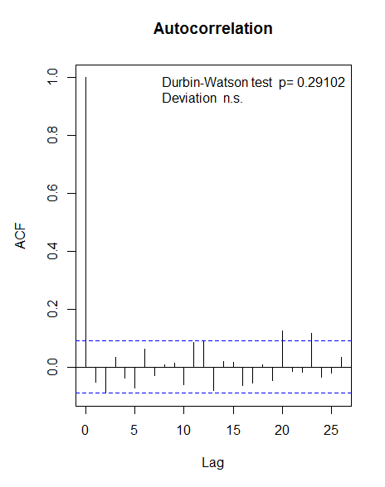
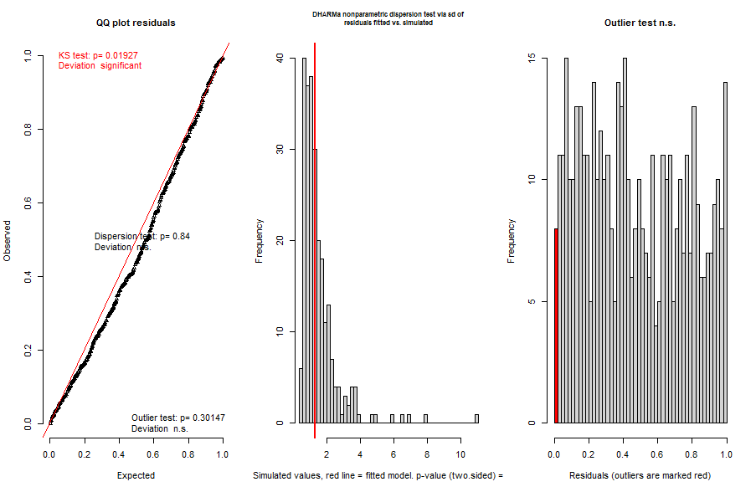

Model 2:

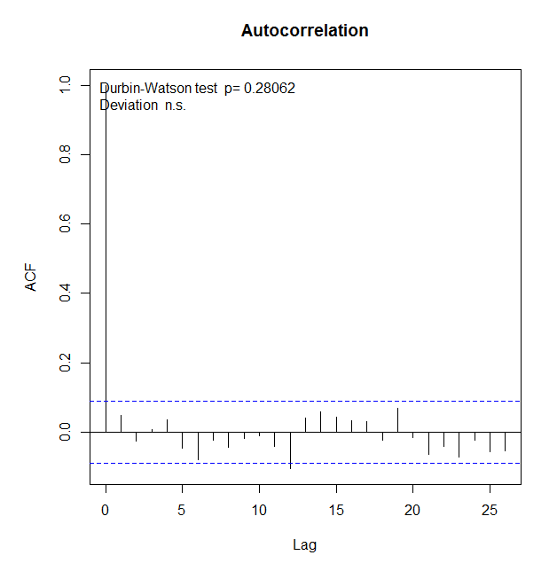
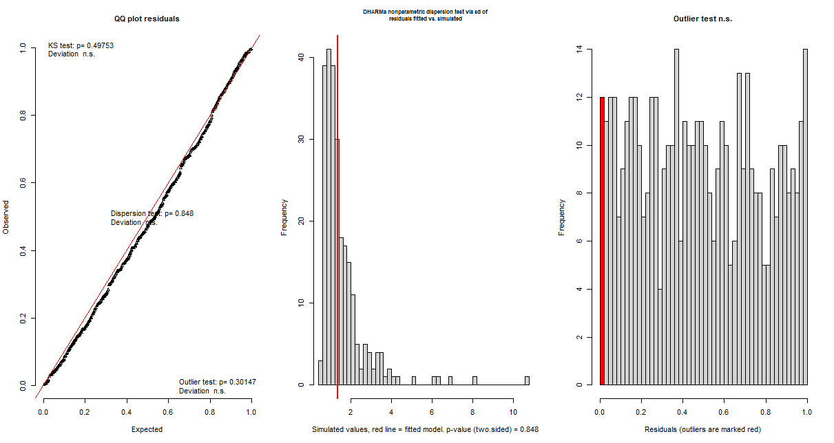

Appendix 8. Model Output with Time Variable Based on Facility Specific Timeline
Variable | Parameter Estimate | Standard Error | Z-test |  | p-value*
Model 1
Early outbreak trend in COVID-19 rate | 0.073 | 0.014 | 5.063 | <0.001*
Level change after intervention | -0.17 | 0.23786 | -0.706 | 0.48041
Trend change after intervention | -0.386 | 0.048 | -8.076 | <0.001*
Post-intervention trend in COVID-19 rate | -0.313 | 0.046 | N/A | N/A
Case Type | -0.451 | 0.127 | -3.546 | <0.001*
Model 2
Early outbreak trend (among residents) | 0.076 | 0.018 | 4.287 | <0.001 *
Level change after intervention (among residents) | 0.189 | 0.275 | 0.070 | 0.490
Trend change after intervention (among residents) | -0.405 | 0.057 | -7.130 | <0.001*
Post-intervention trend in COVID-19 rate (among residents) | -0.329 | 0.054 | N/A | N/A
Case Type | -0.220 | 0.254 | -0.850 | 0.395
Pre-intervention trend x Case Type | -0.008 | 0.026 | -0.312 | 0.755
Level change after intervention x Case Type | -1.19 | 0.553 | -2.157 | 0.031 *
Trend change after intervention x Case Type | 0.072 | 0.103 | 0.693 | 0.488

Appendix 9. Personal Protective Equipment Recommendations During Study Period
