Supplementary Figure 1. Boxplot showing the distribution of the Ct values (n=318)
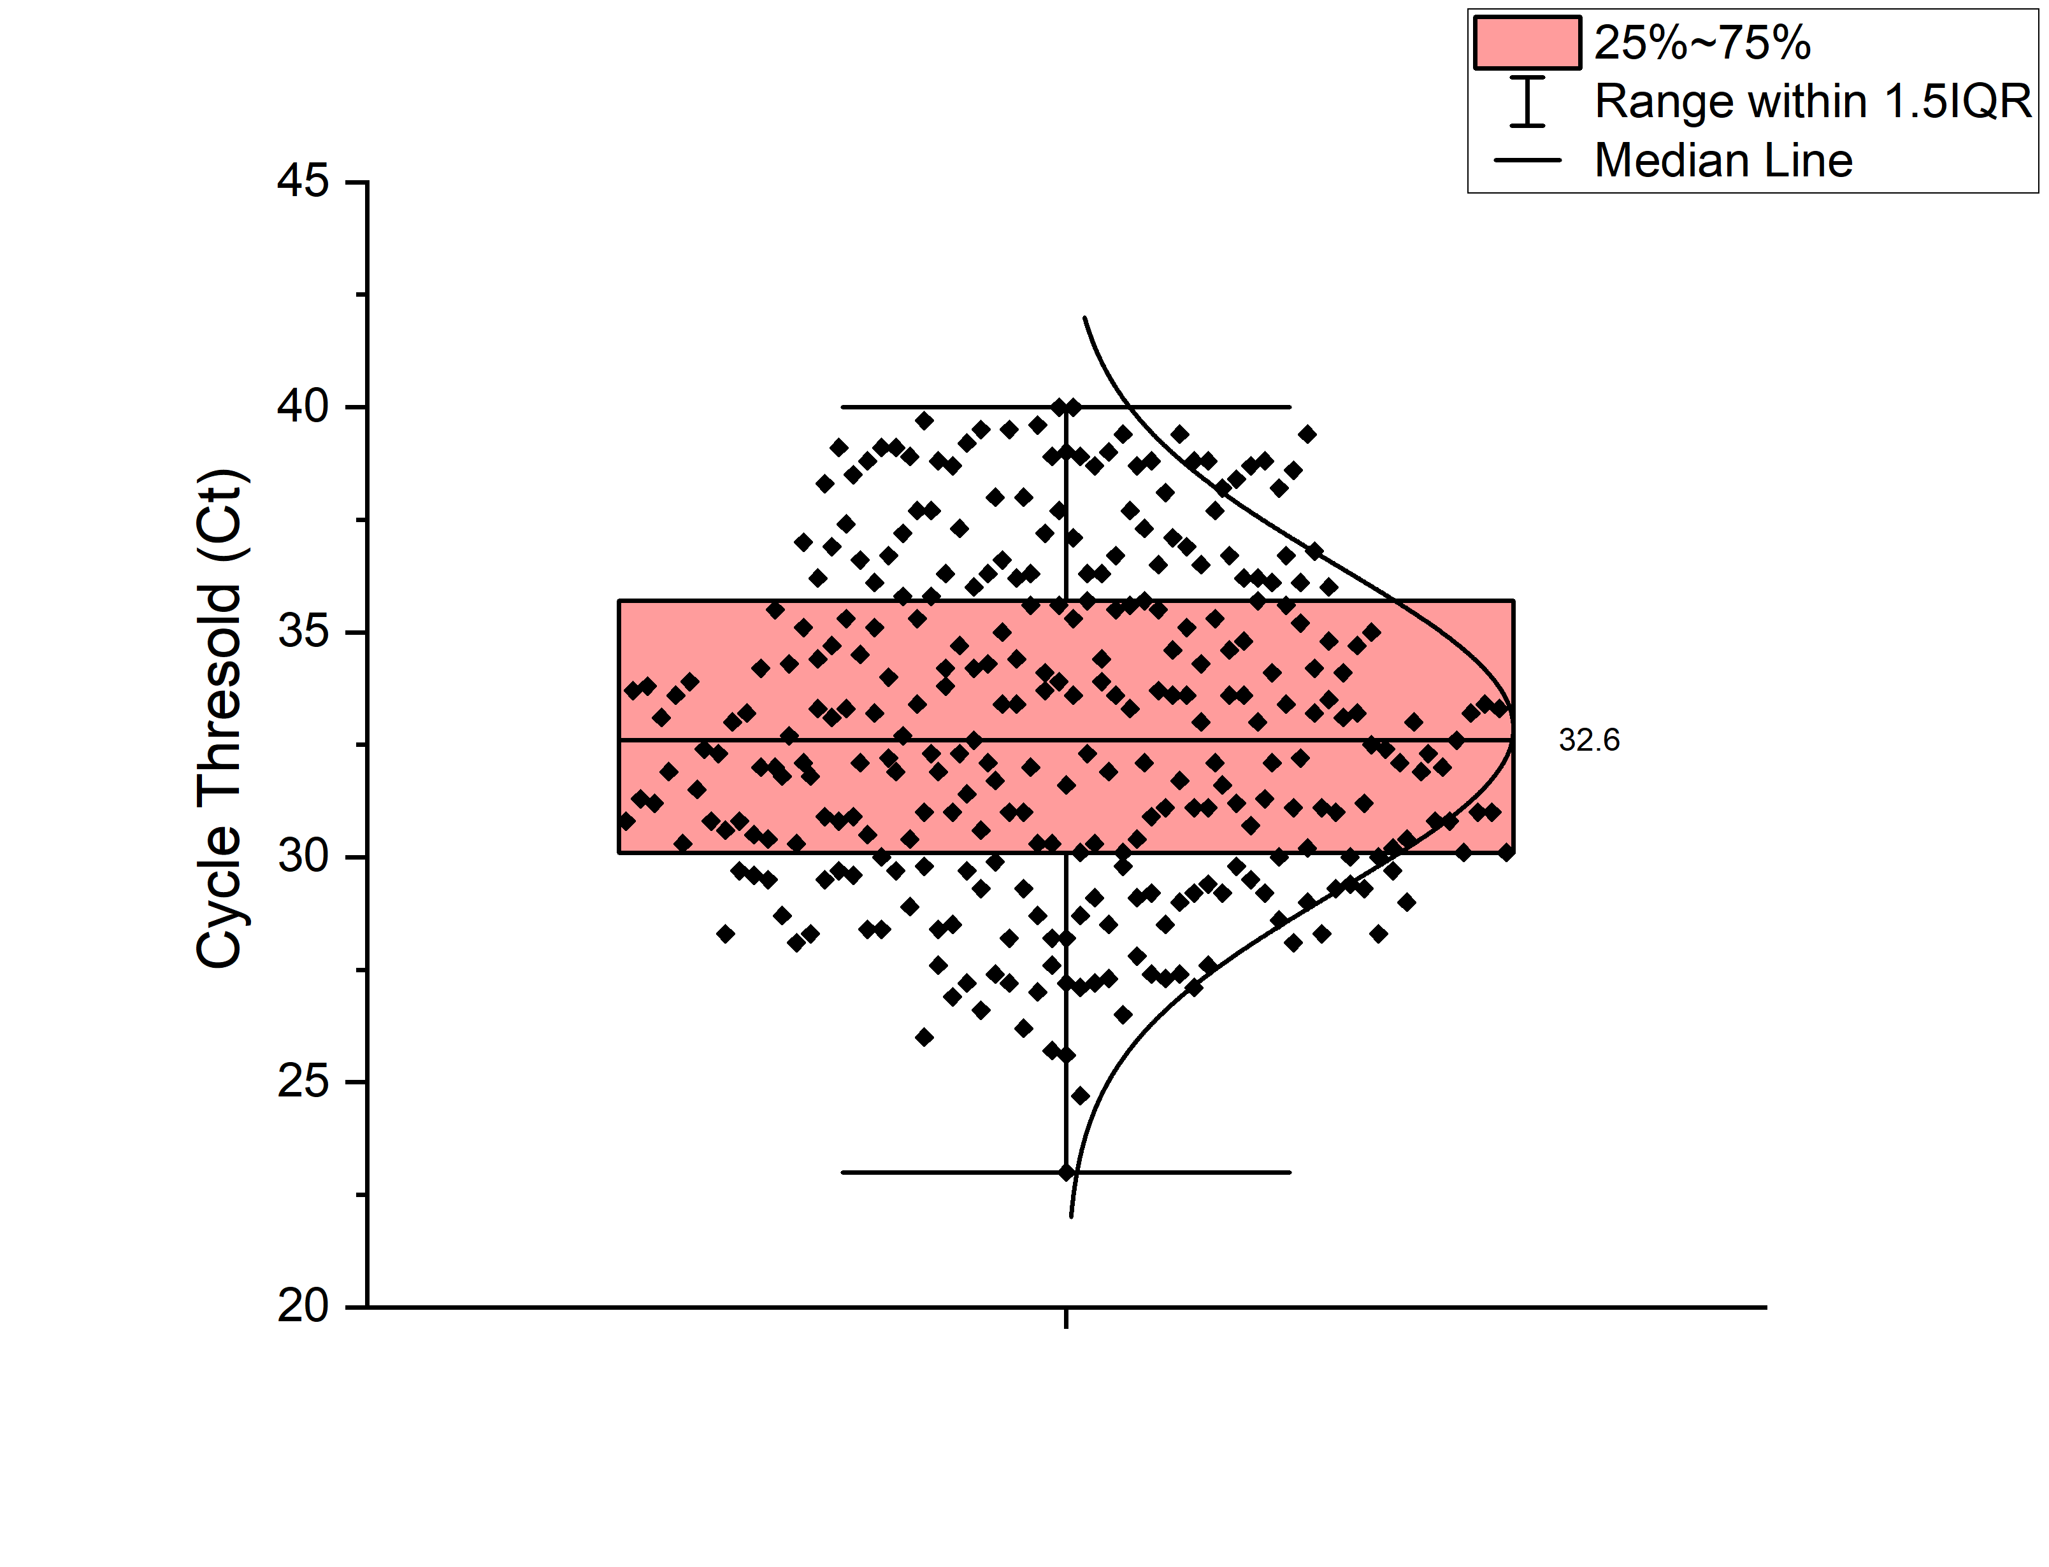
Supplementary Figure 2a: Box plot comparing Ct value among patients with (severe and severe-complicated) and without complications (32.6 ±3.4 versus 33.1 ±3.7; p=0.23)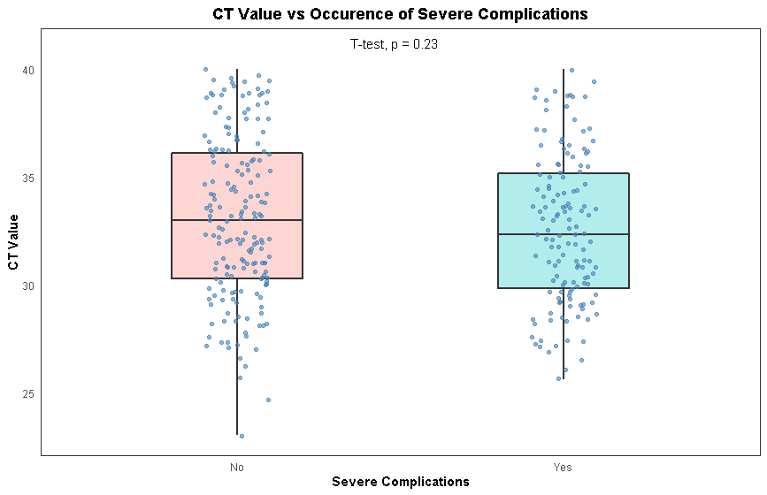

Supplementary Figure 2b: Box plot comparing Ct value among patients with 30-day all-cause mortality and survivors (31.5 ±2.5 versus 33.0 ±3.7; p=0.003)
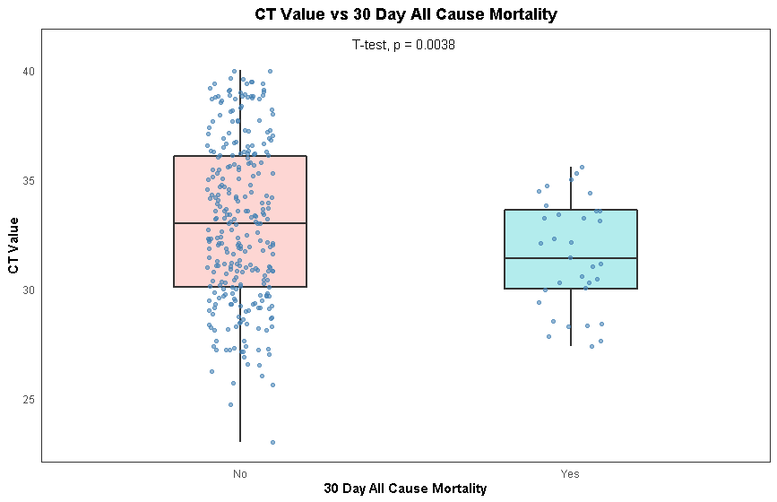

Supplementary Figure 2c: Box plot comparing Ct value among patients with 8-week recurrence compared to patients with no recurrence (31.9 ±2.9 versus 32.9 ±3.7; p=0.17)
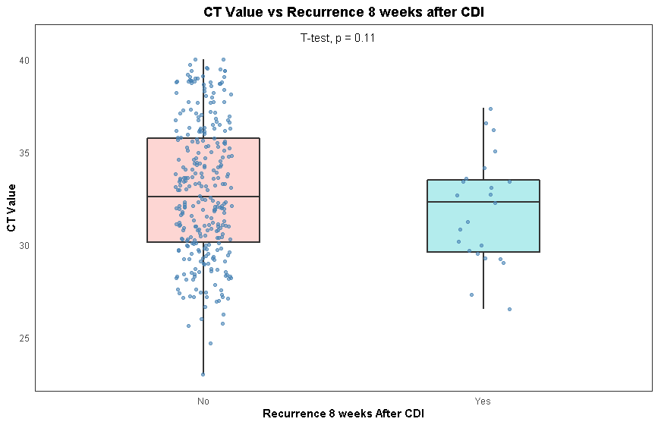

Supplementary Figure 3a: 30-day mortality in association with Ct values receiver operating characteristic (ROC) curve

Supplementary Figure 3b: 8-week recurrence in association with Ct values receiver operating characteristic (ROC) curve.

Supplementary Table 1: Multivariable regression analysis for CDI severe complications
Factor | Odds Ratio | P-value
Age > 65 years | 0.45 (95% CI: 0.21-0.98) | 0.043
Charlson co-morbidity score | 1.03 (95% CI: 0.93-1.14) | 0.571
Highest WBC count within 4 days of CDI | 1.35 (95% CI: 1.24-1.47) | <0.0001
Ct value | 0.99 (95% CI: 0.90-1.09) | 0.806
Minimum albumin value within 4 days of CDI | 0.93 (95% CI: 0.46-1.85) | 0.825
Hypotension/ shock within 4 days of CDI | 6.094 (95% CI: 1.45-25.56) | 0.013
Cr: creatinine, WBC: White Blood Cell

