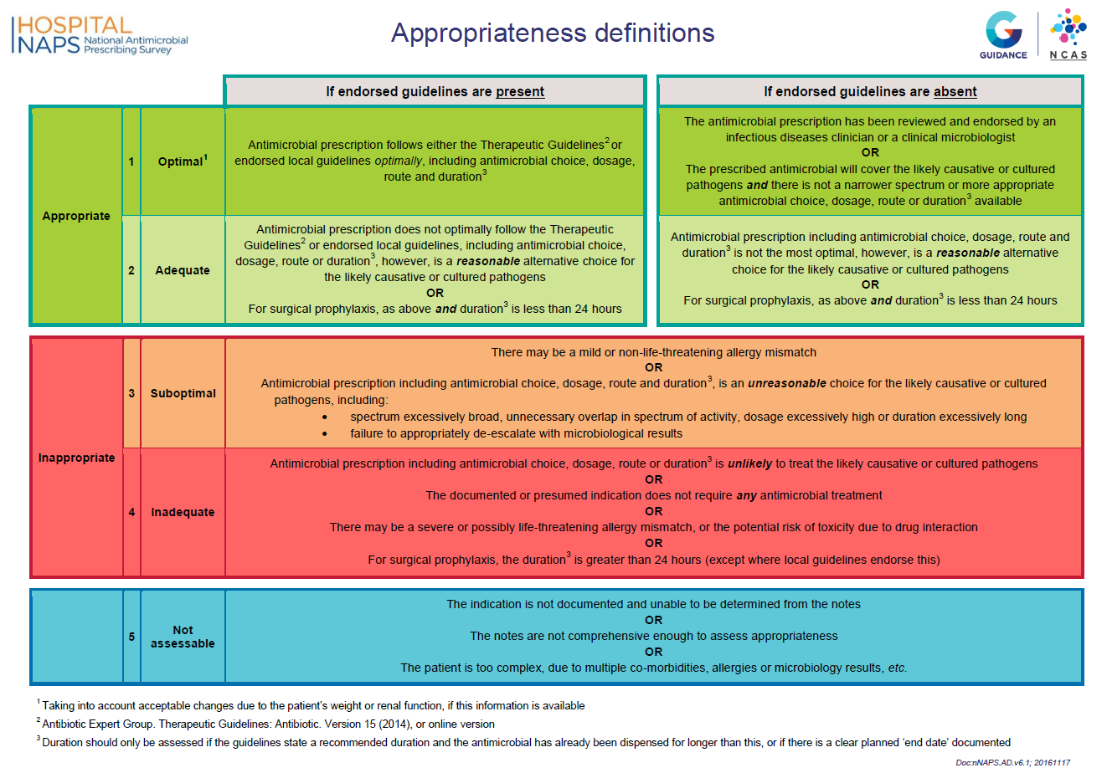
Supplementary Figure 1: Definitions of appropriateness for NAPS auditors

