Supplementary Table 1. Definition of each independent variable included in risk factors analysis for carbapenemase-producing organisms (CPO) infection and colonisation
Variables | Definition
Demographics | According to General Acute Inpatient and Day Case-Scottish Morbidity Record (SMR01) ¹
Age, years | Age at diagnosis
Age>60 years old | Age over 40 years old
Gender, male | As described in medical records
Comorbidities | According to International Classification of Diseases-10th Revision codes (ICD-10) ²
Neoplasms and diseases of the blood and blood-forming organs | C00-D89 ²
Malignancy | C00-C80, C7A, C81-C96, D00-D09 ²
Solid | Including carcinoma and malignant neoplasm
Hematology | Including lymphoma, leukaemia, multiple myeloma and myelodysplastic syndrome
Anaemia | Neoplasms and diseases of the blood and blood-forming organs with anaemia
Endocrine, nutritional and metabolic diseases | E00-E89 ²
Diabetes mellitus | Including Type 1 and Type 2
With complications | Including circulatory complications, ketoacidosis and multiple complications
Diseases of the circulatory system | I00-I99 ²
Heart failure | Circulatory diseases with heart failure
Diseases of the respiratory system | J00-J99 ²
Respiratory failure | Circulatory diseases with respiratory failure
Diseases of the digestive system | K00-K95 ², excluding constipation
Diseases of the genitourinary system | N00-N99 ²
Renal failure | Diseases of the genitourinary system with renal failure or chronic kidney disease at stage 5
Diseases of the nervous system | G00-G99 ²
Diseases of the skin and subcutaneous tissue | L00-L99 ²
Diseases of the musculoskeletal system and connective tissue | M00-M99 ²
External causes of morbidity | V00-Y99 ²
Injury, poisoning and certain other consequences of external causes | S00-T88 ²
Immunocompromised status | Patients with AIDS, malignancy, stem blood cell or organ transplant, chemotherapy or radiotherapy
Healthcare exposure | According to General Acute Inpatient and Day Case-Scottish Morbidity Record (SMR01) ¹, healthcare exposure in the prior 90 days before specimen collection date of the first positive culture for cases and non-CPO controls, before the discharge date of the index hospitalisation for general inpatient controls, unless stated otherwise.
Emergency admission | For the index hospitalisation, Admission Type: 30-39 ¹
Admission from healthcare facilities | For the index hospitalisation, Admission/Transfer From: 24, 25, 40-59, 4A-4H, 5A-5H ¹
Surgical Specialty | For the index hospitalisation, Specialty/Discipline: C1, C3, C6, C8, C9, C11-13, C41-42, CA, CB ¹
TAR, days | For the index hospitalisation, interval between hospital admission and specimen collection date of the first positive culture
HDU stay | Stayed in HDU
Duration of HDU stay, days | Total days of HDU stay
ICU stay | Stayed in ICU
Duration of ICU stay, days | Total days of ICU stay
Hospitalisation | Admitted to a hospital in the prior 90 days before the current index admission date
Duration of hospitalisation, days | Total days of hospital stay
Hospital transfer | Transferred between different hospitals
Ward transfer | Transferred between different significant facilities during hospitalisation
Invasive procedures | According to OPCS Classification of Interventions and Procedures version 4.7 (OPCS-4.7) ³, procedures conducted in the prior 90 days before specimen collection date of the first positive culture for cases and non-CPO controls, before the discharge date of the index hospitalisation for general inpatient controls.
Any | Any invasive procedures mentioned below
Transplantation | Stem blood cell or solid organ transplantation
Centesis | Extraction of bone marrow, spinal puncture, pleural aspiration or percutaneous needle biopsy
Ectomy | Ectomy, excision, resection, amputation or extirpation surgical operation
Catheterisation | Insertion of indwelling devices, including tunnelled catheter, urinary catheter, CVC and percutaneous transluminal cannulation of artery
Urinary catheter | Insertion of urinary catheter
CVC | Insertion of CVC
Dialysis or drainage | Dialysis or drainage requiring catheterisation, including haemodialysis, peritoneal dialysis, drainage of ascites/ventricle of brain/sphenoid sinus/gall bladder/pleural cavity/biliary/cerebrospinal fluid
Endoscopic operation | Endoscopic examination, resection, cauterization, insertion, dilation, aspiration, incision or extirpation
Invasive ventilation | Invasive ventilation
Other surgical procedures | Xenograft replacement, autograft of skin, vein graft, debridement, prosthetic replacement, repair of diaphragmatic hernia, drainage of perianal abscess/lesion of skin, opening of abdomen, posterior instrumented fusion of lumbar spine, open reduction of fracture, internal fixation, ileostomy, tracheostomy, percutaneous insertion of nephrostomy tube, cystostomy, gastrostomy, antrostomy, intubation of stomach, arteriography, stomach bypass, aorta anastomosis, percutaneous transluminal angioplasty, colostomy, evacuation of subdural haematoma, freeing of adhesions of peritoneum, annuloplasty, colporrhaphy, implantation of cardiac pacemaker system, transluminal operations on coronary artery
CPO, Carbapenemase-producing organisms; ICU, intensive care unit; HDU, high dependency unit; TAR, time at risk; CVC, central venous catheter.

Supplementary Table 2. Distribution of cases and controls and care level of each hospital
Hospital | Care level | Number of cases | Number of general inpatient controls | Number of non-CPO controls
1 | Tertiary care | 20 | 60 | 35
2 | Tertiary care | 13 | 39 | 25
3 | Tertiary care | 11 | 33 | 15
4 | Tertiary care | 6 | 18 | 14
5 | Tertiary care | 5 | 15 | 9
6 | Tertiary care | 5 | 15 | 5
7 | Tertiary care | 2 | 6 | 4
8 | Tertiary care | 2 | 6 | 2
9 | Tertiary care | 1 | 3 | 3
10 | Tertiary care | 1 | 3 | 3
11 | Tertiary care | 1 | 3 | 3
12 | Secondary care | 14 | 42 | 21
13 | Secondary care | 7 | 21 | 10
14 | Secondary care | 5 | 15 | 14
15 | Secondary care | 3 | 9 | 5
16 | Secondary care | 2 | 6 | 5
17 | Secondary care | 2 | 6 | 1
18 | Secondary care | 1 | 3 | 3
19 | Secondary care | 1 | 3 | 2
20 | Secondary care | 1 | 3 | 1
21 | Secondary care | 1 | 3 | 1
Total |  | 104 | 312 | 181

Supplementary Table 3. Comparison of mortality rates between 56 CPO infection cases and 121 non-CPO infection controls by infection type
Infection type | All-cause 30-day mortality rate |  |  | All cause 1-year mortality rate
 | CPO^{Ф} | Non-CPO^{Ф} | P§ | CPO^{Ф} | Non-CPO^{Ф} | P§
Urinary tract infection | 2/15 | 1/25 | 0.545 | 6/15 | 5/25 | 0.273
Bloodstream infection | 4/16 | 10/48 | 0.736 | 9/16 | 20/48 | 0.469¶
Respiratory tract infection | 3/9 | 2/15 | 0.326 | 3/9 | 4/15 | 1.000
Wound infection | 0/7 | 2/12 | 0.509 | 4/7 | 4/12 | 0.378
Gastrointestinal infection | 0/5 | 1/11 | 1.000 | 1/5 | 2/11 | 1.000
Bacterial meningitis | 1/3 | 1/9 | 0.455 | 1/3 | 2/9 | 1.000
Skin and soft tissue infection | 0/1 | 0/1 | 1.000 | 0/1 | 0/1 | 1.000
CPO, carbapenemase-producing organisms; non-CPO, organisms that do not yield carbapenemases.
^{Ф}, number of deaths/total number of CPO cases or non-CPO controls by infection type;
§, Fisher’s exact test, unless stated otherwise;
¶, Pearson’s Chi-squared test.

Supplementary Figure 1. Forest plots of results of univariate analyses of risk factors for carbapenemase-producing organisms (CPO) infection by comparing cases and non-CPO controls/general inpatient controls. (A) Demographics and comorbidities related variables; (B) Healthcare exposure and invasive procedures related variables.
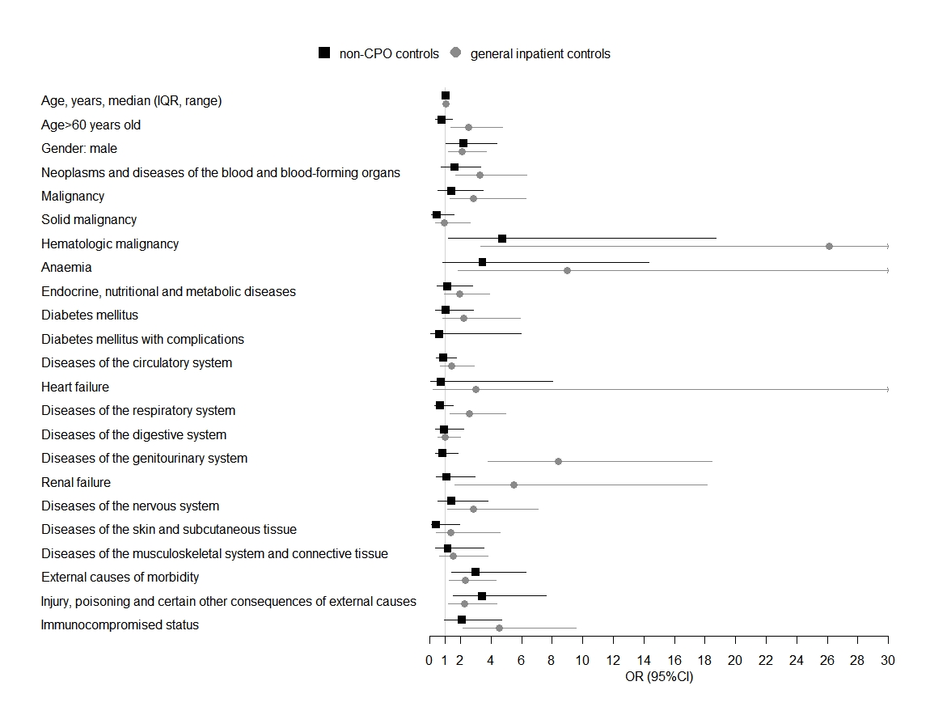
(A)
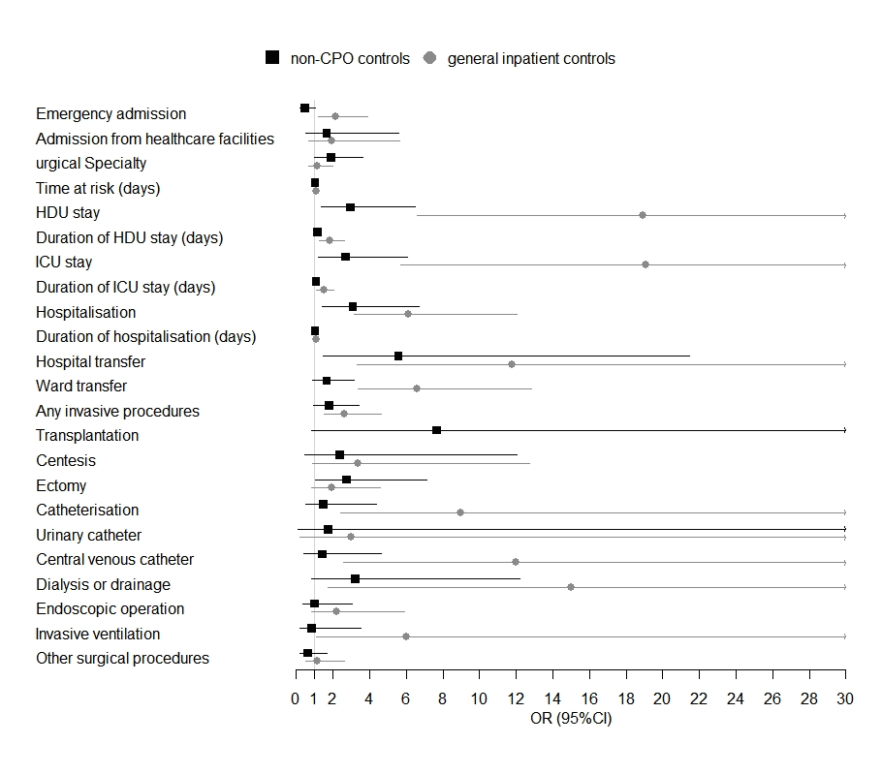
(B)
HDU, high dependency unit; ICU, intensive care unit.

Supplementary Figure 2. Forest plots of results of univariate analyses of risk factors for carbapenemase-producing organisms (CPO) colonisation by comparing cases and non-CPO controls/general inpatient controls. (A) Demographics and comorbidities related variables; (B) Healthcare exposure and invasive procedures related variables.
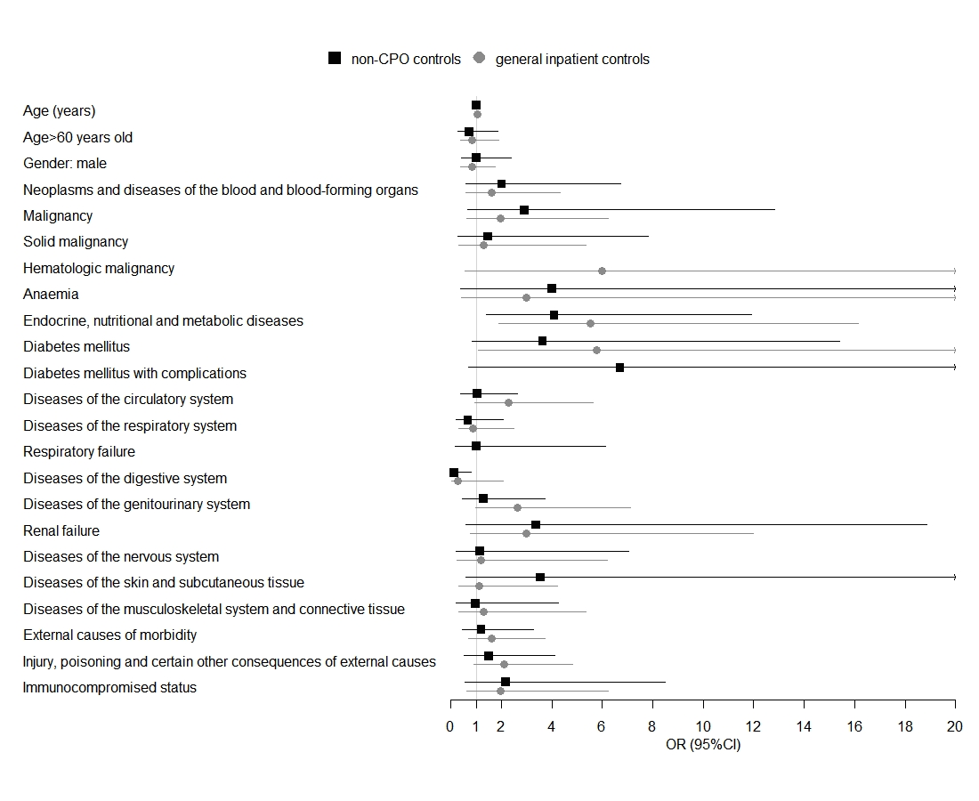
(A)
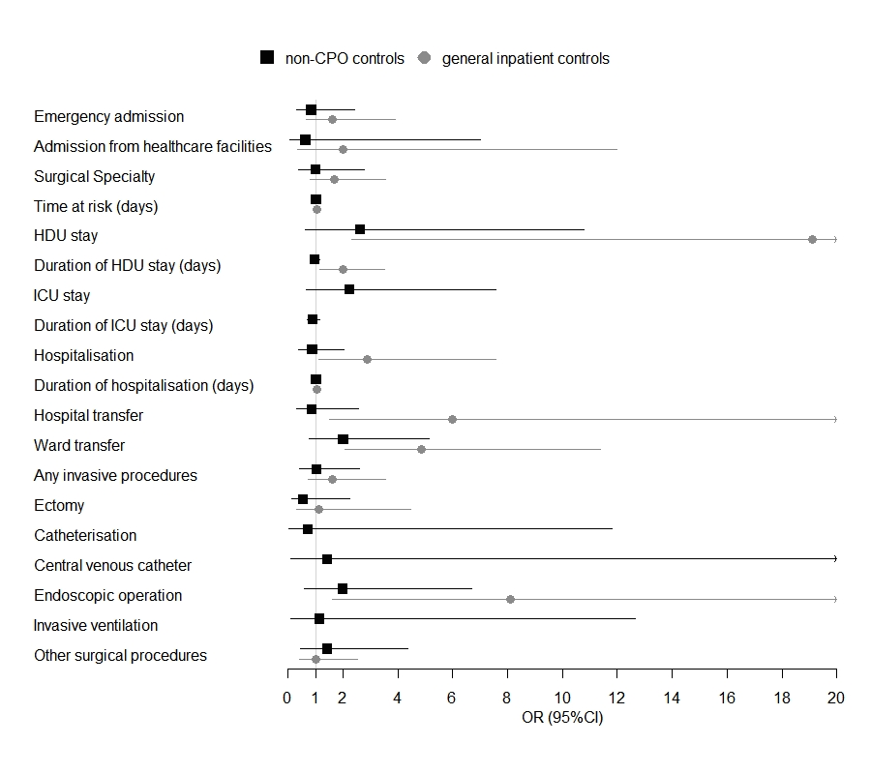
(B)
HDU, high dependency unit; ICU, intensive care unit.

References
1. Information Services Division National Survices Scotland. General Acute Inpatient and Day Case-Scottish Morbidity Record (SMR01). 2016. https://www.ndc.scot.nhs.uk/Data-Dictionary/SMR-Datasets//SMR01-General-Acute-Inpatient-and-Day-Case/.
2. Centers for Disease Control and Prevention. International Classification of Diseases-10th Revision codes. 2017. https://www.cdc.gov/nchs/icd/icd10cm.htm.
3. National Health Service Digital. OPCS Classification of Interventions and Procedures version 4.7. 2017. https://digital.nhs.uk/data-and-information/information-standards/information-standards-and-data-collections-including-extractions/publications-and-notifications/standards-and-collections/scci0084-opcs-classification-of-interventions-and-procedures.

