Appendix B

***Fig. B.1. Impact of hand hygiene compliance rate without additional precautions***

Cumulative number of VRE-carrier cases at the end of the 50 one-year simulations, for the standard precautions with 70% hand hygiene compliance rate scenario (SP 70%HH, scenario #4) and the SP 80%HH scenario (scenario #5).



***Fig. B.2. Comparison of the application of standard precautions alone and the addition of the establishment of an isolation unit***

Cumulative number of VRE-carrier cases at the end of the 50 one-year simulations, for the standard precautions with 60% hand hygiene compliance rate (SP 60%HH, scenario #3), SP 70%HH (scenario #4), SP 80%HH (scenario #5) and SP 50%HH and establishment of an isolation unit with 1-case threshold scenarios (scenario #22)



***Fig. B.3. Cumulative number of VRE-carrier cases according to the different IPC measures and different probabilities of transmission***

Probabilities of caregiver-to-patient transmission (1st percentage) and patient-to-caregiver transmission (2nd percentage).



***Fig. B.4. Distribution of cumulative VRE-carrier cases for the 4 scenarios according to the number of simulations performed***

1)

2)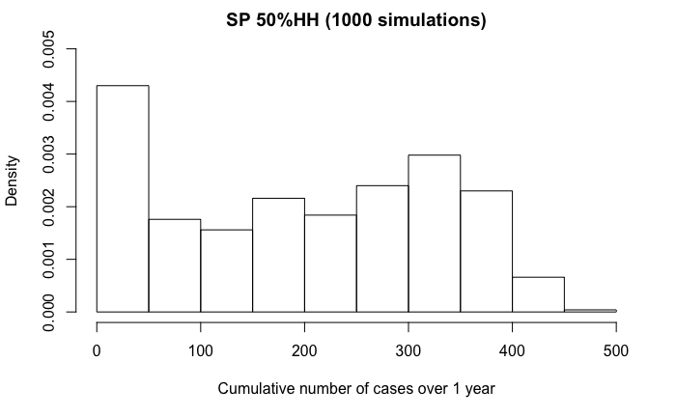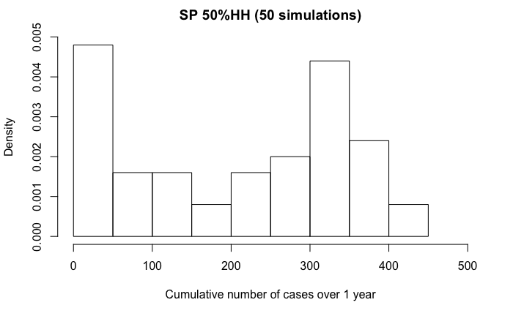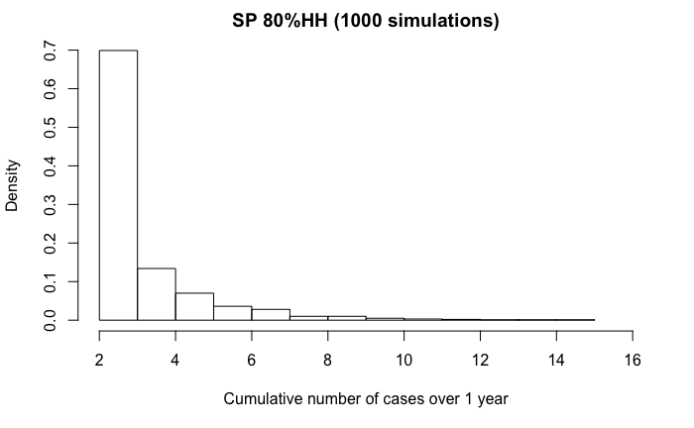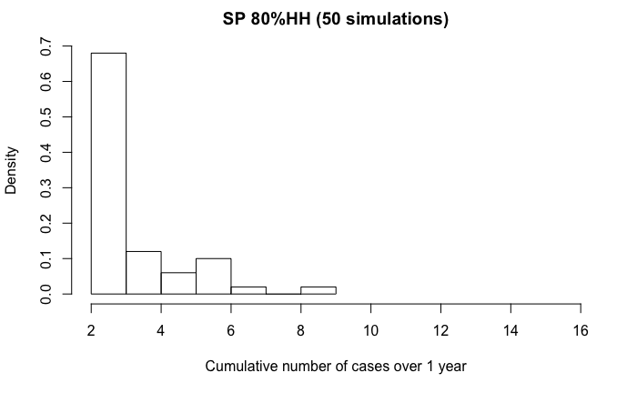

3)

4)