Table S1: List of questions included in hospital walk-through survey
Number | Question | Answer | Units | Format | Q Type  I=Informational  A=Architectural  S=Structural
1 | Hospital Name | Name of Hospital |  | Check box | I
2 | Floor | [#] |  | Number Entry | I
3 | Room Number | [#] |  | Number Entry | I
4 | Type of Room | Single, double |  | Check box | A
5 | Number of beds in room | [#] | Count | Number Entry | S
6 | Number of chairs in room | [#] | Count | Number Entry | S
7 | Number of couches in room | [#] | Count | Number Entry | S
8 | Number of tables in room | [#] | Count | Number Entry | S
9 | Material of chair(s) in room | Plastic, Wood, Fabric, Plastic/Fabric, Wood/Fabric, Other |  | Check box | S
10 | Material of couch(es) in room | Plastic, Wood, Fabric, Plastic/Fabric, Wood/Fabric, Other |  | Check box | S
11 | Material of table(s) in room | Plastic, Wood, other |  | Check box | S
12 | Condition of chair(s) in room | Like New, Good Condition, Fair Condition, Poor Condition, Extensive Damage |  | Check box | S
13 | Condition of couch(es) in room | Like New, Good Condition, Fair Condition, Poor Condition, Extensive Damage |  | Check box | S
14 | Condition of table(s) in room | Like New, Good Condition, Fair Condition, Poor Condition, Extensive Damage |  | Check box | S
15 | Type of bed(s) in room | Electric bed, Stretcher, Low bed |  | Check box | S
16 | Number of headwalls in room | [#] | Count | Number Entry | S
17 | Number of oxygen outlets in room | [#] | Count | Number Entry | S
18 | Number of other gas outlets in room | [#] | Count | Number Entry | S
19 | Number of window curtains in room | [#] | Count | Number Entry | S
20 | Material of window curtains in room | Fabric, plastic, paper, other |  | Check box | S
21 | Number of bed curtains in room | [#] | Count | Number Entry | S
22 | Material of bed curtains in room | Fabric, plastic, paper, other |  | Check box | S
23 | Are window curtains disposable | Yes, No |  | Check box | S
24 | Are bed curtains disposable | Yes, No |  | Check box | S
25 | Floor Type in Main Room | Wood, linoleum, carpet, tile, other |  | Check box | S
26 | Bathroom ajoined to room | Yes, No |  | Check box | A
27 | Floor Type in Bathroom | Wood, linoleum, carpet, tile, other |  | Check box | S
28 | Shower in Bathroom | Yes, No |  | Check box | S
29 | Door on bathroom | Normal swing door, sliding door, no door, other |  | Check box | S
30 | Sink in Bathroom? | Yes, No |  | Check box | S
31 | Sink in main room? | Yes, No |  | Check box | S
32 | Permanent glove dispenser in room? | Yes, No |  | Check box | S
33 | Alcohol disinfectant dispenser in room? | Yes, No |  | Check box | S
34 | Type of sink in main room? | Automatic faucet, Turn handle faucet |  | Check box | S
35 | Type of sink in bathroom? | Automatic faucet, Turn handle faucet |  | Check box | S
36 | Paper towel dispenser in bathroom? | Yes, No |  | Check box | S
37 | Type of paper towel dispenser in bathroom? | Manual, Automatic |  | Check box | S
38 | Paper towel dispenser in main room? | Yes, No |  | Check box | S
39 | Type of paper towel dispenser in main room? | Manual, Automatic |  | Check box | S
40 | Tile present in bathroom? | Yes, No |  | Check box | S
41 | Door type for main room | Normal swing door, sliding door, no door, other |  | Check box | S
42 | Handle type for door on main room | Turn knob, lever knob, push handle, sliding door handle, bar push handle, other |  | Check box | S
43 | Disinfectant present in main room? | Yes, No |  | Check box | S
44 | Disinfectant present in bathroom? | Yes, No |  | Check box | S
45 | Soap dispenser in bathroom? | Automatic, Push, Pull, other, none |  | Check box | S
46 | Length of main room | [#] | Meters | Number Entry | A
47 | Width of main room | [#] | Meters | Number Entry | A
48 | Height of main room | [#] | Meters | Number Entry | A
49 | Length of bathroom | [#] | Meters | Number Entry | A
50 | width of bathroom | [#] | Meters | Number Entry | A
51 | Height of bathroom | [#] | Meters | Number Entry | A
52 | Distance from toilet to sink | [#] | Meters | Number Entry | A
53 | Distance from bed(s) to bathroom | [#] | Meters | Number Entry | A
54 | Shower access type | Shared, Private |  | Check box | A
55 | Distance from Shower to Main room | [#] | Meters | Number Entry | A
56 | Location of nurses station | [Characters] |  | Word Entry | I
57 | Location of air vents in main room | [Characters] |  | Word Entry | I
58 | Location of air vents in bath room | [Characters] |  | Word Entry | I
59 | Location of in room computer | [Characters] |  | Word Entry | I
60 | Presence of sink in hallway from main room door | Yes, No |  | Check box | I
61 | Distance to sink in hallway outside of main room | [#] | Meters | Number Entry | I
62 | Presence of disinfectant in hallway outside of main room | Yes, No |  | Check box | I
63 | Distance to disinfectant in hallway from main room door | [#] |  | Number Entry | I
64 | location of soil utility room | [Characters] |  | Word Entry | I
65 | location of PPE storage | [Characters] |  | Word Entry | I
66 | location of nurse servers | In room, In hallway, not visible |  | Check box | I
67 | Presence of wall art in main room | Yes, No |  | Check box | S
68 | Presence of wall art in bathroom | Yes, No |  | Check box | S
69 | Texture of main room walls | Textured, Smooth, Other |  | Check box | S
70 | Texture of bathroom walls | Textured, Smooth, Other |  | Check box | S
71 | Location of glove dispensers | In room, In hallway, not visible |  | Check box | S
72 | Aeration screen on faucet | Yes, No |  | Check box | S

Additional output from principal components analysis
The original room dataset contained 86 individual variables. Variables that indicated the condition of furniture (such as couches) were broken out for each level (couch condition good, couch condition fair, etc.) which led to an increase from 72 hospital room survey questions to 86 hospital room variables. Principal component analysis (PCA) was used to reduce the amount of hospital room variables through the creation of composite principal component variables (PCs). PCA computes overall variance explanation through eigenvalues of interrelated variables. Eigenvalues from the PCA indicated 24 significant factors; however, the scree plot showed a significant drop in variance explanation after the fourth factor. The total variance explained by the first four variables was 38.85%, all other variables account for less than 5% of the total variance each. The first 10 factor loadings are shown below with the scree plot.
Therefore, four PCs were identified to be retained as weighted linear combinations of the hospital room variables. The first three PCs were clearly related to hygiene, wall fixtures, and furniture/flooring respectively. The final factor was heavily loaded by the variable indicating the presence of a computer within the hospital room. Due to this, the fourth factor was dropped and included as an individual independent variable (computer presence) instead of a composite variable. After the three PCs were defined each set of variables was rerun as separate analyses, which calculated a linear combination of the variables. The final PC is the sum of all the variables included in that component times their individual eigenvector value.
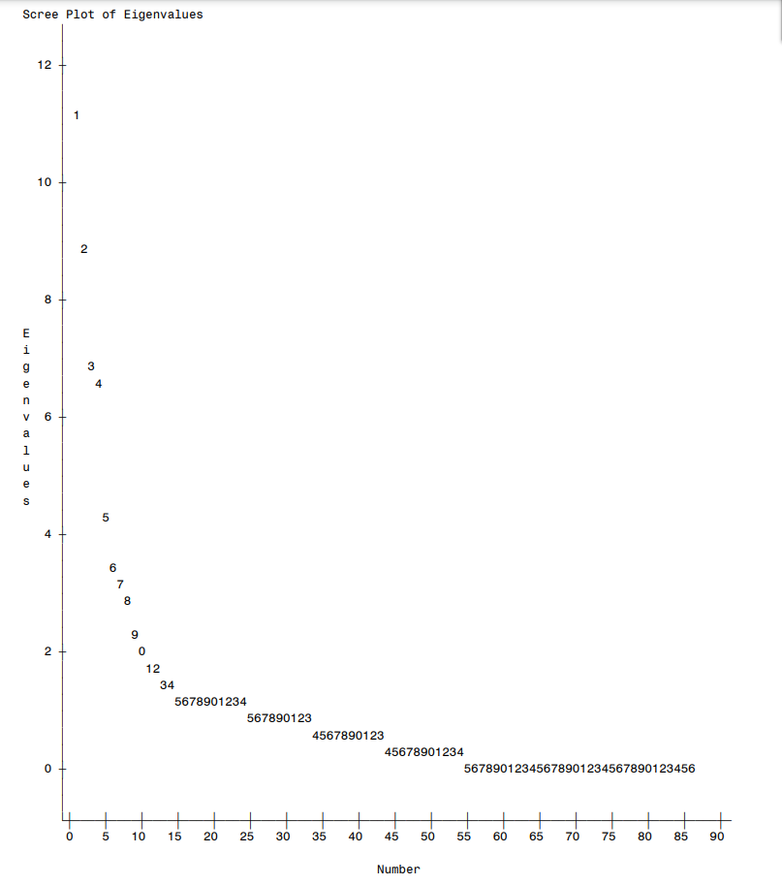
Figure S1: Scree plot from PCA of hospital room features

Table S2: Eigen values for each identified factor and cumulative variance explained
Eigenvalues of the Correlation Matrix:
Total=86 Average=1
 | Eigenvalue | Difference | Proportion | Cumulative
1 | 11.06 | 2.27 | 0.13 | 0.13
2 | 8.79 | 1.87 | 0.10 | 0.23
3 | 6.92 | 0.28 | 0.08 | 0.31
4 | 6.64 | 2.39 | 0.08 | 0.39
5 | 4.25 | 0.85 | 0.05 | 0.44
6 | 3.40 | 0.32 | 0.04 | 0.48
7 | 3.08 | 0.15 | 0.04 | 0.51
8 | 2.92 | 0.50 | 0.03 | 0.55
9 | 2.42 | 0.54 | 0.03 | 0.58
10 | 1.89 | 0.12 | 0.02 | 0.60

