Supplementary Online Material – Ong et al., “Environmental contamination in a COVID-19 intensive care unit (ICU) – what is the risk?”

Contents:
- Supplementary Figure 1: Layout of ICU room depicted surfaces sampled.
- Supplementary Figure 2: Layout of common area in the ICU depicted surfaces sampled.

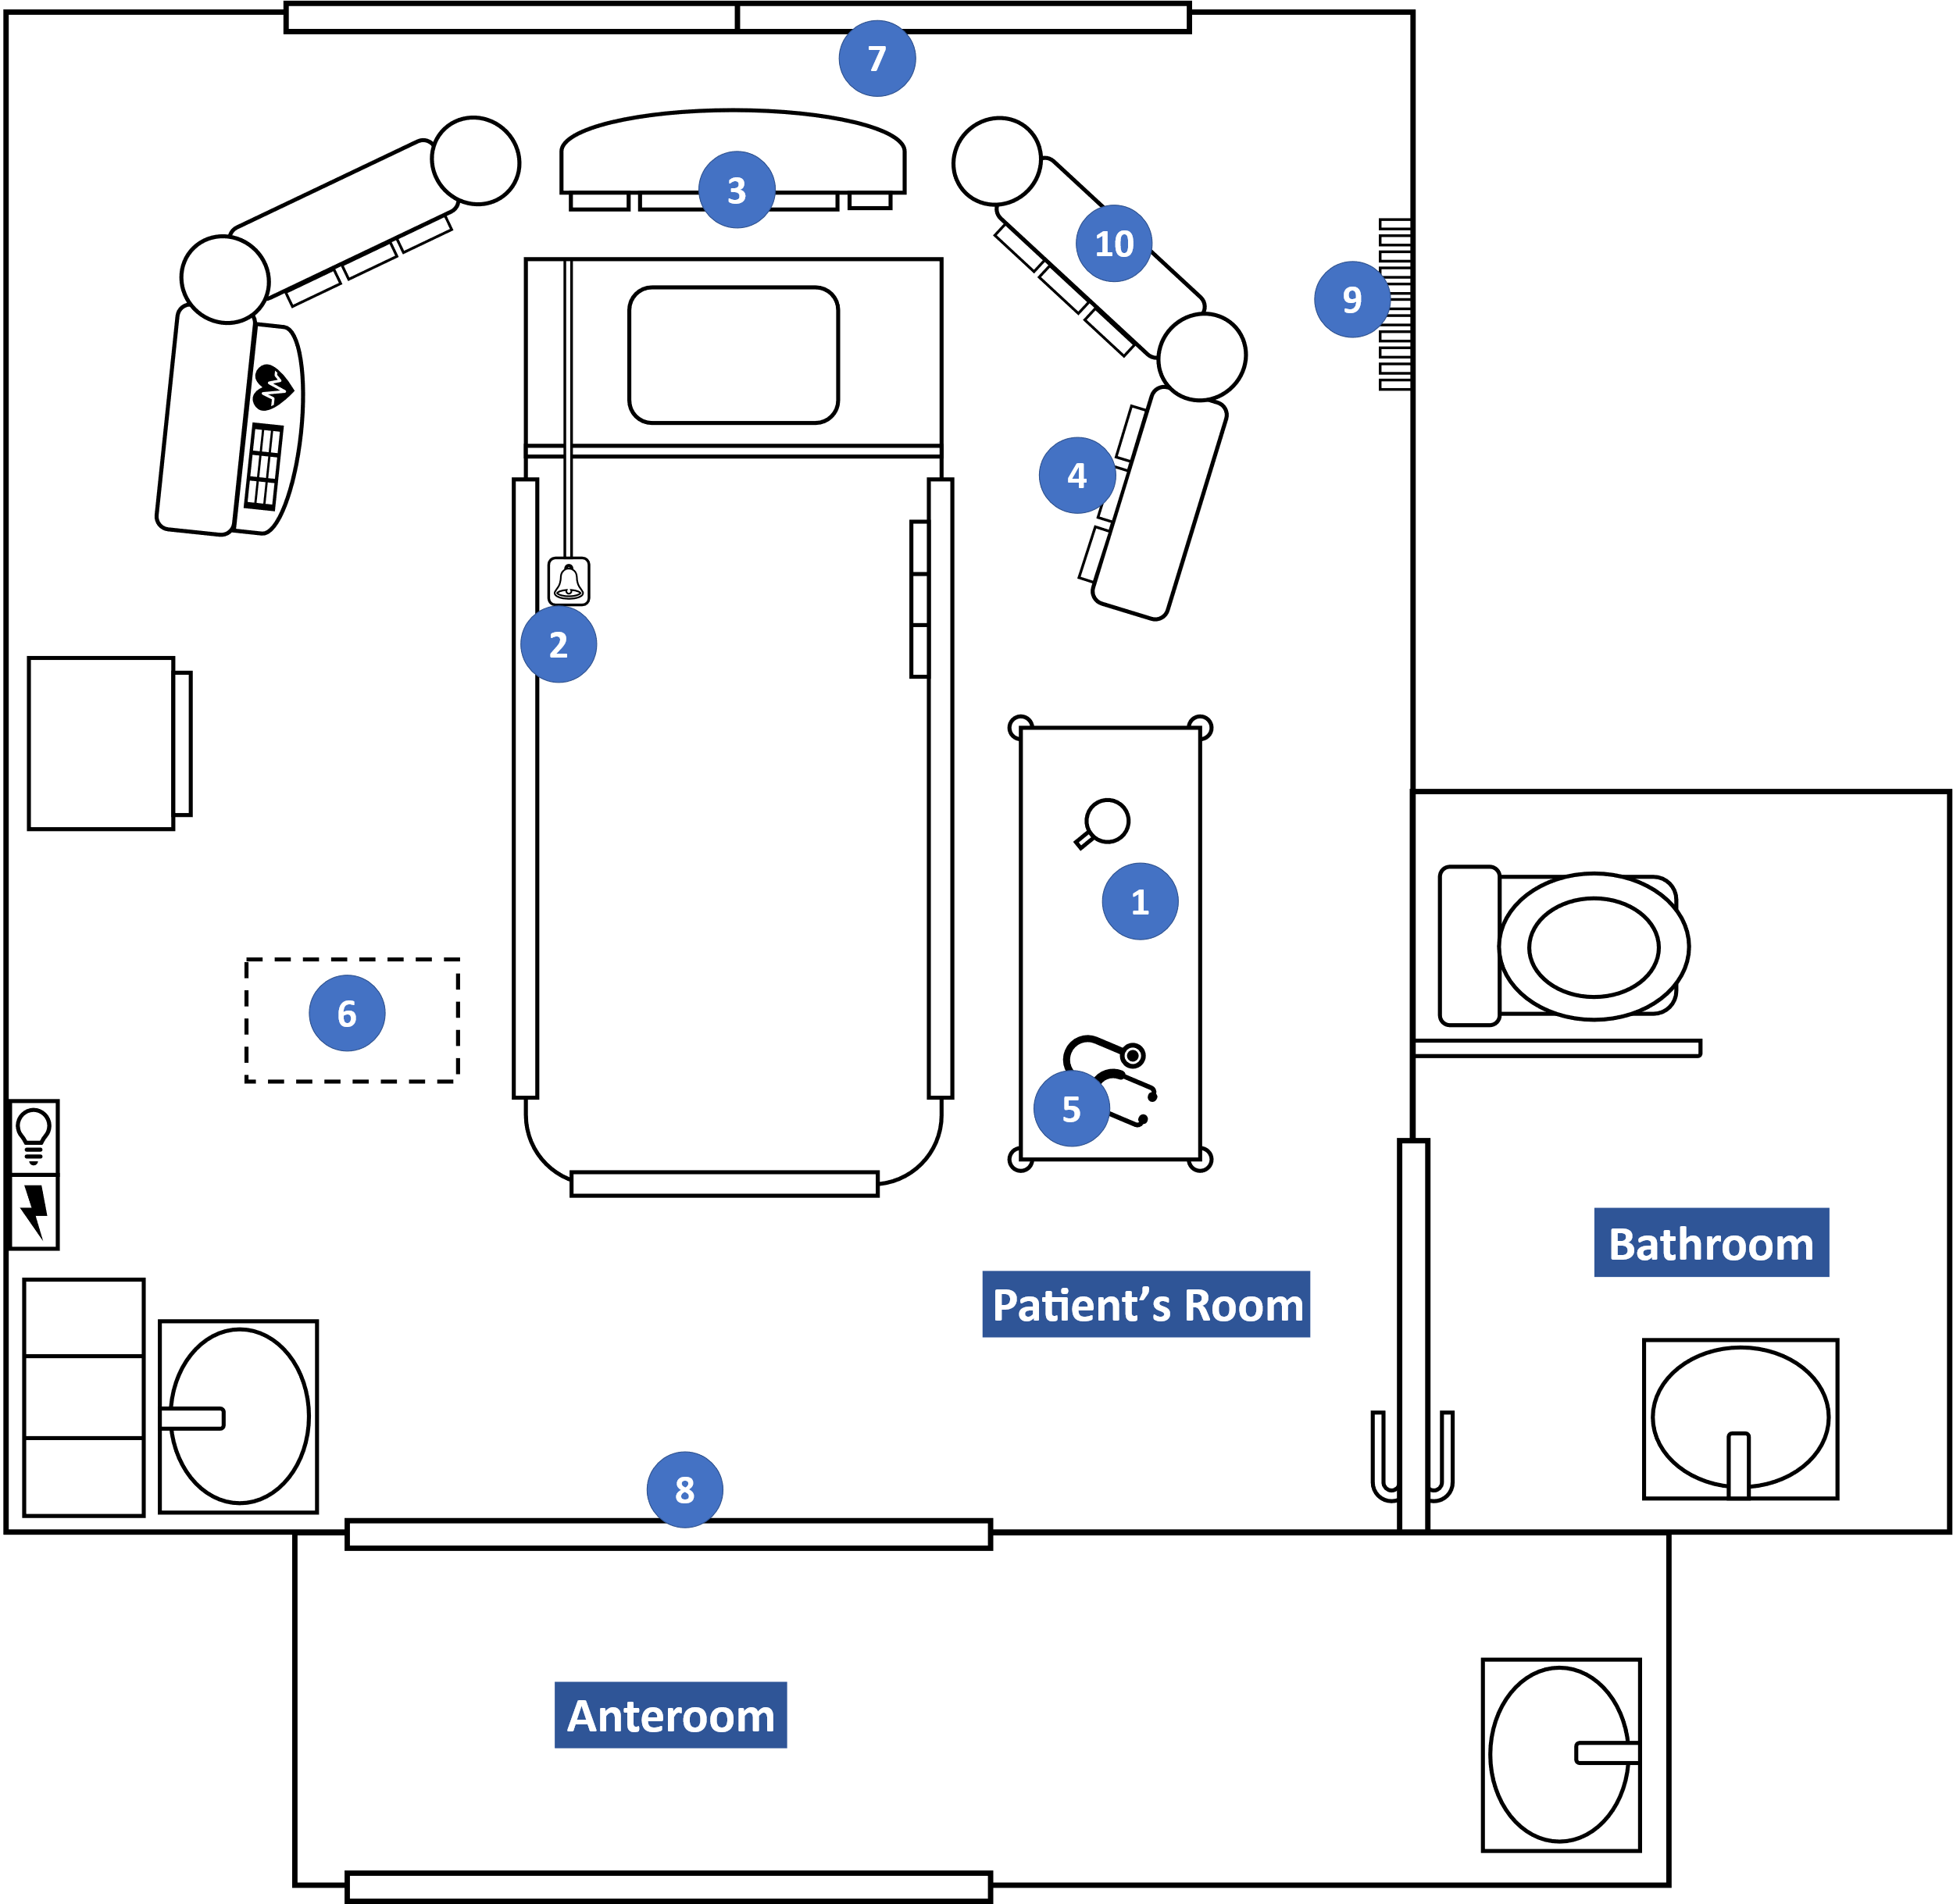
Supplementary Figure 1: Layout of ICU room depicted surfaces sampled.

Blue circles indicate surfaces sampled: (1) cardiac table, (2) bed rail including call bell, (3) ventilator or high-flow nasal oxygen machine*, (4) medication infusion pumps, (5) stethoscope, (6) floor, (7) glass window, (8) glass door, (9) air outlet vent, and (10) surgical pendant.
*For patients not on invasive ventilation and not receiving high-flow nasal oxygen, the corresponding area on the back of the bed was swabbed instead.

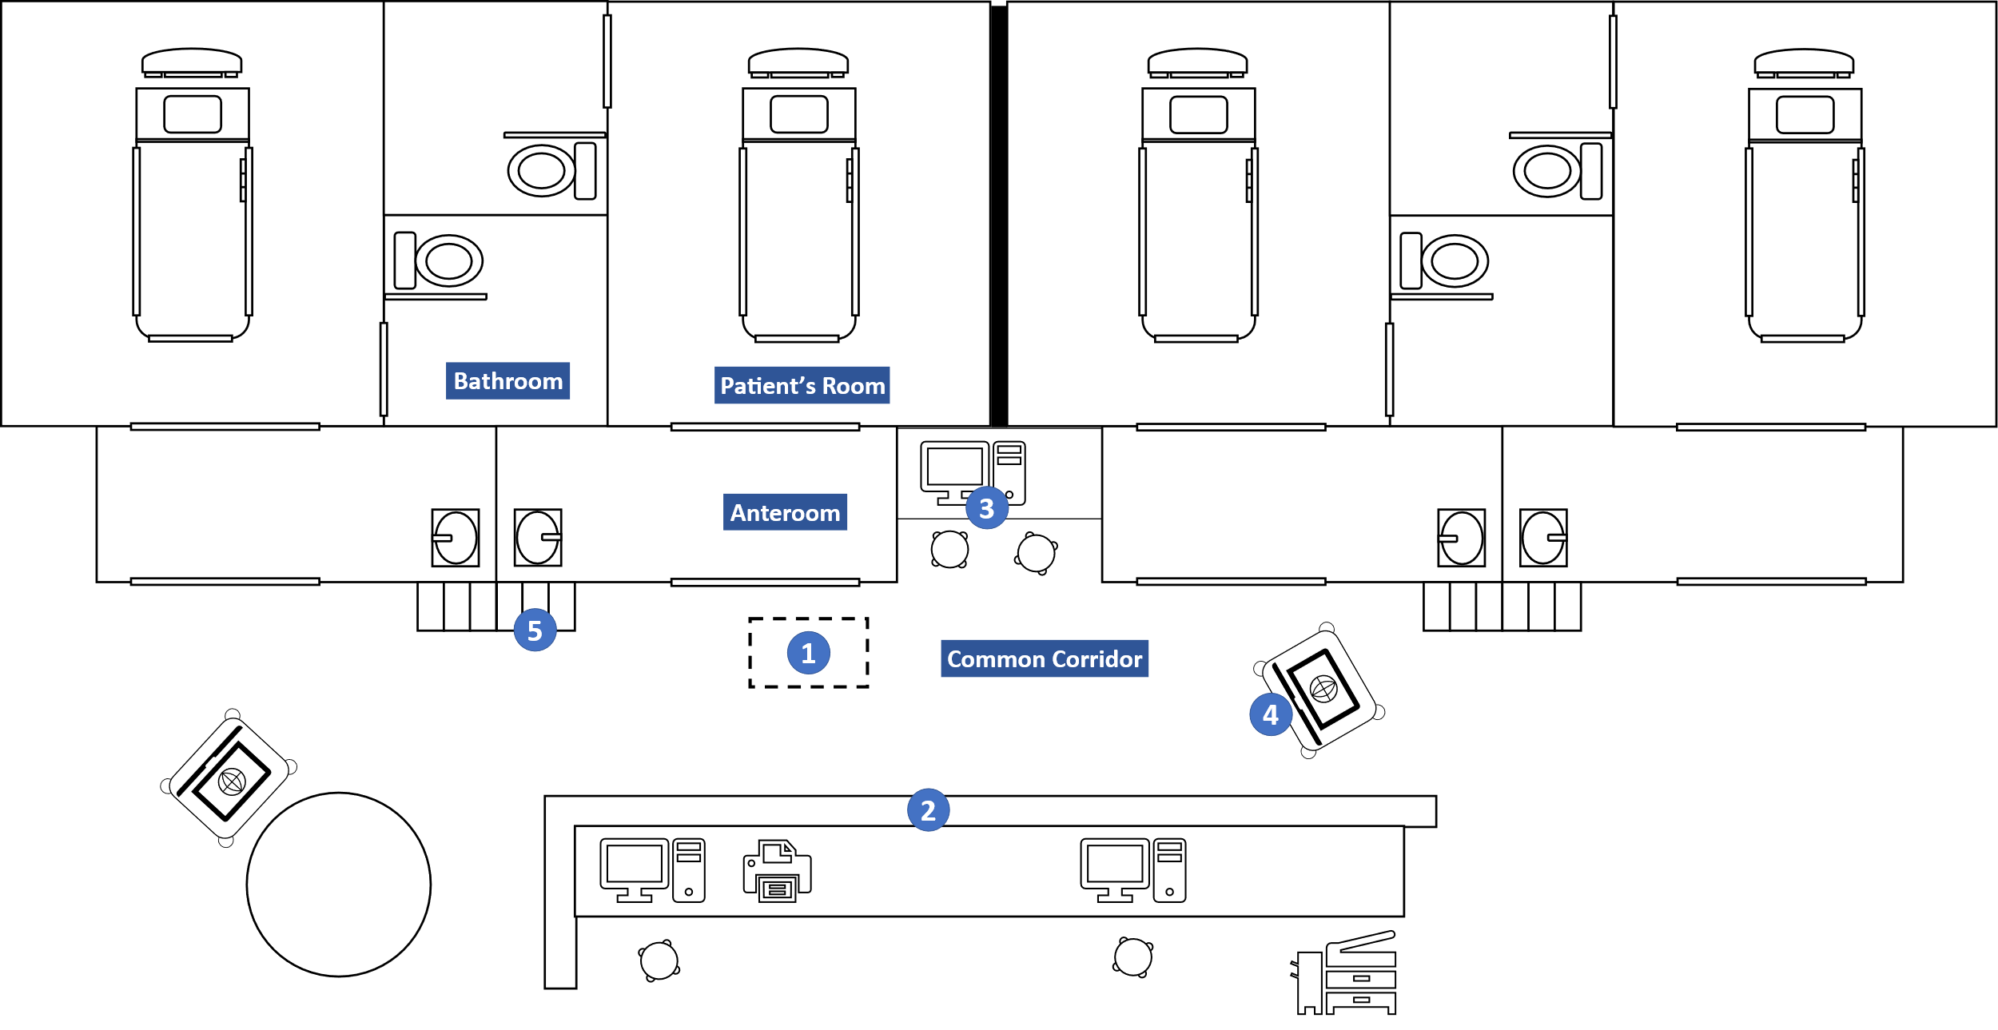
Supplementary Figure 2: Layout of common area in the ICU depicted surfaces sampled.

Blue circles indicated surfaces sampled: (1) floor, (2) nursing counter, (3) desktop computer including keyboard and mouse, (4) mobile computer on wheels, and (5) personal protective equipment storage area

