Supplementary materials.
Carbapenemase-producing Enterobacteriaceae cultures process description.
The surveillance samples were cultured on MacConkey agar plates with 10 µg meropenem and ertapenem disks. Organism identification and full susceptibility testing from surveillance and clinical isolates were performed using the Vitek2® system. Carbapenemase production was tested phenotypically with the Modified Hodge Test until 2014 and using CarbaNP Test starting in 2015. Isolates were frozen for epidemiological reasons. For the purpose of this study, viable isolates were tested by PCR in 2019 to detect bla_{KPC}, bla_{NDM}, and bla_{OXA-48}; Serratia marcescens isolates were also tested for bla_{SME}.

 | Supplementary Table 1. CPE-Infection types based on initial colonization source among patients admitted to large healthcare system in Miami FL. 2012-2016.
 |  |  | Initial Colonization Source |  |  |  |  |  | Total Infections N=28 (%)
 |  |  | Rectal N=11 (%) |  | Respiratory N=8 (%) |  | Urinary tract N=9 (%)
BSI |  | 3 (27) |  | 3 (38) |  | 4 (44) |  | 10 (36)
UTI |  | 2 (18) |  | 1 (12) |  | 2 (22) |  | 5 (18)
PNU |  | 4 (36) |  | 4 (50) |  | 0 (0) |  | 8 (26)
SSI |  | 1 (9) |  | 0 (0) |  | 0 (0) |  | 1(4)
IAB |  | 1 (9) |  | 0 (0) |  | 3 (33) |  | 4 (14)
 | BSI= blood stream infections; UTI= urinary tract infections; PNU= pneumonia; SSI = surgical site infection; IAB = Intrabdominal infection

Supplementary Table 2. Cox Proportional Hazards Ratios by Predictors for CPE infection among colonized patients at a large health care system in Miami, Florida 2012-2016
 |  | Bivariable regression |  |  | Multivariable regression Full Model
 |  | HR | 95% CI | P-value | aHR | 95% CI | P-value
Gender | Female | 0.67 | 0.25-1.78 | 0.418
Age, mean (± SD) |  | 1.01 | 0.99-1.04 | 0.252
Admission source | Home | ref |  | 0.710 | ref |  | 0.24
 | Other hospital | 5.21 | 1.33-20.35 | **0.018 | 2.12 | 0.39-11.47 | 0.385
 | LTCF | 3.95 | 0.87-17.88 | *0.074 | 5.91 | 1.28-27.37 | **0.039
 | Overseas | 8.78 | 1.35-57.20 | **0.023 | 14.85 | 1.43-53.80 | **0.024
Solid organ transplant |  | 1.12 | 0.41-3.12 | 0.821
Immunocompromised |  | 1.43 | 0.53-3.82 | 0.480
Steroids > 2 weeks |  | 2.48 | 0.90-6.83 | *0.079 | 3.04 | 0.79-11.70 | 0.106
Surgery |  | 1.41 | 0.40-4.97 | 0.589
Endoscopy |  | 0.58 | 0.13-2.58 | 0.478
ICU admission |  | 0.61 | 0.14-2.70 | 0.516
Charlson score |  | 1.13 | 0.95-1.35 | 0.167
Devices | CVC | 1.68 | 0.48-5.94 | 0.417
 | IUC | 3.90 | 1.10-13.8 | **0.035 | 5.94 | 1.28-27.37 | **0.023
 | Ventilator | 2.98 | 0.96-9.27 | *0.059 | 1.19 | 0.28-5.09 | 0.814
Organism | Klebsiella pneumoniae | ref |  | 0.936
 | Enterobacter sp | 0.46 | 0.06-3.61 | 0.464
 | Escherichia coli | 1.05 | 0.13-8.15 | 0.963
 | Serratia marcescens | 1.3 | 0.29-5.89 | 0.733
 | Citrobacter sp. | 1.35 | 0.17-10.53 | 0.775
Colonization site | Rectal | ref |  | 0.678
 | Urine | 1.08 | 0.33-3.54 | 0.902
 | Respiratory | 1.66 | 0.50-5.44 | 0.405
Antibiotic exposure |  | 1.54 | 0.20-11.65 | 0.678
Antibiotic days | < 4 days | ref |  | 0.419
 | 4-7 days | 1.42 | 0.09-22.77 | 0.804
 | 8-18 days | 5.45 | 0.56-53.18 | 0.145
 | > 18 days | 2.63 | 0.34-20.43 | 0.355
Number of antibiotics | None | ref |  | 0.340
 | 1 | 1.42 | 0.089-22.86 | 0.802
 | 2 | 3.98 | 0.24-64.81 | 0.332
 | 3-4 | 0.31 | 0.019-4.93 | 0.405
 | >4 | 2.17 | 0.28-16.70 | 0.458
Antibiotic class | Aminoglycosides | 1.58 | 0.59-4.25 | 0.364
 | 3rd-4th gen ceph | 1.12 | 0.39-3.22 | 0.839
 | Carbapenem | 2.21 | 0.76-6.39 | 0.144
 | Vancomycin | 3.00 | 0.85-10.60 | *0.089 | 1.32 | 0.25-6.91 | 0.744
 | Quinolones | 2.23 | 0.81-6.12 | 0.122
 | Metronidazole | 3.00 | 1.10-8.17 | **0.031 | 1.04 | 0.25-4.39 | 0.955
 | Sulfas | 1.37 | 0.51-3.69 | 0.529
 | Colistin | 2.76 | 1.02-7.42 | **0.045 | 3.13 | 0.85-11.50 | 0.086
 | Penicillins | 0.75 | 0.24-2.34 | 0.622
 | Other | 1.19 | 0.41-3.42 | 0.752
* p-value <0.1
** p-value <0.05
CPE = Carbapenemase producing Enterobacteriaceae; HR= Hazard Ratio; aHR= Adjusted Hazard Ratio; CI = confidence interval; SD= standard deviation; ref = reference ; LTCF = long-term-care facility; ICU= Internsive care unit; CVC= Central Venous Catheter; IUC= Indwelling urinary catheter; 3rd-4th gen ceph= 3rd-th generation cephalosporins.

Supplementary Figure 1. Patient selection algorithm, patients colonized with CPE in la large healthcare system in Miami, FL 2012–2016.
Eligible patients who developed infection by CPE
(n = 16)
Patients with CPE colonization without initial infection
(n =54)
Patients with CPE first isolated from normally non-sterile source
(n= 107)
(n = )
Patients with CPE in any source
(n = 152)

Identification

Patients with CPE first isolated from normally sterile source
(n = 42)

Screening
Patients with clinical infection by CPE when first identified
(n = 53)

Eligibility

Eligible patients who did not developed infection by CPE
(n = 38)

Included

CPE= carbapenemase-producing Enterobacteriaceae
Supplementary Figure 2. Kaplan-Meier curve for CPE-colonized patients hazard of developing infections by CPE over time.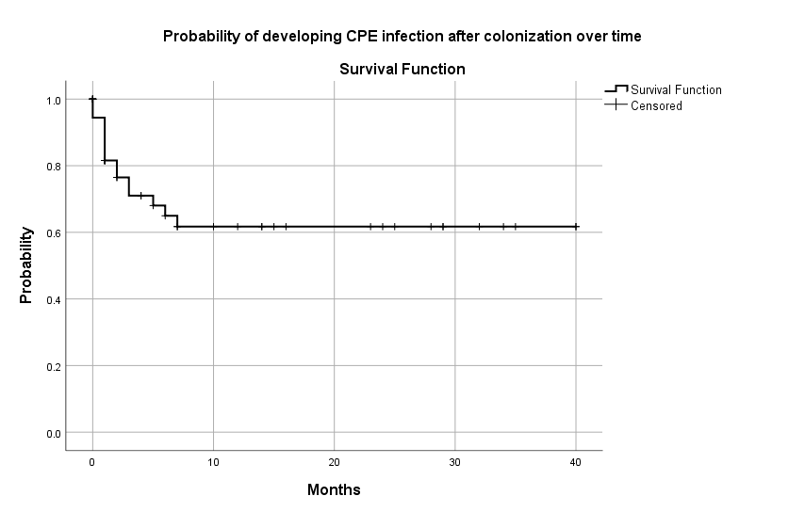
CPE = Carbapenemase-producing Enterobacteriaceae.

