Supplementary Data: Contents

Materials and Methods: Supplementary Data
Inclusion and exclusion criteria | Page 2
MDRO screening protocols
Bioinformatic analysis
Table S1 – Antimicrobial resistance genes included for analysis  Table S2 – Reference genomes used for transmission analysis, and distance to isolates | Page 3  Page 4
Results: Supplementary Data
Table S3 – Reason for sample collection and admission history | Page 6
Table S4 – Medical units, ward types and infection syndromes for MDRO isolates | Page 7
Table S5 – Rates of patient MDRO infection and/or colonization per 100,000 occupied bed days | Page 8
Figure S1 – Epidemiologic connections in the presence and absence of genomic links in patients with bed move data available | Page 9
Figure S2 – Pairwise SNP distribution by species, ST and epidemiology | Page 10
References | Page 11

Material and Methods: Supplementary Data
Inclusion and exclusion criteria
We collected MDROs meeting phenotypic inclusion criteria (see Methods in main text) from hospital inpatients (admitted at least overnight), isolated from patient samples collected either for clinical purposes (suspected infection) or MDRO screening. The first screening isolate of each MDRO species per patient was collected; subsequent screening isolates were excluded. Repeat clinical isolates of the same MDRO species collected within 14 days of a previous clinical isolate were excluded (even from different anatomical sites). If more than one clinical isolate was collected on a single date, the most clinically significant isolate type was included (from highest preference: blood culture, sterile site, non-sterile site, urine, other). Carbapenemase-producing Enterobacterales were excluded, as these were already collected for a comprehensive state-based CPE surveillance program^{1,2}; Acinetobacter and Pseudomonas spp. are not included in this surveillance program, and hence included in this study.

MDRO screening protocols
Additional screening of high-risk wards (ICU, hematology/oncology, transplant wards) was requested for the duration of the pilot study, if not already being performed routinely. No routine screening was performed at subacute hospitals. One hospital network (Network A) conducted a quarterly point-prevalence survey (PPS) during the study period, screening for vanA VRE and multi-resistant Gram negatives (MRGN) via rectal swabs for all hospital inpatients on the day of the survey.

Bioinformatics analysis
Antimicrobial resistance gene (AMR) detection
As described in the Methods (Bioinformatics section), we used the abricate tool to detect a subset of AMR acquired genes (exact matches) from the NCBI Bacterial Antimicrobial Reference Gene database, selected for clinical and epidemiologic relevance (Table S1).

Table S1. Antimicrobial resistance genes included in analysis

Antimicrobial class | Antimicrobial resistance gene family
Aminoglycosides | aac, aph, ant, aad, str, 16S rRNA methyltransferases
ESBL | CTX-M, PER, SFO, VEB  ESBL variants of: GES, OXA, SHV, TEM
ESBL (AmpC) | CMY, DHA, FOX, LAT, MIR, MOX, OCH,
Methicillin resistance | mecA,B,C,D
Trimethoprim | dfr
Fosfomycin | fosA
Macrolides/lincosamides/streptogramins | erm, lnu, lsa, mef, mgt, mph, msr
Fusidic acid | fusB,C,F,H
Colistin | mcr
Mupirocin | mup
Oxazolidinones | optrA, cfr
Quinolones | qnr, qep; oqx (except ESBL-Kp)
Sulfonamides | sul
Tetracycline | tet
Vancomycin | van

Table S2. Reference genomes used for transmission analysis, and distance to isolates
Species | ST | No. isolates in ST | Reference genome | Reference typeª | Reference genome size (bp) | Core alignment length (bp) | Core SNP alignment length without recombination masking (bp) | Core SNP alignment length with recombination masking^{b} (bp) | Median (IQR) SNP distance to reference (bp)^{c}
A. baumannii | ST2 | 2 | AUSMDU00007339 | Draft | 4028009 | 3833873 | 1446 | n/a | 1446
E. coli | ST10 | 10 | NC_000913 | Complete | 4641652 | 4030188 | 20181 | 3458 | 813 (759-867)
E. coli | ST1193 | 8 | CP030111 | Complete | 4939457 | 4701954 | 2167 | 342 | 69 (62-76)
E. coli | ST12 | 2 | AUSMDU00008539 | Draft | 5226611 | 4817512 | 5385 | n/a | 5385
E. coli | ST127 | 3 | NC_008253 | Complete | 4938920 | 4722046 | 6024 | 720 | 716 (715-717)
E. coli | ST131, c1^{d} | 46 | AUSMDU00007306 | Draft | 5127397 | 4495919 | 3810 | 1256 | 112 (80-114)
E. coli | ST131, c2^{d} | 22 | AUSMDU00007449 | Draft | 5251777 | 4450872 | 5386 | 793 | 86 (74-98)
E. coli | ST155 | 2 | CP012380 | Complete | 4847481 | 4328956 | 10198 | n/a | 7079
E. coli | ST1722 | 2 | AUSMDU00008498 | Draft | 4957131 | 4922502 | 5 | n/a | 5
E. coli | ST1727 | 2 | CP015240 | Complete | 4863599 | 4445868 | 4179 | n/a | 2255
E. coli | ST372 | 2 | AUSMDU00034375 | Draft | 4785255 | 4724172 | 26 | n/a | 26
E. coli | ST38 | 15 | CP026723 | Complete | 5041399 | 4364449 | 27314 | 1148 | 333 (327-339)
E. coli | ST393 | 2 | CP018957 | complete | 5056072 | 4841936 | 493 | n/a | 462
E. coli | ST405 | 6 | CP027134 | Complete | 5211570 | 4515380 | 8068 | 699 | 318 (311-325)
E. coli | ST410 | 8 | CP031653 | Complete | 4869482 | 4351815 | 5313 | 604 | 199 (194-204)
E. coli | ST450 | 2 | AUSMDU00007566 | Draft | 5070999 | 4857024 | 1083 | n/a | 1083
E. coli | ST46 | 2 | NC_009800 | Complete | 4697886 | 4113500 | 7900 | n/a | 5605
E. coli | ST648 | 8 | CP023258 | Complete | 5074278 | 4212963 | 26624 | 546 | 118 (114-122)
E. coli | ST69 | 9 | CP030768 | Complete | 5300308 | 4470892 | 18479 | 651 | 154 (143-165)
E. coli | ST73 | 6 | NC_017631 | Complete | 5231428 | 4618836 | 7762 | 1488 | 510 (598-774)
E. coli | ST773 | 3 | AUSMDU00008544 | Draft | 5051728 | 4568525 | 4972 | n/a | 4667 (430-504)
E. coli | ST88 | 2 | CP031546 | Complete | 5184499 | 4383313 | 10087 | n/a | 6180
E. coli | ST963 | 13 | AUSMDU00007336 | Draft | 5142003 | 4954400 | 279 | 279 | 49 (42-56)
E. faecium | ST1421 | 40 | CP027497 | Complete | 2883877 | 2281116 | 2979 | 296 | 158 (144-172)
E. faecium | ST203 | 18 | CP027517 | Complete | 2863087 | 2489508 | 677 | 51 | 12 (8-16)
E. faecium | ST80 | 5 | CP027501 | Complete | 2912017 | 2268758 | 10048 | 549 | 252 (124-380)
K. pneumoniae | ST17 | 4 | CP009461 | Complete | 51188778 | 4840828 | 15039 | 710 | 297 (277-317)
K. pneumoniae | ST307 | 6 | CP025146 | Complete | 5383248 | 5159219 | 259 | 216 | 116 (108-124)
K. pneumoniae | ST323 | 5 | CP024499 | Complete | 5234963 | 5166232 | 32 | 32 | 29 (29-29)
Species | ST | No. isolates in ST | Reference genome | Reference typeª | Reference genome size (bp) | Core alignment length (bp) | Core SNP alignment length without recombination masking (bp) | Core SNP alignment length with recombination masking^{b} (bp) | Median (IQR) SNP distance to reference (bp)^{c}
P. aeruginosa | ST235 | 3 | AUSMDU00008375 | Draft | 7033148 | 6596878 | 2642 | n/a | 1344 (714-1974)
S. aureus | ST1 | 2 | BPH2760 | Complete | 2725223 | 2597811 | 873 | n/a | 704
S. aureus | ST1232 | 2 | AUSMDU00008542 | Draft | 2826231 | 2786893 | 592 | n/a | 592
S. aureus | ST22 | 23 | BPH2900 | Complete | 2823339 | 2548799 | 1837 | n/a | 162 (154-170)
S. aureus | ST239 | 5 | BPH2947 | Complete | 3049603 | 2804912 | 921 | n/a | 187 (152-222)
S. aureus | ST30 | 9 | NC_022113 | Complete | 2756919 | 2567784 | 1860 | n/a | 1165 (1154-1176)
S. aureus | ST45 | 17 | NC_021554 | Complete | 2850503 | 2466557 | 13012 | n/a | 12059 (12045-12073)
S. aureus | ST5 | 6 | BPH2819 | Complete | 2733461 | 2597671 | 2141 | n/a | 767 (719-815)
S. aureus | ST59 | 2 | NC_016928 | Complete | 2850641 | 2696514 | 1044 | n/a | 523
S. aureus | ST6 | 2 | AUSMDU00007481 | Draft | 2821417 | 2723153 | 330 | n/a | 330
S. aureus | ST93 | 9 | NC_017338 | Complete | 2811435 | 2655240 | 549 | n/a | 99 (90-108)
ST, sequence type; bp, base pairs, SNP, single nucleotide polymorphism.
ª If complete genome then only the chromosome was used for mapping and the size of the chromosome is listed in the ‘Reference size’ column, if draft genome then the whole genome (including chromosome and any plasmids present) was used for mapping and the total draft genome size is reflected in the ‘Reference genome size’ column.
^{b} Recombination detecting and masking was performed only for E. coli, E. faecium and K. pneumoniae, and only if there were more than three or more isolates available in the ST (or four or more isolates if one of the isolates was also used as the reference genome); if recombination screening and masking was performed then the median and IQR SNP distance to the reference were based on the recombination-masked core alignment, otherwise it was based on the non-recombination-masked core alignment.
^{c} If the reference genome used was a draft assembly of the earliest local isolate from that ST collection, then this is excluded from the median and IQR calculations. In cases where there were only two isolates, the median value represents the value of mapping the non-reference isolate to the reference isolate and there is no IQR provided.
^{d} c1, clade 1; c2, clade 2.

Results: Supplementary Data

Table S3. Reason for sample collection and admission history
 | Species |  |  |  |  |  | Overall
 | ESBL-Ec | MRSA | vanA VRE | ESBL-Kp | CRPa | CRAb
Reason for sample collection (% of isolates per species)
Suspected infection (clinical isolates) | 97 (45.3%) | 81 (92.0%) | 12 (18.8%) | 14 (45.2%) | 8 (88.9%) | 2 (100%) | 214 (52.5%)
Screening | 117 (54.7%) | 7 (8.0%) | 52 (81.3%) | 17 (54.8%) | 1 (11.1%) | - | 194 (47.5%)
Routine screening | 85 (39.7%) | 7 (8.0%) | 40 (62.5%) | 12 (38.7%) | 1 (11.1%) | - | 145 (35.5%)
Contact screeningª | 1 (0.5%) | - | 4 (6.3%) | - | - | - | 5 (1.2%)
Point-prevalence survey^{b} | 31 (14.5%) | - | 8 (12.5%) | 5 (16.1%) | - | - | 44 (10.8%)
Admitted from (% per species)
Home | 16 (77.7%) | 63 (72.4%) | 52 (81.3%) | 17 (60.7%) | 6 (66.7%) | - | 298 (75.3%)
Aged care facility | 21 (10.2%) | 10 (11.5%) | 4 (6.3%) | 4 (14.3%) | - | - | 39 (9.8%)
Other healthcare facility | 25 (12.1%) | 14 (16.1%) | 8 (12.5%) | 7 (25.0%) | 3 (33.3%) | 2 (100%) | 59 (14.9%)
Admission history in last 12m^{c,d} (% per species)
No admissions last 12m | 46 (24.3%) | 6 (8.7%) | 9 (15.0%) | 2 (6.7%) | 1 (11.1%) | - | 64 (17.9%)
Same healthcare network | 111 (58.7%) | 52 (75.4%) | 41 (68.3%) | 23 (76.7%) | 5 (55.6%) | - | 232 (64.8%)
Other study healthcare network | 12 (6.3%) | 5 (7.2%) | 3 (5.0%) | 1 (3.3%) | 1 (11.1%) | - | 22 (6.1%)
Other non-study healthcare network | 39 (20.6%) | 11 (15.9%) | 12 (20.0%) | 9 (30.0%) | 5 (55.6%) | 1 (100%) | 77 (21.5%)
Abbreviations: ESBL-Ec, extended-spectrum beta-lactamase phenotype E. coli; MRSA, methicillin-resistant S. aureus; vanA VRE, vanA-producing vancomycin-resistant E. faecium; ESBL-Kp, extended-spectrum beta-lactamase phenotype K. pneumoniae; CRPa, carbapenem-resistant P. aeruginosa (also resistant to piperacillin-tazobactam and ceftazidime); CRAb, carbapenem-resistant A. baumannii.
ª Contact screening, screening of room or ward contacts of patient with MDRO for evidence of MDRO colonization, as part of outbreak investigation.
^{b} Point prevalence survey, quarterly screening (by rectal swab) of all available hospital inpatients on single date. Conducted by single healthcare network (Network A) during the study period.
^{c} Admission history (where known) for last 12 months; note, more than one may apply, hence percentages add to more than 100%.
^{d} Comparing no admissions in last 12m vs any admission in last 12m (chi-square test or Fisher exact [if ≤5 in any group]), by species: p=0.049 for vanA VRE vs ESBL-Ec (vanA VRE more likely to have been admitted in last 12m); p=0.006 for ESBL-Kp vs ESBL-Ec (ESBL-Kp more likely to have been admitted in last 12m); p=0.047 for ESBL-Kp vs MRSA (ESBL-Kp more likely to have been admitted in last 12m); other comparisons not statistically significant.

Table S4. Medical units, ward types and infection syndromes for MDRO isolates
 | Species |  |  |  | Overall
 | ESBL-Ec | MRSA | vanA VRE | ESBL-Kp
CLINICAL ISOLATES
Medical unit type (% per species)
Medical (excluding hematology/oncology, transplant) | 44 (45.4%) | 36 (44.4%) | 2 (16.7%) | 3 (21.4%) | 88 (41.1%)
Surgical | 22 (22.7%) | 27 (33.3%) | 3 (25%) | 4 (28.6%) | 59 (27.6%)
Subacute careª | 10 (10.3%) | 6 (7.4%) | 2 (16.7%) | 5 (35.7%) | 25 (11.7%)
Renal Medicine/Liver transplant | 10 (10.3%) | 6 (7.4%) | 4 (33.3%) | 0 (0%) | 22 (10.3%)
Hematology/Oncology | 6 (6.2%) | 5 (6.2%) | 0 (0%) | 0 (0%) | 11 (5.1%)
Other | 5 (5.2%) | 1 (1.2%) | 1 (8.3%) | 2 (14.3%) | 9 (4.2%)
Ward type (% per species)
Other acute wards (excluding high-risk wards) | 72 (74.2%) | 55 (67.5%) | 3 (25%) | 7 (50%) | 140 (65.4%)
Intensive care unit | 4 (4.1%) | 11 (13.6%) | 1 (8.3%) | - | 21 (9.8%)
Subacute care wardsª | 9 (9.3%) | 4 (4.8%) | 2 (16.7%) | 5 (35.7%) | 20 (9.3%)
High-risk wards^{b} | 5 (5.2%) | 4 (4.8%) | 6 (50%) | 1 (7.1%) | 18 (8.4%)
Emergency department | 7 (7.2%) | 7 (8.6%) | - | 1 (7.1%) | 15 (7%)
Infection syndrome^{c} (% of clinical isolates per species)
Urinary tract infection including pyelonephritis | 63 (77.8%) | 4 (5.5%) | 5 (41.7%) | 10 (76.9%) | 82 (43.4%)
Skin/soft tissue infection | 1 (1.2%) | 46 (63%) | 1 (8.3%) | 0 (0%) | 51 (27%)
Sepsis^{d} | 13 (16%) | 8 (11%) | 4 (33.3%) | 2 (15.4%) | 28 (14.8%)
Pneumonia/other respiratory tract infection | 3 (3.7%) | 14 (19.2%) | 2 (16.7%) | 1 (7.7%) | 23 (12.2%)
Intra-abdominal infection | 9 (11.1%) | 1 (1.4%) | 3 (25%) | 1 (7.7%) | 15 (7.9%)
Bone and/or joint infection | 1 (1.2%) | 6 (8.2%) | 0 (0%) | 0 (0%) | 8 (4.2%)
Epidural abscess | 0 (0%) | 2 (2.7%) | 0 (0%) | 0 (0%) | 2 (1.1%)
SCREENING ISOLATES
Medical unit type (% per species)
Medical (excluding hematology/oncology, transplant) | 34 (29.1%) | 3 (42.9%) | 18 (34.6%) | 6 (35.3%) | 61 (31.4%)
Surgical | 35 (29.9%) | 3 (42.9%) | 12 (23.1%) | 3 (17.6%) | 54 (27.8%)
Subacute careª | 20 (17.1%) | - | 6 (11.5%) | 4 (23.5%) | 30 (15.5%)
Renal Medicine/Liver transplant | 12 (10.3%) | 1 (14.3%) | 11 (21.2%) | 1 (5.9%) | 25 (12.9%)
Hematology/Oncology | 16 (13.7%) | - | 5 (9.6%) | 3 (17.6%) | 24 (12.4%)
Ward type (% per species)
Intensive care unit | 34 (29.1%) | 4 (57.1%) | 21 (40.4%) | 1 (5.9%) | 61 (31.4%)
Other acute wards (excluding high-risk wards) | 32 (27.4%) | 2 (42.9%) | 13 (25%) | 9 (52.9%) | 56 (29.4%)
High-risk wards^{b} | 34 (229.1%) | - | 12 (23.1%) | 5 (29.4%) | 51 (26.3%)
Subacute wardsª | 16 (13.7%) | - | 6 (11.5%) | 2 (11.8%) | 26 (12.4%)
Emergency department | 1 (0.9%) | - | - | - | 1 (0.5%)
Abbreviations: ESBL-Ec, extended-spectrum beta-lactamase phenotype E. coli; MRSA, methicillin-resistant S. aureus; vanA VRE, vanA-producing vancomycin-resistant E. faecium; ESBL-Kp, extended-spectrum beta-lactamase phenotype K. pneumoniae, MDRO; multidrug-resistant organism.
ª Subacute care, includes aged care, rehabilitation, palliative care and spinal medical teams and wards.
^{b} High-risk wards, includes hematology, oncology, renal ward (including renal transplant), and liver transplant wards.
^{c} Infection syndrome (where known); note, 4 patients had 2 infection syndromes selected.
^{d} Sepsis category - includes endocarditis, other endovascular infection, line-related infection and febrile neutropenia.

Table S5. Rates of patient MDRO infection and/or colonization per 100,000 occupied bed daysª
 | Species
 | ESBL-Ec | MRSA | vanA VRE | ESBL-Kp | CRPa | CRAb | Overall
All wards
MDRO infections | 50.0 | 42.9 | 4.8 | 6.3 | 3.2 | 0.0 | 107.1
MDRO colonization | 112.7 | 25.4 | 42.9 | 17.5 | 3.2 | 1.6 | 203.2
Total burden | 152.4 | 66.7 | 44.4 | 23.0 | 6.3 | 1.6 | 294.5
Clinical isolates | 77.0 | 64.3 | 9.5 | 11.1 | 6.3 | 1.6 | 169.8
Blood cultures | 7.9 | 5.6 | 3.2 | 1.6 | - | - | 18.3
High-risk wards & ICU ^{b}
MDRO infections | 50.4 | 63.0 | 18.9 | 6.3 | 12.6 | 0.0 | 151.1
MDRO colonization | 421.9 | 50.4 | 226.7 | 37.8 | 25.2 | 12.6 | 774.5
Total burden | 453.3 | 107.0 | 245.6 | 44.1 | 37.8 | 12.6 | 900.4
Abbreviations: ESBL-Ec, extended-spectrum beta-lactamase phenotype E. coli; MRSA, methicillin-resistant S. aureus; vanA VRE, vanA-producing vancomycin-resistant E. faecium; ESBL-Kp, extended-spectrum beta-lactamase phenotype K. pneumoniae; CRPa, carbapenem-resistant P. aeruginosa (also resistant to piperacillin-tazobactam and ceftazidime); CRAb, carbapenem-resistant A. baumannii; MDRO, multidrug-resistant organism.
ª Occupied bed days - number of patients admitted overnight (excluding mental health and hospital-in-the-home services).
^{b} High-risk wards, includes hematology, oncology, renal ward (including renal transplant), and liver transplant wards; ICU, intensive care unit.
Note: Total burden less than infection + colonization as duplicates excluded.

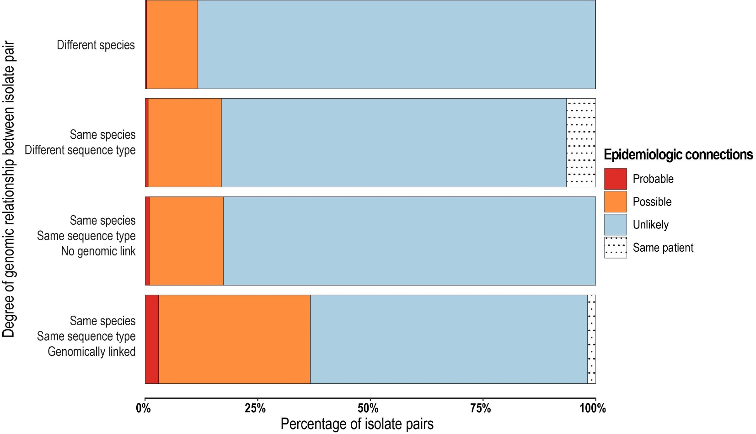
Figure S1. Epidemiologic connections in the presence and absence of genomic links in patients with bed move data available
Figure shows extent of epidemiologic connections in the presence of genomic links (bottom bar; a pair of isolates of same species, same ST and below the screening SNP threshold) and the absence of genomic links (top three bars; different species, different ST, or same species and ST but above the screening SNP threshold). Note that epidemiologic (bed move) data were only collected for patients with at least one isolate with genomic links (n=113 patients), therefore this dataset may be biased (n=245 patients without any genomic links did not have bed move data collected).
Definitions of epidemiologic links: Probable, patients admitted to same ward at the same time; Possible, patients admitted to same hospital at same time, or same ward within 60 days (but without overlapping stays); Unlikely, all other patients outside these definitions; Same patient, isolates from same patient at different times.
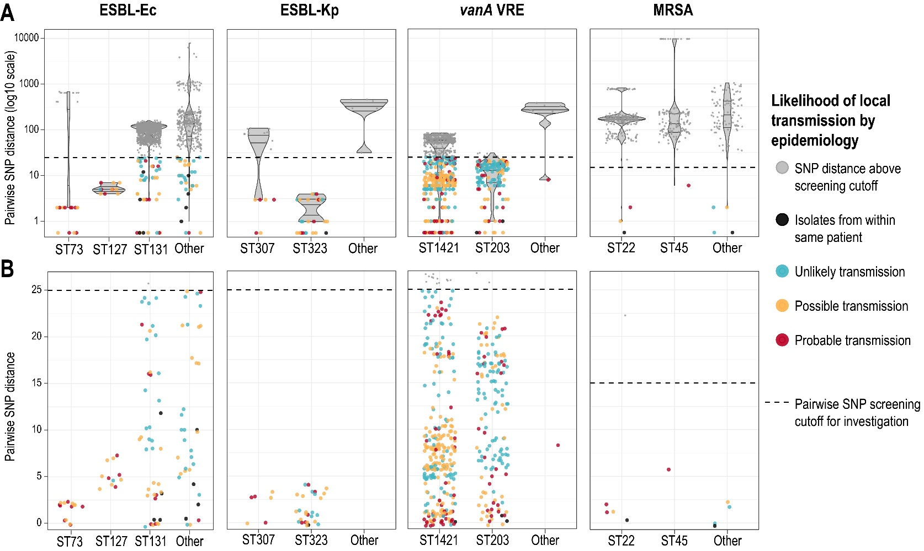
Figure S2. Pairwise SNP distribution by species, ST and epidemiology

Panel A: overall view of pairwise SNP distances for each species, grouped by most common sequence types (ST), and other STs (note: log₁₀ scale).
Panel B: zoomed-in view of pairwise SNP distances for each species (linear scale). Dotted line represents transmission screening threshold of ≤15 SNPs for MRSA, and ≤25 SNPs for other species; bed movement data was only collected for patients with at least one isolate below this threshold. Each dot represents a pair of isolates; dots are colored by likelihood of local transmission based on epidemiologic data (grey represents where no data collected as all pairwise SNP distances were above the transmission screening threshold).
Abbreviations: ESBL-Ec, extended-spectrum beta-lactamase phenotype E. coli; MRSA, methicillin-resistant S. aureus; vanA VRE, vanA-producing vancomycin-resistant E. faecium; ESBL-Kp, extended-spectrum beta-lactamase phenotype K. pneumoniae.

References

1. Sherry NL, Lane CR, Kwong JC, et al. Genomics for molecular epidemiology and detecting transmission of carbapenemase-producing Enterobacterales in Victoria, Australia, 2012 to 2016. Journal of Clinical Microbiology 2019;57.
2. Department of Health and Human Services Victoria. Victorian guideline on carbapenemase-producing Enterobacteriaceae for health services (version 2.1). In: Department of Communicable Disease Prevention and Control, ed. Melbourne: Victorian Government; 2018.

