Supplementary Figures
Supplementary Figure 1. Symptoms of study participants within 3 weeks before baseline, by result of serology tests.
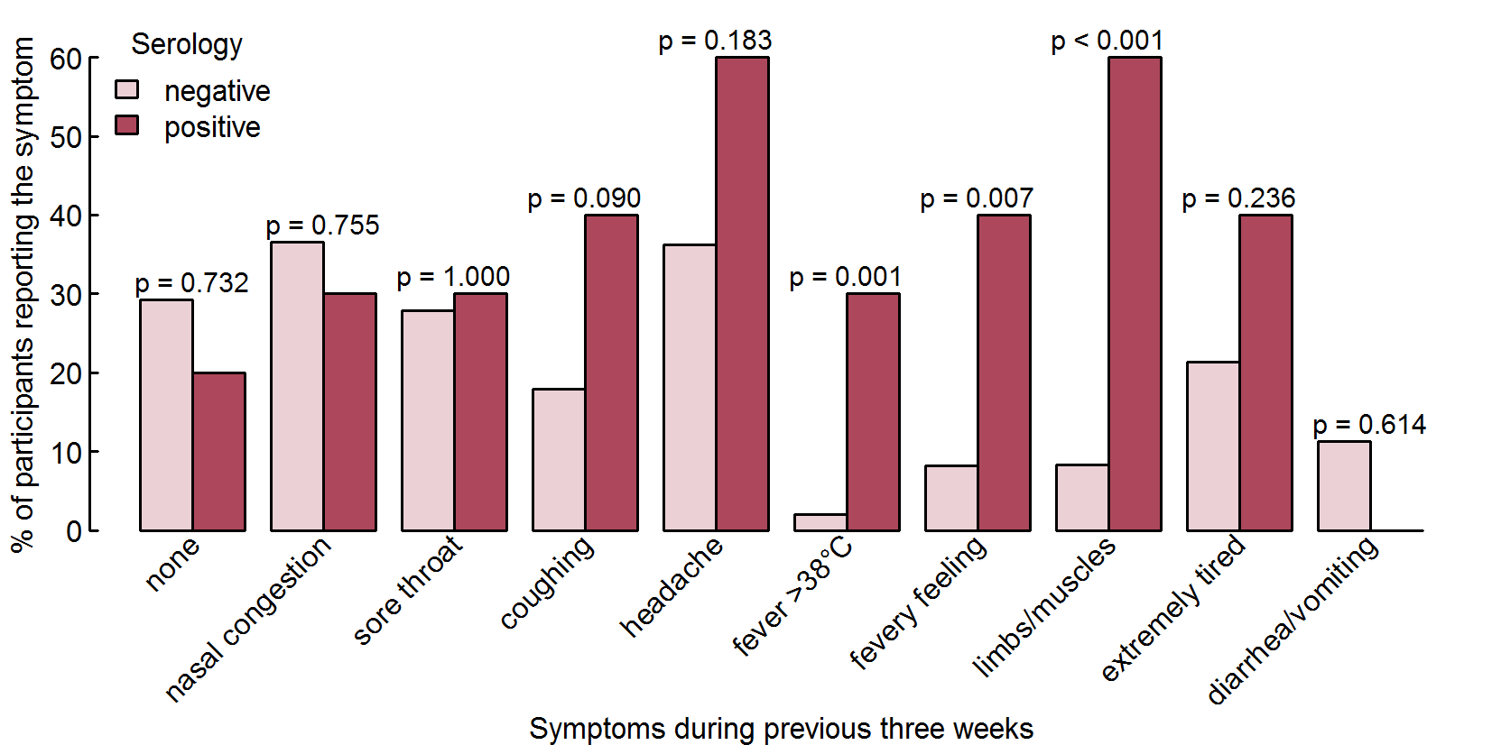

Supplementary Figure 2. Symptoms of participants with true and false positive serology within 3 weeks before baseline serology.

