Appendix 1. Search Methods

Search strategies were developed with the assistance of a health sciences librarian with expertise in searching for systematic reviews. Searches were developed by the librarian and authors using an iterative process of gathering/evaluating terms, as well as testing search strategies to ensure adequate sensitivity. Searches were finalized in July 2019. Comprehensive strategies, including both index and keyword methods, were devised for the following databases: PubMed, CINAHL (Cumulative Index for Nursing Allied Health Literature, EBSCO platform), and Embase (Elsevier platform). In order to maximize sensitivity, no pre-established database filters were used. The full PubMed search strategy, as detailed below, was adapted for use with the other electronic databases. Complete search strategies are available upon request.

PubMed strategy 7/26/19
#1
"Bacterial Infections/drug therapy"[Mesh] OR "Anti-Bacterial Agents"[Mesh] OR "Anti-Bacterial Agents" [Pharmacological Action]
OR
Antimicrobial [Title/Abstract] OR Antimicrobials [Title/Abstract] OR Anti bacterial [Title/Abstract] OR Antibacterials [Title/Abstract] OR Anti bacterials [Title/Abstract] OR Antibacterial [Title/Abstract] OR Microbicides[Title/Abstract] OR antibiotic [Title/Abstract] OR antibiotics [Title/Abstract]

#2
"Death"[Mesh OR "Prognosis"[Mesh] OR "Survival Rate"[Mesh] OR "adverse effects" [Subheading] OR "Mortality"[Mesh] OR "Treatment Outcome"[Mesh] OR "Clostridium difficile"[Mesh] OR "Drug-Related Side Effects and Adverse Reactions"[Mesh] OR "Acute Kidney Injury"[Mesh] OR “Pharmacovigilance”[Mesh]
OR
reduction [Title/Abstract] OR pharmacovigilance [Title/Abstract] OR antibiotic use [Title/Abstract] OR antimicrobial use [Title/Abstract] OR stewardship [Title/Abstract] OR Outcome [Title/Abstract] OR outcomes [Title/Abstract] OR survival [Title/Abstract] OR death [Title/Abstract] OR mortality [Title/Abstract] OR prognosis [Title/Abstract] OR adverse [Title/Abstract] OR symptom relief [Title/Abstract] OR clostridium difficile [Title/Abstract] OR c diff [Title/Abstract] OR drug side effect[Title/Abstract] OR drug side effects[Title/Abstract] OR drug toxicity[Title/Abstract] OR drug toxicities[Title/Abstract] OR acute kidney injury [Title/Abstract] OR acute kidney injuries [Title/Abstract] OR acute kidney failure [Title/Abstract] OR acute renal injury [Title/Abstract] OR acute renal injuries [Title/Abstract] OR acute renal failure [Title/Abstract] OR acute renal insufficiency [Title/Abstract]
#3
"Hospice Care"[Mesh] OR "Palliative Care"[Mesh] OR "Terminal Care"[Mesh] OR "Hospices"[Mesh]
OR
(End stage [Title/Abstract] OR advanced [Title/Abstract] OR terminal [Title/Abstract] OR terminally [Title/Abstract] or last days [Title/Abstract] or patient comfort [Title/Abstract] OR palliative [Title/Abstract] OR DNR [Title/Abstract] OR resuscitate[Title/Abstract]) AND (cancer [Title/Abstract] OR neoplasm [Title/Abstract] OR neoplasms [Title/Abstract] OR dementia [Title/Abstract] OR heart failure [Title/Abstract] OR alzheimer [Title/Abstract] OR alzheimers [Title/Abstract] OR multiple organ failure [Title/Abstract] OR frailty [Title/Abstract])
OR
terminally ill [Title/Abstract] OR terminal illness [Title/Abstract] OR hospice [Title/Abstract] OR end of life [Title/Abstract] OR palliative care [Title/Abstract] OR comfort care [Title/Abstract] OR metastatic [Title/Abstract] OR advanced disease [Title/Abstract] OR advanced illness [Title/Abstract]

#4
"Letter" [Publication Type] OR "Comment" [Publication Type] OR "Editorial" [Publication Type] OR "Review" [Publication Type]

(#1 AND #2 AND #3) NOT #4= 3184

CINAHL 7/26/19

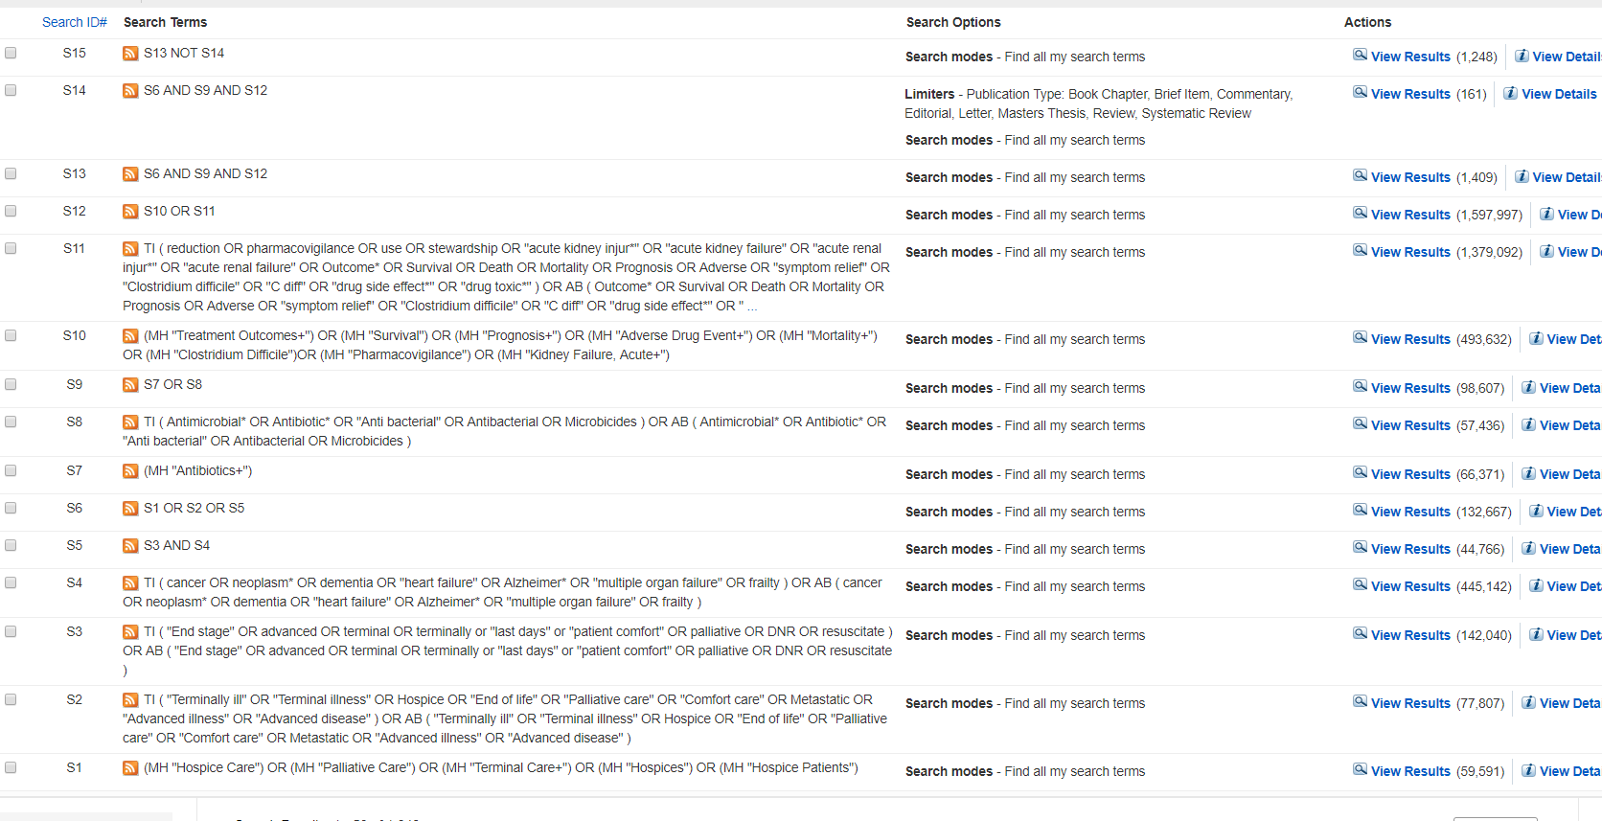
Embase 7/26/19

#1
'hospice patient'/exp OR 'terminally ill patient'/exp OR 'hospice'/exp OR 'terminal care'/exp OR 'palliative therapy'/exp
AND
'bacterial infection'/exp/dm_dt OR 'antibacterial activity'/exp OR 'antibiotic agent'/exp
AND
'acute kidney failure'/exp OR 'clostridium difficile infection'/exp OR 'mortality'/exp OR 'prognosis'/exp OR 'adverse drug reaction'/exp OR 'pharmacovigilance'/exp

#2
'terminally ill':ab,ti OR 'terminal illness':ab,ti OR hospice:ab,ti OR 'end of life':ab,ti OR 'palliative care':ab,ti OR 'comfort care':ab,ti OR metastatic:ab,ti OR 'advanced illness':ab,ti OR 'advanced disease':ab,ti
OR
(('end stage' OR advanced OR terminal OR terminally OR 'last days' OR 'patient comfort' OR palliative OR dnr OR resuscitate) NEAR/3 (cancer OR neoplasm OR neoplasms OR dementia OR 'heart failure' OR alzheimer OR alzheimers OR 'multiple organ failure' OR frailty)):ab,ti

AND
antimicrobrial*:ab,ti OR antibiotic*:ab,ti OR 'anti bacterial*':ab,ti OR antibacterial*:ab,ti OR microbicides:ab,ti
AND
reduction:ab,ti OR pharmacovigilance:ab,ti OR use:ab,ti OR stewardship:ab,ti OR outcome*:ab,ti OR survival:ab,ti OR death:ab,ti OR mortality:ab,ti OR prognosis:ab,ti OR 'adverse reaction':ab,ti OR 'adverse drug':ab,ti OR 'symptom relief':ab,ti OR 'clostridium difficile':ab,ti OR 'c diff':ab,ti OR 'acute kidney injur*':ab,ti OR 'acute renal insufficiency':ab,ti OR 'acute renal injur*':ab,ti OR 'acute renal failure':ab,ti OR 'acute kidney failure':ab,ti OR 'drug side effect*':ab,ti OR 'drug toxic*':ab,ti

#3
'editorial'/it OR 'letter'/it OR 'note'/it OR 'review'/it
#1 OR #2 NOT #3= 3842

 | Advanced dementia studies |  | Cancer  studies |  | Mixed population studies
Subgroups | No. of studies | No. of  advanced dementia patients (%) | No. of studies | No. of  advanced cancer patients (%) | No. of studies | No. of  patients (%)
All studies | 17 | 2,501 | 22 | 35,239 | 33 | 13,028
Alzheimer’s disease | 5 | 698 (27.9) | - | - | - | -
Any type of dementia | 12 | 1,803 (72.1) | - | - | 11 | -
Any type of cancer | - | - | 16 | 4,707 (13.4) | 21 | -
RCTs | 1 | 99 (4.0) | - | - | 1 | 132 (1.0)
Prospective cohort study | 9 | 1,203 (48.1) | 4 | 2,087 (5.9) | 3 | 164 (1.3)
Retrospective cohort study | 7 | 1,199 (47.9) | 18 | 33,152 (94.1) | 27 | 11,587 (88.9)
Cross-sectional study | - | - | - | - | 2 | 1,145 (8.8)
Palliative care | 5 | 498 (19.9) | 17 | 4,332 (12.3) | 25 | 7,607 (58.4)
Not reported the duration of antimicrobial therapy | 15 | - | 16 | - | 26 | -
Not reported the outcome measured after antibiotic use (survival or comfort) | 11 | 1,437 (57.5) | 10 | 31,440 (89.2) | 25 | 9,260 (71.1)
Risk of bias (D&B score) ≥18 points of the 28 (%) | 9 | (52.9%) | 3 | (13.6%) | 5 | (15.2%)
Appendix 2. Summary of included studies in the systematic literature review

RCT: randomized clinical trial; D&B: Downs&Black

