COMMUNITY CENTRAL LINE INFECTION PREVENTION (CCLIP) Trial
SUPPLEMENT B

CONTENTS

Table B1. Site ENROLLMENT periods and IRB
APPROVAL 2
Figure B1. BESt practice central line maintenance
bundle 3
figure b2. when and how to use 3m curos caps at home……...………....4
Figure b3. CCLIP ambulatory cl days worksheet…………………………...5
Table b2. OutcomeS by site 6-7
table B3. sensitivity analysis for per protocol
analysis 8
Figure B4. Crude incidence of any positive blood culture 9-10
table B4. microorganism isolated from patients
with CLABSI or any positive blood culture 11-12

Table B1. Site Enrollment Periods and IRB Approval Specifications for Consent
Site | Period 1 | Start Date | Period 2 | Start Date | IRB Approval Category
Akron Children’s Hospital | Intervention | 11/01/15 | Control | 01/01/17 | Waiver of Consent With Documentation
Children’s of Alabama | Control | 11/01/15 | Intervention | 11/01/16 | Waiver of Documentation of Consent
Arkansas Children’s Hospital | Control | 11/01/15 | Intervention | 11/01/16 | Determined not human subject research
Children’s Hospital Colorado | Intervention | 11/01/15 | Control | 01/01/17 | Waiver of Consent With Documentation
Doernbecher Children’s Hospital at Oregon Health & Science University | Intervention | 11/01/15 | Control | 01/01/17 | Waiver of Documentation of Consent
Johns Hopkins Children’s Hospital | Intervention | 11/01/15 | Control | 01/01/17 | Waiver of Consent With Documentation
Children’s Hospital of Michigan | Control | 11/01/15 | Intervention | 02/01/17 | Written Consent
Minnesota ^{A} |  |  |  |  | Written Consent
The Children’s Hospital at Montefiore ^{B} | Intervention | 04/01/16 | Control | 06/01/17 | Written Consent for Participation and Data Use
MUSC Children’s Hospital | Control | 11/01/15 | Intervention | 11/01/16 | Waiver of Consent
Nationwide ^{C} | Control | 11/01/15 | Intervention | 11/01/16 | Waiver of Documentation of Consent
Nemours/Alfred DuPont Hospital for Children | Intervention | 11/01/15 | Control | 01/01/17 | Written Consent
Norton Children’s Hospital | Intervention | 11/01/15 | Control | 01/01/17 | Waiver of Consent
UF Health Shands Children’s Hospital | Control | 11/01/15 | Intervention | 11/01/16 | Waiver of Documentation of Consent
St. Louis Children’s Hospital | Control | 01/01/16 | Intervention | 01/01/17 | Waiver of Consent
Texas Children’s Hospital  (Heme/Onc) | Intervention | 03/01/16 | Control | 05/01/17 | Waiver of Documentation of Consent
Texas Children’s Hospital  (BMT) | Intervention | 03/01/16 | Control | 05/01/17 | Waiver of Documentation of Consent
^{A} Minnesota withdrew as they used caps in ambulatory setting before the trial started and were unable to enroll patients into the trial
^{B} Used SwabcapTM prior to trial, but started in Intervention arm so just kept using the caps.
^{C} Used CurosTM cap prior to trial, but stopped using caps in ambulatory setting one month before trial started

Figure B1. Best Practice Central Line Maintenance Care Bundle
Maintenance Bundle
1. Daily assessment whether central line is needed
2. Central line Site Care
a) No iodine ointment
b) CHG scrub to site with dressing changes (30 second scrub, 30 second air dry)
c) Change gauze dressings every 2 days; unless soiled, dampened, loosened (CDC recommended)
d) Change clear dressing every 7 days; unless soiled, dampened, loosened (CDC recommended)

e) Prepackaged dressing change kit
3. Central line Hub / Cap / Tubing Care
a) Replace administration sets and add on devices at 72 hours, unless soiled or suspected infection
b) Replace tubing used to administer blood, blood products, or lipids at 24 hours (CDC recommended)
c) Change caps at 72 hours and should be replaced with administration set (CDC recommended)
d) Prepackaged Cap Change Kit/Cart/Central Location

Figure B2. When and How to Use 3M Curos Caps at Home
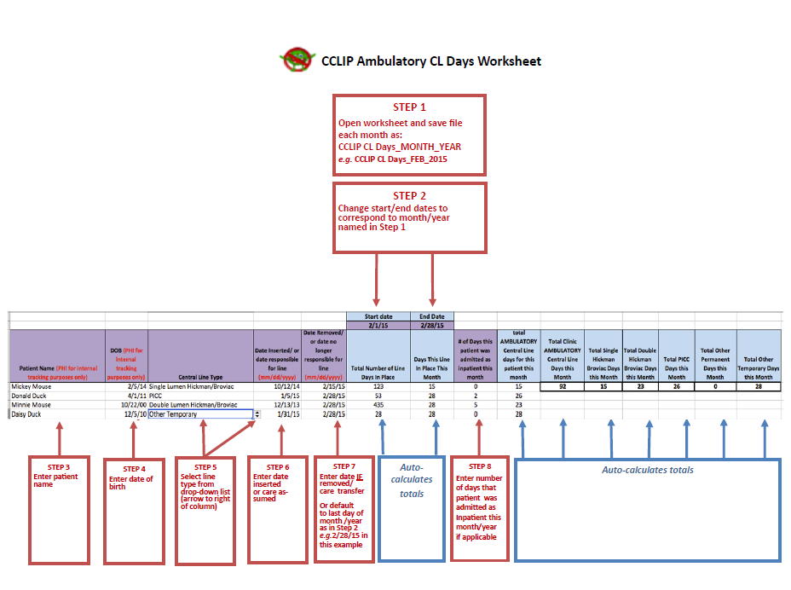
Figure B3. CCLIP Ambulatory CL Days Worksheet instructions
Table B2. Outcomes by site for intent to treat and per protocol analyses
 | Intent to treat CLABSI |  |  |  | Intent to treat Any Positive Culture
Site | Intervention Rate  (events/line days) | Control Rate  (events/line days) | Absolute Change | Relative Change  (95% CI) | Intervention Rate  (events/line days) | Control Rate  (events/line days) | Absolute Change  (95% CI) | Relative Change  (95% CI)
1 | 0.27  (1/3671) | 0.62  (2/3239) | -0.35  (-1.35, 0.66) | 0.44  (0.007, 8.47) | 0.27  (1/3671) | 0.93  (3/3239) | -0.65  (-1.83, 0.52) | 0.29  (0.006, 3.66)
2 | 1.53  (1/655) | 0.00  (0/143) | 1.53  (-1.47, 4.52) | 0.00  (-) | 10.69  (7/655) | 0.00  (0/143) | 10.69  (2.77, 18.6) | 0.00  (-)
3 | 2.30  (14 /6092) | 1.65  (10/6075) | 0.65  (-0.93, 2.23) | 1.40  (0.58, 3.51) | 2.79  (17/6092) | 1.65  (10/6075) | 1.14  (-0.53, 2.82) | 1.70  (0.73, 4.14)
4 | 0.62  (2/3203) | 0.60  (3/5027) | 0.03  (-1.07, 1.13) | 1.05  (0.09, 9.13) | 0.94  (3/3203) | 1.79  (9/5027) | -0.85  (-2.43, 0.72) | 0.52  (0.09, 2.10)
5 | 0.87  (12/13807) | 1.12  (15/13438) | -0.25  (-1.0, 0.5) | 0.78  (0.33, 1.78) | 1.88  (26/13807) | 2.31  (31/13438) | -0.42  (-1.51, 0.66) | 0.82  (0.47, 1.42)
6 | 1.19  (5/4199) | 1.95  (13/6664) | -0.76  (-2.25, 0.73) | 0.61  (0.17, 1.82) | 1.19  (5/4199) | 3.60  (24/6664) | -2.41  (-4.19, -0.63) | 0.33  (0.10, 0.88)
7 | 2.03  (23/11326) | 0.98  (7/7143) | 1.05  (-0.05, 2.15) | 2.07  (0.86, 5.72) | 3.00  (34/11326) | 1.96  (14/7143) | 1.04  (-0.40, 2.48) | 1.53  (0.80, 3.09)
8 | 1.45  (9/6192) | 2.17  (14/6442) | -0.72  (-2.20, 0.76) | 0.67  (0.26, 1.66) | 2.26  (14/6192) | 2.79  (18/6442) | -0.53  (-2.29, 1.22) | 0.81  (0.37, 1.72)
9 | 0.61  (4/6549) | 0.56  (5/8892) | 0.05  (-0.73, 0.82) | 1.09  (0.22, 5.05) | 0.61  (4/6549) | 0.67  (6/8892) | -0.06  (-0.87, 0.74) | 0.91  (0.19, 3.82)
10 | 1.47  (14/9495) | 1.91  (19/9949) | -0.44  (-1.59, 0.72) | 0.77  (0.36, 1.62) | 3.05  (29/9495) | 2.91  (29/9949) | 0.14  (-1.40, 1.68) | 1.05  (0.60, 1.82)
11 | 0.91  (8/8836) | 2.17  (20/9208) | -1.27  (-2.41, -0.13) | 0.42  (0.16, 0.99) | 0.91  (8/8836) | 2.28  (21/9208) | -1.38  (-2.54, -0.22) | 0.40  (0.15, 0.93)
12 | 0.36  (1/2767) | 0.40  (1/2515) | -0.04  (-1.09, 1.02) | 0.91  (0.01, 71.35) | 0.36  (1/2767) | 0.40  (1/2515) | -0.04  (-1.09, 1.02) | 0.91  (0.01, 71.35)
13 | 1.62  (4/2467) | 0.89  (2/2244) | 0.73  (-1.28, 2.74) | 1.82  (0.26, 20.11) | 3.65  (9/2467) | 1.78  (4/2244) | 1.87  (-1.09, 4.82) | 2.05  (0.57, 9.09)
14 | 0.00  (0/1004) | 0.00  (0/0) | 0.00  (-) | 0.00  (-) | 0.00  (0/1004) | 0.00  (0/0) | 0.00  (-) | 0.00  (-)
15 | 1.61  (4/2479) | 3.95  (2/506) | -2.34  (-8.04, 3.36) | 0.41  (0.06, 4.52) | 1.61  (4/2479) | 7.91  (4/506) | -6.29  (-14.2, 1.62) | 0.20  (0.04, 1.10)
16 | 1.16  (7/6050) | 1.33  (10/7541) | -0.17  (-1.36, 1.02) | 0.87  (0.28, 2.54) | 1.32  (8/6050) | 1.59  (12/7541) | -0.27  (-1.55, 1.02) | 0.83  (0.29, 2.21)

 | Per Protocol CLABSI |  |  |  | Per Protocol Any Positive Culture
 | Per Protocol CLABSI Rate: Intervention  (events/line days) | Per Protocol CLABSI Rate: Control  (events/line days) | Absolute Change | Relative Change | Per Protocol All Infection Rate: Intervention  (events/line days) | Per Protocol All Infection Rate: Control  (events/line days) | Absolute Change | Relative Change
1 | 0.27  (1/3671) | 0.62  (2/3239) | -0.35  (-1.35, 0.66) | 0.44  (0.007, 8.47) | 0.27  (1/3671) | 0.93  (3/3239) | -0.65  (-1.83, 0.52) | 0.29  (0.006, 3.66)
2 | 1.53  (1/655) | 0.00  (0/143) | 1.53  (-1.47, 4.52) | 0.00  (-) | 10.69  (7/655) | 0.00  (0/143) | 10.69  (2.77, 18.60) | 0.00  (-)
3 | 1.64  (10/6092) | 1.65  (10/6075) | 0.00  (-1.45, 1.44) | 1.00  (0.37, 2.67) | 2.13  (13/6092) | 1.65  (10/6075) | 0.49  (-1.06, 2.03) | 1.30  (0.53, 3.30)
4 | 0.62  (2/3203) | 0.60  (3/5027) | 0.03  (-1.07, 1.13) | 1.05  (0.09, 9.13) | 0.94  (3/3203) | 1.79  (9/5027) | -0.85  (-2.43, 0.72) | 0.52  (0.09, 2.10)
5 | 0.65  (9/13807) | 1.04  (14/13438) | -0.39  (-1.08, 0.30) | 0.63  (0.24, 1.55) | 1.67  (23/13807) | 2.16  (29/13438) | -0.49  (-1.53, 0.55) | 0.77  (0.43, 1.38)
6 | 1.19  (5/4199) | 1.65  (11/6664) | -0.46  (-1.89, 0.97) | 0.72  (0.20, 2.25) | 1.19  (5/4199) | 3.15  (21/6664) | -1.96  (-3.67, -0.26) | 0.38  (0.11, 1.03)
7 | 1.59  (18/11326) | 0.98  (7/7143) | 0.61  (-0.42, 1.64) | 1.62  (0.65, 4.59) | 2.30  (26/11326) | 1.40  (10/7143) | 0.90  (-0.34, 2.13) | 1.64  (0.77, 3.81)
8 | 1.29  (8/6192) | 2.17  (14/6442) | -0.88  (-2.33, 0.57) | 0.59  (0.22, 1.52) | 1.94  (12/6192) | 2.79  (18/6442) | -0.86  (-2.55, 0.84) | 0.69  (0.30, 1.52)
9 | 0.61  (4/6549) | 0.22  (2/8892) | 0.39  (-0.29, 1.07) | 2.72  (0.39, 30.02) | 0.61  (4/6549) | 0.34  (3/8892) | 0.27  (-0.44, 0.98) | 1.81  (0.31, 12.36)
10 | 1.05  (10/9495) | 1.71  (17/9949) | -0.66  (-1.70, 0.39) | 0.62  (0.25, 1.43) | 2.00  (19/9495) | 2.51  (25/9949) | -0.51  (-1.85, 0.82) | 0.80  (0.41, 1.51)
11 | 0.45  (4/8836) | 2.17  (20/9208) | -1.72  (-2.77, -0.67) | 0.21  (0.05, 0.62) | 0.45  (4/8836) | 2.28  (21/9208) | -1.83  (-2.90, -0.76) | 0.20  (0.05, 0.59)
12 | 0.36  (1/2767) | 0.40  (1/2515) | -0.04  (-1.09, 1.02) | 0.91  (0.01, 71.35) | 0.36  (1/2767) | 0.40  (1/2515) | -0.04  (-1.09, 1.02) | 0.91  (0.01, 71.35)
13 | 1.22  (3/2467) | 0.89  (2/2244) | 0.32  (-1.52, 2.17) | 1.36  (0.16, 16.34) | 2.84  (7/2467) | 1.78  (4/2244) | 1.05  (-1.68, 3.79) | 1.59  (0.40, 7.42)
14 | 0.00  (0/1004) | 0.00  (0/0) | 0.00  (-) | 0.00  (-) | 0.00  (0/1004) | 0.00  (0/0) | 0.00  (-) | 0.00  (-)
15 | 1.61  (4/2479) | 0.00  (0/506) | 1.61  (0.03, 3.19) | 0.00  (-) | 1.61  (4/2479) | 1.98  (1/506) | -0.36  (-4.55, 3.82) | 0.82  (0.08, 40.21)
16 | 0.66  (4/6050) | 1.33  (10/7541) | -0.66  (-1.71, 0.38) | 0.50 | 0.83  (5/6050) | 1.59  (12/7541) | -0.76  (-1.92, 0.39) | 0.52  (0.14, 1.58)

Table B3. Per Protocol Sensitivity Analysis for Primary (CLABSI) and Secondary (MBI, SBSI, SPBC, Any positive blood culture) Outcomes
 | Events in Control Clinics | Events in Treatment Clinics | Crude Control IR per 1000  at-risk days  (95%CI) | Crude Treatment IR per 1000  at-risk days  (95%CI) | Crude IRR  (95% CI) | p-value |  | Adjusted IRR  (95% CI) | p-value
NOTE: removed 15 days from the denominator for the site and month when exceptions occurred
CLABSI | 113 | 84 | 1.27  (0.96 to 1.69) | 0.95  (0.72 to 1.26) | 0.73*  (0.50 to 1.07) | 0.11 |  | 0.71  (0.49 to 1.04) | 0.08
MBI | 14 | 8 | 0.16  (0.06 to 0.39) | 0.09  (0.04 to 0.20) | 0.52  (0.19 to 1.46) | 0.21 |  | 0.48  (0.15 to 1.59) | 0.23
Secondary BSI | 11 | 0 | 0.12  (0.06 to 0.26) | 0 | 0 | - |  | - | -
Single positive blood culture | 29 | 42 | 0.33  (0.19 to 0.57) | 0.47  (0.28 to 0.80) | 1.39*, **  (0.76 to 2.57) | 0.29 |  | 1.35  (0.73 to 2.49) | 0.34
Any positive blood culture (includes CLABSI, MBI, SBSI, SPBC) | 167 | 134 | 1.88  (1.47 to 2.40) | 1.52  (1.14 to 2.02) | 0.75*  (0.53 to 1.06) | 0.10 |  | 0.72  (0.52 to 1.00) | 0.05
NOTE: removed 30 days from the denominator for the site and month when exceptions occurred
CLABSI | 113 | 84 | 1.27  (0.96 to 1.69) | 0.95  (0.72 to 1.26) | 0.73*  (0.50 to 1.07) |  | 0.11 | 0.71  (0.49 to 1.04) | 0.08
MBI | 14 | 8 | 0.16  (0.06 to 0.39) | 0.09  (0.04 to 0.20) | 0.52  (0.19 to 1.46) |  | 0.22 | 0.48  (0.15 to 1.60) | 0.23
Secondary BSI | 11 | 0 | 0.12  (0.06 to 0.26) | 0 | 0 |  | - | - | -
Single positive blood culture | 29 | 42 | 0.33  (0.19 to 0.57) | 0.47  (0.28 to 0.80) | 1.39*, **  (0.76 to 2.57) |  | 0.29 | 1.35  (0.73 to 2.49) | 0.33
Any positive blood culture (includes CLABSI, MBI, SBSI, SPBC) | 167 | 134 | 1.89  (1.48 to 2.41) | 1.53  (1.15 to 2.03) | 0.75*  (0.53 to 1.07) |  | 0.11 | 0.72  (0.52 to 1.00) | 0.05
IR – Incidence rate; IRR – Incidence rate ratio
CVC – central venous catheter
Figure B4. Crude incidence of any positive blood culture. Each line represents one clinic. The slope shows the change in incidence of any positive blood culture between the intervention and control periods. The red line represents the change in overall crude incidence during treatment and control periods. Black lines represent clinics that had a decrease in any positive blood culture during the intervention period and blue lines represent clinics that did not have a decrease in any positive blood culture during intervention periods. Arrows indicate the assignment change from period one to period two, such that an arrow pointing to the intervention side indicates that the unit was assigned to control in period 1 and crossed over to intervention in period 2.
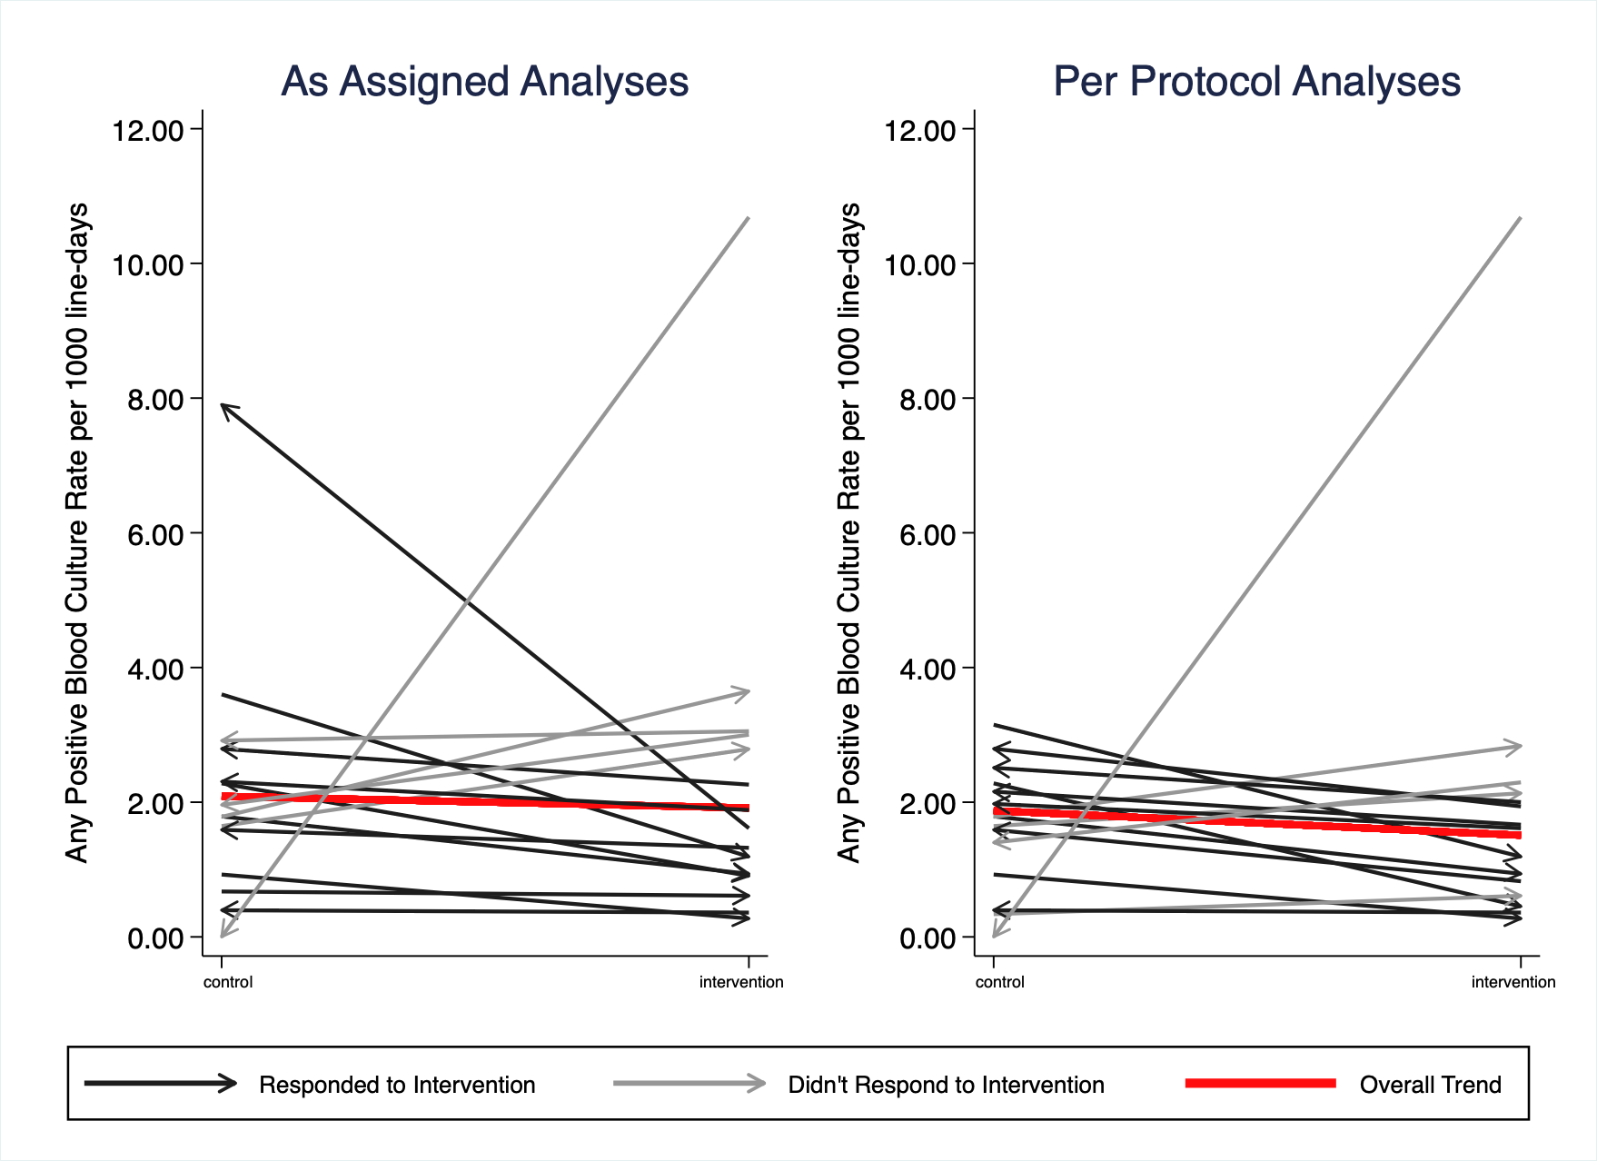

Figure B4a. Crude incidence of any positive blood culture excluding the two sites from Figure B4 with rates greater than 4 per 1,000 line-days. Each line represents one clinic. The slope shows the change in incidence of any positive blood culture between the intervention and control periods. The red line represents the change in overall crude incidence during treatment and control periods. Black lines represent clinics that had a decrease in any positive blood culture during the intervention period and gray lines represent clinics that did not have a decrease in any positive blood culture during intervention periods. Arrows indicate the assignment change from period one to period two, such that an arrow pointing to the intervention side indicates that the unit was assigned to control in period 1 and crossed over to intervention in period 2.
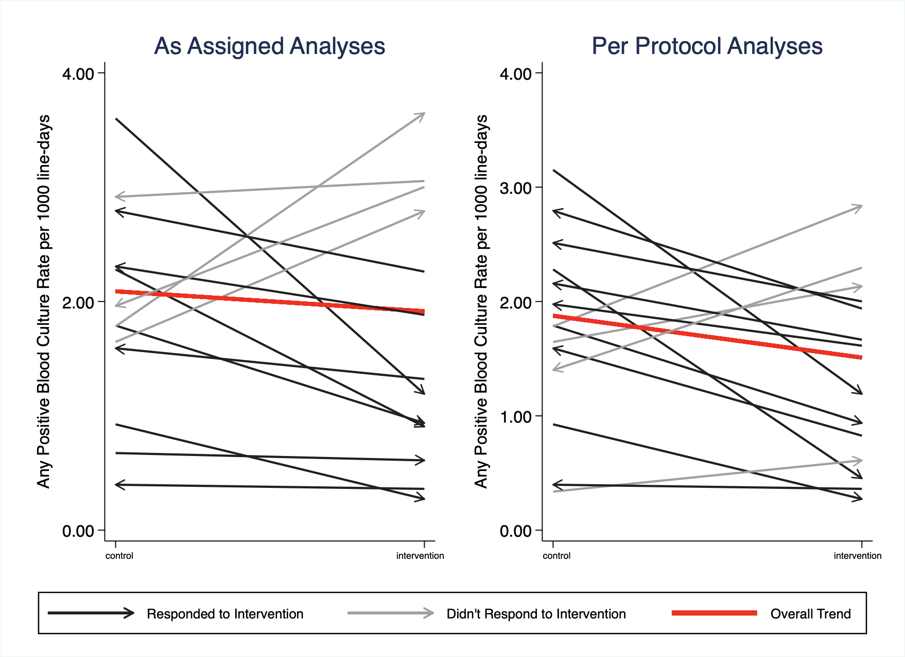

Supplemental Table B4. Microorganisms isolated from patients with central line-associated bloodstream infections (CLABSI) and any positive blood culture
 | CLABSI |  |  |  |  | Any positive blood culture
 | Treatment |  | Control |  | p-valueª | Treatment |  | Control |  | p-valueª
Microorganisms, number^{b} | 140 |  | 146 |  | 0.69 | 202 |  | 217 |  | 0.66
Gram positive, number | 63 | 45.00% | 69 | 47.26% |  | 113 | 55.94% | 116 | 53.46%
Staphylococcus species, coagulase negative | 25 | 17.86% | 25 | 17.12% |  | 42 | 20.79% | 43 | 19.82%
Staphylococcus aureus | 21 | 15.00% | 14 | 9.59% |  | 25 | 12.38% | 18 | 8.29%
Enterococcus faecalis | 3 | 2.14% | 10 | 6.85% |  | 4 | 1.98% | 10 | 4.61%
Streptococcus species | 5 | 3.57% | 5 | 3.42% |  | 18 | 8.91% | 20 | 9.22%
Bacillus species | 3 | 2.14% | 3 | 2.05% |  | 5 | 2.48% | 8 | 3.69%
Enterococcus faecium | 2 | 1.43% | 1 | 0.68% |  | 2 | 0.99% | 1 | 0.46%
Streptococcus pneumoniae | 2 | 1.43% | 1 | 0.68% |  | 2 | 0.99% | 1 | 0.46%
Abiorophia defective | 1 | 0.71% | 1 | 0.68% |  | 1 | 0.50% | 1 | 0.46%
Gordonia species | 0 | 0.00% | 2 | 1.37% |  | 0 | 0.00% | 2 | 0.92%
Gram positive, not otherwise specified | 0 | 0.00% | 2 | 1.37% |  | 2 | 0.99% | 4 | 1.84%
micrococcus species | 0 | 0.00% | 2 | 1.37% |  | 5 | 2.48% | 2 | 0.92%
Clostridium species | 1 | 0.71% | 0 | 0.00% |  | 1 | 0.50% | 0 | 0.00%
Enterococcus species | 0 | 0.00% | 1 | 0.68% |  | 1 | 0.50% | 1 | 0.46%
Lactobacillus species | 0 | 0.00% | 1 | 0.68% |  | 0 | 0.00% | 1 | 0.46%
Rhothia Species | 0 | 0.00% | 1 | 0.68% |  | 0 | 0.00% | 1 | 0.46%
Propionibacterium acnes | 0 | 0.00% | 0 | 0.00% |  | 0 | 0.00% | 1 | 0.46%
Propionibacterium species | 0 | 0.00% | 0 | 0.00% |  | 0 | 0.00% | 1 | 0.46%
Corynebacterium species | 0 | 0.00% | 0 | 0.00% |  | 5 | 2.48% | 1 | 0.46%
Gram negative, number | 75 | 53.57% | 72 | 49.32% |  | 77 | 38.12% | 79 | 36.41%
Enterobacter cloacae | 16 | 11.43% | 5 | 3.42% |  | 18 | 8.91% | 8 | 3.69%
Escherichia coli | 6 | 4.29% | 13 | 8.90% |  | 9 | 4.46% | 19 | 8.76%
Klebsiella pneumonia | 9 | 6.43% | 8 | 5.48% |  | 9 | 4.46% | 13 | 5.99%
Acinetobacter species | 7 | 5.00% | 8 | 5.48% |  | 7 | 3.47% | 9 | 4.15%
Pseudomonas aeruginosa | 7 | 5.00% | 6 | 4.11% |  | 8 | 3.96% | 9 | 4.15%
Pseudomonas species | 5 | 3.57% | 5 | 3.42% |  | 5 | 2.48% | 6 | 2.76%
Klebsiella oxytoca | 6 | 4.29% | 3 | 2.05% |  | 8 | 3.96% | 4 | 1.84%
Stenotrophomonas maltophilia | 5 | 3.57% | 4 | 2.74% |  | 5 | 2.48% | 4 | 1.84%
Pantoea species | 3 | 2.14% | 3 | 2.05% |  | 3 | 1.49% | 3 | 1.38%
Citrobacter species | 3 | 2.14% | 1 | 0.68% |  | 3 | 1.49% | 1 | 0.46%
Gram negative, not otherwise specified | 2 | 1.43% | 1 | 0.68% |  | 4 | 1.98% | 1 | 0.46%
Serratia marcescens | 0 | 0.00% | 3 | 2.05% |  | 0 | 0.00% | 3 | 1.38%
Achromobacter species | 1 | 0.71% | 1 | 0.68% |  | 1 | 0.50% | 1 | 0.46%
Enterobacter species | 0 | 0.00% | 2 | 1.37% |  | 1 | 0.50% | 2 | 0.92%
Rhizobium radiobacter | 0 | 0.00% | 2 | 1.37% |  | 0 | 0.00% | 2 | 0.92%
Sphingomonas species | 0 | 0.00% | 2 | 1.37% |  | 0 | 0.00% | 2 | 0.92%
aeromonas hydrophilia | 0 | 0.00% | 1 | 0.68% |  | 0 | 0.00% | 1 | 0.46%
Capnocytophaga species | 1 | 0.71% | 0 | 0.00% |  | 1 | 0.50% | 1 | 0.46%
Citrobacter youngae | 1 | 0.71% | 0 | 0.00% |  | 1 | 0.50% | 0 | 0.00%
Delftia acidovorans | 0 | 0.00% | 1 | 0.68% |  | 0 | 0.00% | 1 | 0.46%
haemophilus parainfluenza | 0 | 0.00% | 1 | 0.68% |  | 0 | 0.00% | 2 | 0.92%
Leclericia adecarboxylata | 0 | 0.00% | 1 | 0.68% |  | 0 | 0.00% | 1 | 0.46%
Moraxella species | 0 | 0.00% | 1 | 0.68% |  | 0 | 0.00% | 2 | 0.92%
Proteus Mirabilis | 1 | 0.71% | 0 | 0.00% |  | 1 | 0.50% | 0 | 0.00%
Roseomonas gilardii | 1 | 0.71% | 0 | 0.00% |  | 1 | 0.50% | 0 | 0.00%
Salmonella species | 1 | 0.71% | 0 | 0.00% |  | 1 | 0.50% | 0 | 0.00%
Bacteroides species | 0 | 0.00% | 0 | 0.00% |  | 1 | 0.50% | 0 | 0.00%
Yeast, number | 1 | 0.71% | 3 | 2.05% |  | 1 | 0.50% | 3 | 1.38%
Candida albicans | 0 | 0.00% | 1 | 0.68% |  | 0 | 0.00% | 1 | 0.46%
Candida species | 0 | 0.00% | 2 | 1.37% |  | 0 | 0.00% | 2 | 0.92%
Candida parapsilosis | 1 | 0.71% | 0 | 0.00% |  | 1 | 0.50% | 0 | 0.00%
Mycobacterium | 1 | 0.71% | 2 | 1.37% |  | 1 | 0.50% | 2 | 0.92%
mycobacterium fortuitum complex | 0 | 0.00% | 1 | 0.68% |  | 0 | 0.00% | 1 | 0.46%
mycobacterium mucogenicum | 0 | 0.00% | 1 | 0.68% |  | 0 | 0.00% | 1 | 0.46%
Mycobacterium | 1 | 0.71% | 0 | 0.00% |  | 1 | 0.50% | 0 | 0.00%
Other | 0 | 0.00% | 0 | 0.00% |  | 0 | 0.00% | 1 | 0.46%
ªBased on crude incidence rate ratios
^{b}These numbers represent total organisms and may exceed the total events due to some events being polymicrobial

