Healthcare Worker Infection with SARS-CoV-2 and Test-Based Return to Work

Erica S. Shenoy, MD, PhD^{1, 2, 3 †}
Lauren R. West, MPH²
David C. Hooper, MD^{1, 2, 3}
Rosemary R. Sheehan⁴
Dean Hashimoto, MD⁵
Ellyn R. Boukus, MA⁶
Marisa M. Aurora, MPH⁶
Dustin S. McEvoy⁷
Michael Klompas, MD, MPH^{8,9}

¹ Division of Infectious Diseases, Massachusetts General Hospital, Boston, MA
² Infection Control Unit, Massachusetts General Hospital, Boston, MA
³ Department of Medicine, Harvard Medical School, Boston, MA
⁴ Human Resources, Mass General Brigham, Boston, MA
⁵ Occupational Health Services, Mass General Brigham, Boston, MA
⁶Data and Analytics Organization, Mass General Brigham, Boston, MA
⁷Clinical Informatics, Mass General Brigham, Boston, MA
⁸ Department of Population Medicine, Harvard Medical School and Harvard Pilgrim Health Care Institute, Boston, MA
⁹ Department of Medicine, Brigham and Women’s Hospital, Boston, MA

Keywords: SARS-CoV-2, COVID-19, healthcare worker infection
† Corresponding author: Erica S. Shenoy, MD, PhD
55 Fruit Street, BUL-3-334
Boston, MA 02114
Tel: 617-643-5637
eshenoy@mgh.harvard.edu
Supplement.

SARS-CoV-2 Viral RNA Detection Methods

During the course of the study, the following assays were in use across MGB.
- TaqPath COVID-19 Combo Kit (ThermoFisher, Waltham, MA)
- Panther Fusion® SARS-CoV-2 Assay (Hologic, Marlborough, MA)
- CRSP SARS-CoV-2 Real-time Reverse Transcriptase (RT)-PCR Diagnostic Assay (Broad Institute, Cambridge, MA)
- cobas® SARS-CoV-2 Test (Roche Diagnostics Corporation, Indianapolis, IN)
- Xpert® Xpress SARS-CoV-2 (Cepheid, Sunnyvale, CA)
- Abbott RealTime SARS-CoV-2 (Abbott Laboratories, Abbott Park, IL)
- Massachusetts Department of Public Health State Lab

Figure S1 Legend. Employee Testing Outcomes. Note that detailed outcomes after indeterminate results were obtained are not shown, nor are subsequent testing results in retest groupings shaded in grey. NP: nasopharyngeal swab.

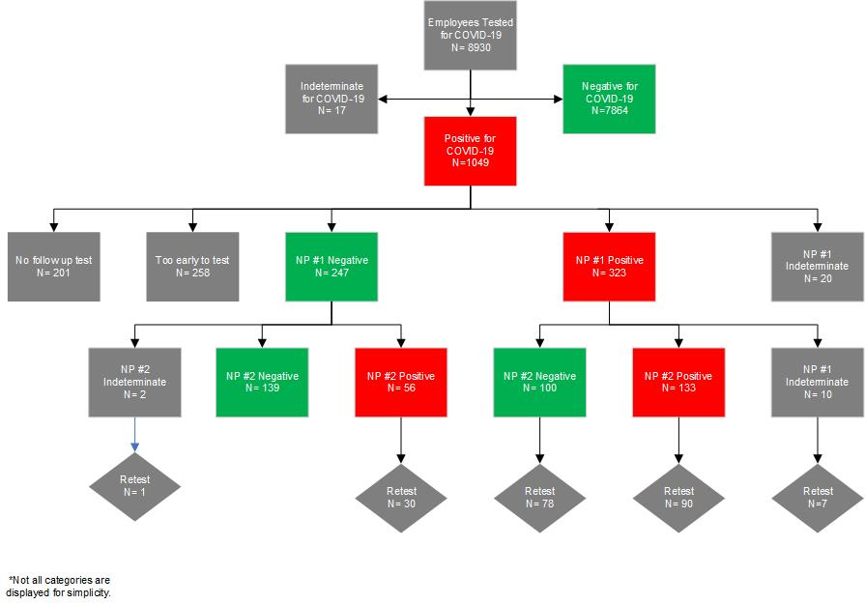

Figure S2 Legend. Kaplan-Meier Estimate of Time to Employee RTW. Clearance defined as time to two sequential negative nasopharyngeal swabs, obtained at least 24 hours apart.
