Appendix A. Change in conditions of interest among Minimum Data Set 3.0 assessments showing 1-day antibiotic use, comparing 2012 vs. 2016,** adjusted for seasonality (calendar month) and NH cluster standard errors.

 | All (regardless of cognitive status) | All ADRD  (n= 1,243,779) | ADRD with ACI  (n= 286,066) | ADRD without ACI  (n= 957,783)
 | AOR | 95% CI |  |  | AOR | 95% CI |  |  |  | AOR |  | 95% CI |  |  | AOR |  | 95% CI
UTI | 0.56* | 0.53 | 0.59 | 0.53* |  |  | 0.48 | 0.59 | 0.58* |  | 0.54 |  | 0.61 | 0.59* |  | 0.55 |  | 0.63
No Infection | 1.44* | 1.37 | 1.50 | 1.07* |  |  | 1.02 | 1.11 | 1.18* |  | 1.15 |  | 1.21 | 1.15* |  | 1.12 |  | 1.18
Any Infection, Except UTI | 0.99 | 0.92 | 1.06 | 0.89 |  |  | 0.79 | 1.00 | 0.98 |  | 0.91 |  | 1.06 | 1.01 |  | 0.92 |  | 1.09
Note: *Statistically significant at alpha = .05; **Represents a 10% random sample of CMS-certified U.S. NHs’ quarterly and annual assessments, 2012 includes April 1st 2012- December 31st 2012 and 2016 includes January 1st 2016 -November 30th 2016 as per consistently defined variables and data availability. AOR, Adjusted Odds Ratio; CI: Confidence Interval; “All” represents all quarterly and annual resident assessments; ADRD, Alzheimer's Disease or Related Dementia; ACI, advanced cognitive impairment; UTI, urinary tract infection.

Appendix B. Proportion of Minimum Data Set 3.0 assessments recording conditions of interest among those with 1-day antibiotic use, comparing 2012 vs. 2016,* adjusted for seasonality (calendar month) and NH cluster standard errors.

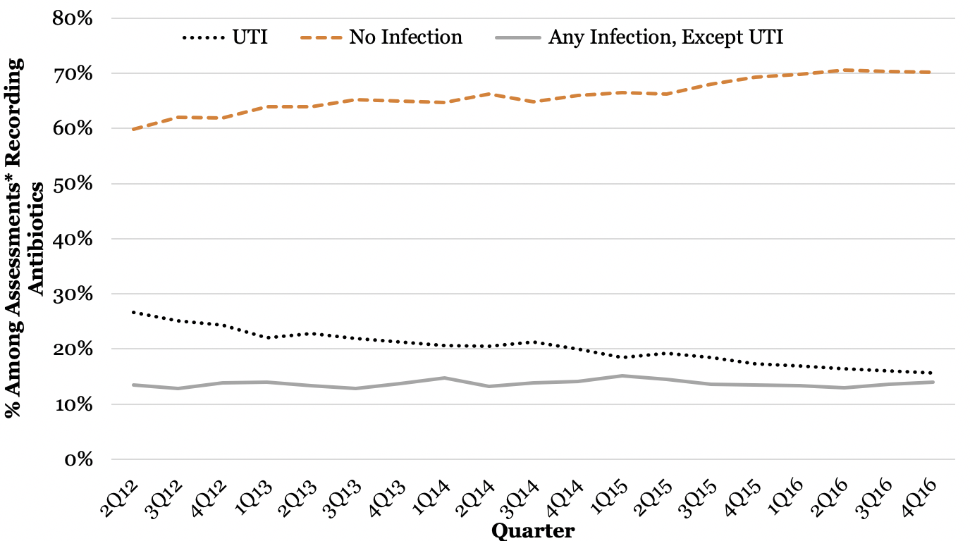
Note: *Represents a 10% random sample of CMS-certified U.S. NHs’ quarterly and annual assessments, 2012 includes April 1st 2012- December 31st 2012 and 2016 includes January 1st 2016 -November 30th 2016 as per consistently defined variables and data availability. UTI, urinary tract infection.

