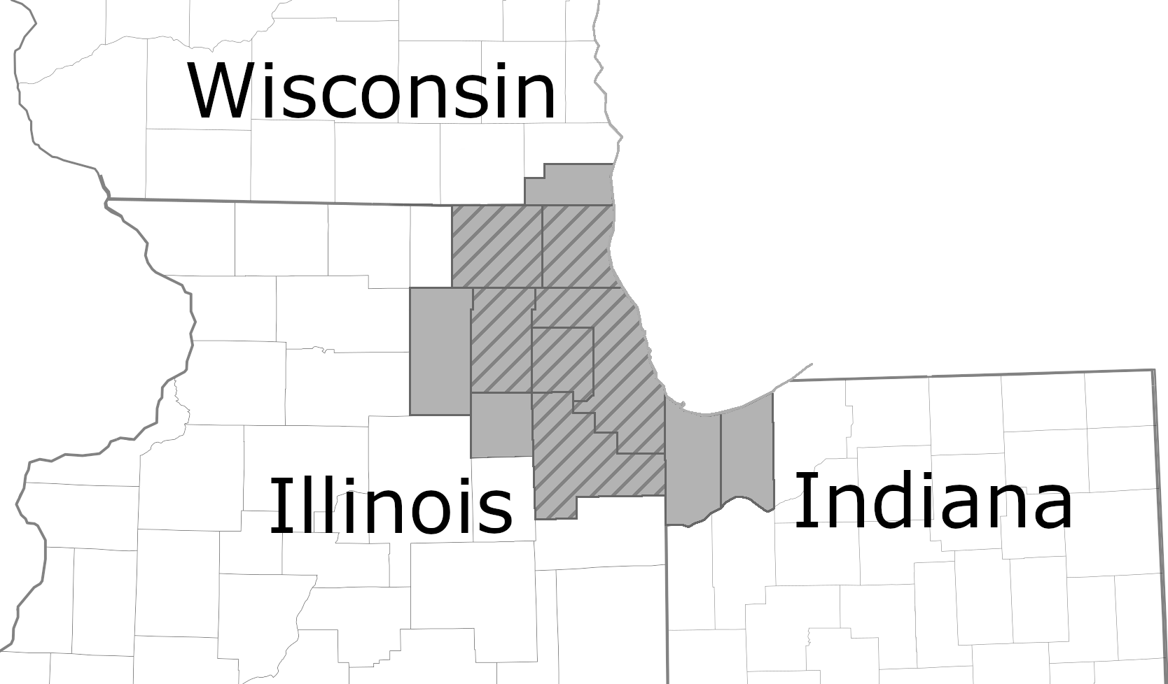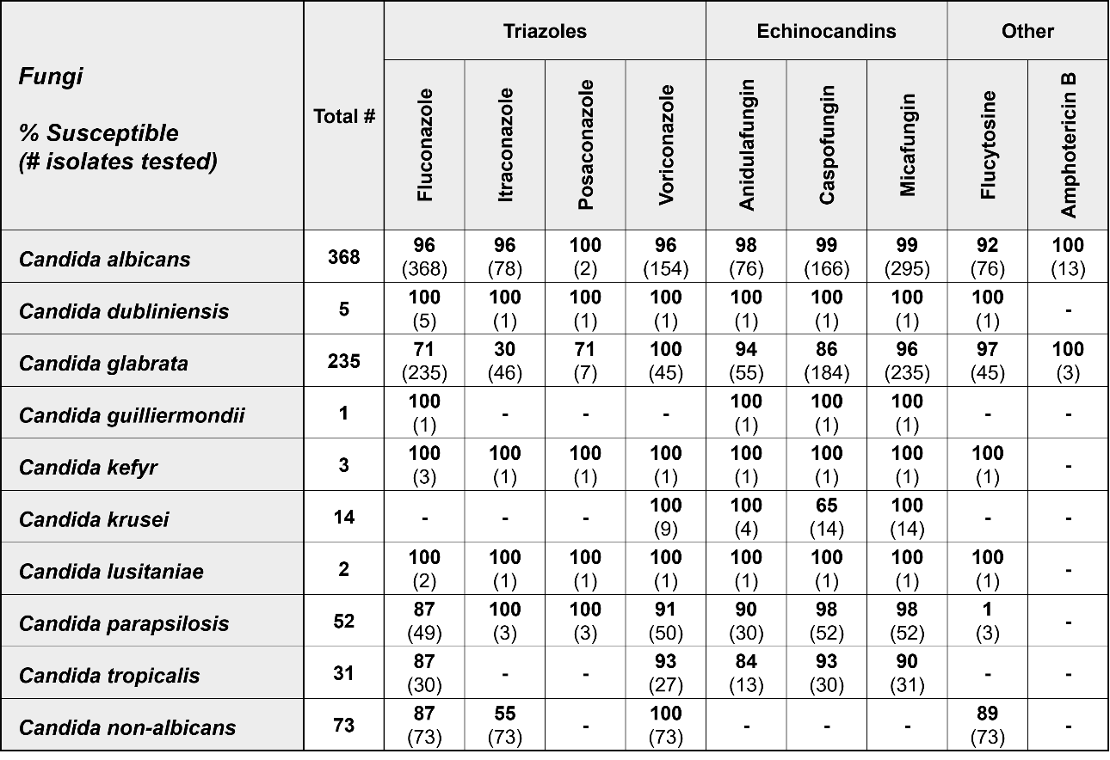

Supplemental Figure 1. Map of the Chicago-Naperville-Elgin Metropolitan Statistical Area (grey) and the counties represented in the Chicagoland antibiogram (hash)

Supplemental Figure 2. Chicagoland regional antibiogram from calendar year 2017 for fungi.

-, not reported

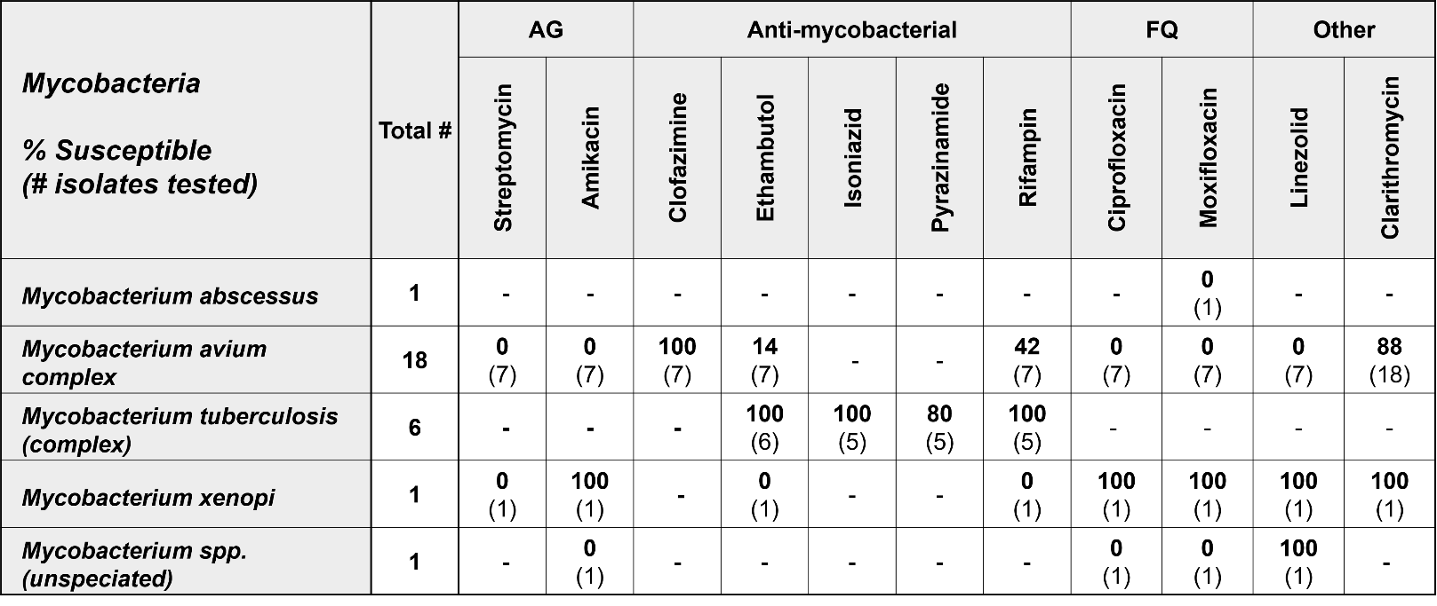

Supplemental Figure 3. Chicagoland regional antibiogram from calendar year 2017 for mycobacteria.

AG, aminoglycoside; FQ, fluoroquinolone; -, not reported