Supplemental Figure 1: Clinical Practice Guideline 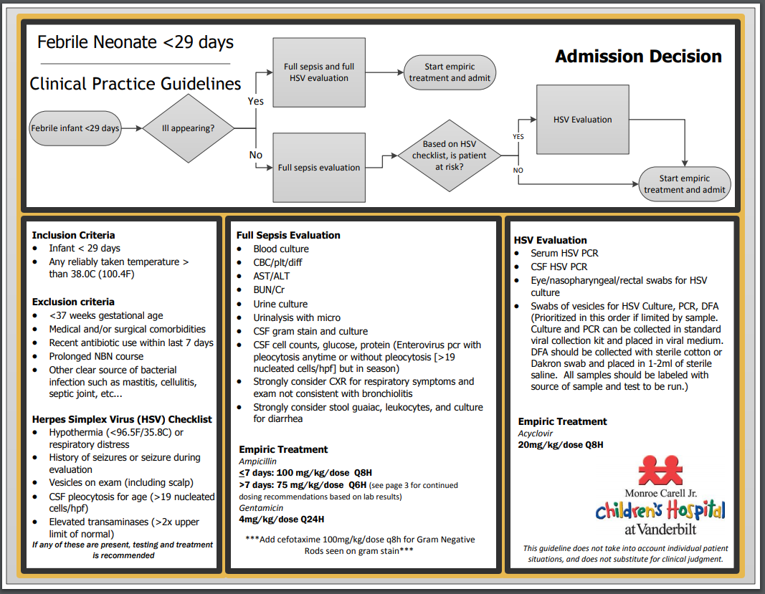
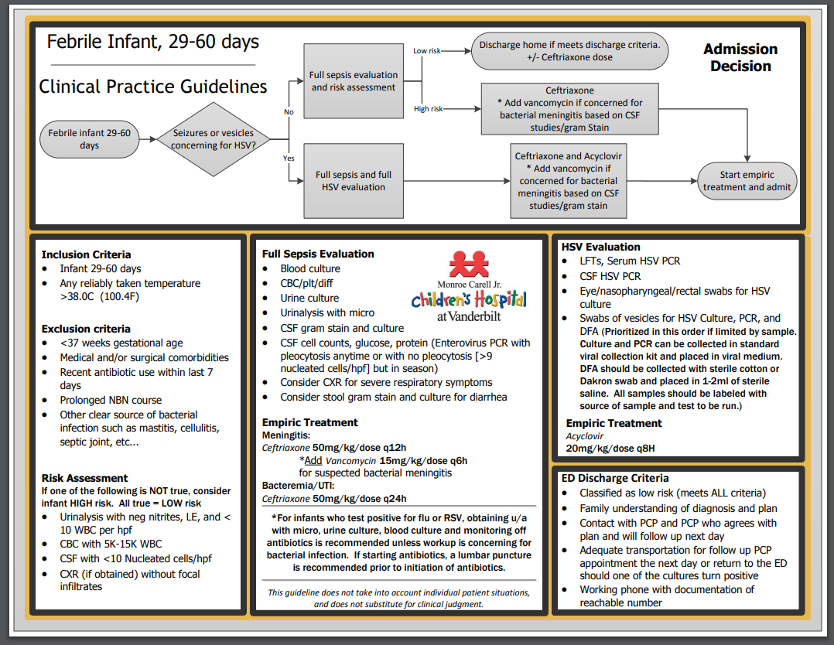

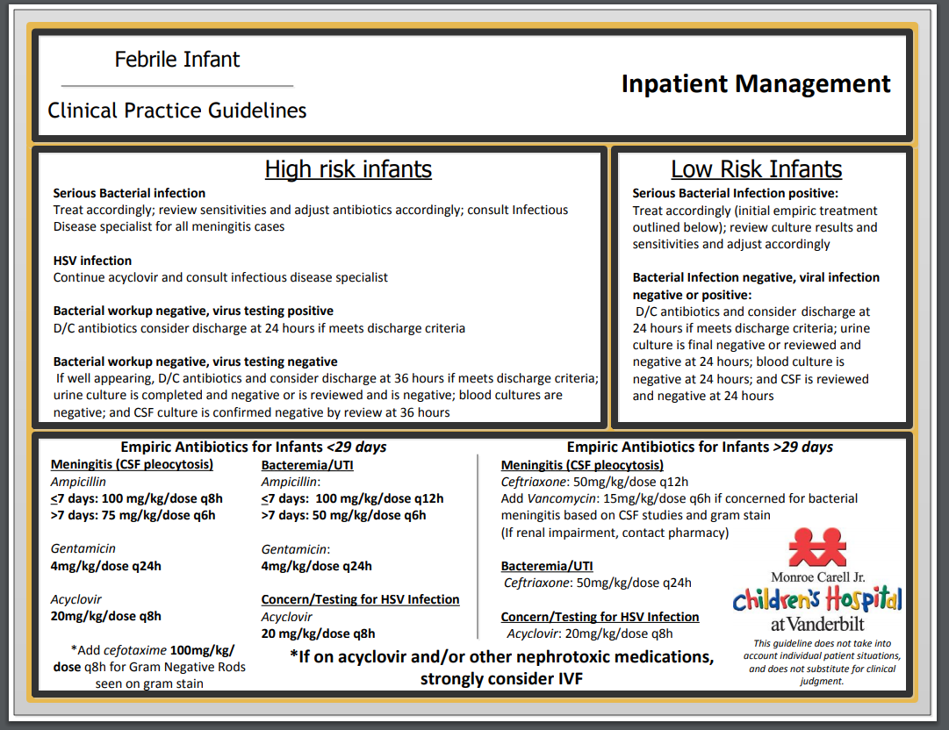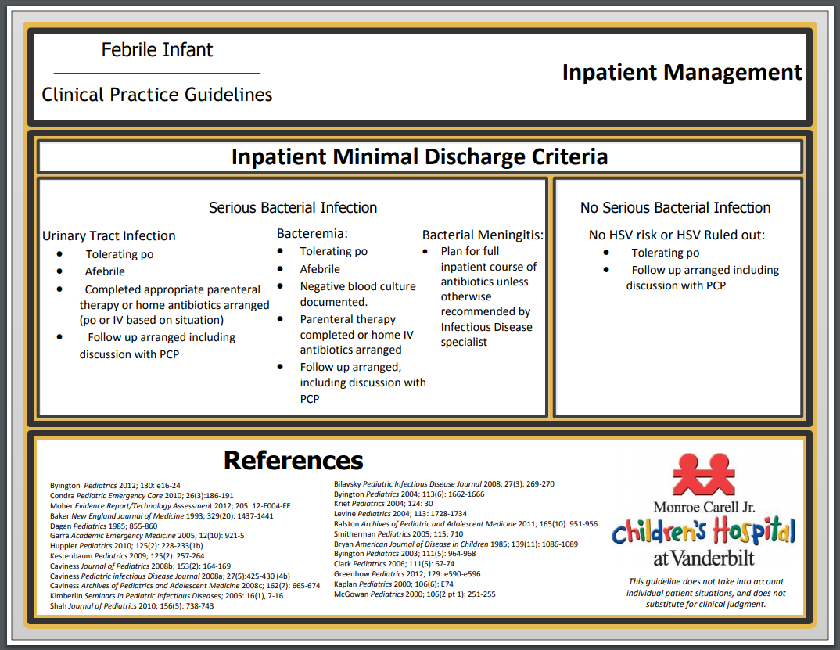

Supplemental Figure 2: Pathogens detected using mPCR testing
Supplemental Figure 2a

Figure 2a: Detected Respiratory Pathogens. Lighter colors represent single detections; darker colors represent co-detections with other organisms. P1 (1/1/2011-12/31/2014) and P2 (1/1/2015-4/30/2018) pathogens detected using batched Respiratory Viral Panel (RVP); P3 (5/1/2018-6/15/2019) pathogens detected using on-demand Respiratory Panel (RP). Pathogen abbreviations are as follows: Rhino/Enterovirus: Human Rhinovirus/Enterovirus; RSV: Respiratory Syncytial Virus; Parainfluenza: Parainfluenza 1, 2, 3, 4; Coronavirus: Coronavirus 229E, HKU1, OC43, NL63; Metapneumovirus: Human Metapneumovirus; Influenza: Influenza A/H1, A/H1-2009, A/H3, B. Enterovirus was not tested for in P1 or P2 but was co-detected with rhinovirus in P3 because the assay could not distinguish between these viruses. 76 pathogens were detected from 72 unique samples in P1; 83 pathogens were detected from 74 unique samples in P2; and 283 pathogens were detected from 247 unique samples in P3.

Supplemental Figure 2b
E. coli S. agalactiae
Figure 2b: Pathogen detection from cerebrospinal fluid. Using the Meningitis Encephalitis Panel (MEP). Lighter color represents single detections; darker color represents co-detections with other organisms. Cerebrospinal fluid mPCR testing was only available during P3 (5/1/2018-6/15/2019). Pathogen abbreviations are as follows: Parechovirus: Human Parechovirus; HHV-6: Human Herpes Virus 6; E. coli: Escherichia coli K1; S. agalactiae: Streptococcus agalactiae. Coinfections count as multiple pathogens. *Indicates two subjects with detection of Enterovirus and HHV-6. 48 pathogens were detected from 46 unique samples.

Supplemental Table 1a: Outcomes among infants 0-28 days (n=1603)
Outcome | P1  n=679 | P2  Guideline  n=676 | P3  Guideline plus rapid mPCR  n=248 | P-value ª
Admitted ^{e}, number (%) | 637 (93.8) | 638 (94.4) | 231 (93.1) | .77
Inpatient LOS ^{e,f}, days, median (IQR) | 2.1 (1.8-3.0) | 1.9 (1.6-2.5) | 1.9 (1.5-2.5) | <.001^{b,c}
Readmission within 30 days, number (%) | 35 (5.2) | 26 (3.8) | 25 (10.1) | .002^{b,d}
Deaths within 30 days, number (%) | 1 (0.1) | 1 (0.1) | 0 (0.0) | -----
Antimicrobial usage
Received no antimicrobials ^{g}, number (%) | 48 (7.1) | 53 (7.8) | 36 (14.5) | .001^{b,d}
Received a single dose of 1-2 antimicrobials ^{g}, number (%) | 3 (0.4) | 9 (1.3) | 3 (1.2) | .21
Antibiotic duration ^{h}, days, median (IQR) | 3.9 (3.2-4.5) | 2.8 (2.3-3.8) | 2.5 (1.9-2.8) | <.001^{b,c,d}
Antiviral duration ^{i}, days, median (IQR) | 1.4 (0.9-1.9) | 1.0 (0.7-1.7) | 1.0 (0.6-1.6) | <.001^{b,c}
Number of ancillary tests per patient ^{j}, median (IQR) | 9 (8-11) | 10 (7-11) | 6.5 (3-8) | <.001^{b,d}
Received chest radiograph, number (%) | 188 (27.7) | 98 (14.5) | 25 (10.1) | <.001^{b,c}
Received lumbar puncture, number (%) | 568 (83.7) | 533 (78.8) | 185 (74.6) | .005^{b,c}
P1: 1/1/2011-12/31/2014; no clinical practice guideline or rapid multiplex polymerase chain reaction (mPCR) testing
P2: 1/1/2015-4/30/2018; clinical practice guideline available, no rapid mPCR testing
P3: 5/1/2018-6/15/2019; clinical practice guideline and rapid mPCR testing available
ª P-value shown comparing all 3 periods
^{b} Significant difference between all 3 periods, with P-value <.05
^{c} Significant difference between P1 and P2, with P-value <.05
^{d} Significant difference between P2 and P3, with P-value <.05
^{e} Considered inpatient if discharged from an inpatient unit
^{f} Excludes 35 patients in Period 1 and 25 patients in Period 2 with unverifiable inpatient admission times
^{g} Antimicrobials include acyclovir, ampicillin, cefepime, cefotaxime, ceftriaxone, gentamicin, oseltamivir, penicillin, and vancomycin
^{h} Among patients receiving more than a single dose of 1-2 antibiotics
^{i} Among patients receiving more than a single dose of 1-2 antivirals
^{j} Includes complete blood count, basic metabolic panel, urinalysis, cerebrospinal fluid cell count and chemistries, enterovirus PCR, Respiratory Syncytial Virus antigen, influenza antigen, Herpes Simplex Virus PCR, aspartate aminotransferase, alanine aminotransferase, total and direct bilirubin, and bacterial cultures obtained during the hospital encounter

Supplemental Table 1b: Outcomes among infants 29-60 days (n=2434)
Outcome | P1  n=1207 | P2  Guideline  n=917 | P3  Guideline plus rapid mPCR  n=310 | P-value ª
Admitted ^{e}, number (%) | 827 (68.5) | 585 (63.8) | 161 (51.9) | <.001 ^{b,d}
Inpatient LOS ^{e,f}, days, median (IQR) | 1.8 (1.4-2.3) | 1.6 (1.0-2.3) | 1.5 (1.0-2.1) | <.001 ^{b,c}
Readmission within 30 days, number (%) | 59 (4.9) | 46 (5.0) | 12 (3.9) | .70
Deaths within 30 days, number (%) | 0 (0.0) | 0 (0.0) | 0 (0.0) | -----
Antimicrobial usage
Received no antimicrobials ^{g}, number (%) | 303 (25.1) | 250 (27.3) | 147 (47.4) | <.001 ^{b,d}
Received single dose of 1-2 antimicrobials ^{g}, number (%) | 154 (12.8) | 215 (23.4) | 58 (18.7) | <.001 ^{b,c,d}
Antibiotic duration ^{h}, days, median (IQR) | 2.9 (1.5-4.0) | 1.5 (1.0-2.1) | 1.0 (1.0-1.5) | <.001 ^{b,c,d}
Antiviral duration ^{i}, days, median (IQR) | 1.2 (0.8-1.8) | 1.0 (0.5-1.7) | 1.2 (0.7-1.6) | .19
Number of ancillary tests per patient ^{j}, median (IQR) | 8 (6-10) | 7 (4-9) | 4 (3-6) | <.001 ^{b,c,d}
Received chest radiograph, number (%) | 340 (28.2) | 171 (18.6) | 30 (9.7) | <.001 ^{b,c,d}
Received lumbar puncture, number (%) | 843 (69.8) | 573 (62.5) | 162 (52.3) | <.001 ^{b,c,d}
P1: 1/1/2011-12/31/2014; no clinical practice guideline or rapid multiplex polymerase chain reaction (mPCR) testing
P2: 1/1/2015-4/30/2018; clinical practice guideline available, no rapid mPCR testing
P3: 5/1/2018-6/15/2019; clinical practice guideline and rapid mPCR testing available
ª P-value shown comparing all 3 periods
^{b} Significant difference between all 3 periods, with P-value <.05
^{c} Significant difference between P1 and P2, with P-value <.05
^{d} Significant difference between P2 and P3, with P-value <.05
^{e} Considered inpatient if discharged from an inpatient unit
^{f} Excludes 49 patients in Period 1 and 27 patients in Period 2 with unverifiable inpatient admission times
^{g} Antimicrobials include acyclovir, ampicillin, cefepime, cefotaxime, ceftriaxone, gentamicin, oseltamivir, penicillin, and vancomycin
^{h} Among patients receiving more than a single dose of 1-2 antibiotics
^{i} Among patients receiving more than a single dose of 1-2 antivirals
^{j} Includes complete blood count, basic metabolic panel, urinalysis, cerebrospinal fluid cell count and chemistries, enterovirus PCR, Respiratory Syncytial Virus antigen, influenza antigen, Herpes Simplex Virus PCR, aspartate aminotransferase, alanine aminotransferase, total and direct bilirubin, and bacterial cultures during the hospital encounter

Supplemental Table 1c: Outcomes among infants 61-90 days (n=1280)
Characteristic / Outcome | P1  n=628 | P2  Guideline  n=489 | P3  Guideline plus rapid mPCR  n=163 | P-value ª
Admitted ^{e}, number (%) | 146 (23.2) | 109 (22.3) | 52 (31.9) | .04^{b,c,d}
Inpatient LOS ^{e,f}, days, median (IQR) | 1.9 (1.3-2.8) | 1.8 (0.8-2.8) | 1.5 (0.9-2.4) | .07
Readmission within 30 days, number (%) | 46 (7.3) | 17 (3.5) | 11 (6.7) | .02^{b,c}
Deaths within 30 days, number (%) | 0 (0.0) | 1 (0.2) | 0 (0.0) | -----
Antimicrobial usage
Received no antimicrobials ^{g}, number (%) | 433 (68.9) | 371 (75.9) | 128 (78.5) | .008^{b,c}
Received a single dose of 1-2 antimicrobials ^{g}, number (%) | 87 (13.9) | 60 (12.3) | 15 (9.2) | .267
Antibiotic duration ^{h}, days, median (IQR) | 2.1 (1.3-3.8) | 1.5 (0.9-3.1) | 1.0 (0.9-3.2) | .02^{b,c}
Antiviral duration ^{i}, days, median (IQR) | 1.3 (0.6-2.0) | 1.6 (0.7-3.4) | 0.8 (0.6-1.0) | .42
Number of ancillary tests per patient ^{j}, median (IQR) | 4 (2-6) | 2 (0-5) | 3 (1-5) | <.001^{b,c}
Received chest radiograph, number (%) | 159 (25.3) | 81 (16.6) | 22 (13.5) | <.001^{b}
Received lumbar puncture, number (%) | 118 (18.8) | 63 (12.9) | 25 (15.3) | .028^{b,c}
P1: 1/1/2011-12/31/2014; no clinical practice guideline or rapid multiplex polymerase chain reaction (mPCR) testing
P2: 1/1/2015-4/30/2018; clinical practice guideline available, no rapid mPCR testing
P3: 5/1/2018-6/15/2019; clinical practice guideline and rapid mPCR testing available
ª P-value shown comparing all 3 periods
^{b} Significant difference between all 3 periods, with P-value <.05
^{c} Significant difference between P1 and P2, with P-value <.05
^{d} Significant difference between P2 and P3, with P-value <.05
^{e} Considered inpatient if discharged from an inpatient unit
^{f} Excludes 14 patients in Period 1 and 5 patients in Period 2 with unverifiable inpatient admission times
^{g} Antimicrobials include acyclovir, ampicillin, cefepime, cefotaxime, ceftriaxone, gentamicin, oseltamivir, penicillin, and vancomycin
^{h} Among patients receiving more than a single dose of 1-2 antibiotics
^{i} Among patients receiving more than a single dose of 1-2 antivirals
^{j} Includes complete blood count, basic metabolic panel, urinalysis, cerebrospinal fluid cell count and chemistries, enterovirus PCR, Respiratory Syncytial Virus antigen, influenza antigen, Herpes Simplex Virus PCR, aspartate aminotransferase, alanine aminotransferase, total and direct bilirubin, and bacterial cultures obtained during the hospital encounter

Supplemental Table 2: Combinations of mPCR testing in P3 (n=512)
Characteristic | RP Only | RP and MEP | MEP Only
Number (%) of patients receiving mPCR testing | 308 (60.2) | 162 (31.6) | 42 (8.2)
Age of patients, days, median (IQR) | 44 (29-57.2) | 28 (15-40) | 22 (11-33)
P3: 5/1/2018-6/15/2019.
mPCR: multiplex polymerase chain reaction
RP: respiratory panel
MEP: meningitis/encephalitis panel

