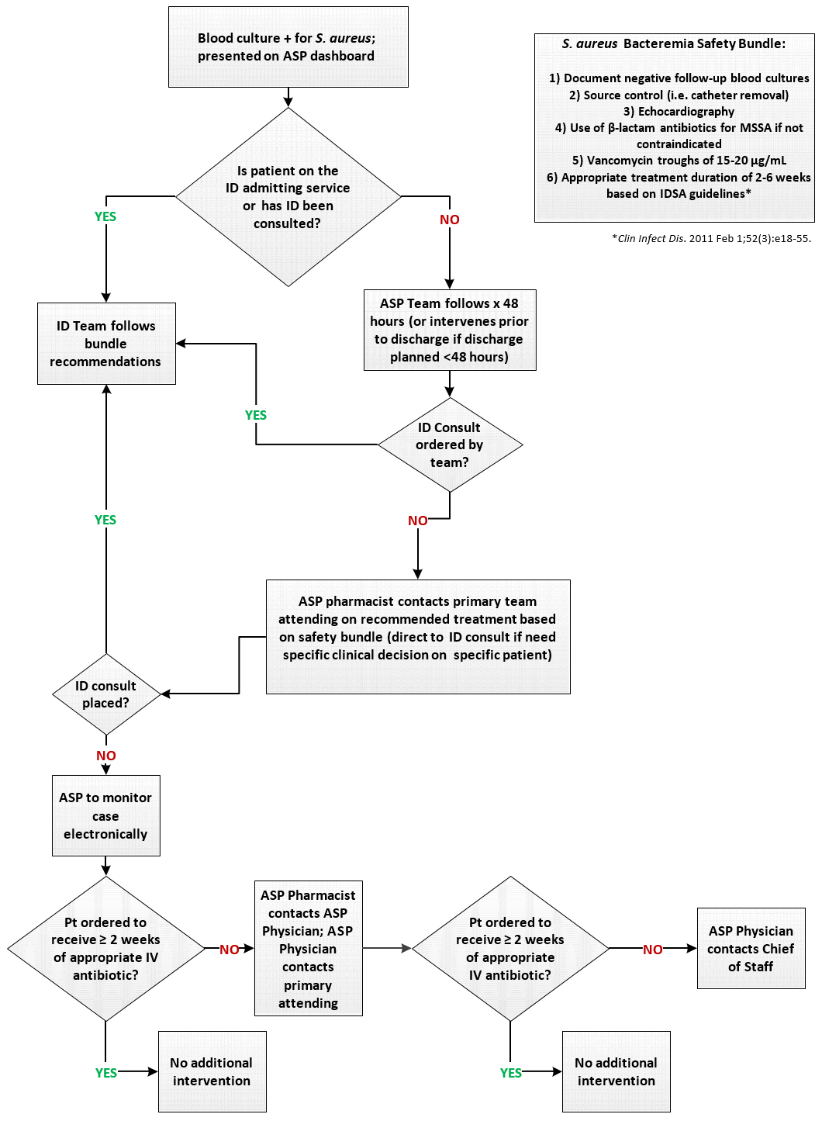
Appendix A: Staphylococcus aureus Bacteremia Safety Algorithm

