S1. Model derivation
Our group previously published two agent-based models of C. difficile transmission in the adult hospital setting.^{1,2} The pediatric model in this paper incorporates aspects from both prior sets of work, while utilizing a conceptual framework unique to the pediatric setting. A similar discrete-time Markov chain is central to all three of our group’s models. Modification and recalibration of this for the pediatric setting is discussed in Supplement S2.
Several workflow and biological differences relevant to C. difficile transmission in the adult versus pediatric setting are outlined in Table S1. Two of the most important modeling decisions unique to the pediatric model include the incorporation of a caregiver agent type and a central hospital-wide playroom/school area. Caregiver agents approximate parents or guardians, who remain with a patient for longer periods of time than a typical visitor. They engage more actively in patient care, can accompany the patient to the playroom/school, and have more direct physical contact with patients than traditional visitors. Caregivers’ longer duration of stay and mobility around the hospital increases patient and environmental contamination, affecting C. difficile outcomes. In the pediatrics model, the playroom/school allows for daily contact among patients and between patients and the room’s physical environment.

Table S1: Modeling considerations in the pediatric versus adult setting
Quality | Adult setting | Pediatric setting
Workflow differences
Hospital size | An average sized hospital has more wards, beds, healthcare workers, and patients | Fewer total wards, beds, healthcare workers, and patients; More frequent nursing contact
Visitor interactions | Shorter duration (50% of visits less than 30 minutes),³ fewer total visits and visitors, less physical contact between visitors and patients, nurses serve as primary caregivers | Longer duration of visits (often overnight or for multiple daytime hours), more total visits and visitors, parent/guardian caregivers accompany patients to playroom/school common area and take on an active role in patient care, more direct physical contact between visitors and patients
Patient interactions | Minimal interactions between patients | Frequent interactions between patients in hospital-wide playroom/school
Biological differences
Colonization | Uncommon in the community setting without predisposing factors or prior interaction with healthcare system^{4,5} | Common among children less than 3, including healthy children in the community setting^{6–11}
Symptom presentation | Colonized patients can progress to symptomatic infection | Other infectious causes of diarrhea are more common¹²
CDI-associated mortality | CDI patients at a higher risk for mortality than non-CDI patients^{4,13} | The CDI-attributable death rate is minimal once patient comorbidities are accounted for¹⁴
CDI: C. difficile infection

S2. Recalibration of discrete time Markov chain
The pediatric discrete-time Markov chain underpinning patients’ progressions through eight C. difficile clinical states was derived from a discrete-time Markov chain developed in our group’s first agent-based model of nosocomial C. difficile transmission in the adult setting.¹ Extensive calibration of the discrete-time Markov chain was conducted during development of that model. As part of the process, a set of ten final matrices were selected from over 100,000 realistic discrete-time Markov chain matrix possibilities on the basis of their performance with regards to four benchmark calibration targets: asymptomatic colonization, symptomatic infection, relapse CDI, and CDI-related mortality.¹
The pediatrics model employs a modified version of the top ten adult discrete-time Markov chain matrices, adapted for the pediatrics setting. The modifications revolve around three major changes: CDI-related death, the transition between exposed and infected patients, and the transition between exposed and colonized patients. Because CDI-associated in-hospital death is rare in the pediatrics setting,^{14–17} the transition probabilities from infection to death and recurrent infection to death were reduced to zero. The model does not track mortality, because death occurs in only 0.4% of all pediatric hospital admissions.¹⁸ Among this 0.4%, CDI-attributable death rate is minimal once patient comorbidities are accounted for.¹⁴ Thus, death was removed completely from the pediatrics model, reducing the number of possible clinical patient transition states from nine in the adult models to eight.
The probability of transitioning from C. difficile exposure to symptomatic infection was recalibrated to 5.54 cases per 10,000 patient days based on pediatric-specific rates of CDI in the literature and 2015 to 2016 internal data from the American Family Children’s Hospital in Madison, Wisconsin (Table S2).^{17,19–22} Several studies reported only a composite all-cause CDI measure that included both community-associated and HO-CDI. We converted this to HO-CDIs using a 46:54 HO-CDI:non-HO-CDI ratio. This ratio was based on two studies of inpatient CDIs from 2006 to 2011 using the nationwide Pediatric Health Information System database.^{21,22}

Table S2: CDI recalibration target for pediatric discrete-time Markov chain
Source | Data year | Population | Rate (cases per 10,000 patient days) | Rate (cases per 1,000 admissions) | Sample size (admissions)
AFCH (ID) | 2015, 2016 | 1 hospital, non-ICU wards | 5.20 (HO-CDI) | 2.82 (HO-CDI) | 5,310; 28,867 patient days
Kim¹⁹ | 2006 | 22 hospitals nationwide | 6.5 (all CDI) | 4.0 (all CDI) | --
 |  | HO-CDI correction¹ | 2.99 (HO-CDI) | 1.84 (HO-CDI)
Zilberberg²⁰ | 2006 | HCUP-KID | 12.80 (all CDI) | -- | --
 |  | HO-CDI correction¹ | 5.89 (HO-CDI)
 | 2006 | NHDS | -- | 1.403 (all CDI) | 69,649
 |  | HO-CDI correction¹ |  | 0.65 (HO-CDI)
Source | Data year | Population | Rate (cases per 10,000 patient days) | Rate (cases per 1,000 admissions) | Sample size (admissions)
Nylund¹⁷ | 1997, 2000, 2003, 2006 | HCUP-KID | -- | 2.03 (all CDI); increasing every year, data not stratified | 10,474,454
 |  | HO-CDI correction¹ |  | 0.93 (HO-CDI)
AFCH, American Family Children’s Hospital, Madison, Wisconsin; HCUP-KID, Health care utilization project kid’s inpatient database; ID, Internal data; NHDS, National Hospital Discharge Survey; ¹HO-CDI average 46% of all CDI cases in pediatrics hospitals^{21,22}

Robust pediatric-specific data on in-hospital asymptomatic colonization rates were not available in the literature and we assumed that the probability of transitioning from C. difficile exposure to asymptomatic colonization is the same in pediatric and adult settings. We believe this is an appropriate assumption, given that the majority of non-neonatal hospitalized patients are aged three and older²³ and by age three a child’s gastrointestinal microbiome composition and C. difficile pathology approximate that of an adult.^{11,21,24–28} We utilized a target asymptomatic colonization rate of 35.72 colonizations per 1,000 admissions, identical to that of our second adult model.²
Using target rates of 5.54 HO-CDI per 10,000 patient days and 35.72 colonizations per 1,000 admissions, all top-ten discrete-time Markov chain matrices were initially employed simultaneously for recalibration. Each patient was randomly assigned one matrix, chosen with equal probability, at the time of admission. All combinations of the recalibrated transition probabilities were run 4,500 times at baseline conditions (Table S3).
Ultimately, we recalibrated the discrete-time Markov chain using transition probabilities 6.5% and 53% times our initial adult model’s¹ exposed to infected and exposed to colonized probabilities, respectively. We used a probability of zero for transitioning from infection and recurrent infection to death.

Table S3: Recalibration of Codella, et al. discrete time Markov-chains¹ for the pediatrics model
Multiple of Codella transition from exposed to infected | Multiple of Codella transition from exposed to colonized | HO-CDI per 10,000 patient days | Asymptomatic colonizations per 1,000 admissions
3% | 48% | 3.58 (3.54, 3.63) | 32.74 (32.63, 32.84)
4.5% | 52% | 4.40 (4.35, 4.45) | 35.46 (35.35, 35.57)
6% | 53% | 5.21 (5.16, 5.26) | 36.14 (36.03, 36.25)
6.5% | 52% | 5.50 (5.45, 5.56) | 35.49 (35.38, 35.60)
6.5% | 53% | 5.53 (5.47, 5.58) | 36.11 (36.00, 36.22)
7% | 53% | 5.81 (5.76, 5.87) | 36.11 (36.00, 36.22)

Each of the recalibrated top-ten matrices was then evaluated to determine if one matrix could reasonably replicate the results obtained by all using ten simultaneously. We assessed this by simulating 1000 runs of each top-ten matrix at baseline condition. For each set of 1000 runs, all patients were assigned the same discrete-time Markov chain matrix. Matrix seven was ultimately determined to be the best single matrix for replicating the results of running all ten matrices simultaneously (Table S4).

Table S4: Matrix selection results at baseline
Matrix | HO-CDI (per 10,000 PD) | Asymptomatic colonizations (per 1,000 admissions)
1 | 6.02 (5.90, 6.14) | 28.61 (28.41, 28.82)
2 | 4.76 (4.65, 4.87) | 16.27 (16.13, 16.41)
3 | 6.11 (5.99, 6.23) | 45.64 (45.37, 45.92)
4 | 5.52 (5.40, 5.64) | 24.38 (24.20, 24.57)
5 | 5.98 (5.86, 6.10) | 72.22 (71.85, 72.58)
6 | 4.80 (4.69, 4.91) | 37.17 (36.92, 37.41)
7 | 5.47 (5.35, 5.58) | 32.81 (32.59, 33.03)
8 | 4.20 (4.10, 4.31) | 41.42 (41.17, 41.68)
9 | 5.51 (5.40, 5.63) | 50.03 (49.74, 50.32)
10 | 6.05 (5.93, 6.17) | 20.27 (20.11, 20.44)
All 10 | 5.46 (5.35, 5.58) | 36.23 (36.00, 36.46)
Results of matrix selection testing under the baseline condition of no intervention implementation. AC: Asymptomatic colonization; HO-CDI: Hospital onset Clostridium difficile infection; PD: Patient days

We subsequently compared the results for the intervention strategies using all ten matrices to that of matrix seven alone. This was done to ensure that the single matrix could be used as a surrogate for random selection from all ten matrices when assessing trends in intervention effectiveness. We simulated 5,000 runs for each intervention strategy (Table S5).

Table S5: Replication of intervention results with matrix seven
Intervention | Top-ten |  | Matrix seven
 | HO-CDI per 10,000 PD | Asymptomatic colonizations per 1,000 admissions | HO-CDI per 10,000 PD | Asymptomatic colonizations per 1,000 admissions
Baseline | 5.53  (5.47, 5.58) | 36.11  (36.01, 36.22) | 5.50  (5.45, 5.56) | 32.73  (32.63, 32.83)
Daily cleaning | 2.83  (2.79, 2.87) | 9.48  (9.43, 9.54) | 2.83  (2.80, 2.87) | 8.65  (8.59, 8.70)
HCW contact precautions | 5.47  (5.42, 5.53) | 35.70  (35.60, 35.81) | 5.43  (5.38, 5.48) | 32.40  (32.30, 32.50)
HCW hand hygiene | 4.43  (4.38, 4.48) | 25.21  (25.12, 25.30) | 4.46  (4.41, 4.51) | 22.81  (22.73, 22.89)
Patient hand hygiene | 5.04  (4.99, 5.09) | 31.49  (31.39, 31.59) | 5.04  (4.99, 5.09) | 28.54  (28.45, 28.63)
Patient transfer | 5.38  (5.33, 5.43) | 34.07  (33.97, 34.18) | 5.35  (5.30, 5.40) | 30.88  (30.78, 30.98)
Screening | 3.94  (3.90,3.99) | 22.34  (22.24, 22.44) | 3.93  (3.89, 3.98) | 20.09  (20.00, 20.19)
Terminal cleaning | 4.87  (4.82, 4.92) | 27.38  (27.28, 27.48) | 4.84  (4.79, 4.89) | 24.81  (24.72, 24.90)
Visitor contact precautions | 5.50  (5.45, 5.55) | 36.12  (36.01, 36.22) | 5.50  (5.45, 5.55) | 32.74  (32.64, 32.84)
Visitor hand hygiene | 5.51  (5.46, 5.56) | 36.11  (36.00, 36.22) | 5.52  (5.46, 5.57) | 32.68  (32.51, 32.70)
Results of matrix seven testing at baseline and an enhanced level of each intervention individually. HO-CDI: Hospital onset Clostridium difficile infection; PD: Patient days

Matrix seven replicated the results compared to using all ten matrices very well and was used for all subsequent model runs and analyses. Matrix seven results for HO-CDI replicated all ten matrices almost exactly. While the asymptomatic colonization rate was slightly lower using matrix seven, the trends were consistent across all interventions.

S3. Data Sources
Primary administrative data from the American Family Children’s Hospital in Madison, Wisconsin were used to develop a mean:standard deviation length of stay ratio, which was subsequently used to determine the measure’s standard deviation. These data were also used to derive the patient transfer intervention estimates. Caretaker service time parameters were defined based on expert opinion, as no comprehensive workflow studies of visitors to children’s hospitals have been conducted, to date.

S4. Order of events in the model
The order of events is outlined for each agent type in the subsequent flow diagrams: Figures S2.A (patients), S2.B (nurses and doctors), S2.C (visitors), and S2.D (caregivers). The overall order of events at each time point in the model is run as follows:
- New patients arrive and are assigned an infectious status, hospital room, any intra- and inter-ward transfer times, and a 3 nurse, 2 physician healthcare worker team. Patients may be tested for C. difficile and begin treatment, depending on patient symptoms and the status of the asymptomatic screening intervention. If the screening intervention is active or patient has symptoms, screening and initiation of contact precautions for C. difficile positive patients occurs immediately at the time of admission.
- Every 24 hours, visitor and caregiver additions are determined for the following day.
- Visitors who have completed their stay are removed (Figure S2.C).
- Caregivers who have completed their stay are removed (Figure S2.D).
- Every 6 hours, patients’ clinical statuses are updated using the discrete-time Markov chain. Newly symptomatic patients are immediately tested for CDI and may begin treatment.
- Every hour, patients scheduled for intra- or inter-ward transfers within the hour are transferred. Room transfers include terminal cleaning of the patient’s original room. Inter-ward transfers also include assignment of a new nursing team.
- Every 6 hours, healthcare worker visit times are defined.
- Patients scheduled to meet with another patient at this time go with them to the ward patient common room, which represents children playing together.
- Patients scheduled to attend playroom/school at this time go to central playroom/school.
- Every 24 hours, patient:patient and playroom/school meeting times are determined for the following day
- Patients who have completed their hospital stay are removed and the patient room is terminally cleaned.
- Nurses and doctors change location, as applicable (see Figure S2.B).
- Every 24 hours, rooms may undergo daily cleaning.
- Every 24 hours, C. difficile treatment status is updated for patients receiving vancomycin.
- New visitors with this entry time are added to their patient’s room (Figure S2.C).
- New caregivers with this entry time are added at their patient’s location (Figure S2.D).

Figure S1: Transmission Pathways

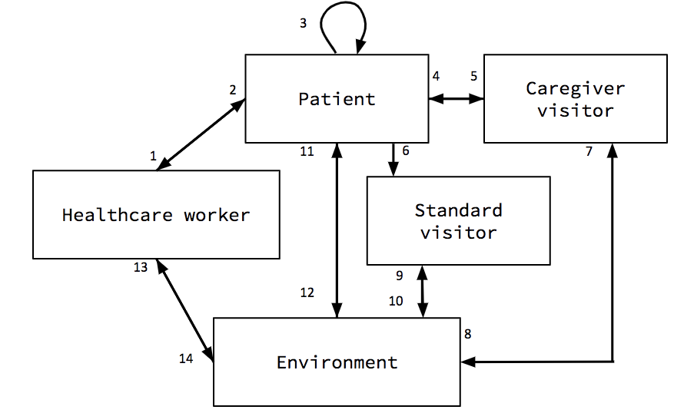
Pathways for C. difficile transmission between patients, healthcare workers, visitors, and the environment. There are 14 interactions in which C. difficile transmission can occur.

Figure S2: Flow diagrams of agent logic

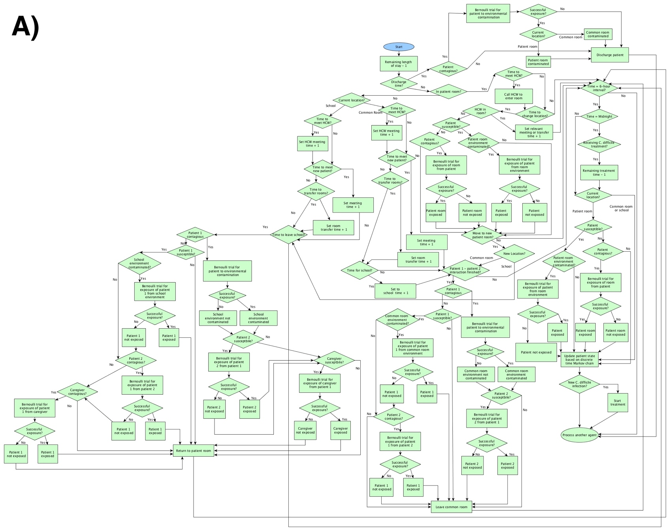
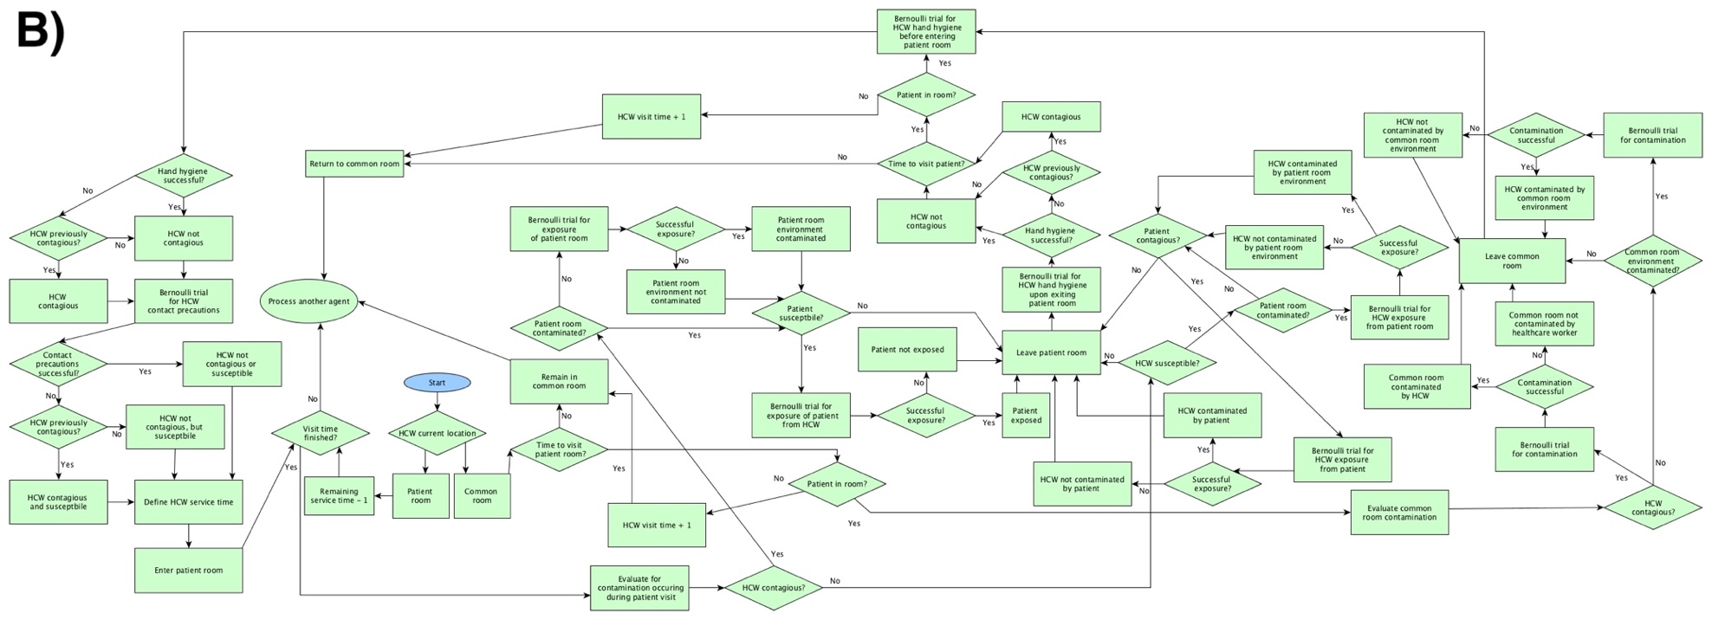
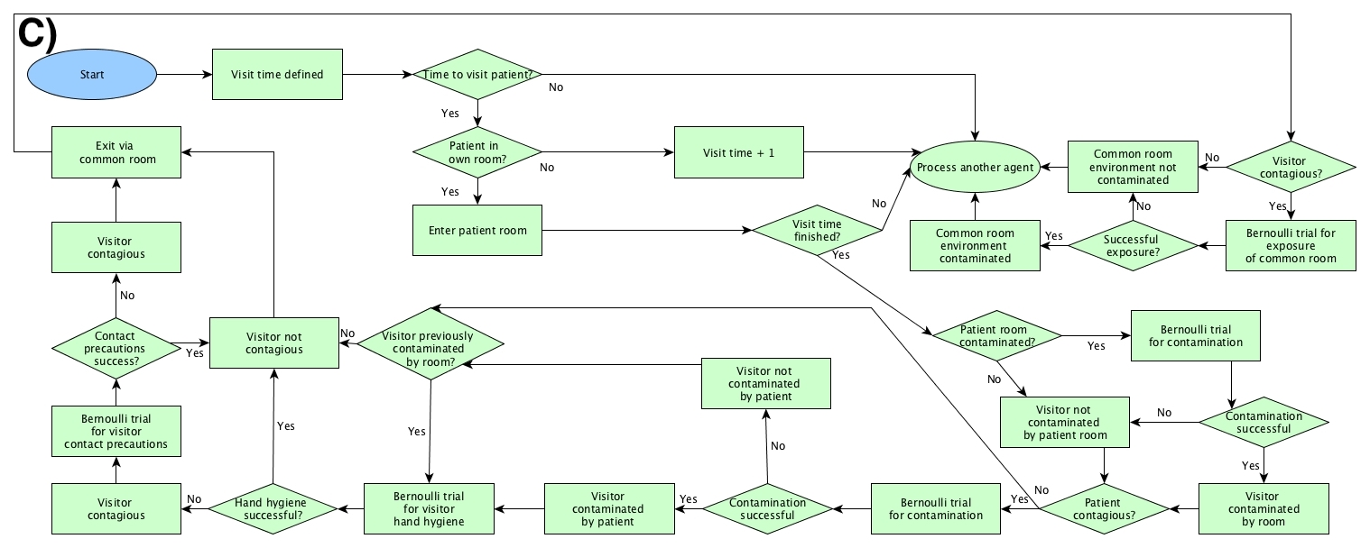
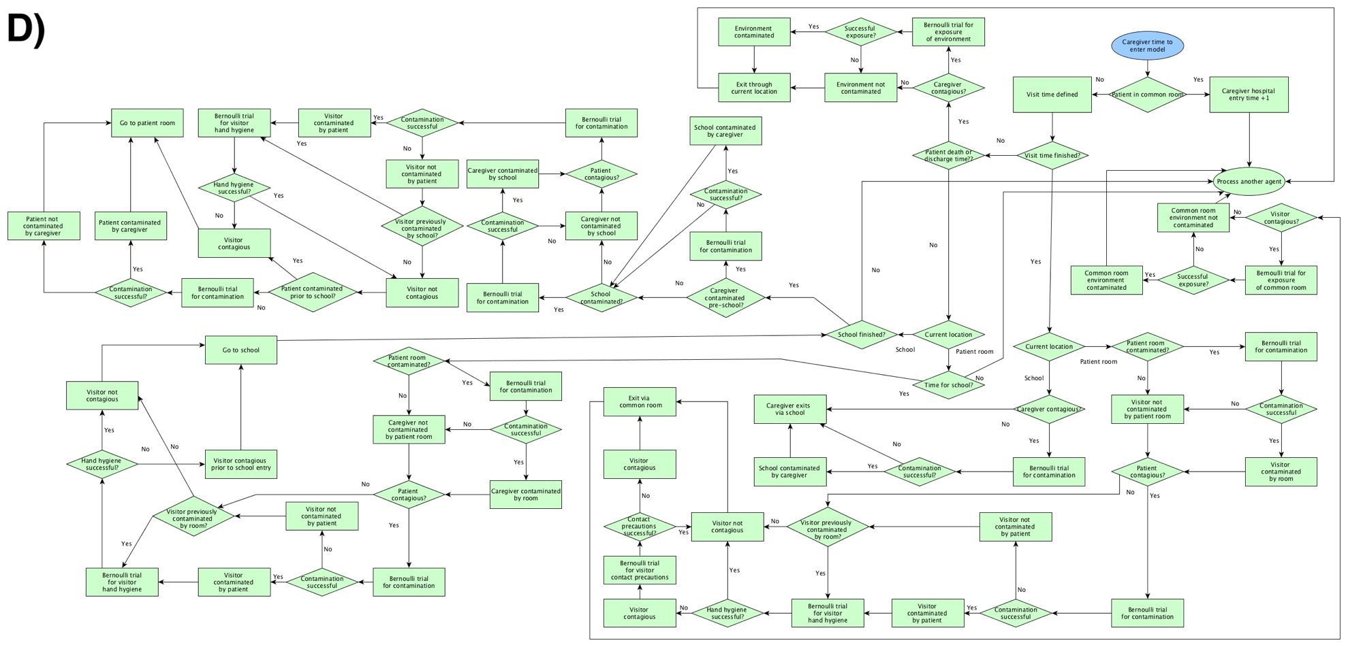

Flow diagrams for A) patient, B) healthcare workers, C) visitor, and D) caregiver model logic. HCW: Healthcare worker; Figures S1.A-C adapted from flow diagrams in Barker et al.²

S5. Patient transfer parameter
Pediatric patient transfer data from the American Family Children’s Hospital in Madison, Wisconsin were abstracted from the University of Wisconsin Hospital and Clinics’ data warehouse and used to create a distribution for patient transfer frequency and timing. Both intra- and inter-ward transfers were evaluated. Data were obtained on all American Family Children’s Hospital inpatient discharges that occurred between October 1 and December 31, 2016. A total of 708 patients were discharged during this time period, of which 24.3% experienced one or more room transfers during their stay. The average time between admission and room transfer or between the initial and a subsequent transfer, normalized to the patient’s total length of stay, was 28% of the patient’s length of stay. Intra-ward transfers accounted for 27.4% of all transfers, compared to 72.6% for inter-ward transfers.

S6. Synchronization
We synchronized common random numbers using the Colt Project’s Mersenne Twister-based pseudorandom number generator.²⁹ The random number generator was employed via the rngs extension in NetLogo. The model relies on 229 random number streams that are reproducible when initialized with the same seed. We assessed the stability of the results for each intervention at iteratively increasing sample sizes (Table S6). The visitor hand hygiene and visitor and healthcare worker contact precautions interventions were ineffective at reducing HO-CDI compared to baseline. Despite our process of synchronizing random numbers, a non-trivial residual effect of chance remains at 5,000 runs for these three interventions because of their negligible clinical effects.

S7. Validation and Verification
Verification of the computerized model was conducted to evaluate whether it was coded properly to reflect the intended simulation.^{30–32} Modeling errors are less likely when a special-purpose simulation language like NetLogo is used, compared to a general purpose higher level programming language or general purpose simulation language.³² Static testing included a structured line-by-line walkthrough of the code. Dynamic testing included the use of animation and traces to detect programing and conceptual errors.
Validation was conducted to determine that the model satisfactorily reproduced the system behavior well enough to produce accurate, credible results.^{31,32} The validation techniques that we employed included face validity, discrete-time Markov chain calibration (discussed in the Supplement section S2), sensitivity analysis, and cross-validation.^{31,32}
Face validation took place throughout the model development process and entailed working with content experts to determine that the model logic, parameters, transmission dynamics, and results were reasonable representations of real-life hospital settings. Sensitivity analyses were conducted to evaluate the effects of variability in six key parameters: nurse and physician service time, the proportion of patients that was asymptomatically colonized and infected at admission, and C. difficile’s person-to-person and person-to-environment transfer efficiency. All nine enhanced level interventions and the no-visitor contact precautions intervention were evaluated by simulating 5,000 runs of each scenario at minimum and maximum values for these key parameter estimates. This resulted in a total of 110,000 runs for each sensitivity analysis (Figure S3).

Table S6: Stability of intervention results for different sample sizes
n (sample size) |  | Baseline | Daily cleaning | HCW contact precautions | HCW hand hygiene | Patient hand hygiene | Patient transfer | Screening | Terminal cleaning | Visitor contact precautions | Visitor hand hygiene
30 | HO-CDI per 10,000 PD | 5.74  (5.02, 6.46) | 3.15  (2.63, 3.67) | 5.86  (5.12, 6.6) | 4.50  (3.96, 5.04) | 5.28  (4.69, 5.87) | 5.24  (4.4, 6.09) | 4.20  (3.61, 4.78) | 5.25  (4.65, 5.85) | 5.80  (5.24, 6.36) | 5.58  (4.88, 6.28)
 | AC per 1,000 admissions | 33.4  (32.26, 34.53) | 8.58  (7.89, 9.28) | 32.86  (31.78, 33.94) | 23.28  (22.18, 24.39) | 29.15  (28.09, 30.21) | 31.40  (30.31, 32.5) | 20.42  (19.16, 21.67) | 24.90  (23.61, 26.18) | 33.30  (32.03, 34.57) | 33.41  (32.17, 34.65)
50 | HO-CDI per 10,000 PD | 5.72  (5.18, 6.27) | 2.91  (2.51, 3.31) | 5.79  (5.24, 6.35) | 4.44  (4.02, 4.86) | 5.30  (4.79, 5.81) | 5.29  (4.71, 5.87) | 4.17  (3.76, 4.59) | 5.03  (4.53, 5.54) | 5.51  (5.04, 5.97) | 5.61  (5.07, 6.16)
 | AC per 1,000 admissions | 33.46  (32.52, 34.41) | 8.67  (8.16, 9.19) | 33.01  (32.12, 33.9) | 23.31  (22.43, 24.19) | 29.06  (28.19, 29.93) | 31.52  (30.57, 32.46) | 20.28  (19.33, 21.22) | 24.97  (24.00, 25.93) | 33.34  (32.34, 34.35) | 33.42  (32.49, 34.34)
75 | HO-CDI per 10,000 PD | 5.73  (5.30, 6.15) | 2.83  (2.53, 3.14) | 5.59  (5.17, 6.01) | 4.59  (4.25, 4.94) | 5.27  (4.87, 5.67) | 5.37  (4.93, 5.80) | 4.01  (3.68, 4.34) | 4.80  (4.41, 5.19) | 5.35  (4.96, 5.73) | 5.40  (4.98, 5.81)
 | AC per 1,000 admissions | 33.2  (32.39, 34.00) | 8.81  (8.35, 9.26) | 32.77  (32.02, 33.52) | 23.37  (22.69, 24.06) | 29.13  (28.44, 29.82) | 31.46  (30.70, 32.23) | 20.46  (19.73, 21.20) | 25.11  (24.39, 25.84) | 33.18  (32.38, 33.98) | 33.15  (32.37, 33.92)
100 | HO-CDI per 10,000 PD | 5.83  (5.44, 6.22) | 2.85  (2.58, 3.12) | 5.58  (5.22, 5.94) | 4.56  (4.25, 4.88) | 5.30  (4.96, 5.64) | 5.51  (5.15, 5.88) | 4.11  (3.82, 4.40) | 4.88  (4.55, 5.22) | 5.44  (5.10, 5.78) | 5.47  (5.11, 5.83)
 | AC per 1,000 admissions | 32.96  (32.29, 33.63) | 8.57  (8.18, 8.96) | 32.44  (31.8, 33.09) | 22.98  (22.39, 23.57) | 28.86  (28.28, 29.44) | 31.20  (30.55, 31.86) | 19.98  (19.31, 20.65) | 24.92  (24.28, 25.57) | 32.92  (32.24, 33.59) | 32.88  (32.22, 33.55)
150 | HO-CDI per 10,000 PD | 5.70  (5.37, 6.03) | 2.85  (2.63, 3.08) | 5.58  (5.27, 5.9) | 4.59  (4.31, 4.87) | 5.25  (4.97, 5.53) | 5.45  (5.16, 5.74) | 4.07  (3.82, 4.32) | 4.78  (4.51, 5.05) | 5.50  (5.20, 5.79) | 5.47  (5.17, 5.77)
 | AC per 1,000 admissions | 32.75  (32.22, 33.27) | 8.51  (8.20, 8.82) | 32.32  (31.80, 32.83) | 22.89  (22.41, 23.36) | 28.58  (28.09, 29.06) | 31.00  (30.47, 31.53) | 19.93  (19.39, 20.48) | 24.73  (24.23, 25.23) | 32.56  (32.02, 33.10) | 32.62  (32.09, 33.15)
200 | HO-CDI per 10,000 PD | 5.62  (5.35, 5.89) | 2.85  (2.66, 3.04) | 5.56  (5.30, 5.83) | 4.57  (4.33, 4.81) | 5.14  (4.91, 5.38) | 5.42  (5.18, 5.66) | 4.09  (3.88, 4.3) | 4.82  (4.58, 5.05) | 5.47  (5.22, 5.72) | 5.60  (5.34, 5.86)
 | AC per 1,000 admissions | 32.58  (32.10, 33.06) | 8.41  (8.15, 8.68) | 32.17  (31.7, 32.64) | 22.65  (22.24, 23.06) | 28.32  (27.88, 28.77) | 30.83  (30.35, 31.32) | 19.77  (19.3, 20.24) | 24.51  (24.07, 24.94) | 32.46  (31.97, 32.94) | 32.47  (31.99, 32.95)
300 | HO-CDI per 10,000 PD | 5.58  (5.36, 5.80) | 2.85  (2.69, 3.00) | 5.5  (5.29, 5.71) | 4.54  (4.35, 4.74) | 5.14  (4.95, 5.33) | 5.36  (5.17, 5.56) | 4.03  (3.86, 4.21) | 4.85  (4.65, 5.04) | 5.51  (5.30, 5.73) | 5.58  (5.36, 5.80)
 | AC per 1,000 admissions | 32.87  (32.46, 33.29) | 8.61  (8.39, 8.83) | 32.46  (32.05, 32.87) | 22.86  (22.52, 23.20) | 28.54  (28.16, 28.92) | 31.04  (30.63, 31.46) | 20.04  (19.66, 20.43) | 24.78  (24.41, 25.15) | 32.72  (32.30, 33.13) | 32.74  (32.33, 33.15)
500 | HO-CDI per 10,000 PD | 5.47  (5.30, 5.63) | 2.78  (2.66, 2.90) | 5.43  (5.27, 5.59) | 4.45  (4.3, 4.6) | 5.06  (4.91, 5.21) | 5.30  (5.14, 5.45) | 3.98  (3.84, 4.12) | 4.78  (4.63, 4.94) | 5.35  (5.19, 5.52) | 5.44  (5.27, 5.61)
 | AC per 1,000 admissions | 32.69  (32.36, 33.01) | 8.61  (8.44, 8.77) | 32.35  (32.02, 32.67) | 22.79  (22.53, 23.06) | 28.49  (28.19, 28.79) | 30.85  (30.54, 31.17) | 20.01  (19.72, 20.31) | 24.73  (24.44, 25.02) | 32.61  (32.29, 32.93) | 32.55  (32.23, 32.86)
750 | HO-CDI per 10,000 PD | 5.47  (5.34, 5.61) | 2.82  (2.72, 2.92) | 5.44  (5.30, 5.57) | 4.45  (4.32, 4.57) | 5.02  (4.90, 5.15) | 5.30  (5.17, 5.43) | 3.93  (3.82, 4.04) | 4.80  (4.67, 4.92) | 5.44  (5.30, 5.58) | 5.46  (5.33, 5.60)
 | AC per 1,000 admissions | 32.75  (32.49, 33.01) | 8.65  (8.52, 8.79) | 32.43  (32.17, 32.69) | 22.88  (22.67, 23.1) | 28.60  (28.36, 28.84) | 30.96  (30.70, 31.21) | 20.07  (19.83, 20.31) | 24.86  (24.63, 25.10) | 32.72  (32.46, 32.98) | 32.68  (32.42, 32.94)
1000 | HO-CDI per 10,000 PD | 5.47  (5.35, 5.58) | 2.85  (2.76, 2.93) | 5.43  (5.32, 5.54) | 4.51  (4.40, 4.61) | 5.02  (4.91, 5.13) | 5.35  (5.23, 5.46) | 3.95  (3.85, 4.05) | 4.80  (4.69, 4.91) | 5.45  (5.33, 5.56) | 5.47  (5.35, 5.58)
 | AC per 1,000 admissions | 32.81  (32.59, 33.03) | 8.64  (8.53, 8.75) | 32.52  (32.3, 32.75) | 22.91  (22.73, 23.10) | 28.62  (28.41, 28.82) | 30.96  (30.74, 31.18) | 20.15  (19.94, 20.36) | 24.90  (24.69, 25.10) | 32.80  (32.57, 33.02) | 32.74  (32.52, 32.96)
1500 | HO-CDI per 10,000 PD | 5.51  (5.42, 5.61) | 2.84  (2.77, 2.91) | 5.46  (5.37, 5.55) | 4.54  (4.45, 4.62) | 5.03  (4.94, 5.12) | 5.36  (5.27, 5.45) | 3.98  (3.9, 4.06) | 4.84  (4.75, 4.93) | 5.47  (5.38, 5.57) | 5.52  (5.43, 5.62)
 | AC per 1,000 admissions | 32.73  (32.55, 32.91) | 8.60  (8.50, 8.69) | 32.48  (32.30, 32.66) | 22.85  (22.70, 23.00) | 28.56  (28.39, 28.73) | 30.91  (30.73, 31.09) | 20.11  (19.94, 20.28) | 24.84  (24.67, 25.01) | 32.74  (32.56, 32.92) | 32.70  (32.52, 32.88)
2000 | HO-CDI per 10,000 PD | 5.49  (5.41, 5.58) | 2.82  (2.76, 2.88) | 5.44  (5.36, 5.53) | 4.52  (4.44, 4.59) | 5.02  (4.94, 5.10) | 5.38  (5.30, 5.46) | 3.95  (3.88, 4.02) | 4.84  (4.77, 4.92) | 5.47  (5.39, 5.55) | 5.50  (5.41, 5.58)
 | AC per 1,000 admissions | 32.73  (32.57, 32.88) | 8.60  (8.53, 8.68) | 32.44  (32.28, 32.60) | 22.86  (22.73, 22.99) | 28.55  (28.41, 28.69) | 30.93  (30.77, 31.08) | 20.09  (19.95, 20.24) | 24.85  (24.70, 24.99) | 32.77  (32.61, 32.92) | 32.70  (32.55, 32.86)
2500 | HO-CDI per 10,000 PD | 5.50  (5.42, 5.57) | 2.83  (2.78, 2.89) | 5.44  (5.36, 5.51) | 4.51  (4.44, 4.57) | 5.02  (4.95, 5.09) | 5.37  (5.30, 5.44) | 3.97  (3.90, 4.03) | 4.83  (4.76, 4.90) | 5.49  (5.41, 5.56) | 5.50  (5.43, 5.58)
 | AC per 1,000 admissions | 32.71  (32.57, 32.85) | 8.62  (8.55, 8.69) | 32.42  (32.28, 32.56) | 22.84  (22.73, 22.96) | 28.55  (28.42, 28.68) | 30.90  (30.76, 31.04) | 20.10  (19.97, 20.24) | 24.83  (24.70, 24.96) | 32.77  (32.63, 32.91) | 32.70  (32.56, 32.84)
3000 | HO-CDI per 10,000 PD | 5.48  (5.41, 5.55) | 2.83  (2.78, 2.88) | 5.42  (5.35, 5.49) | 4.51  (4.45, 4.57) | 5.02  (4.96, 5.08) | 5.36  (5.30, 5.43) | 3.94  (3.88, 3.99) | 4.83  (4.77, 4.90) | 5.49  (5.42, 5.56) | 5.50  (5.44, 5.57)
 | AC per 1,000 admissions | 32.72  (32.59, 32.85) | 8.64  (8.57, 8.70) | 32.43  (32.30, 32.56) | 22.84  (22.73, 22.95) | 28.56  (28.44, 28.68) | 30.89  (30.76, 31.02) | 20.09  (19.97, 20.21) | 24.83  (24.71, 24.95) | 32.77  (32.64, 32.89) | 32.71  (32.58, 32.84)
4000 | HO-CDI per 10,000 PD | 5.50  (5.45, 5.56) | 2.83  (2.79, 2.88) | 5.42  (5.37, 5.48) | 4.49  (4.43, 4.54) | 5.05  (4.99, 5.10) | 5.37  (5.31, 5.43) | 3.95  (3.90  4.00) | 4.84  (4.79, 4.90) | 5.50  (5.44, 5.56) | 5.53  (5.47, 5.59)
 | AC per 1,000 admissions | 32.76  (32.65, 32.88) | 8.66  (8.60, 8.71) | 32.46  (32.34, 32.57) | 22.84  (22.75, 22.94) | 28.57  (28.46, 28.67) | 30.92  (30.81, 31.03) | 20.09  (19.99, 20.20) | 24.84  (24.73, 24.94) | 32.78  (32.67, 32.90) | 32.73  (32.61, 32.84)
5000 | HO-CDI per 10,000 PD | 5.50  (5.45, 5.56) | 2.83  (2.80, 2.87) | 5.43  (5.38, 5.48) | 4.46  (4.41, 4.51) | 5.04  (4.99, 5.09) | 5.35  (5.30, 5.40) | 3.93  (3.89, 3.98) | 4.84  (4.79, 4.89) | 5.50  (5.45, 5.55) | 5.52  (5.46, 5.57)
 | AC per 1,000 admissions | 32.73  (32.63, 32.83) | 8.65  (8.59, 8.70) | 32.40  (32.30, 32.50) | 22.81  (22.73, 22.89) | 28.54  (28.45, 28.63) | 30.88  (30.78, 30.98) | 20.09  (20.00, 20.19) | 24.81  (24.72, 24.90) | 32.74  (32.64, 32.84) | 32.68  (32.59, 32.78)

AC: Asymptomatic colonization, HO-CDI: Hospital onset C. difficile infection, HCW: Healthcare worker

Figure S3: Sensitivity analyses for six key parameters in the pediatric agent-based model of C. difficile transmission

We evaluate the comparative intervention effectiveness for six key parameters: A and B) the proportion infected and colonized at admission: 0.27% infected and 6% colonized (left) and 0.31% infected and 13% colonized (right); C and D) nursing service time: 3 minutes (left) and 7 minutes (right); E and F) doctor service time: 4 minutes (left) and 14 minutes (right); G and H) C. difficile spore transfer efficiency environment:person: 29% (left) and 59% (right); I) and J) C. difficile spore transfer efficiency person:person: 15% (left) and 45% (right).
The proportion of patients asymptomatically colonized and infected at admission are both dependent upon the prevalence of C. difficile in a hospital’s surrounding community and the community’s level of interaction with the healthcare system. Thus, we assumed that asymptomatic colonization and infection rates at admission are correlated and we varied these two parameters simultaneously. The parameters for the proportion of patients colonized, infected, and susceptible at admission sum to one for all model runs. Therefore, varying the parameter estimates for colonization and infection at admission also inherently changed the parameter estimate for the proportion of susceptible patients at admission (Figure S3).
Studies evaluating C. difficile interventions in the pediatric context are extremely limited.³³ Cross-validation was conducted using the results from the only two relevant intervention bundles described in the literature (See Supplement section S8).^{34,35} Additional pediatric C. difficile intervention studies in the literature have focused on antibiotic stewardship,³⁶ probiotic use,^{37–39} and workflow changes to reduce symptomatic testing.^{40–42}

S8. Cross validation
The study by Ramphal, et al. found a 22% reduction in CDI, compared to 49% in our model (Table S7).³⁴ There are two main factors that may have contributed to our overestimation. First, the pre-intervention rate of 2.7 HO-CDI per 10,000 patient days in the study hospital was much lower than the average hospital rate that we modeled (5.50 HO-CDI per 10,000 patient days). Interventions have non-linear effects, such that it is easier to reduce HO-CDI from 20.0 to 15.0 cases per 10,000 patient days, than from 8.0 to 3.0. It is likely that the reported reduction would be larger if the intervention had been conducted in a patient population and context more similar to our simulation. Second, the timing of pre- and post-intervention data were not provided. It is unclear if they were the maximum, minimum, or average rates over the study period, which complicates comparison with our simulated data.
Flesch, et al. reported the same study twice, both times in abstract form only.^{35,43} Given the abstracts’ inherent lack of intervention descriptions, it was not surprising that this study was underestimated by our model. They found a 79% reduction, compared to 58% predicted (Table S7). The authors state that healthcare worker hand hygiene was implemented with other interventions, however, these are not described in detail. Bleach terminal cleaning and an education campaign were implemented prior to the hand hygiene intervention, but it is unclear if the 16.8 cases per 10,000 patient days baseline comparison rate reported in the second abstract refers to a period before any intervention was implemented or just prior to healthcare worker hand hygiene.⁴³ If their reduction includes the effects of implementation of all interventions, then it is not surprising that our single-intervention healthcare worker hand hygiene simulation underestimates the reported effect. Furthermore, the study took place on a BMT unit, with a much higher baseline rate of HO-CDI in that population. We may have had a more similar reduction in HO-CDI, had the study taken place in the hospital-wide setting that we modeled.

Table S7: Studies for cross-validation testing of the pediatrics agent-based model
Study | Population | Intervention (Bundle) | Study HO-CDI rate per 10,000 patient days |  |  | Simulated HO-CDI rate per 10,000 patient days
 |  |  | Baseline | Intervention | Reduct-ion | Baseline | Interven-tion | Reduct-ion
Ramphal³⁴ | Cook Children’s Hospital, Fort Worth, Texas; 2012-2013 | Daily and terminal cleaning | 2.7 | 2.1; Concurrent nursing education intervention | 22% | 5.50 (5.45, 5.56) | 2.80 (2.77, 2.84) | 49%
Flesch⁴³ | 24-bed BMT unit; Cincinnati Children’s Hospital Medical Center, Cincinnati, Ohio; 2009 - 2010 | Healthcare worker hand hygiene | 16.8; Non-sporicidal daily cleaning in all rooms | 3.5; Non-sporicidal daily cleaning and healthcare worker soap and water HH in all rooms | 79% | 6.33 (6.27, 6.39) | 2.66 (2.63, 2.70) | 58%
BMT: Bone marrow transplant

Supplement references
1. Codella J, Safdar N, Heffernan R, Alagoz O. An agent-based simulation model for Clostridium difficile infection control. Med Decis Making. 2015;35:211-229.
2. Barker AK, Alagoz O, Safdar N. Interventions to reduce the incidence of hospital-onset Clostridium difficile infection: An agent-based modeling approach to evaluate clinical effectiveness in adult acute care hospitals. Clin Infect Dis. 2018;66:1192-1203.
3. Cohen B, Hyman S, Rosenberg L, Larson E. Frequency of Patient Contact with Health Care Personnel and Visitors: Implications for Infection Prevention. Jt Comm J Qual Patient Saf. 2012;38:560-565.
4. Lessa FC, Mu Y, Bamberg WM, et al. Burden of Clostridium difficile Infection in the United States. New England J Med. 2015;372:825-834.
5. Loo VG, Bourgault A-M, Poirier L, et al. Host and Pathogen Factors for Clostridium difficile Infection and Colonization. New England J Med. 2011;365:1693-1703.
6. Penders J, Vink C, Driessen C, London N, Thijs C, Stobberingh EE. Quantification of Bifidobacterium spp., Escherichia coli and Clostridium difficile in faecal samples of breast-fed and formula-fed infants by real-time PCR. FEMS Microbiology Letters. 2005;243:141-147.
7. Tonooka T, Sakata S, Kitahara M, et al. Detection and Quantification of Four Species of the Genus Clostridium in Infant Feces. Microbiol Immunol. 2005;49:987-992.
8. Tullus K, Aronsson B, Marcus S, Möllby R. Intestinal colonization with Clostridium difficile in infants up to 18 months of age. Eur J Clin Microbiol Infect Dis. 1989;8:390-393.
9. Rousseau C, Poilane I, De Pontual L, Maherault A-C, Le Monnier A, Collignon A. Clostridium difficile Carriage in Healthy Infants in the Community: A Potential Reservoir for Pathogenic Strains. Clin Infect Dis. 2012;55:1209-1215.
10. Adlerberth I, Huang H, Lindberg E, et al. Toxin-Producing Clostridium difficile Strains as Long-Term Gut Colonizers in Healthy Infants. J Clin Microbiol. 2014;52:173-179.
11. Jangi S, Lamont JT. Asymptomatic colonization by Clostridium difficile in infants: implications for disease in later life. J Pediatr Gastroenterol Nutr. 2010;51:2-7.
12. Koletzko S, Osterrieder S. Acute Infectious Diarrhea in Children. Dtsch Arztebl Int. 2009;106:539-548.
13. Tabak YP, Zilberberg MD, Johannes RS, Sun X, McDonald LC. Attributable burden of hospital-onset Clostridium difficile infection: a propensity score matching study. Infect Control Hosp Epidemiol. 2013;34:588-596.
14. Deshpande A, Pant C, Anderson MP, Donskey CJ, Sferra TJ. Clostridium difficile infection in the hospitalized pediatric population: increasing trend in disease incidence. Pediatr Infect Dis J. 2013;32:1138-1140.
15. Schwartz KL, Darwish I, Richardson SE, Mulvey MR, Thampi N. Severe clinical outcome is uncommon in Clostridium difficile infection in children: a retrospective cohort study. BMC Pediatrics. 2014;14:28.
16. Pai S, Aliyu SH, Enoch DA, Karas JA. Five years experience of Clostridium difficile infection in children at a UK tertiary hospital: proposed criteria for diagnosis and management. PLoS ONE. 2012;7:e51728.
17. Nylund CM, Goudie A, Garza JM, Fairbrother G, Cohen MB. Clostridium difficile Infection in Hospitalized Children in the United States. Arch Pediatr Adolesc Med. 2011;165:451-457.
18. Yu H, Wier LM, Elixhauser A. Hospital Stays for Children, 2009: Statistical Brief #118. In: Healthcare Cost and Utilization Project (HCUP) Statistical Briefs. Rockville (MD): Agency for Healthcare Research and Quality (US); 2011. http://www.ncbi.nlm.nih.gov/books/NBK65134/. Accessed February 7, 2018.
19. Kim J, Smathers SA, Prasad P, Leckerman KH, Coffin S, Zaoutis T. Epidemiological features of Clostridium difficile-associated disease among inpatients at children’s hospitals in the United States, 2001-2006. Pediatrics. 2008;122:1266-1270.
20. Zilberberg MD, Tillotson GS, McDonald C. Clostridium difficile infections among hospitalized children, United States, 1997-2006. Emerging Infect Dis. 2010;16(4):604-609.
21. Sammons JS, Toltzis P, Zaoutis TE. Clostridium difficile Infection in Children. JAMA Pediatr. 2013;167:567-573.
22. Vendetti N, Zaoutis T, Coffin SE, Sammons JS. Risk factors for in-hospital mortality among a cohort of children with Clostridium difficile infection. Infect Control Hosp Epidemiol. 2015;36:1183-1189.
23. Witt W, Weiss A, Elixhauser A. Overview of Hospital Stays for Children in the United States, 2012. December 2014. https://www.hcup-us.ahrq.gov/reports/statbriefs/sb187-Hospital-Stays-Children-2012.pdf. Accessed May 21, 2019.
24. Schutze GE, Willoughby RE, Committee on Infectious Diseases, et al. Clostridium difficile Infection in Infants and Children. Pediatrics. 2013;131:196-200.
25. Yatsunenko T, Rey FE, Manary MJ, et al. Human gut microbiome viewed across age and geography. Nature. 2012;486:222-227.
26. Matamoros S, Gras-Leguen C, Le Vacon F, Potel G, de La Cochetiere M-F. Development of intestinal microbiota in infants and its impact on health. Trends Microbiol. 2013;21:167-173.
27. Rodríguez JM, Murphy K, Stanton C, et al. The composition of the gut microbiota throughout life, with an emphasis on early life. Microb Ecol Health Dis. 2015;26:26050.
28. Lees EA, Miyajima F, Pirmohamed M, Carrol ED. The role of Clostridium difficile in the paediatric and neonatal gut — a narrative review. Eur J Clin Microbiol Infect Dis. 2016;35:1047-1057.
29. C CERN European Organization for Nuclear Research. Colt. 2017; Available at: http://dst.lbl.gov/ACSSoftware/colt/. Accessed 4 May 2017.
30. Maria A. Introduction to Modeling and Simulation. In: Proceedings of the 29th Conference on Winter Simulation. WSC ’97. Washington, DC, USA: IEEE Computer Society; 1997:7–13.
31. Kleijnen JPC. Verification and validation of simulation models. European Journal of Operational Research. 1995;82:145-162.
32. Sargent RG. Verification and validation of simulation models. J Simulation. 2013;7:12-24.
33. McFarland LV, Ozen M, Dinleyici EC, Goh S. Comparison of pediatric and adult antibiotic-associated diarrhea and Clostridium difficile infections. World J Gastroenterol. 2016;22:3078-3104.
34. Ramphal L, Suzuki S, McCracken IM, Addai A. Improving hospital staff compliance with environmental cleaning behavior. Proc (Bayl Univ Med Cent). 2014;27:88-91.
35. Flesch L, Connelly B, Hayward M, et al. Experience with a Simple Intervention to Decrease Clostridium Difficile Infections (CDIs) on a Bone Marrow Transplant Unit. Biology of Blood and Marrow Transplantation. 2012;18:S396.
36. Yu D, Lee B, Newland J, Goldman J. Clostridium difficile Infection Rates in a Children’s Hospital With an Antimicrobial Stewardship Program. Open Forum Infect Dis. 2015;2:S1467.
37. Shan L-S, Hou P, Wang Z-J, et al. Prevention and treatment of diarrhoea with Saccharomyces boulardii in children with acute lower respiratory tract infections. Benef Microbes. 2013;4:329-334.
38. Arvola T, Laiho K, Torkkeli S, et al. Prophylactic Lactobacillus GG reduces antibiotic-associated diarrhea in children with respiratory infections: a randomized study. Pediatrics. 1999;104:e64.
39. Johnston BC, Goldenberg JZ, Vandvik PO, Sun X, Guyatt GH. Probiotics for the prevention of pediatric antibiotic-associated diarrhea. Cochrane Database Syst Rev. 2011;11:CD004827.
40. Nicholson MR, Freswick PN, Di Pentima MC, et al. The Use of a Computerized Provider Order Entry Alert to Decrease Rates of Clostridium difficile Testing in Young Pediatric Patients. Infect Control Hosp Epidemiol. 2017;38:542-546.
41. Kociolek LK, Bovee M, Carter D, et al. Impact of a Healthcare Provider Educational Intervention on Frequency of Clostridium difficile Polymerase Chain Reaction Testing in Children: A Segmented Regression Analysis. J Pediatric Infect Dis Soc. 2017;6:142-148.
42. Klatte JM, Selvarangan R, Jackson MA, Myers AL. Reducing Overutilization of Testing for Clostridium difficile Infection in a Pediatric Hospital System: A Quality Improvement Initiative. Hosp Pediatr. 2016;6:9-14.
43. Flesch L, Hayward M, Demmel K, Brown R, Cloughessy M. Away with the Alcohol: The Impact on Clostridium Difficile Infection (CDI) Rate on a Complex Bone Marrow Transplant Unit. Biology of Blood and Marrow Transplantation. 2014;20:S103.

Additional References, Tables 2 and 3
1. Agency for Healthcare Research and Quality. Healthcare Cost and Utilization Project Statistical Brief #180: Overview of Hospital stays in the United States, 2012. 2012. https://www.hcup-us.ahrq.gov/reports/statbriefs/sb180-Hospitalizations-United-States-2012.pdf. Accessed May 21, 2019.
2. Witt W, Weiss A, Elixhauser A. Overview of Hospital Stays for Children in the United States, 2012. December 2014. https://www.hcup-us.ahrq.gov/reports/statbriefs/sb187-Hospital-Stays-Children-2012.pdf. Accessed May 21, 2019.
3. National Center for Health Statistics, Centers for Disease Control. Number, rate, and average length of stay for discharges from short-stay hospitals, by age, region, and sex: United States, 2010. 2010. https://www.cdc.gov/nchs/nchs_for_you/general_public.htm. Accessed May 21, 2019.
4. American Hospital Association. AHA Hospital Statistics, 2016 Edition. 2016.
5. Centers for Disease Control. Table 89. Hospitals, beds, and occupancy rates, by type of ownership and size of hospital: United States, selected years 1975–2013. 2015. https://www.cdc.gov/nchs/data/hus/2015/089.pdf. Accessed May 21, 2019.
6. Rubin MA, Jones M, Leecaster M, et al. A Simulation-Based Assessment of Strategies to Control Clostridium Difficile Transmission and Infection. PLoS ONE. 2013;8:e80671.
7. McArdle FI, Lee RJ, Gibb AP, Walsh TS. How much time is needed for hand hygiene in intensive care? A prospective trained observer study of rates of contact between healthcare workers and intensive care patients. J Hosp Infect. 2006;62:304-310.
8. Cohen B, Hyman S, Rosenberg L, Larson E. Frequency of Patient Contact with Health Care Personnel and Visitors: Implications for Infection Prevention. Jt Comm J Qual Patient Saf. 2012;38:560-565.
9. Morgan DJ, Pineles L, Shardell M, et al. The effect of contact precautions on healthcare worker activity in acute care hospitals. Infect Control Hosp Epidemiol. 2013;34:69-73.
10. Cohen SH, Gerding DN, Johnson S, et al. Clinical practice guidelines for Clostridium difficile infection in adults: 2010 update by the society for healthcare epidemiology of America (SHEA) and the infectious diseases society of America (IDSA). Infect Control Hosp Epidemiol. 2010;31:431-455.
11. Louie TJ, Miller MA, Mullane KM, et al. Fidaxomicin versus vancomycin for Clostridium difficile infection. N Engl J Med. 2011;364:422-431.
12. Cornely OA, Crook DW, Esposito R, et al. Fidaxomicin versus vancomycin for infection with Clostridium difficile in Europe, Canada, and the USA: a double-blind, non-inferiority, randomised controlled trial. Lancet Infect Dis. 2012;12:281-289.
13. Musher DM, Logan N, Bressler AM, Johnson DP, Rossignol J-F. Nitazoxanide versus Vancomycin in Clostridium difficile Infection: A Randomized, Double-Blind Study. Clin Infect Dis. 2009;48:e41-e46.
14. Johnson S, Louie TJ, Gerding DN, et al. Vancomycin, metronidazole, or tolevamer for Clostridium difficile infection: results from two multinational, randomized, controlled trials. Clin Infect Dis. 2014;59:345-354.
15. California Code of Regulations. Nurse service staff 2003. 22 C.C.R., Sec. 70217. July 2003. https://govt.westlaw.com/calregs/Document/I8612C410941F11E29091E6B951DDF6CE?viewType=FullText&originationContext=documenttoc&transitionType=CategoryPageItem&contextData=(sc.Default&bhcp=1. Accessed May 21, 2019.
16. Spetz J, Donaldson N, Aydin C, Brown DS. How Many Nurses per Patient? Measurements of Nurse Staffing in Health Services Research. Health Serv Res. 2008;43:1674-1692.
17. Aiken LH, Clarke SP, Sloane DM, Sochalski J, Silber JH. Hospital Nurse Staffing and Patient Mortality, Nurse Burnout, and Job Dissatisfaction. JAMA. 2002;288:1987-1993.
18. Evans HL, Shaffer MM, Hughes MG, et al. Contact isolation in surgical patients: A barrier to care? Surgery. 2003;134:180-188.
19. Barker AK, Codella J, Ewers T, Dundon A, Alagoz O, Safdar N. Changes to physician and nurse time burdens when caring for patients under contact precautions. Am J Infect Control. 2017;45:542-543.
20. Cross KW, Turner RD. Factors affecting the visiting pattern of geriatric patients in a rural area. Br J Prev Soc Med. 1974;28:133-139.
21. Eriksson T, Bergbom I. Visits to intensive care unit patients--frequency, duration and impact on outcome. Nurs Crit Care. 2007;12:20-26.
22. Gonzalez CE, Carroll DL, Elliott JS, Fitzgerald PA, Vallent HJ. Visiting preferences of patients in the intensive care unit and in a complex care medical unit. Am J Crit Care. 2004;13:194-198.
23. Fumagalli S, Boncinelli L, Lo Nostro A, et al. Reduced cardiocirculatory complications with unrestrictive visiting policy in an intensive care unit: results from a pilot, randomized trial. Circulation. 2006;113:946-952.
24. Latva R, Lehtonen L, Salmelin RK, Tamminen T. Visits by the family to the neonatal intensive care unit. Acta Paediatr. 2007;96:215-220.
25. Yu H, Wier LM, Elixhauser A. Hospital Stays for Children, 2009: Statistical Brief #118. In: Healthcare Cost and Utilization Project (HCUP) Statistical Briefs. Rockville (MD): Agency for Healthcare Research and Quality (US); 2011. http://www.ncbi.nlm.nih.gov/books/NBK65134/. Accessed February 7, 2018.
26. Rousseau C, Poilane I, De Pontual L, Maherault A-C, Le Monnier A, Collignon A. Clostridium difficile Carriage in Healthy Infants in the Community: A Potential Reservoir for Pathogenic Strains. Clin Infect Dis. 2012;55:1209-1215.
27. Adlerberth I, Huang H, Lindberg E, et al. Toxin-Producing Clostridium difficile Strains as Long-Term Gut Colonizers in Healthy Infants. J Clin Microbiol. 2014;52:173-179.
28. Penders J, Vink C, Driessen C, London N, Thijs C, Stobberingh EE. Quantification of Bifidobacterium spp., Escherichia coli and Clostridium difficile in faecal samples of breast-fed and formula-fed infants by real-time PCR. FEMS Microbiol Lett. 2005;243:141-147.
29. Weiss A, Elixhauser A. Overview of Hospital Stays in the United States, 2012. October 2014. https://www.hcup-us.ahrq.gov/reports/statbriefs/sb180-Hospitalizations-United-States-2012.pdf. Accessed May 21, 2019.
30. Agency for Healthcare Research and Quality. Care of children and adolescents in U.S. Hospitals: HCUP Fact Book. https://archive.ahrq.gov/data/hcup/factbk4/factbk4.htm. Accessed May 21, 2019.
31. Tonooka T, Sakata S, Kitahara M, et al. Detection and Quantification of Four Species of the Genus Clostridium in Infant Feces. Microbiol Immunol. 2005;49:987-992.
32. Stoesser N, Crook DW, Fung R, et al. Molecular Epidemiology of Clostridium difficile Strains in Children Compared with That of Strains Circulating in Adults with Clostridium difficile-Associated Infection. J Clin Microbiol. 2011;49:3994-3996.
33. Zilberberg MD, Tillotson GS, McDonald C. Clostridium difficile infections among hospitalized children, United States, 1997-2006. Emerg Infect Dis. 2010;16:604-609.
34. Jabbar U, Leischner J, Kasper D, et al. Effectiveness of alcohol-based hand rubs for removal of Clostridium difficile spores from hands. Infect Control Hosp Epidemiol. 2010;31:565-570.
35. Lopez GU, Gerba CP, Tamimi AH, Kitajima M, Maxwell SL, Rose JB. Transfer Efficiency of Bacteria and Viruses from Porous and Nonporous Fomites to Fingers under Different Relative Humidity Conditions. Appl Environ Microbiol. 2013;79:5728-5734.
36. Barker AK, Zellmer C, Tischendorf J, et al. On the hands of patients with Clostridium difficile: A study of spore prevalence and the effect of hand hygiene on C difficile removal. Am J Infect Control. 2017;45:1154-1156.
37. Bobulsky GS, Al-Nassir WN, Riggs MM, Sethi AK, Donskey CJ. Clostridium difficile skin contamination in patients with C. difficile-associated disease. Clin Infect Dis. 2008;46:447-450.
38. Sethi AK, Al-Nassir WN, Nerandzic MM, et al. Persistence of Skin Contamination and Environmental Shedding of Clostridium difficile during and after Treatment of C. difficile Infection. Infect Control Hosp Epidemiol. 2010;31:21-27.
39. McFarland LV, Mulligan ME, Kwok RYY, Stamm WE. Nosocomial Acquisition of Clostridium difficile Infection. N Engl J Med. 1989;320:204-210.
40. Struelens MJ, Maas A, Nonhoff C, et al. Control of nosocomial transmission of Clostridium difficile based on sporadic case surveillance. Am J Med. 1991;91:S138-S144.
41. Eckstein BC, Adams DA, Eckstein EC, et al. Reduction of Clostridium Difficile and vancomycin-resistant Enterococcus contamination of environmental surfaces after an intervention to improve cleaning methods. BMC Infect Dis. 2007;7:61.
42. Faires MC, Pearl DL, Berke O, Reid-Smith RJ, Weese JS. The identification and epidemiology of meticillin-resistant Staphylococcus aureus and Clostridium difficile in patient rooms and the ward environment. BMC Infect Dis. 2013;13:342.
43. Dubberke ER, Reske KA, Noble-Wang J, et al. Prevalence of Clostridium difficile environmental contamination and strain variability in multiple health care facilities. Am J Infect Control. 2007;35:315-318.
44. Bettin K, Clabots C, Mathie P, Willard K, Gerding DN. Effectiveness of Liquid Soap vs. Chlorhexidine Gluconate for the Removal of Clostridium Difficile from Bare Hands and Gloved Hands. Infect Control Hosp Epidemiol. 1994;15:697-702.
45. Oughton MT, Loo VG, Dendukuri N, Fenn S, Libman MD. Hand Hygiene with Soap and Water Is Superior to Alcohol Rub and Antiseptic Wipes for Removal of Clostridium difficile. Infect Control Hosp Epidemiol. 2009;30:939-944.
46. Edmonds SL, Zapka C, Kasper D, et al. Effectiveness of hand hygiene for removal of Clostridium difficile spores from hands. Infect Control Hosp Epidemiol. 2013;3:302-305.
47. Dierssen-Sotos T, Brugos-Llamazares V, Robles-García M, et al. Evaluating the impact of a hand hygiene campaign on improving adherence. Am J Infect Control. 2010;38:240-243.
48. Randle J, Firth J, Vaughan N. An observational study of hand hygiene compliance in paediatric wards. J Clin Nurs. 2013;22:2586-2592.
49. Monistrol O, Calbo E, Riera M, et al. Impact of a hand hygiene educational programme on hospital-acquired infections in medical wards. Clin Microbiol Infect. 2012;18:1212-1218.
50. Tromp M, Huis A, de Guchteneire I, et al. The short-term and long-term effectiveness of a multidisciplinary hand hygiene improvement program. Am J Infect Control. 2012;40:732-736.
51. Kowitt B, Jefferson J, Mermel LA. Factors associated with hand hygiene compliance at a tertiary care teaching hospital. Infect Control Hosp Epidemiol. 2013;34:1146-1152.
52. Mestre G, Berbel C, Tortajada P, et al. “The 3/3 Strategy”: A Successful Multifaceted Hospital Wide Hand Hygiene Intervention Based on WHO and Continuous Quality Improvement Methodology. PLOS ONE. 2012;7:e47200.
53. Eldridge NE, Woods SS, Bonello RS, et al. Using the Six Sigma Process to Implement the Centers for Disease Control and Prevention Guideline for Hand Hygiene in 4 Intensive Care Units. J Gen Intern Med. 2006;21:S35-S42.
54. Zerr DM, Allpress AL, Heath J, Bornemann R, Bennett E. Decreasing hospital-associated rotavirus infection: a multidisciplinary hand hygiene campaign in a children’s hospital. Pediatr Infect Dis J. 2005;24:397-403.
55. Mayer J, Mooney B, Gundlapalli A, et al. Dissemination and sustainability of a hospital-wide hand hygiene program emphasizing positive reinforcement. Infect Control Hosp Epidemiol. 2011;32:59-66.
56. Muto CA, Blank MK, Marsh JW, et al. Control of an Outbreak of Infection with the Hypervirulent Clostridium difficile BI Strain in a University Hospital Using a Comprehensive “Bundle” Approach. Clin Infect Dis. 2007;45:1266-1273.
57. Grant AM, Hofmann DA. It’s Not All About Me: Motivating Hand Hygiene Among Health Care Professionals by Focusing on Patients. Psychol Sci. 2011;22:1494-1499.
58. Crews JD, Whaley E, Syblik D, Starke J. Sustained Improvement in Hand Hygiene at a Children’s Hospital. Infect Control Hosp Epidemiol. 2013;34:751-753.
59. Grayson ML, Russo PL, Cruickshank M, et al. Outcomes from the first 2 years of the Australian National Hand Hygiene Initiative. Med J Aust. 2011;195:615-619.
60. Pittet D, Simon A, Hugonnet S, Pessoa-Silva CL, Sauvan V, Perneger TV. Hand hygiene among physicians: performance, beliefs, and perceptions. Ann Intern Med. 2004;141:1-8.
61. Clock SA, Cohen B, Behta M, Ross B, Larson EL. Contact Precautions for Multidrug-Resistant Organisms (MDROs): Current Recommendations and Actual Practice. Am J Infect Control. 2010;38:105-111.
62. Birnbach DJ, Rosen LF, Fitzpatrick M, Arheart KL, Munoz-Price LS. An evaluation of hand hygiene in an intensive care unit: Are visitors a potential vector for pathogens? J Infect Public Health. 2015;8:570-574.
63. Randle J, Arthur A, Vaughan N, Wharrad H, Windle R. An observational study of hand hygiene adherence following the introduction of an education intervention. J Infect Prev. 2014;15:142-147.
64. Birnbach DJ, Nevo I, Barnes S, et al. Do hospital visitors wash their hands? Assessing the use of alcohol-based hand sanitizer in a hospital lobby. Am J Infect Control. 2012;40:340-343.
65. Caroe Aarestrup S, Moesgaard F, Schuldt-Jensen J. Nudging hospital visitors’ hand hygiene compliance. 2016. Available at: http://inudgeyou.com/wp-content/ uploads/2016/05/Hand_Hygiene.pdf. Accessed 25 March 2017.
66. Nishimura S, Kagehira M, Kono F, Nishimura M, Taenaka N. Handwashing before entering the intensive care unit: What we learned from continuous video-camera surveillance. Am J Infect Control. 1999;27:367-369.
67. Randle J, Arthur A, Vaughan N. Twenty-four-hour observational study of hospital hand hygiene compliance. J Hosp Infect. 2010;76:252-255.
68. Davis C. Infection-free surgery: how to improve hand-hygiene compliance and eradicate methicillin-resistant Staphylococcus aureus from surgical wards. Ann R Coll Surg Engl. 2010;92:316-319.
69. Srigley JA, Furness CD, Gardam M. Measurement of Patient Hand Hygiene in Multiorgan Transplant Units Using a Novel Technology: An Observational Study. Infect Control Hosp Epidemiol. 2014;35:1336-1341.
70. Cheng VCC, Wu AKL, Cheung CHY, et al. Outbreak of human metapneumovirus infection in psychiatric inpatients: implications for directly observed use of alcohol hand rub in prevention of nosocomial outbreaks. J Hosp Infect. 2007;67:336-343.
71. Hedin G, Blomkvist A, Janson M, Lindblom A. Occurrence of potentially pathogenic bacteria on the hands of hospital patients before and after the introduction of patient hand disinfection. APMIS. 2012;120:802-807.
72. Gagné D, Bédard G, Maziade PJ. Systematic patients’ hand disinfection: impact on meticillin-resistant Staphylococcus aureus infection rates in a community hospital. J Hosp Infect. 2010;75:269-272.
73. Golan Y, Doron S, Griffith J, et al. The Impact of Gown-Use Requirement on Hand Hygiene Compliance. Clin Infect Dis. 2006;42:370-376.
74. Swoboda SM, Earsing K, Strauss K, Lane S, Lipsett PA. Isolation status and voice prompts improve hand hygiene. Am J Infect Control. 2007;35:470-476.
75. Almaguer-Leyva M, Mendoza-Flores L, Medina-Torres AG, et al. Hand hygiene compliance in patients under contact precautions and in the general hospital population. Am J Infect Control. 2013;41:976-978.
76. Zellmer C, Blakney R, Van Hoof S, Safdar N. Impact of sink location on hand hygiene compliance for Clostridium difficile infection. Am J Infect Control. 2015;43:387-389.
77. Morgan DJ, Rogawski E, Thom KA, et al. Transfer of multidrug-resistant bacteria to healthcare workers’ gloves and gowns after patient contact increases with environmental contamination. Crit Care Med. 2012;40:1045-1051.
78. Landelle C, Verachten M, Legrand P, Girou E, Barbut F, Buisson CB. Contamination of Healthcare Workers’ Hands with Clostridium difficile Spores after Caring for Patients with C. difficile Infection. Infect Control Hosp Epidemiol. 2014;35:10-15.
79. Tomas ME, Kundrapu S, Thota P, et al. Contamination of Health Care Personnel During Removal of Personal Protective Equipment. JAMA Intern Med. 2015;175:1904-1910.
80. Weber DJ, Sickbert-Bennett EE, Brown VM, et al. Compliance With Isolation Precautions at a University Hospital. Infect Control Amp Hosp Epidemiol. 2007;28:358-361.
81. Manian FA, Ponzillo JJ. Compliance with routine use of gowns by healthcare workers (HCWs) and non-HCW visitors on entry into the rooms of patients under contact precautions. Infect Control Hosp Epidemiol. 2007;28:337-340.
82. Bearman GML, Marra AR, Sessler CN, et al. A controlled trial of universal gloving versus contact precautions for preventing the transmission of multidrug-resistant organisms. Am J Infect Control. 2007;35:650-655.
83. Bearman G, Rosato AE, Duane TM, et al. Trial of Universal Gloving with Emollient‐Impregnated Gloves to Promote Skin Health and Prevent the Transmission of Multidrug‐Resistant Organisms in a Surgical Intensive Care Unit. Infect Control Hosp Epidemiol. 2010;31:491-497.
84. Deyneko A, Cordeiro F, Berlin L, Ben-David D, Perna S, Longtin Y. Impact of sink location on hand hygiene compliance after care of patients with Clostridium difficile infection: a cross-sectional study. BMC Infect Dis. 2016;16:203.
85. Sitzlar B, Deshpande A, Fertelli D, Kundrapu S, Sethi AK, Donskey CJ. An environmental disinfection odyssey: evaluation of sequential interventions to improve disinfection of Clostridium difficile isolation rooms. Infect Control Hosp Epidemiol. 2013;34:459-465.
86. Goodman ER, Platt R, Bass R, Onderdonk AB, Yokoe DS, Huang SS. Impact of an Environmental Cleaning Intervention on the Presence of Methicillin-Resistant Staphylococcus aureus and Vancomycin-Resistant Enterococci on Surfaces in Intensive Care Unit Rooms. Infect Control Hosp Epidemiol. 2008;29:593-599.
87. Hayden MK, Bonten MJM, Blom DW, et al. Reduction in Acquisition of Vancomycin-Resistant Enterococcus after Enforcement of Routine Environmental Cleaning Measures. Clin Infect Dis. 2006;42:1552-1560.
88. Boyce JM, Havill NL, Dumigan DG, Golebiewski M, Balogun O, Rizvani R. Monitoring the effectiveness of hospital cleaning practices by use of an adenosine triphosphate bioluminescence assay. Infect Control Hosp Epidemiol. 2009;30:678-684.
89. Hess AS, Shardell M, Johnson JK, et al. A randomized, controlled trial of enhanced cleaning to reduce contamination of healthcare worker gowns and gloves with multidrug-resistant bacteria. Infect Control Hosp Epidemiol. 2013;34:487-493.
90. Ramphal L, Suzuki S, McCracken IM, Addai A. Improving hospital staff compliance with environmental cleaning behavior. Proc Bayl Univ Med Cent. 2014;27:88-91.
91. Anderson DJ, Chen LF, Weber DJ, et al. Enhanced terminal room disinfection and acquisition and infection caused by multidrug-resistant organisms and Clostridium difficile (the Benefits of Enhanced Terminal Room Disinfection study): a cluster-randomised, multicentre, crossover study. Lancet. 2017;389:805-814.
92. Clifford R, Sparks M, Hosford E, et al. Correlating Cleaning Thoroughness with Effectiveness and Briefly Intervening to Affect Cleaning Outcomes: How Clean Is Cleaned? PLoS ONE. 2016;11:e0155779.
93. Carling PC, Parry MM, Rupp ME, et al. Improving cleaning of the environment surrounding patients in 36 acute care hospitals. Infect Control Hosp Epidemiol. 2008;29:1035-1041.
94. Nerandzic MM, Donskey CJ. A Quaternary Ammonium Disinfectant Containing Germinants Reduces Clostridium difficile Spores on Surfaces by Inducing Susceptibility to Environmental Stressors. Open Forum Infect Dis. 2016;3:ofw196.
95. Wullt M, Odenholt I, Walder M. Activity of three disinfectants and acidified nitrite against Clostridium difficile spores. Infect Control Hosp Epidemiol. 2003;24:765-768.
96. Perez J, Springthorpe VS, Sattar SA. Activity of selected oxidizing microbicides against the spores of Clostridium difficile: Relevance to environmental control. Am J Infect Control. 2005;33:320-325.
97. Deshpande A, Mana TSC, Cadnum JL, et al. Evaluation of a Sporicidal Peracetic Acid/Hydrogen Peroxide–Based Daily Disinfectant Cleaner. Infect Control Hosp Epidemiol. 2014;35:1414-1416.
98. Block C. The effect of Perasafe® and sodium dichloroisocyanurate (NaDCC) against spores of Clostridium difficile and Bacillus atrophaeus on stainless steel and polyvinyl chloride surfaces. J Hosp Infect. 2004;57:144-148.
99. Jain R, Kralovic SM, Evans ME, et al. Veterans Affairs Initiative to Prevent Methicillin-Resistant Staphylococcus aureus Infections. N Engl J Med. 2011;364:1419-1430.
100. Harbarth S, Fankhauser C, Schrenzel J, et al. Universal Screening for Methicillin-Resistant Staphylococcus aureus at Hospital Admission and Nosocomial Infection in Surgical Patients. JAMA. 2008;299:1149-1157.
101. Deshpande A, Pasupuleti V, Rolston DDK, et al. Diagnostic Accuracy of Real-time Polymerase Chain Reaction in Detection of Clostridium difficile in the Stool Samples of Patients With Suspected Clostridium difficile Infection: A Meta-Analysis. Clin Infect Dis. 2011;53:e81-e90.
102. Bagdasarian N, Rao K, Malani PN. Diagnosis and treatment of Clostridium difficile in adults: a systematic review. JAMA. 2015;313:398-408.
103. O’Horo JC, Jones A, Sternke M, Harper C, Safdar N. Molecular Techniques for Diagnosis of Clostridium difficile Infection: Systematic Review and Meta-analysis. Mayo Clin Proc. 2012;87:643-651.

