Supplementary material
Preoperative Risk Stratification of Deep Sternal Wound Infection after Coronary Surgery

Fausto Biancari et al.

Table 1. Baseline characteristics and operative data of patients undergoing coronary surgery in the derivation and validation datasets.

Covariates | Derivation dataset  4901 patients | Validation dataset  2451 patients | P-value
Baseline risk factors
Age (years) | 67.4±9.4 | 67.4±9.4 | 0.975
Female | 771 (15.7) | 433 (17.7) | 0.035
Body mass index (kg/m²) | 27.5±4.2 | 27.5±4.0 | 0.738
Body mass index ≥30 kg/m² | 1200 (24.6) | 583 (23.9) | 0.495
Hemoglobin (g/L) | 137±17 | 137±17 | 0.990
eGFR (mL/min/1.73 m²) | 82±25 | 81±26 | 0.552
eGFR <45 mL/min/1.73 m² | 302 (6.2) | 147 (6.0) | 0.775
Dialysis | 57 (1.2) | 25 (1.0) | 0.582
Functioning renal transplant | 18 (0.4) | 10 (0.4) | 0.789
Diabetes on drug treatment | 1507 (30.7) | 785 (32.0) | 0.264
Insulin-dependent diabetes | 601 (12.3) | 335 (13.7) | 0.088
Prior stroke/transient ischemic attack | 304 (6.2) | 135 (5.5) | 0.236
Atrial fibrillation | 418 (8.5) | 181 (7.4) | 0.090
Chronic lung disease | 514 (10.5) | 247 (10.1) | 0.586
Extracardiac arteriopathy | 1127 (23.0) | 588 (24.0) | 0.346
Left ventricular ejection fraction ≤50% | 1435 (29.3) | 712 (29.0) | 0.829
Recent myocardial infarction | 1573 (32.1) | 799 (32.6) | 0.663
Prior percutaneous coronary intervention | 1032 (21.1) | 508 (20.7) | 0.743
Prior cardiac surgery | 23 (0.5) | 16 (0.7) | 0.307
Critical preoperative state | 329 (6.7) | 150 (6.1) | 0.331
Preop. IABP | 188 (3.8) | 82 (3.3) | 0.292
Urgency of the procedure |  |  | 0.627
Elective | 2632 (53.7) | 1335 (54.5)
Urgent | 2041 (41.7) | 995 (40.6)
Emergency | 227 (4.6) | 121 (4.9)
EuroSCORE II (%) | 2.8±4.2 | 2.8±4.2 | 0.511
Operative data
Off-pump surgery | 1013 (20.7) | 498 (20.3) | 0.725
No. of distal anastomoses | 2.7±0.9 | 2.7±0.9 | 0.849
BIMA grafting | 1794 (36.6) | 875 (35.7) | 0.447
Continuous variables are reported as mean and standard deviation. Categorical variables are reported as counts and percentages (in parentheses). eGFR, estimated glomerular filtration rate according to the Modification of Diet in Renal Disease Study Group equation; IABP, intra-aortic balloon pump; BIMA: bilateral internal mammary artery.

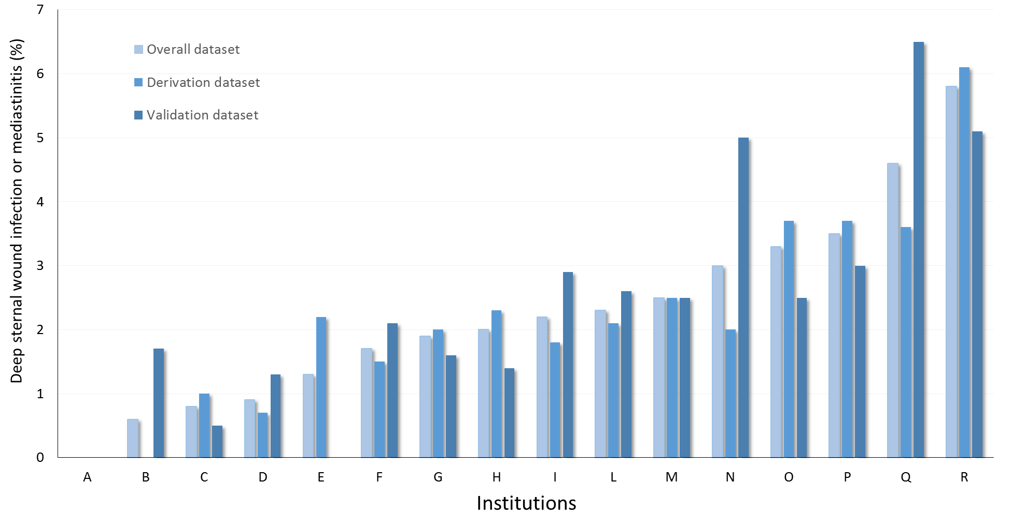

Supplementary figure 1. Rates of deep sternal wound infection/mediastinitis among the participating institutions in the overal, derivation and validation datasets.

