APPENDIX 1 Search terms utilized in MEDLINE
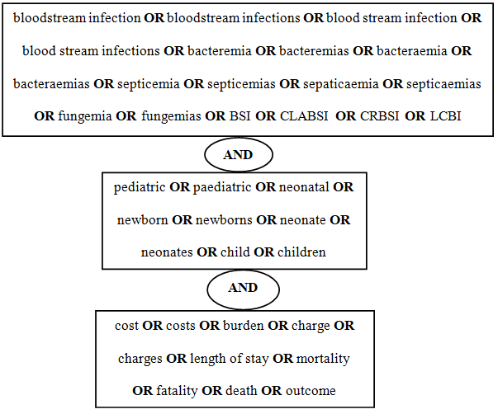

APPENDIX 2 Attributable length of stay (LOS), Funnel Plot with 95% confidence limits. SE standard error

0
2
4
6
8
0
10
20
30
40
Mean attributable LOS days
SE of mean attributable LOS days

