Impact of an Automated Antibiotic Time-Out Alert on the De-Escalation of Broad-Spectrum Antibiotics at a Large Community Teaching Hospital

Supplementary Material

Table of Contents

Automated Antibiotic Time-Out Alert………………………………………………………….…3

Mercy Hospital – St. Louis Antimicrobial Stewardship Program………………………………...5

Supplementary Figures and Tables………………………………………..………………………6

References…………………………………………………………………………………………7

Automated Antibiotic Time-Out Alert
In January 2017, the Mercy Health System Antimicrobial Stewardship Program instituted an Automated Antibiotic Time-Out Alert in its electronic medical record. This effort was independent of the current research study. The alert was designed in the electronic medical record, Epic®, to fire for any patient receiving broad-spectrum antimicrobials for 72-hours. It reads as follows:
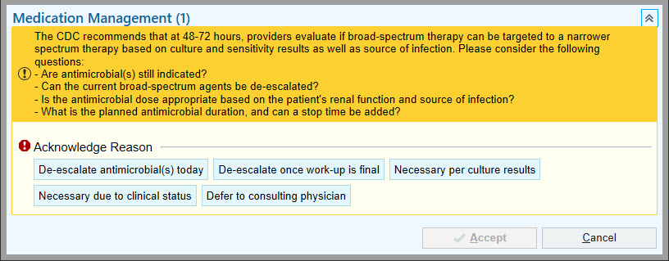
The alert was built to fire for all medical providers (physicians, physician assistants, and nurse practitioners) caring for a patient, alerting them of their patient’s prolonged broad-spectrum antimicrobial use and encouraging them to consider de-escalation. As a “hard-stop” function, providers were required to select from one of the above choices before they were able to move forward with their workflows. Providers would then be responsible for independently carrying-out the actions they indicated, with no orders automatically placed by the prompt. To minimize alert fatigue and maximize efficiency of provider alerting, the alert was built to never fire for the same provider twice, to not fire for any subsequent providers if anyone selected “de-escalate antimicrobial(s) today,” and to only fire during day-time hours.
Broad-spectrum antimicrobials for which the alert was built to fire included the following. Only the intravenous formulations of each drug were included, aside from linezolid (in which both intravenous and oral formulations were included). As the scope of this study was the de-escalation of antibiotics, the few anti-fungal agents included below were not considered in the current research efforts.
  - Amikacin
  - Amphotericin B
  - Aztreonam
  - Cefepime
  - Ceftaroline
  - Ceftazidime
  - Ceftazidime/avibactam
  - Ceftolozane/tazobactam
  - Ciprofloxacin
  - Colistin
  - Daptomycin
  - Ertapenem
  - Gentamicin
  - Imipenem/cilastatin
  - Isavuconazonium
  - Levofloxacin
  - Linezolid
  - Meropenem
  - Micafungin
  - Piperacillin/tazobactam
  - Posaconazole
  - Tigecycline
  - Tobramycin
  - Vancomycin
  - Voriconazole

The Automated Antibiotic Time-Out Alert was implemented throughout the Mercy Health System, which includes 45 acute care and specialty hospitals throughout Missouri, Arkansas, Kansas, and Oklahoma. Prior to the alert’s execution, all providers were notified of its purpose and functionality via an e-mail notification as well as verbal communication at provider meetings. The current research study was designed to be a real-world analysis of this alert’s impact on antibiotic de-escalation specifically within the Mercy Hospital – St. Louis location, the flagship of the Mercy Health System.

Mercy Hospital – St. Louis Antimicrobial Stewardship Program
The Mercy Hospital – St. Louis Antimicrobial Stewardship program includes each of the components of the Center for Disease Control and Prevention’s Core Elements for hospital antibiotic stewardship programs and meets or exceeds the standards set forth by the Joint Commission.^{1,2} Despite this robust program, the hospital employs only one dedicated Infectious Disease Clinical Pharmacist and one Infectious Disease Physician dedicated to its stewardship efforts. The Automated Antibiotic Time-Out Alert was developed in order to further strengthen the reach and consistency of the stewardship program through automated interventions.

Supplementary Figures and Tables

Figure A1: Monthly Antibiotic De-Escalation after Alert Implementation
Figure 1. Proportions of broad-spectrum antibiotic de-escalation after implementation of the Antibiotic Time-Out Alert were consistent across the study period.

Table A1: Antibiotic-Related Adverse Events
Adverse Event | De-Escalated Group | Broad-Spectrum Group
Allergic reaction | 1 | 2
Clostridium difficile infection | 0 | 1
Antibiotic-associated diarrhea* | 7 | 10
Other*:
Thrush | 1 | 2
Nausea/vomiting | 0 | 2
Thrombocytopenia | 1 | 0
Total: | 10 | 17
Proportion of subjects: | 10/84 (11.9%) | 17/104 (16.3%)

*Diarrhea and Other reactions were required to be specifically attributed to the antibiotic in the provider’s documentation.

References
¹Centers for Disease Control and Prevention. The Core Elements of Hospital Antibiotic
Stewardship Programs. Atlanta, GA: U.S. Department of Health and Human Services, CDC; 2014. Available at https://www.cdc.gov/antibiotic-use/healthcare/pdfs/core-elements.pdf
²The Joint Commission. Approved: New antimicrobial stewardship standard. Jt Comm Perspect
2016;36:1-8.

