Supplementary Material
Supplementary Figure: Sick leave Index
The monthly sick leave index (sick leave hours/expected work hours) per hospital of the group is indicated on the y axis. The period of the implementation of the droplet precautions on site (DroPoS) is indicated by the green bar. The four rural hospitals are represented with blue points/lines, the (control) non-rural hospitals of the hospital group are plotted with red points/lines.
In none of the four rural hospitals (in blue) did we notice an accentuation of the increase in the sick leave index during the winter months following the introduction of the DroPoS concept (marked with bars). For comparison, the longitudinal courses of the non-rural hospitals of the hospital group (in red) were included (Supplementary Material).
Similar findings were observed for the indices of the employee subgroups of physicians and nurses.
To compare the figure with the intensity of overall influenza activity: The reports on the intensity of influenza in Switzerland can be found on the website of the Federal Office of Public Health. (https://www.bag.admin.ch/bag/de/home/krankheiten/krankheiten-im-ueberblick/grippe.html)
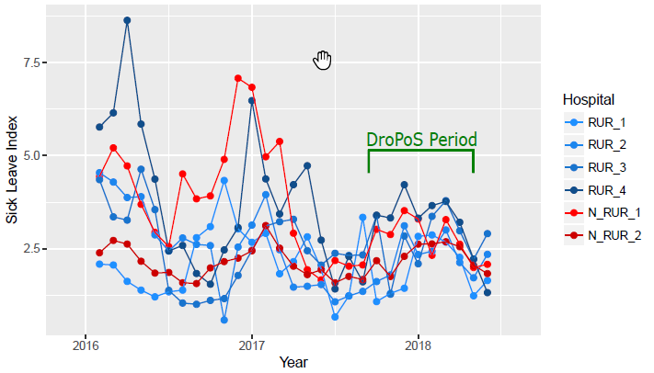
Rural hospitals: Overview over bedroom situation
RUR_1: Predominately two-bed rooms, some single rooms
RUR_2: Predominately two-bed rooms, some 4-bed rooms
RUR_3: Predominately two-bed and three-bed rooms
RUR_4: Predominately two-bed

Survey
The 12 original questions were assigned to three main blocks (Comprehension / Safety / Acceptance). Each block consisted of a main question per block and 1-4 auxiliary questions. For quality control reasons, Questions 3, 4, and 6 were asked negatively and then inverted for the evaluation.
Original Question | Category | Main/Aux | Inverted | Final  Question
1) The concept of droplet precautions on site (DroPoS) is intuitive and understandable for me | Comprehension | 1_Main |  | 1
2) The process of introduction was sufficient and detailed | Comprehension | 2_Aux |  | 2
3) Nosocomial transmissions have increased after introduction of the DroPoS | Safety | 1_Main | YES | 6
4) I / my team had trouble adapting to the new recommendations | Comprehension | 3_Aux | YES | 3
5) Wearing masks and hand disinfection were observed while using the DroPoS | Safety | 2_Aux |  | 7
6) I feel that I / my colleagues were more frequently infected with respiratory viruses than before | Safety | 3_Aux | YES | 8
7) For patients the DroPoS concept was clearly understandable | Comprehension | 4_Aux |  | 4
8) Our patients’ compliance with the DroPoS instructions was good | Safety | 4_Aux |  | 9
9) I / my team have/has independently isolated patients with respiratory symptoms at the bed site | Comprehension | 5_Aux |  | 5
10) The concept had an additional positive effect on the application of respiratory etiquette to patients/visitors | Safety | 5_Aux |  | 10
11) DroPoS is a good replacement for our previous concept | Acceptance | 2_Aux |  | 12
12) I would recommend DroPoS concept to another hospital of the same size | Acceptance | 1_Main |  | 11

Baseline Characteristics of Respondents
Characteristic | n | %
Function
Physician | 10 | 21%
Nurse | 35 | 74%
NA | 2 | 4%
Gender
male | 5 | 11%
female | 40 | 85%
NA | 2 | 4%
Hospital
L1 | 8 | 17%
L2 | 13 | 28%
L3 | 13 | 28%
L4 | 13 | 28%
Age Group
<25 | 7 | 15%
25-45 | 27 | 57%
>45 | 11 | 23%
NA | 2 | 4%
Position
Executive employee | 11 | 23%
Non-executive employee | 34 | 72%
NA | 2 | 4%

Detailed Survey Results
- Overall agreement of responses as per question topic (percentage, n=47))
1 | Comprehension | main | 85.1
2 | Comprehension | auxiliary | 56.5
3 | Comprehension | auxiliary | 50
4 | Comprehension | auxiliary | 48.9
5 | Comprehension | auxiliary | 69.6
6 | Safety | main | 69.6
7 | Safety | auxiliary | 85.1
8 | Safety | auxiliary | 68.1
9 | Safety | auxiliary | 42.6
10 | Safety | auxiliary | 34.1
11 | Acceptance | main | 59.6
12 | Acceptance | auxiliary | 66

- Agreement according to subgroup analysis (percentage)
 | Stratified by function=physician
Question | yes (n=10) | no (n=35) | p
1 | 90 | 82.9 | 0.956
2 | 66.7 | 54.3 | 0.771
3 | 66.7 | 45.7 | 0.455
4 | 80 | 42.9 | 0.087
5 | 90 | 61.8 | 0.194
6 | 50 | 76.5 | 0.223
7 | 100 | 80 | 0.296
8 | 70 | 68.6 | 1
9 | 70 | 34.3 | 0.098
10 | 50 | 31.2 | 0.483
11 | 70 | 57.1 | 0.714
12 | 70 | 62.9 | 0.967
 | Stratified by position=executive
Question | yes (n=11) | no (n=34) | p
1 | 90.9 | 82.4 | 0.84
2 | 90 | 47.1 | 0.041
3 | 70 | 44.1 | 0.28
4 | 72.7 | 44.1 | 0.193
5 | 72.7 | 66.7 | 1
6 | 90.9 | 63.6 | 0.182
7 | 81.8 | 85.3 | 1
8 | 81.8 | 64.7 | 0.49
9 | 72.7 | 32.4 | 0.045
10 | 66.7 | 27.3 | 0.073
11 | 90.9 | 50 | 0.04
12 | 90.9 | 55.9 | 0.081
 | Stratified by rural hospital
Question | L1 (n=8) | L2 (n=13) | L3 (n=13) | L4 (n=13)
1 | 87.5 | 84.6 | 76.9 | 92.3 | 0.739
2 | 87.5 | 53.8 | 41.7 | 53.8 | 0.233
3 | 50 | 53.8 | 66.7 | 30.8 | 0.343
4 | 62.5 | 38.5 | 46.2 | 53.8 | 0.723
5 | 75 | 53.8 | 75 | 76.9 | 0.546
6 | 87.5 | 66.7 | 69.2 | 61.5 | 0.646
7 | 87.5 | 92.3 | 92.3 | 69.2 | 0.298
8 | 50 | 76.9 | 76.9 | 61.5 | 0.495
9 | 12.5 | 38.5 | 61.5 | 46.2 | 0.17
10 | 16.7 | 53.8 | 16.7 | 38.5 | 0.187
11 | 75 | 61.5 | 38.5 | 69.2 | 0.293
12 | 87.5 | 61.5 | 53.8 | 69.2 | 0.444
 | Stratified by age group
Question | <25 (n=7) | 25-45 (n=27) | >45 (n=11) | p
1 | 85.7 | 85.2 | 81.8 | 0.931
2 | 42.9 | 57.7 | 54.5 | 0.551
3 | 42.9 | 46.2 | 54.5 | 0.496
4 | 57.1 | 44.4 | 54.5 | 0.909
5 | 50 | 66.7 | 81.8 | 0.416
6 | 42.9 | 76.9 | 63.6 | 0.253
7 | 100 | 77.8 | 90.9 | 0.39
8 | 28.6 | 70.4 | 81.8 | 0.072
9 | 71.4 | 33.3 | 36.4 | 0.102
10 | 33.3 | 33.3 | 33.3 | 0.972
11 | 42.9 | 59.3 | 72.7 | 0.641
12 | 57.1 | 63 | 72.7 | 0.658
 | Stratified by gender
Question | Male (n=5) | Female (n=40) | p
1 | 80 | 87.5 | 0.328
2 | 60 | 55 | 0.66
3 | 80 | 45 | 0.02
4 | 60 | 50 | 0.336
5 | 80 | 66.7 | 0.525
6 | 80 | 66.7 | 0.525
7 | 100 | 82.5 | 0.487
8 | 100 | 62.5 | 0.145
9 | 60 | 37.5 | 0.154
10 | 40 | 35.1 | 0.568
11 | 60 | 60 | 0.961
12 | 90 | 65 | 0.569

