SUPPLEMENTARY MATERIAL

Appendix Table A1. Distribution of particle counts, airborne bacteria and wound contamination at three time points during the 59 procedures with the recording of doors openings only.

 | Overall (n=59) |  |  | Orthopaedic surgery (n=34) |  |  | Cardiac surgery (n=25) |  |  | P*
 | Mean (SD) | Median (IQR) |  | Mean (SD) | Median (IQR) |  | Mean (SD) | Median (IQR)
Time 1 : Incision
Air microbiological sampling | 7.9 (10.6) | 4 [0 - 10] |  | 3.7 (3.8) | 2.5 [0 - 6] |  | 13.6 (14) | 10 [2 - 20] |  | <.01
0, n (%) | 16 (27.1) |  |  | 12 (35.3) |  |  | 4 (16) |  |  | <.01
1-10, n (%) | 30 (50.8) |  |  | 21 (61.8) |  |  | 9 (36) |  |  | ·
>10, n (%) | 13 (22) |  |  | 1 (2.9) |  |  | 12 (48) |  |  | ·
Log₁₀ 0·3 µm | 7.7 (0.8) | 7.8 [7.1 – 8.1] |  | 7.5 (0.8) | 7.5 [7 - 8] |  | 7.9 (0.7) | 8 [7.7 – 8.1] |  | 0.05
Log₁₀ 0·5 µm | 6.8 (0.8) | 6.9 [6.3 – 7.3] |  | 6.6 (0.8) | 6.8 [6 - 7] |  | 7.1 (0.6) | 7.1 [6.7 – 7.7] |  | 0.02
Log₁₀ 5 µm | 3.9 (2.1) | 4.8 [3.5 – 5.2] |  | 3.7 (2.2) | 4.8 [0 – 5.2] |  | 4.2 (2) | 5.1 [4.5 – 5.3] |  | 0.16
Time 2 : After bone cut
Air microbiological sampling | 6 (9.1) | 3 [0 - 7] |  | 2.4 (2.9) | 1.5 [0 - 4] |  | 10.8 (12) | 4 [2 - 16] |  | <.01
0, n (%) | 17 (28.8) |  |  | 15 (44.1) |  |  | 2 (8) |  |  | <.01
1-10, n (%) | 31 (52.5) |  |  | 18 (52.9) |  |  | 13 (52) |  |  | ·
>10, n (%) | 11 (18.6) |  |  | 1 (2.9) |  |  | 10 (40) |  |  | ·
Log₁₀ 0·3 µm | 7 (0.9) | 6.9 [6.2 - 8] |  | 6.6 (0.8) | 6.3 [6.1 - 7] |  | 7.5 (0.8) | 7.6 [6.9 – 8.2] |  | <.01
Log₁₀ 0·5 µm | 6.2 (0.9) | 6.1 [5.4 – 7.1] |  | 5.8 (0.8) | 5.6 [5.2 – 6.1] |  | 6.8 (0.7) | 7 [6.1 – 7.3] |  | <.01
Log₁₀ 5 µm | 3.1 (2.5) | 4.4 [0 – 5.2] |  | 3.1 (2.5) | 4.4 [0 - 5] |  | 3.1 (2.5) | 4.1 [0 – 5.2] |  | 0.63
Time 3 : Wound closure
Air microbiological sampling | 6.9 (9.1) | 4 [0 - 8] |  | 3.7 (5.5) | 2 [0 - 5] |  | 11.2 (11.2) | 8 [2 - 21] |  | 0.01
0, n (%) | 17 (28.8) |  |  | 12 (35.3) |  |  | 5 (20) |  |  | <.01
1-10, n (%) | 29 (49.2) |  |  | 20 (58.8) |  |  | 9 (36) |  |  | ·
>10, n (%) | 13 (22) |  |  | 2 (5.9) |  |  | 11 (44) |  |  | ·
Log₁₀ 0·3 µm | 6.4 (0.7) | 6.2 [6 - 7] |  | 6.3 (0.7) | 6.2 [5.9 – 6.5] |  | 6.6 (0.7) | 6.5 [6.1 – 7.1] |  | 0.07
Log₁₀ 0·5 µm | 5.6 (0.7) | 5.5 [5.2 - 6] |  | 5.5 (0.7) | 5.4 [5.1 – 5.9] |  | 5.8 (0.7) | 6 [5.2 – 6.3] |  | 0.08
Log₁₀ 5 µm | 2.9 (2.3) | 4.1 [0 - 5] |  | 2.5 (2.4) | 4.1 [0 – 4.9] |  | 3.3 (2.2) | 4.1 [0 - 5] |  | 0.26
*Chi2 or Mann Whiney test

Appendix Table A2. Evaluation of the Hawthorne effect by the description of doors openings during procedures with and without the presence of camera in the operating room.

From patient entry to exit | Presence of cameras in the OR (N=21) |  | Absence of cameras in the OR (N=14) |  |  | P value
 | Mean (SD) | Median (IQR) | Mean (SD) | Median (IQR)
Frequency of doors opening, per hour | 35.4 (14.1) | 34.5 (23.6 – 48.8) | 38 (6.3) | 36.6 (33.3 – 42.6) | 0.5

Appendix Figure A1. Timeline of variable selected for the analysis of the relationship between behaviors and the surrogates of the infectious risk.

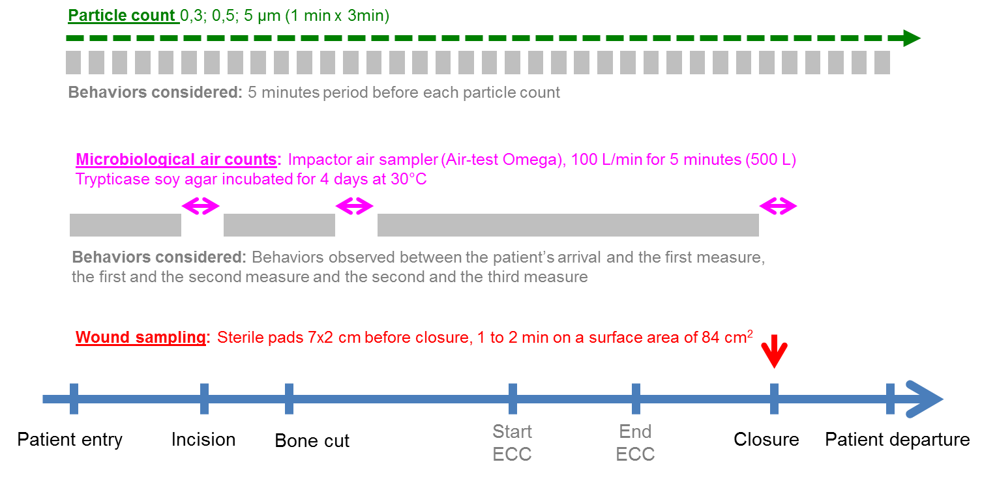

Appendix Figure A2. Linear regression of particle counts according to the time, by specialty and by type of ventilation system.

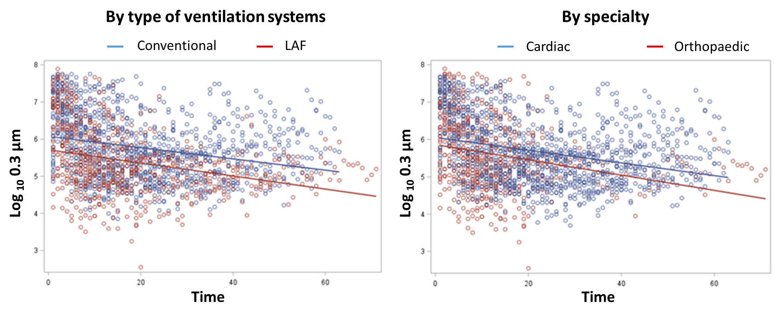

Footnotes: Blue and red lines represent overlaid linear prediction plot of the scatterplot.

Comments: The counts of 0.3 µm particles varied according to ventilation systems. The Log₁₀ of 0.3 µm varied according to ORs and procedures, with a mean in ORs with LAF of 6.8 (SD, 1) and 6.8 (SD, 0.9) during orthopedic procedures. These values were consistently below those observed in ORs with turbulent ventilation systems (mean, 7.2; SD, 0.9) and during cardiac surgery (mean, 7.3; SD, 0.9) (p<0.01). These results suggest that laminar airflow consistently better control the airborne contamination than conventional ventilation systems. As orthopedic OR were more equipped with LAF, this results is also obtained when comparing specialties.

