Supplementary Materials:
Supplemental Table 1. Evaluation of quality of included observational studies using the Newcastle-Ottawa Scale (NOS) score.
Author | Year published | Study design | Selection |  |  |  | Comparability |  | Outcome |  |  | NOS score
 |  |  | Representativeness of exposed cohort | Representativeness of non-exposed cohort | Ascertainment of exposure | Demonstration that outcome of interest was not present at start of study | Study controls for age | Study controls for any additional factor | Assessment of outcome from secure records | Delay between episodes ≤ 90 days | Follow up period clearly reported
Apisarnthanarak²⁶ | 2014 | PC | 1 | 1 | 1 | 0 | 1 | 1 | 1 | 1 | 1 | 8
Bleasdale²⁰ | 2007 | PC | 1 | 1 | 1 | 0 | 1 | 1 | 1 | 1 | 1 | 8
Cassir⁶ | 2015 | PC | 1 | 1 | 1 | 0 | 1 | 1 | 1 | 1 | 1 | 8
Chung²⁷ | 2015 | PC | 1 | 1 | 1 | 0 | 0 | 0 | 1 | 1 | 1 | 6
Dicks²⁸ | 2016 | RC | 1 | 1 | 1 | 0 | 0 | 0 | 1 | 1 | 1 | 6
Evans²⁹ | 2010 | RC | 1 | 1 | 1 | 0 | 1 | 1 | 1 | 1 | 1 | 8
Gould⁴ | 2007 | RC | 1 | 1 | 1 | 0 | 1 | 1 | 1 | 1 | 1 | 8
Martínez-Reséndez³⁰ | 2014 | PC | 1 | 1 | 1 | 0 | 1 | 1 | 1 | 1 | 1 | 8
Montecalvo³¹ | 2012 | PC | 1 | 1 | 1 | 0 | 0 | 0 | 1 | 1 | 1 | 6
Hong³² | 2017 | RC | 1 | 1 | 1 | 1 | 1 | 1 | 1 | 1 | 1 | 9
Urbancic³³ | 2018 | PC | 1 | 1 | 1 | 0 | 1 | 1 | 1 | 1 | 1 | 8
PC = Prospective cohort; RC = Retrospective Cohort

Supplemental Table 2. Evaluation of risk of bias of included RCTs using the Cochrane Risk of Bias tool
First author, year published | Random sequence generation | Allocation concealment | Blinding of participants and personnel | Blinding of outcome assessment | Incomplete outcome data | Selective reporting | Other bias
Boonyasiri, 2015⁷ | + | + | + | + | + | + | ?
Camus, 2005⁸ | + | + | + | + | + | + | ?
Climo, 2013³ | + | + | + | + | + | + | -
Noto, 2015⁵ | + | + | + | + | + | + | +
+ = low risk, - = high risk, ? = unknown risk

Supplemental Figure 1:
1A: Funnel Plot illustrating the risk of Acinetobacter infection with chlorhexidine bathing versus comparator. Dashed line indicates pooled relative risk of 0.67.
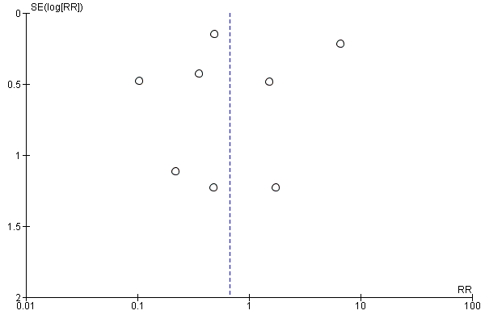

1B: Funnel Plot illustrating the risk of Klebsiella species infections with chlorhexidine bathing versus comparator. Dashed line indicates pooled relative risk of 0.57.
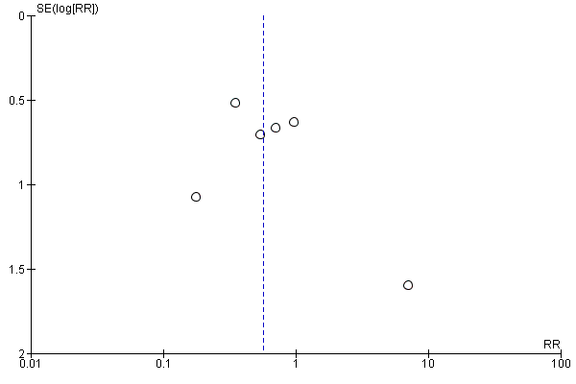

1C: Funnel Plot illustrating the risk of E.coli infection with chlorhexidine bathing versus comparator. Dashed line indicates pooled relative risk of 1.74.
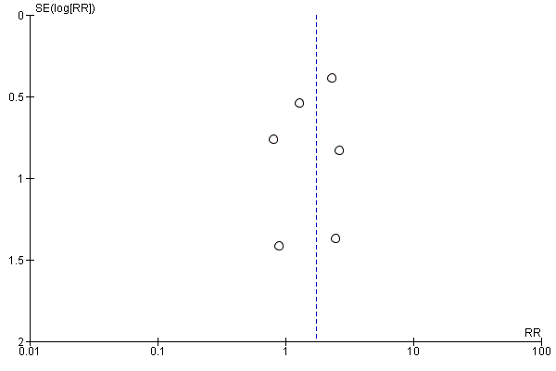

1D: Funnel Plot illustrating the risk of Enterobacter infection with chlorhexidine bathing versus comparator. Dashed line indicates pooled relative risk of 0.75.
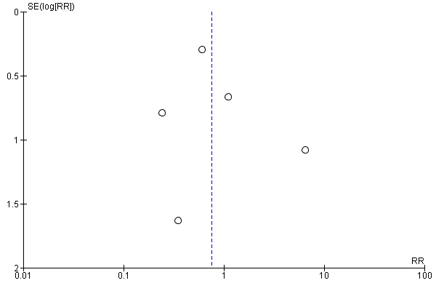

1E: Funnel Plot illustrating the risk of Pseudomonas infection with chlorhexidine bathing versus comparator. Dashed line indicates pooled relative risk of 0.92.
