Appendix Table 1. ICD-9-CM Diagnosis Codes for Acute Conditions and Frailty Indicators
Risk factor |  | ICD-9-CM diagnosis code
Acute Noninfectious Conditions
Acute myocardial infarction | 410.00-410.92
COPD exacerbation | 491.21, 493.22
Gastrointestinal bleed | 531.00, 531.01, 531.20, 531.21, 531.40, 531.41, 531.60, 531.61, 532.00, 532.01, 532.20, 532.21, 532.40, 532.41, 532.60, 532.61, 533.00, 533.01, 533.20, 533.21, 533.40, 533.41, 533.60, 533.61, 534.00, 534.01, 534.20, 534.21, 534.40, 534.41, 534.60, 534.61, 535.01, 535.11, 535.21, 535.31, 535.41, 535.51, 535.61, 535.71, 537.83, 562.02, 562.03, 562.12, 562.13, 569.3, 569.85, 569.86, 578.0, 578.1, 578.9
Diverticulosis | 562.00, 562.02, 562.10, 562.12
Subdural hematoma | 852.20, 852.39
Cerebrovascular accident | 430-437.9
Closed fracture – lower extremity | 820.00-820.09, 820.20-820.22, 820.8, 821.00, 821.01, 821.20-821.29, 822.0, 823.00-823.02, , 823.20-823.22, 823.40-823.42, 823.80-823.82, 824.0, 824.2, 824.4, 824.6, 824.8, 825.0, 825.20-825.29, 827.0, 828.0, 829.0
Open fracture – lower extremity | 820.10-820.19, 820.30-820.32, 820.9, 821.10, 821.11, 821.30-821.39, 822.1, 823.10-823.12, 823.30-823.32, 823.90-823.92, 824.1, 824.3, 824.5, 824.7, 824.9, 825.1, 825.30-825.39, 827.1, 828.1, 829.1
Closed fracture – other | 805.00-805.08, 805.2, 805.4, 805.6, 805.8, 806.00-806.09, 806.20-806.29, 806.4, 806.60-806.69, 806.8, 807.00-807.09, 807.2, 807.5, 808.0, 808.2, 808.41-808.49, 808.8, 809.0, 810.00-810.03, 811.00-811.09, 812.00-812.09, 812.20, 812.21, 812.40-812.49, 813.00-813.08, 813.20-813.23, 813.40-813.47, 813.80-813.83, 814.00-814.09, 815.00-815.09, 817.0, 818.0, 819.0
Open fracture – other | 805.10-805.18, 805.3, 805.5, 805.7, 805.9, 806.10-806.19, 806.30-806.39, 806.5, 806.70-806.79, 806.9, 807.10-807.19, 807.3, 807.6, 808.1, 808.3, 808.51-808.59, 808.9, 809.1, 810.10-810.13, 811.10-811.13, 812.10-812.19, 812.30, 812.31, 812.50-812.59, 813.10-813.18, 813.30-813.33, 813.50-813.34, 813.90-813.93, 814.10-814.19, 815.10-815.19, 817.1, 818.1, 819.1
Frailty indicators
Decubitus ulcer | 707.00-707.09, 707.20-707.29
Dementia | 290.0-290.9, 292.82, 294.10, 294.11, 331.0, 331.11, 331.19, 331.2 331.82
Dehydration, past 30 days | 276.50-276.52
Deep venous thrombosis | 451.11, 451.19, 451.2, 451.81, 451.83, 451.9, 453.40-453.42, 453.81-453.89, 453.9
Pulmonary embolism | 415.11, 415.13, 415.19
Urinary incontinence | 625.6, 788.30-788.39
Parkinson’s disease | 332.0, 332.1
Senility/frailty | 797, 799.3
Failure to thrive | 783.7, 799.4
Sleep disturbance | 780.50-780.59
Difficulty walking | 719.7, 781.2, 781.3

Appendix Table 2. Characteristics of Matched CDI Cases and Unmatched CDI Cases*
Risk Factor | Matched CDI Cases  (% with characteristic) | Unmatched CDI Cases  (% with characteristic)
Age, mean (SD) | 80.3 (8.1) | 81.2 (7.7)
Race (white) | 88.7 | 85.8
Sex (female) | 65.1 | 61.6
Dual eligible (Medicare/Medicaid) status | 29.4 | 40.1
Comorbidities
Congestive heart failure | 29.2 | 49.4
Cardiac disease | 35.1 | 52.7
Valvular disease | 15.1 | 24.6
Pulmonary circulation disorder | 6.2 | 12.4
Peripheral vascular disease | 24.8 | 40.2
Diabetes | 33.3 | 45.1
Hypertension | 80.8 | 92.0
Chronic renal failure | 24.9 | 46.1
Liver disease | 2.1 | 3.5
Rheumatologic disease | 6.1 | 9.0
Chronic pulmonary disease | 28.4 | 42.0
Hypothyroidism | 22.7 | 27.9
Paralysis | 5.5 | 11.3
Other neurologic disease | 13.5 | 25.5
Peptic ulcer disease | 0.1 | 0.3
Solid organ tumor | 13.6 | 17.1
Lymphoma | 2.2 | 3.6
Metastatic cancer | 3.7 | 5.2
Coagulopathy | 8.5 | 18.2
Obesity | 7.2 | 13.2
Blood loss anemia | 3.2 | 6.3
Deficiency anemia | 41.3 | 71.4
Psychoses | 7.6 | 12.8
Depression | 16.6 | 28.8
Electrolyte disorders (> 30 days before) | 25.4 | 48.6
Weight loss (> 30 days before) | 10.0 | 24.2
Acute Infections
Septicemia | 10.5 | 49.8
Pneumonia | 18.2 | 47.2
Urinary tract infection/prostatistis | 26.2 | 45.0
Skin/soft tissue infection | 10.8 | 20.0
Surgical site infection | 2.1 | 6.5
Bone infection/osteomyelitis | 1.9 | 5.7
Organ infection | 0.5 | 1.1
Pelvic/gynecologic infection | 0.6 | 0.8
Intraabdominal abscess/peritonitis | 9.9 | 16.1
Diverticulitis | 6.8 | 12.5
Upper respiratory infection | 9.6 | 9.1
Tonsillitis | 0.9 | 1.0
Otitis/ear infection | 0.9 | 0.7
Oral infection | 0.3 | 0.5
Viral infection | 2.5 | 3.9
Healthcare Utilization in Past 12 months
Inpatient surgery | 32.9 | 59.2
Outpatient surgery | 15.1 | 17.5
Non-elective hospitalization | 69.4 | 98.7
Elective hospitalization | 24.9 | 38.7
Treat-and-release emergency department encounter, 1 | 31. 4 | 35.4
Treat-and-release emergency department encounter, 2 or more | 38.0 | 52.1
Skilled nursing facility | 41.7 | 86.0
Long-term care facility resident | 18.5 | 35.3
Acute Noninfectious Conditions
Acute myocardial infarction | 9.4 | 19.6
Exacerbation of chronic pulmonary disease | 13.4 | 24.1
Gastrointestinal hemorrhage | 20.4 | 40.9
Diverticulosis | 19.5 | 29.5
Subdural hematoma | 1.0 | 1.7
Cerebrovascular accident | 35.8 | 52.9
Fracture, lower, closed | 11.0 | 16.7
Fracture, lower, open | 1.4 | 2.5
Fracture, other, closed | 11.5 | 16.0
Fracture, other, open | 0.6 | 1.0
Frailty indicators
Deep venous thrombosis | 12.4 | 28.0
Pulmonary embolus | 4.4 | 9.0
Decubitus ulcer | 12.2 | 38.8
Dementia | 25.0 | 41.1
Parkinson’s disease | 3.7 | 5.5
Dehydration (> 30 days before) | 21.9 | 41.4
Urinary incontinence | 12.5 | 18.6
Senility/frailty | 15.9 | 36.8
Failure to thrive (> 30 days before) | 5.1 | 11.8
Sleep disturbance | 13. 1 | 17.8
Difficulty walking | 39.9 | 67.1
Outcomes
Death within 1 year | 35.6 | 55.7
New transfer to a long term care facility within 1 year | 6.7 | 9.9
New skilled nursing facility encounter within 1 year | 35.3 | 60.0
Inpatient hospitalization, 30 days | 19.7 | 24.8
Inpatient hospitalization, 90 days | 33.7 | 43.0
Inpatient hospitalization, 1 year | 55.7 | 68.6
*All p < 0.001 except tonsillitis (p = 0.005)
Appendix Table 3. Outcomes within one year in pairs matched on the propensity for Clostridium difficile infection. A. Death, B. New Entry into a Long-Term Care Facility, C. New Entry into a Skilled Nursing Facility
 |  | Control
 |  | Died | Survived
CDI Case | Died | 13551 | 32130
 | Survived | 18125 | 64600

OR = 1.77 (CI: 1.74-1.81), p < .001 (McNemar’s test).
One year risk difference in all-cause mortality = 35.6% (CDI cases) – 24. 7% (controls) = 10.9%

 |  | Control
 |  | New LTCF | No Entry into LTCF
CDI Case | New LTCF | 363 | 6,032
 | No Entry into LTCF | 3,464 | 85,959

OR = 1.74 (CI: 1.67-1.82), p < .001 (McNemar’s test)
One year risk difference in new transfer to a LTCF = 6.7% (CDI cases) – 4.0% (controls) = 2.7%

 |  | Control
 |  | SNF | Not SNF
Case | SNF | 7,263 | 27,410
 | Not SNF | 10,880 | 59,328

OR = 2.52 (CI: 2.46-2.58), p < .001 (McNemar’s test)
One year risk difference in new transfer to a short-term SNF = 33.1% (CDI cases) – 17.3% (controls) = 15.8%

Appendix Figure 1. Standardized differences before and after matching by the propensity score for CDI.

Appendix Figure 1 legend:
The absolute value of the standardized differences for all covariates in the propensity score model are presented before matching (open circles) and after matching (filled circles). The goal of the propensity score model is to reduce differences in all covariates between matched pairs, such that the absolute value of the standardized difference is < 0.10. The only variable that exceeded this threshold after matching was septicemia (difference = 0.114), due to the very unequal distribution of septicemia between CDI cases and controls.

Appendix Figure 2. Distribution of the propensity scores in the population, for CDI case patients and control patients. Higher magnification is shown in the 2nd figure to more closely display the area of overlap between CDI case and control patients.

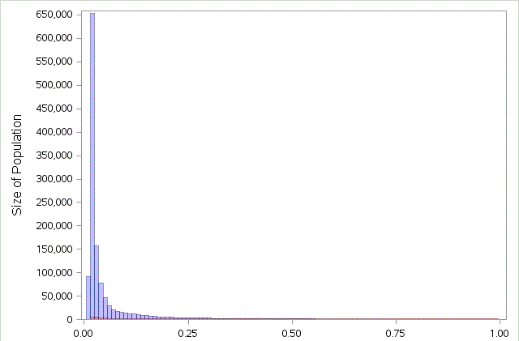
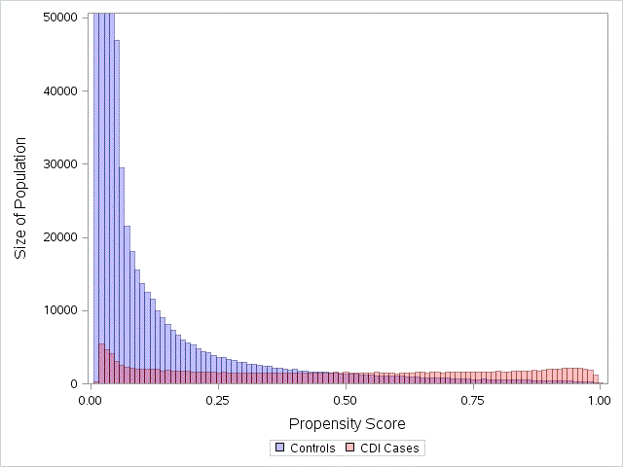

Appendix Figure 3. Stratified Hazard Ratios and Rates of New Entry into a Short-Term Skilled Nursing Facility within One year after CDI or Control Index Date. The bars represent the new SNF rates in control patients (open bars) and CDI case patients (grey bars).
Hazard ratio and 95% confidence interval. The null hazard ratio of 1.0 is indicated by the horizontal dashed line.

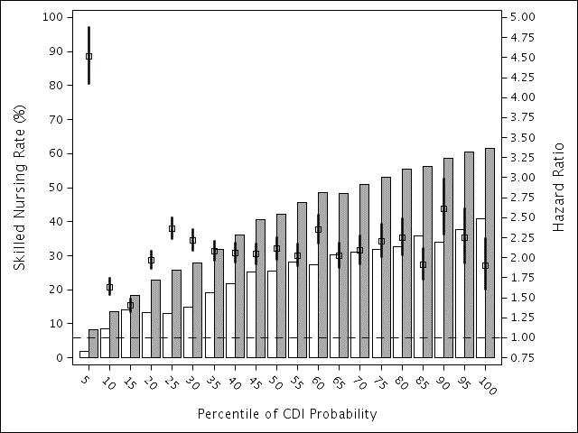

Appendix Table 4. Subsequent hospitalization in pairs matched on the propensity for Clostridium difficile infection within A. 30 days, B. 90 days, C. One Year after the CDI/onset date.
 |  | Control
 |  | Hospitalization within 30 days | Not hospitalized within 30 days
CDI Case | Hospitalization within 30 days | 2,930 | 23,299
 | Not hospitalized within 30 days | 9,405 | 86,196

HR = 2.27 (CI:2.22-2.32), p < .001
Attributable risk = 21.5% (CDI cases) – 10.1% (controls) = 11.4%

 |  | Control
 |  | Hospitalization within 90 days | Not hospitalized within 90 days
CDI Case | Hospitalization within 90 days | 10,640 | 34,378
 | Not hospitalized within 90 days | 15,332 | 61,480

HR = 1.95 (CI:1.92-1.98), p < .001
Attributable risk = 37.0% (CDI cases) – 21.3% (controls) = 15.7%

 |  | Control
 |  | Hospitalization within one year | Not hospitalized within one year
Case | Hospitalization within one year | 31,447 | 36,817
 | Not hospitalized within one year | 21,669 | 31,897

HR = 1.52 (CI:1.51-1.54), p < .001
Attributable risk = 56.0% (CDI cases) – 43.6% (controls) = 12.4%

Appendix Figure 4. Stratified Hazard Ratios and Rates of Hospitalization within 90 days after CDI or Control Index Date. The number of total patient included in the hospitalization analyses was 1,475,045 (158,558 CDI case patients and 1,316,487 control patients), after excluding 18,396 persons who died during the index hospitalization. The bars represent the hospitalization rates in control patients (open bars) and CDI case patients (grey bars).
Hazard ratio and 95% confidence interval. The null hazard ratio of 1.0 is indicated by the horizontal dashed line.
