Appendix 2: Anatomical-based assessment scale
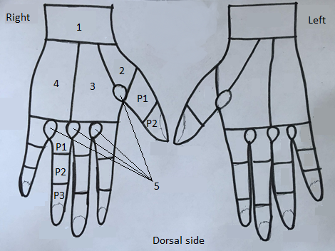
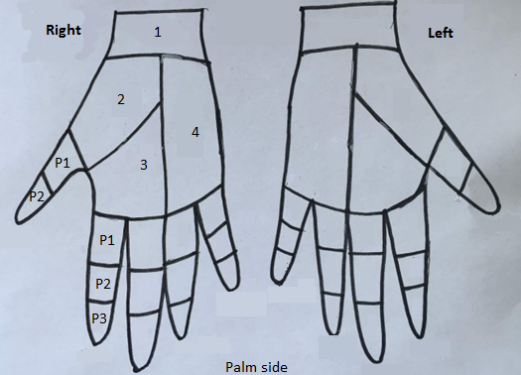
Legend: 1: wrist; 2: thenar eminence; 3: intermediate zone; 4: hypothenar eminence; 5: interdigital space; for the thumb: P1: proximal phalanx; P2: distal phalanx; for other fingers: P1: proximal phalanx; P2: intermediate phalanx; P3: distal phalanx.

