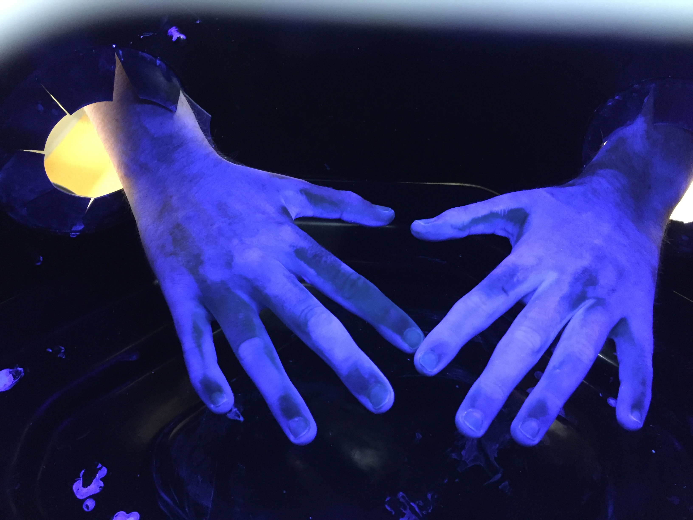
Supplemental Materials: Example of ultraviolet (UV)-dyed AHG-treated hand areas to highlight in a black box the areas of the hand surface that are adequately disinfected.
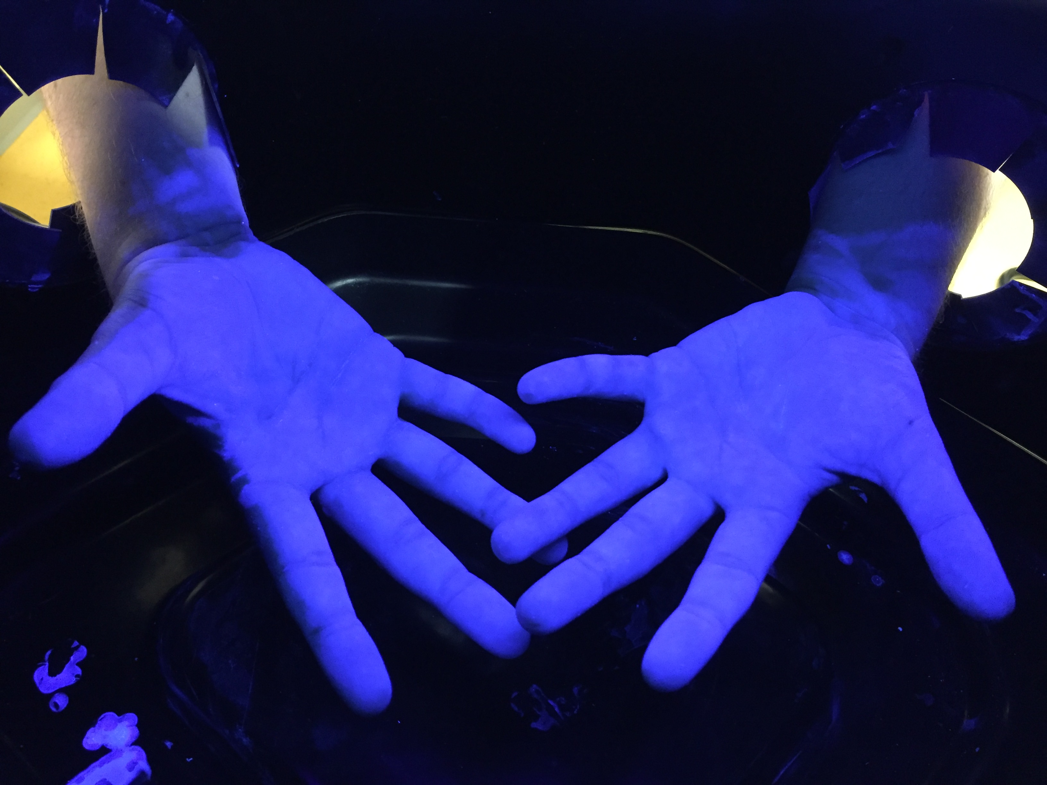

Legend: A blue fluorescence on the hands attests to efficient application of alcohol hand gel and disinfection of the corresponding zone, whereas the color black signifies an uncleaned area.

