Table S1. Use of optional real-time tracking tab (phase II) and triggered pop-up alert (phase III)
 | Phase II | Phase III
Views  per 10,000 hospitalized patient days | 11,622  83 | 98,068  3,139
Assessment made, (%)  Opt-out, (%) | 307 (2.6%)  11,355 (97.4%) | 61,580 (62.8%)  36,509 (37.2%)
IUCs assessedª  per catheter day | 129  0.0005 | 23,386  0.48
Remove today, (%)  Maintain, (%)  Already removed, (%) | 89 (69.0%)  36 (27.9%)  4 (3.1%) | 2,237 (9.6%)  15,787 (67.5%)  5,362 (22.9%)
- Counts of views and assessments reflect all indwelling devices captured by the decision support tool. The mean number of devices addressed per assessment was 1.74.

Table S2. Selection of catheter alternatives and indications from new order set
Alternatives: Can patient be managed using one of the following products? |  |  | n (%)
Yes | 519 (0.9)
Superabsorbent underpad  External male urinary device (condom catheter)  Straight bladder catheterization after bladder scan  Straight bladder catheterization, intermittent  Daily Weight |  | 28 (5.4)  308 (59.3)  70 (13.5)  103 (19.8)  10 (1.9)
No: Select IUC Indicationª | 59,543 (99.1)
Perioperative use for selected surgeries^{b}  Urological procedures/surgery on contiguous structures of the genitourinary tract  Prolonged surgery > 4 hours  Large volume infusions or diuretics during surgery  Intraoperative monitoring of urine output needed  Perineal/sacral grafting  Obstetrics/caesarean section with epidural |  | 6,836 (11.5) | 1,931 (28.2)  2,768 (40.5)  396 (5.8)  1,443 (21.1)  20 (0.3)  278 (4.1)
Urine output monitoring for critically ill patients^{b}  Sepsis management in the first 24 hours  Acute renal failure  Pressors with titration  ECMO  Hypothermia device  Intra-aortic balloon pump  Subarachnoid hemorrhage with triple H (hypertension, hypervolemia, hemodilution) |  | 12,842 (21.6) | 3,230 (25.1)  5,287 (41.2  3,297 (25.7)  495 (3.9)  107 (0.8)  153 (1.2)  274 (2.1)
Hourly monitoring of urine output |  | 27,592 (46.3)
Management of urinary retention/blockage |  | 8,063 (13.5)
Gross hematuria |  | 457 (0.8)
Patients requiring prolonged immobilization (e.g. unstable thoracic or lumbar spine) |  | 3,056 (5.1)
Comfort care (end of life) |  | 695 (1.2)
- In order to continue with an order for an indwelling urinary catheter, clinicians were required to select one of seven possible indications from a drop down menu. Options are listed in the order in which they appeared in the order set.
- Selection of “Perioperative use for selected surgeries” or “Urine output monitoring for critically ill patients” prompted clinicians to select a more specific indication from additional menus of sub-criteria.

Table S3. Use of alternatives to indwelling urinary catheters (IUCs) 1-year before and after implementation of the new orderset
 | 1-year before  (n) | 1-year after  (n) | Total % change | % change from orderset | % change from stand-alone orders
Daily weight | 21,911 | 23,166 | +5.7% | 0.0% | +5.7%
External male urinary device (condom catheter) | 943 | 1,253 | +32.9% | +32.7% | +0.2%
Straight bladder catheterization after bladder scan | 141 | 2,544 | +1704.3% | +50.5% | +1653.7%
Straight bladder catheterization, intermittent | 11,663 | 14,072 | +20.7% | +0.8% | +19.8%
Superabsorbent underpad | 14 | 99 | +607.1% | +200.1% | +407.0%

Figure S1. Real-time electronic tracking (Phase II)
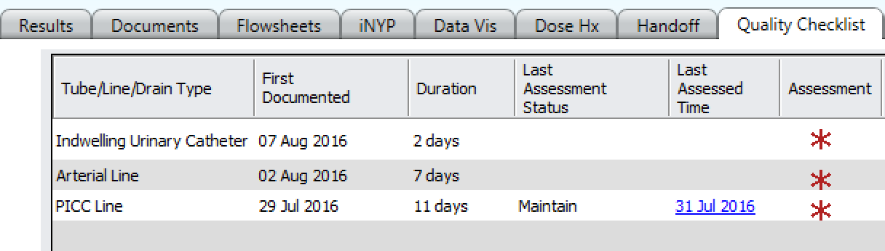

In phase II, clinicians could access a tab in the patient’s electronic chart called the “Quality Checklist” to visualize a real-time, customized list of all of the patient’s active lines and catheters along with their placement dates and length of time since placement. Within the tool, clinicians could select to update the status of each line or catheter from a drop down menu with the following options: “Maintain,” “Already Removed,” or “Remove Today.”

Figure S2. Triggered pop-up reminder (Phase III)
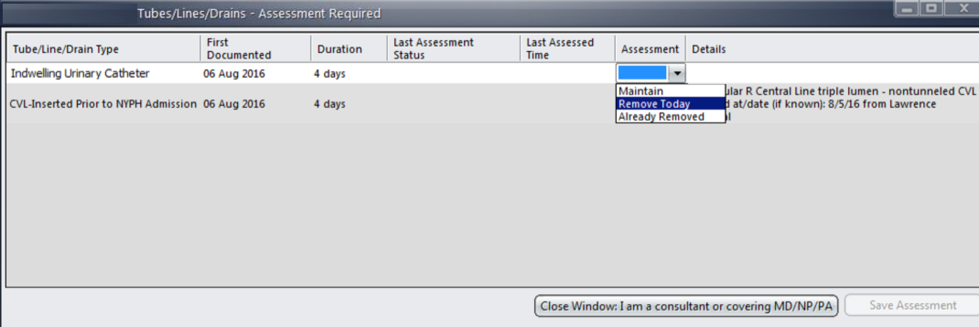
In Phase III, the real-time tracking tool became a triggered pop-up reminder of the presence of remaining lines and catheters that needed to be viewed and assessed by a clinician daily.

Figure S3. Warning to clinicians that a catheters order will automatically expire triggering catheter removal (Phase IV)
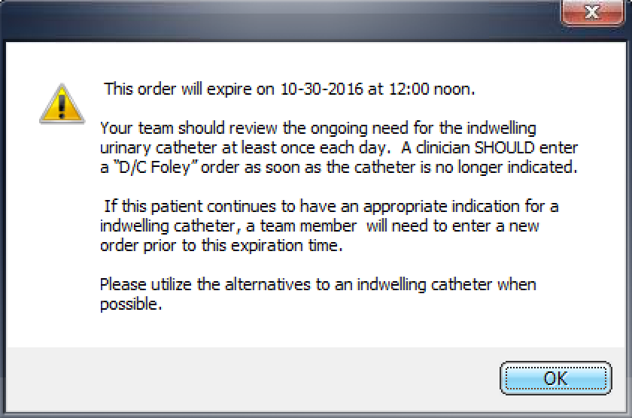
In phase IV, a warning message after order entry and with the triggered pop-up reminder informed clinicians that the order would be expiring on 12 noon on the second day after placement and that the catheter would be removed at this time unless the order was renewed.

Figure S4. New order set requiring consideration of alternatives and selection of an appropriate indication (Phase IV)
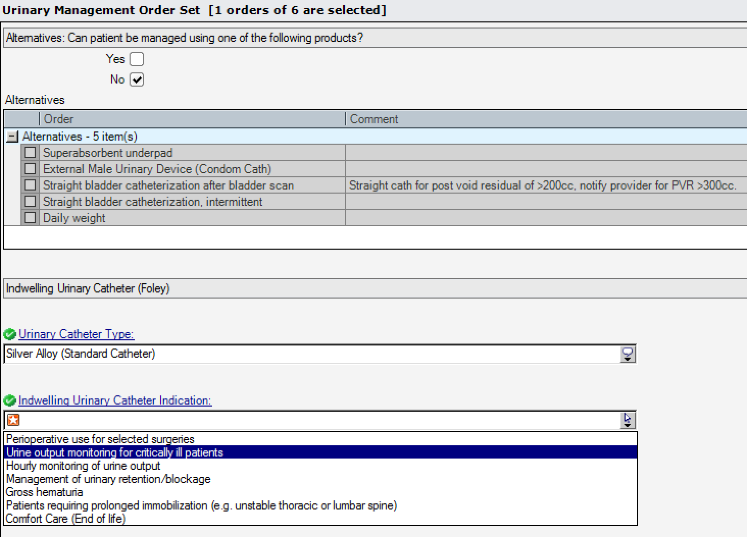
In phase IV, a new order set required the user to consider the use of alternatives and enter clinical justification for catheter placement based on the criteria and sub-criteria organized into a set of drop down menus.

