Supplementary Material

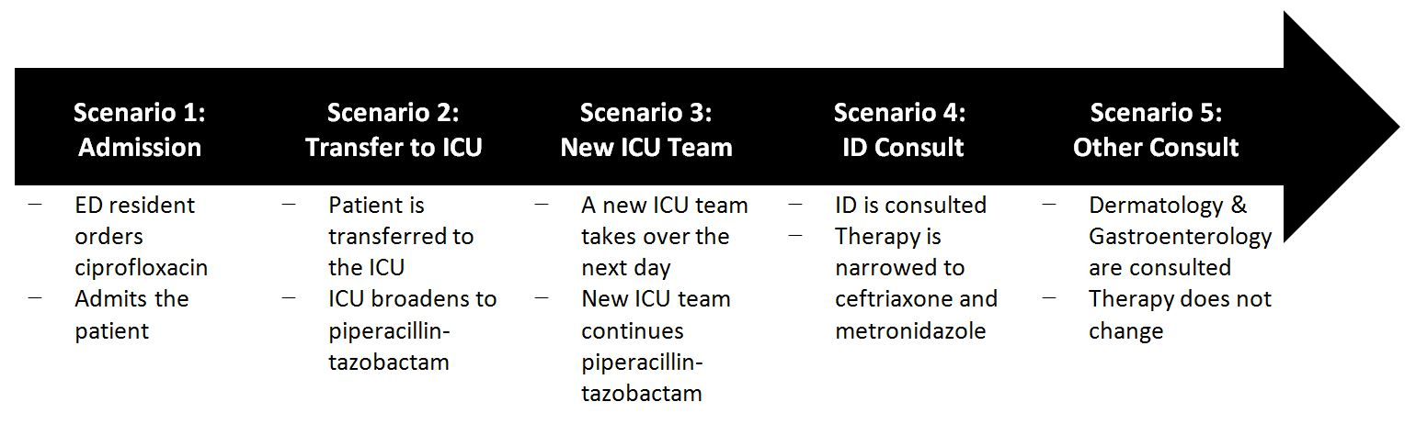
Appendix A: Timeline outlining the five attribution scenarios incorporated into the survey for a single patient through a hospital stay involving many different healthcare providers.

Appendix B: Questions and responses to attribution survey questions reflecting provider opinions of attribution
Scenario 1: Admission¹
At the beginning of an admission, an emergency department resident orders ciprofloxacin and admits the patient.
To whom should the antimicrobial be attributed at this time?
Scenario 2: Transfer¹
The patient is transferred to the ICU with hypotension and persistent fever and the ICU resident broadens antibiotic coverage to empiric piperacillin-tazobactam.
To whom should the antimicrobial be attributed at this time?
Scenario 3: New team¹
A new ICU team takes over this patient’s care.
To whom should the antimicrobial be attributed at this time?

Scenario 4: ID Consult
The ICU consults Infectious Diseases who recommends narrowing to ceftriaxone and metronidazole.
To whom should the antimicrobial be attributed at this time?
p=0.012
p=0.002

Scenario 5: Other Consult²
The course is complicated by skin nodules and bloody stool, prompting the ICU to consult Dermatology and Gastroenterology and the patient is diagnosed with Crohn’s disease.
To whom should the antimicrobial be attributed at this time?

CC: critical care, EM: emergency medicine, ID: infectious diseases, MED: medicine subspecialty, SG: surgery
¹ No between group differences occurred in these responses for any answer
² Attribution to ICU Team only: p=0.012 across groups; attribution to ID team only: p=0.014 across groups; attribution to both ICU and ID team: p=0.016 across groups

