SUPPLEMENTARY MATERIAL

The prevalence of healthcare-associated infections in Mainland China – A systematic review and meta-analysis

Supplementary table 1A. Strengthening the Reporting of Observational Studies in Epidemiology (STROBE) checklist ¹
Parameters | Item | Criteria | Yes/No
Introduction
Background/rationale | 1 | The study explains the specific background and rationale for HAI prevalence
Objectives | 2 | To assess the HAI prevalence in Chinese hospitals
Methods
Study design | 3 | Point prevalence survey/cross-sectional study
Settings | 4 | General hospitals, children hospitals, hospitals for maternal and child health, and/or oncology hospitals
Participants | 5 | Hospitalized adults, children and/or neonates
Variables | 6 | Author, publication year, timescale of study, number of hospitals in the study, patients with HAI, type of infection, *[isolated pathogens, MDROs, prevalence by department (ICU, internal medicine, surgery, pediatric)]
Data sources | 7 | Investigator actively collected data from the patient’s (electronic) information system
Bias | 8 | The study provides information on assessment of bias
Study sample size | 9 | The study reports sample sizes for the different hospital settings
Statistical methods | 10 | The study explains applied statistical methods:  - Descriptive analysis of overall prevalence  - Distribution of HAIs  - Distribution of microorganism isolations
Results
Descriptive data | 11 | - Prevalence of HAI prevalence stratified by hospitals (e.g. General hospitals, children hospitals, hospitals for maternal and child health, and oncology hospitals)  - Type of infections (URTI, LRTI, UTI, SSI, BSI, GI, IA, STI, OTH)  - *(microorganism pathogens causing HAI)
Discussion
Key results | 12 | Key results are summarized with reference to study objectives
Limitations | 13 | Limitations are sufficiently discussed
Interpretation | 14 | Overall interpretation of results is based on the findings and in the context of the evidence base
Generalizability | 15 | Generalizability (external validity) of the study results is discussed
Total

Supplementary table 1B. Strengthening the Reporting of Observational Studies in Epidemiology (STROBE) quality assessment criteria ¹
Rating | Description
High quality | Fulfilled >75% of STROBE criteria
Moderate quality | Fulfilled 50-75% of STROBE criteria
Low quality | Fulfilled <50% of STROBE criteria

Supplementary table 2A. Summary of quality assessment – Systematic review on healthcare-associated infections in Mainland China, 2006-2016
Healthcare setting | Level of quality | Studies  (N) | Weighted prevalence  (95%CI)
General hospitals | High | 16 | 2.89 (2.52-3.27)
 | Moderate | 26 | 3.11 (2.79-3.43)
Children hospitals | High | 1 | 4.60 (3.39-6.09)
 | Moderate | 13 | 4.35 (2.97-5.74)
 | Low | 5 | 4.49 (2.68-6.29)
Maternal and child health hospitals | Moderate | 22 | 1.99 (1.53-2.46)
 | Low | 5 | 1.34 (0.57-2.11)
Oncology hospitals | Moderate | 23 | 4.28 (3.37-5.20)
 | Low | 4 | 1.94 (1.04-2.84)

Supplementary table 2B. Study quality assessment – Systematic review on healthcare-associated infections in Mainland China, 2006-2016
Author | Year | Province | Sample size | HAI Patients | HAI | Quality
General hospitals
Chen L² | 2016 | Guizhou | 7799 | 198 | 207 | moderate
Chen L³ | 2016 | Guizhou | 6541 | 120 | 127 | high
Chen P⁴ | 2011 | Chongqing | 20432 | 985 | 1174 | moderate
Cui Y⁵ | 2010 | Shanghai | 49458 | 1962 | 2193 | high
Fu T⁶ | 2016 | Hainan | 3122 | 170 | 170 | moderate
Gan Y⁷ | 2011 | Guangxi | 8043 | 156 | 156 | moderate
Huang H⁸ | 2014 | Fujian | 10643 | 358 | 375 | high
Huang W⁹ | 2016 | Sichuan | 27144 | 691 | 737 | high
Ji Z¹⁰ | 2013 | Hebei | 2183 | 27 | 27 | moderate
Li H¹¹ | 2013 | Guangdong | 21242 | 628 | 689 | high
Liu J¹² | 2016 | Beijing | 61990 | 1294 | 1389 | high
Liu W¹³ | 2011 | Inner Mongolia | 18172 | 462 | 474 | moderate
Liu W¹⁴ | 2014 | Inner Mongolia | 31504 | 573 | 614 | moderate
Liu W¹⁵ | 2014 | Inner Mongolia | 26940 | 553 | 586 | moderate
Liu W¹⁶ | 2015 | Inner Mongolia | 43463 | 871 | 919 | high
Liu X¹⁷ | 2012 | Hubei | 23441 | 791 | 829 | moderate
Shao Y¹⁸ | 2007 | Anhui | 100742 | 1962 | 1962 | moderate
Shen Y¹⁹ | 2013 | Shanghai | 148446 | 5748 | 6405 | high
Sun S²⁰ | 2012 | Hubei | 43646 | 1494 | 1756 | moderate
Wei X²¹ | 2015 | Jiangsu | 21033 | 630 | 657 | moderate
Wu X²² | 2011 | Fujian | 48947 | 1595 | 1739 | high
Xiang Q²³ | 2013 | Sichuan | 74457 | 1966 | 2001 | high
Xie D²⁴ | 2010 | Hubei | 20350 | 790 | 833 | high
Xiong W²⁵ | 2010 | Hubei | 7745 | 309 | 331 | moderate
Xu C²⁶ | 2015 | Hubei | 63320 | 1915 | 2051 | high
Xu F²⁷ | 2011 | Shandong | 11493 | 171 | 196 | moderate
Xu X²⁸ | 2014 | Fujian | 144091 | 5216 | 5620 | moderate
Yang H²⁹ | 2015 | Xinjiang | 66208 | 1211 | 1338 | high
Yang L³⁰ | 2012 | Jiangsu | 9691 | 362 | 382 | moderate
Yang L³¹ | 2015 | Tianjin | 29513 | 996 | 1106 | high
Yu L³² | 2015 | Xinjiang | 12787 | 369 | 392 | moderate
Yu W³³ | 2013 | Hebei | 4390 | 238 | 241 | moderate
Yu W³⁴ | 2013 | Hebei | 4879 | 174 | 191 | moderate
Zeng B³⁵ | 2011 | Fujian | 83787 | 2870 | 3099 | high
Zhan R³⁶ | 2009 | Fujian | 34840 | 1275 | 1360 | moderate
Zhang J³⁷ | 2011 | Guizhou | 29358 | 1025 | 1063 | moderate
Zhang L³⁸ | 2013 | Anhui | 10686 | 264 | 281 | moderate
Zhang M³⁹ | 2015 | Guizhou | 65885 | 1546 | 1643 | moderate
Zhang M⁴⁰ | 2015 | Guizhou | 143342 | 4030 | 4262 | moderate
Zhang W⁴¹ | 2015 | Sichuan | 152475 | 3426 | 3426 | high
Zhao Y⁴² | 2010 | Yunnan | 5514 | 233 | 233 | moderate
Zhu W⁴³ | 2016 | Shanghai | 12419 | 483 | 512 | moderate
Children's hospitals
Geng R⁴⁴ | 2015 | Hebei | 924 | 40 | 44 | moderate
Guo Q⁴⁵ | 2016 | Guangdong | 997 | 30 | 32 | moderate
Hao Y⁴⁶ | 2009 | Henan | 140 | 10 | 10 | low
Hu M⁴⁷ | 2010 | Yunnan | 475 | 28 | 29 | low
Hu Y⁴⁸ | 2010 | Guangdong | 552 | 28 | 28 | moderate
Huang K⁴⁹ | 2016 | Hunan | 565 | 28 | 40 | moderate
Jia Y⁵⁰ | 2011 | Shandong | 442 | 15 | 15 | moderate
Liu F⁵¹ | 2014 | Beijing | 1127 | 27 | 28 | low
Liu H⁵² | 2010 | Henan | 372 | 17 | 18 | moderate
Sun L⁵³ | 2010 | Hebei | 464 | 16 | 16 | moderate
Wang J⁵⁴ | 2008 | Henan | 507 | 38 | 44 | moderate
Wang J⁵⁵ | 2015 | Hebei | 999 | 46 | 48 | high
Wang X⁵⁶ | 2011 | Jiangsu | 626 | 41 | 41 | moderate
Xu Y⁵⁷ | 2013 | Hebei | 241 | 4 | 4 | moderate
Yin A⁵⁸ | 2015 | Hunan | 3899 | 233 | 243 | moderate
Zhang L⁵⁹ | 2010 | Henan | 324 | 26 | 26 | low
Zhang L⁶⁰ | 2015 | Jiangsu | 1368 | 31 | 33 | low
Zhang Y⁶¹ | 2015 | Beijing | 1027 | 8 | 10 | moderate
Zhao X⁶² | 2015 | Jiangxi | 2424 | 145 | 171 | moderate
Maternal and child health hospitals
Chen T⁶³ | 2014 | Jiangsu | 720 | 15 | 17 | moderate
Deng Y⁶⁴ | 2013 | Guangxi | 193 | 9 | 9 | moderate
Fan D⁶⁵ | 2013 | Sichuan | 188 | 5 | 5 | moderate
Fu R⁶⁶ | 2013 | Henan | 231 | 2 | 2 | moderate
Huang G⁶⁷ | 2011 | Guangxi | 639 | 16 | 16 | moderate
Huang S⁶⁸ | 2014 | Hunan | 2404 | 96 | 105 | moderate
Huang X⁶⁹ | 2015 | Guangdong | 339 | 8 | 8 | moderate
Li H⁷⁰ | 2012 | Guangdong | 653 | 12 | 12 | moderate
Li H⁷¹ | 2013 | Guangdong | 769 | 12 | 12 | moderate
Li H⁷² | 2015 | Guangdong | 768 | 9 | 9 | moderate
Li S⁷³ | 2008 | Henan | 265 | 6 | 6 | low
Li X⁷⁴ | 2012 | Sichuan | 109 | 4 | 4 | moderate
Liao Z⁷⁵ | 2015 | Jiangxi | 700 | 8 | 8 | moderate
Liao Z⁷⁶ | 2015 | Jiangxi | 165 | 7 | 7 | moderate
Liu Y⁷⁷ | 2015 | Guangdong | 283 | 2 | 2 | moderate
Nie X⁷⁸ | 2012 | Yunnan | 433 | 5 | 5 | moderate
Qi L⁷⁹ | 2013 | Shandong | 652 | 4 | 4 | low
Shang H⁸⁰ | 2015 | Xinjiang | 1659 | 16 | 17 | moderate
Wang X⁸¹ | 2013 | Shanxi | 126 | 1 | 1 | low
Wang Y⁸² | 2012 | Shandong | 267 | 14 | 14 | moderate
Wen Y⁸³ | 2014 | Guangdong | 1258 | 33 | 33 | moderate
Xie J⁸⁴ | 2012 | Zhejiang | 658 | 7 | 7 | moderate
Xie L⁸⁵ | 2010 | Jiangsu | 560 | 8 | 8 | low
Xu C⁸⁶ | 2014 | Shandong | 320 | 9 | 9 | low
Yun R⁸⁷ | 2014 | Inner Mongolia | 311 | 4 | 4 | moderate
Zhang Q⁸⁸ | 2014 | Jiangxi | 401 | 11 | 11 | moderate
Zhao D⁸⁹ | 2014 | Guangdong | 1461 | 37 | 39 | moderate
Oncology hospitals
Gong G⁹⁰ | 2010 | Jiangsu | 739 | 8 | 9 | moderate
Gong G⁹¹ | 2015 | Jiangsu | 890 | 7 | 7 | moderate
He G⁹² | 2009 | Guizhou | 350 | 15 | 16 | moderate
Hou J⁹³ | 2010 | Henan | 794 | 26 | 26 | low
Huang Y⁹⁴ | 2011 | Zhejiang | 560 | 26 | 27 | moderate
Ji Y⁹⁵ | 2013 | Jiangsu | 804 | 32 | 37 | moderate
Li L⁹⁶ | 2009 | Jiangxi | 1031 | 54 | 54 | moderate
Li W⁹⁷ | 2013 | Sichuan | 1554 | 87 | 97 | moderate
Liu S⁹⁸ | 2009 | Henan | 1261 | 57 | 65 | moderate
Long J⁹⁹ | 2013 | Guizhou | 737 | 36 | 36 | moderate
Su J¹⁰⁰ | 2012 | Xinjiang | 3824 | 230 | 230 | moderate
Wang M¹⁰¹ | 2013 | Jiangsu | 836 | 8 | 8 | moderate
Wang S¹⁰² | 2014 | Shanghai | 1121 | 23 | 30 | moderate
Wang Y¹⁰³ | 2016 | Zhejiang | 3286 | 138 | 138 | moderate
Wu D¹⁰⁴ | 2016 | Shandong | 5131 | 78 | 81 | low
Xu X¹⁰⁵ | 2014 | Zhejiang | 1740 | 90 | 91 | moderate
Yang X¹⁰⁶ | 2016 | Hebei | 4856 | 324 | 361 | moderate
Yang R¹⁰⁷ | 2013 | Shanxi | 294 | 11 | 12 | moderate
Zhai R¹⁰⁸ | 2014 | Shanxi | 1558 | 108 | 120 | moderate
Zhang M¹⁰⁹ | 2014 | Shandong | 498 | 15 | 15 | low
Zhang X¹¹⁰ | 2012 | Henan | 2053 | 96 | 100 | moderate
Zhao L¹¹¹ | 2016 | Shanxi | 5333 | 427 | 458 | moderate
Zhao X¹¹² | 2014 | Henan | 6537 | 254 | 274 | moderate
Zheng H¹¹³ | 2013 | Shandong | 321 | 15 | 16 | moderate
Zhou H¹¹⁴ | 2012 | Jiangsu | 742 | 6 | 6 | low
Zhou Y¹¹⁵ | 2009 | Hunan | 1602 | 76 | 76 | moderate
Zou Y¹¹⁶ | 2015 | Jiangsu | 3913 | 87 | 89 | moderate

Supplementary Table 3. Information of healthcare-associated infection and GDP by region
Region | Province | Hospital setting, N |  |  |  | Total, N | Patients | HAI | HAI prevalence | GDP per capita
 |  | GH | CH | MCH | OH |  | N | (N | % (95% CI) | CNY
Eastern | Shanghai | 3 |  |  | 1 | 4 | 211,444 | 8216 | 3.73 (3.44-4.03) | 103,796
 | Jiangsu | 2 | 2 | 2 | 6 | 12 | 41,922 | 1235 | 2.26 (1.57-2.95) | 87,995
 | Zhejiang |  |  | 1 | 3 | 4 | 6244 | 261 | 3.73 (1.74-5.72) | 77,644
 | Anhui | 2 |  |  |  | 2 | 111,428 | 2226 | 1.99 (1.91-2.07) | 35,997
 | Fujian | 5 |  |  |  | 5 | 322,308 | 11,314 | 3.47 (3.32-3.63) | 67,966
 | Jiangxi |  | 1 | 3 | 1 | 5 | 4,721 | 225 | 3.85 (1.52-6.18) | 36,724
 | Shandong | 1 | 1 | 3 | 3 | 8 | 19,124 | 321 | 2.05 (1.45-2.64) | 64,168
Southern | Guangdong | 1 | 2 | 7 |  | 10 | 28,322 | 799 | 2.28 (1.66-2.90) | 67,503
 | Guangxi | 1 |  | 2 |  | 3 | 8875 | 181 | 2.34 (1.42-3.25) | 35,190
 | Hainan | 1 |  |  |  | 1 | 3122 | 170 | 5.45 (4.68-6.30) | 40,818
Central | Henan |  | 4 | 2 | 4 | 10 | 12,484 | 532 | 4.23 (3.21-5.24) | 39,123
 | Hubei | 5 |  |  |  | 5 | 158,502 | 5299 | 3.51 (3.18-3.84) | 50,654
 | Hunan |  | 2 | 1 | 1 | 4 | 8470 | 433 | 4.92 (3.88-5.96) | 42,754
Northern | Beijing | 1 | 2 |  |  | 3 | 64,144 | 1329 | 1.73 (0.80-2.66) | 106,497
 | Tianjin | 1 |  |  |  | 1 | 29,513 | 996 | 3.37 (3.17-3.59) | 107,960
 | Hebei | 3 | 4 |  | 1 | 8 | 18,936 | 869 | 3.89 (2.34-5.43) | 40,255
 | Shanxi |  |  | 1 | 3 | 4 | 7311 | 547 | 4.93 (1.69-8.17) | 34,919
 | Inner Mongolia | 4 |  | 1 |  | 5 | 120,390 | 2463 | 2.06 (1.82-2.31) | 71,101
Western | Chongqing | 1 |  |  |  | 1 | 20,432 | 985 | 4.82 (4.53-5.12) | 52,321
 | Sichuan | 3 |  | 2 | 1 | 6 | 255,927 | 6179 | 2.72 (2.37-3.08) | 36,775
 | Guizhou | 5 |  |  | 2 | 7 | 254,012 | 6970 | 2.78 (2.38-3.19) | 29,847
 | Yunnan | 1 | 1 | 1 |  | 3 | 6422 | 266 | 3.64 (1.20-6.08) | 28,806
 | Xinjiang | 2 |  | 1 | 1 | 4 | 84,478 | 1826 | 2.87 (1.69-4.05) | 40,036
 | Overall | 42 | 19 | 27 | 27 | 115 | 1,798,531 | 53,642 | 3.12 (2.94-3.29)

GDP: gross domestic product based on the national bureau of statistics of China (2015); GH: General hospitals; CH: Children hospitals; MCH; Maternal and child health hospitals; OH: Oncology hospitals. Note: The data of GDP per capita and indices in China are derived from China Statistical Yearbook 2016, which was compiled by National Bureau of Statistics of China.¹¹⁷

Supplementary Table 4. Antimicrobials use in general hospitals, children hospitals, maternal and child health hospitals, and oncology hospitals --- Systematic review on healthcare-associated infections in Mainland China, 2006-2016

Hospital type | Publications  N | Patients  N | Antimicrobial Use  N | Proportion  %
General Hospitals | 32 | 1,365,327 | 544,887 | 39.91%
Children hospitals | 18 | 13,574 | 9023 | 66.47%
Maternal and child health hospitals | 27 | 16,532 | 7381 | 44.65%
Oncology hospitals | 26 | 51,334 | 9729 | 18.95%
Overall | 103 | 1,446,767 | 571,020 | 39.47%

Supplementary Figure 1. Weighted prevalence of healthcare-associated infections in the different provinces of China – Systematic review on healthcare-associated infections in Mainland China, 2006-2016
Boxes show prevalence of healthcare associated infections and their 95% confidence intervals. The bars show the 95% CI of the prevalence of healthcare associated infections for the total sample population.

Supplementary Figure 2. Weighted point prevalence of healthcare-associated infections in intensive care, internal medicine, surgery, pediatrics, and gynecology and obstetrics in general hospitals – Systematic review on healthcare-associated infections in Mainland China, 2006-2016
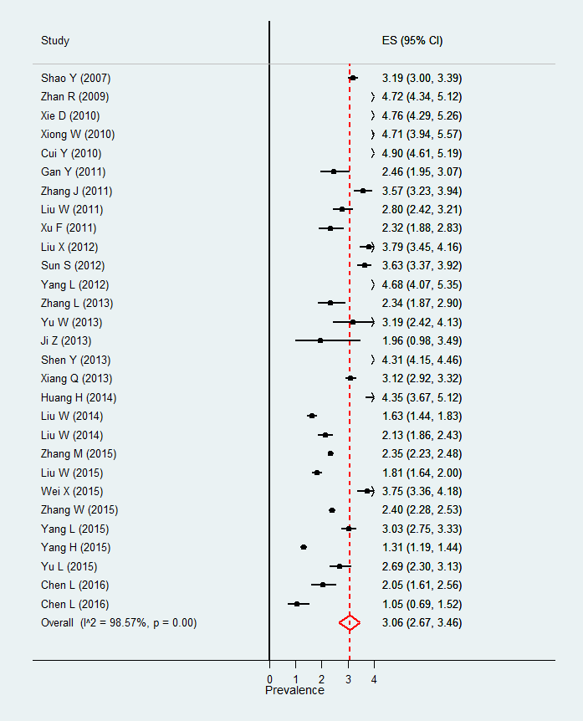
- Intensive care B. Internal medicine
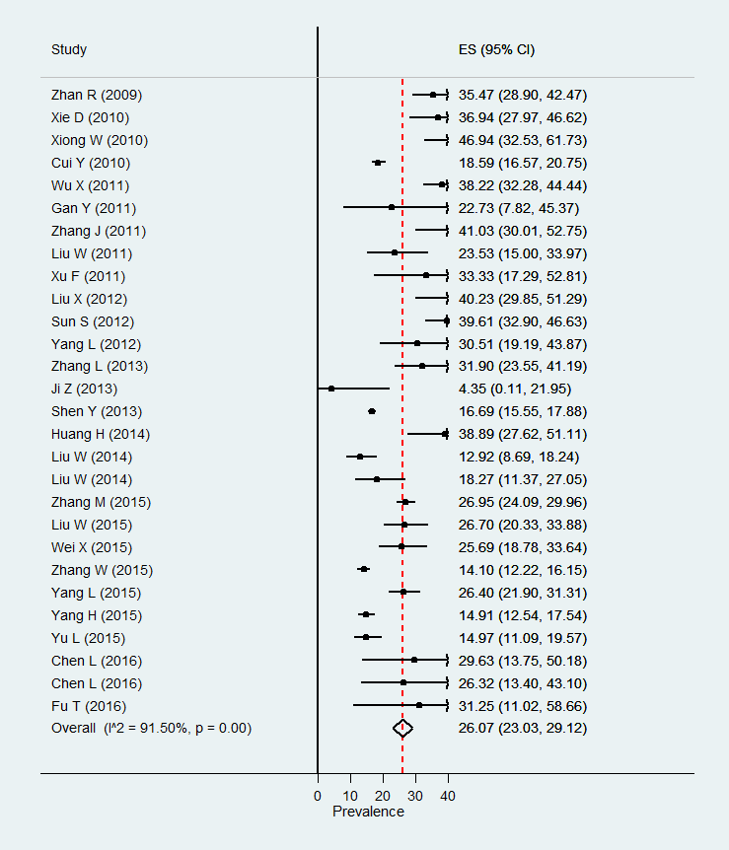

C. Surgery D. Pediatrics
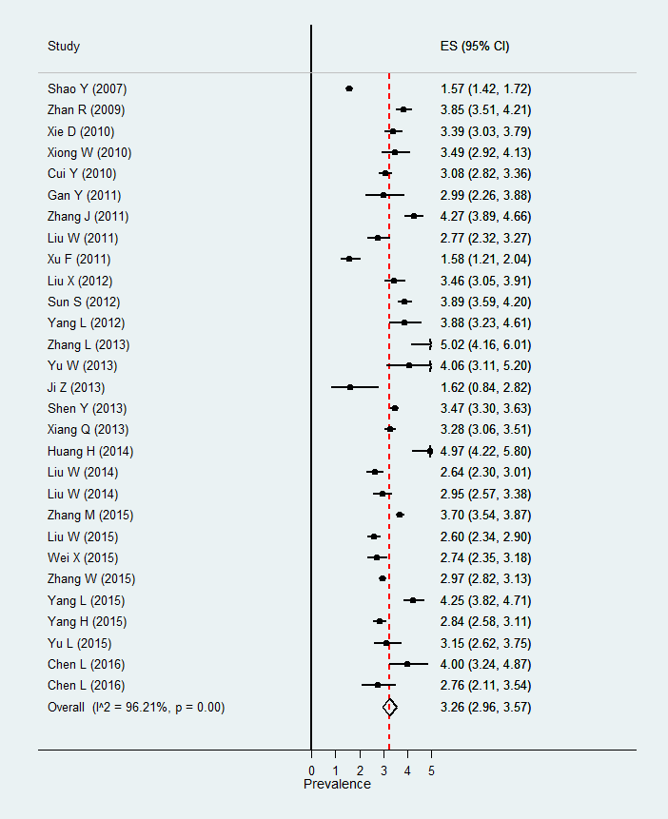
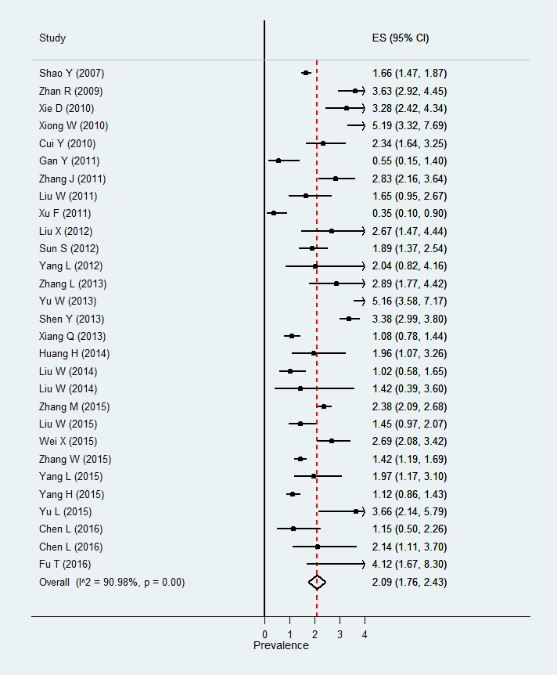

E. Gynecology and obstetrics
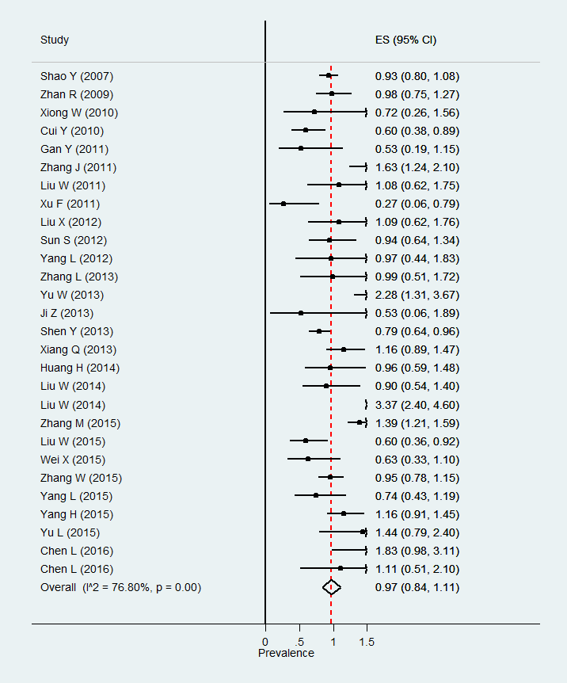

Supplementary Figure 3. Association of healthcare-associated infection prevalence and gross domestic product per capita in Mainland China – Systematic review on healthcare-associated infections in Mainland China, 2006-2016
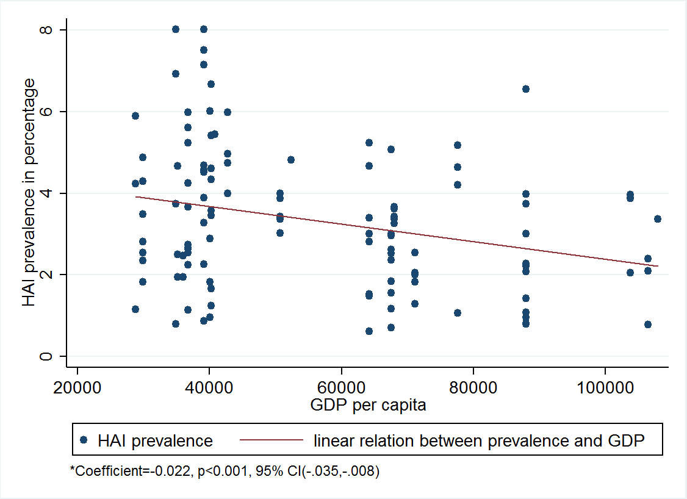

* HAI prevalence decreases by 2.2% with an increase of 1,000 Chinese Yuan (CNY) in GDP per capita.¹¹⁷

REFERENCES

1. von Elm E, Altman DG, Egger M, Pocock SJ, Gøtzsche PC, Vandenbroucke JP. The Strengthening the Reporting of Observational Studies in Epidemiology (STROBE) statement: guidelines for reporting observational studies. Lancet 2007;370:1453-1457.
2. Chen L, Qiu Z, Yang H, et al. Cross-sectional survey on healthcare-associated infection in Miao and Dong Autonomous Prefecture of Guizhou province in 2014. Chin J Infect Control 2016;15:10-14 (in Chinese).
3. Chen L, Qiu Z, Yang H, et al. Point prevalence of healthcare associated infection and antimicrobial use in Buyi autonomous prefecture hospitals in Guizhou province. Chin J Infect Control 2016;15:155-159 (in Chinese).
4. Chen P, Liu D, Wang H, Wang Z, Cheng Y. A survey of point prevalence rate of nosocomial infection in Chongqing area. Chongqing Med 2011;40:3660-3661 (in Chinese).
5. Cui Y, Hu B, Gao X, Tao L, Zhou Q, He L. Prevalence surveillance of healthcare associated infection in 70 Shanghai hospitals in 2009. Chin J Nosocomiol 2010;20:1667-1669 (in Chinese).
6. Fu T, Wei S, Huang L, Yang J, Zhan C. Cross-sectional surveys of prevalence of nosocomial infections in tertiary hospitals of Sanya and analysis of risk factors. Chin J Nosocomiol 2016;26:1159-1161 (in Chinese).
7. Gan Y. Prevalence survey of healthcare associated infection in Nanning, Guangxi, 2010. Chin Med info 2011;24:4955-4957 (in Chinese).
8. Huang H, Zhang S, Qiu L, Ye L, Qin W, Lian X. Prevalence rate of nosocomial infection in Xiamen. Chin J Nosocomiol 2014;24:5291-5293 (in Chinese).
9. Huang W, Zhuang H, Li S, et al. Survey and analysis on prevalence of hospital-acquired infections in 23 hospitals from Sichuan Province on the day of June 25, 2011. Chin J Multi Organ Dis Elderly 2016;15:657-661 (in Chinese).
10. Ji Z, Wang M. Survey on hospital infection rate in the county hospital. Chin J Disinfect 2013;30:1050-1051 (in Chinese).
11. Li H, Zhong Q, Liang Z, et al. Cross-sectional survey on nosocomial infections in 64 hospitals. Chin J Nosocomiol 2013;23:5143-5145 (in Chinese).
12. Liu JY, Wu YH, Cai M, Zhou CL. Point-prevalence survey of healthcare-associated infections in Beijing, China: a survey and analysis in 2014. J Hosp Infect 2016;93:271-279.
13. Liu W, Xing H, Yang X, Su R, Yan Z. Prevalence rate of nosocomial infection in 40 hospitals in Inner Mongolia Autonomous Region in 2010. Chin J Infect Control 2011;10:445-448 (in Chinese).
14. Liu W, Zhang K, Yan Z, Hai Y, Cao Q, Zheng Z. Prevalence survey on healthcare associated infection in 91 hospitals of Inner Mongolia Autonomous Region in 2013. Chin J Infect Control 2014;13:690-692 (in Chinese).
15. Liu W, Xian B, Xing H, Yan Z, Su R. Survey on inpatients hospital infection prevalence in Inner Mongolia Autonomous Region. Chin J Disinfect 2014;31:1066-1067 (in Chinese).
16. Liu W, Tian Y, Zheng Z, Li Z, Qin L. Prevalence rate of nosocomial infection in 2014. Chin J Nosocomiol 2015;25:4894-4896 (in Chinese).
17. Liu X, Liang J, Deng B, Xu G. Prevalence rate of nosocomial infections in Wuhan. Chin J Nosocomiol 2012;22:4992-4994 (in Chinese).
18. Shao Y, Ma H, Wei X, Zhang L. Investigation and analysis about the prevalence rate of nosocomial infections in fourty hospitals in Anhui province. Chin Med Herald 2007;4:35-36 (in Chinese).
19. Shen Y, Hu B, Gao X, Zhou Q, Cui Y, Sun W. Prevalence of healthcare associated infections in 72 hospitals of Shanghai. Chin J Nosocomiol 2013;23:1503-1506 (in Chinese).
20. Sun S, Ni G. Investigation and analysis of prevalence of nosocomial infections. Chin J Nosocomiol 2012;22:2026-2028 (in Chinese).
21. Wei X, Wang X, Yi X, Song H. Investigation of prevalence rate of nosocomial infections in Xuzhou. Chin J Nosocomiol 2015;25:1070-1072 (in Chinese).
22. Wu X, Zhan R, Zeng B, et al. Prevalence survey on nosocomial infection and community-acquired infection in 116 hospitals in Fujian province. Chin J Infect Control 2011;10:181-184 (in Chinese).
23. Xiang Q, Wei D, Zhou Z, Liu H, Dai M, Chen S. Cross-sectional survey on healthcare associated infection in 248 hospitals of Sichuan province in 2011. Chin J Infect Control 2013;12:186-189 (in Chinese).
24. Xie DS, Xiong W, Xiang LL, et al. Point prevalence surveys of healthcare-associated infection in 13 hospitals in Hubei Province, China, 2007-2008. J Hosp Infect 2010;76:150-155.
25. Xiong W, Xie D, Xu M, Wang H. Prevalence rate of hospital associated infection in 6 university hospitals in Hubei province in 2008. Chin J Nosocomiol 2010;20:3116-3118 (in Chinese).
26. Xu C, Xu M, Liang Y, Xiong W. Risk factors analysis of nosocomial infection in a prevalence survey of 75 hospitals. Modern Prev Med 2015;42:2266-2268 (in Chinese).
27. Xu F, Ma X, Zhang X, Wang M. Prevalence rates of nosocomial infection in 27 hospitals. Chin J Nosocomiol 2011;21:2677-2679 (in Chinese).
28. Xu X, Zeng B, Zhan R, et al. Cross-sectional survey of nosocomial infections in Fujian province from 2010 to 2012. Chin J Nosocomiol 2014;24:5543-5545 (in Chinese).
29. Yang H, Wang B, Yao X, Zhou Y, Lu C. Epidemiology cross-sectional investigation on healthcare-associated infection of 132 hospitals in Xinjiang in 2014. Chin J Infect Control 2015;14:676-680 (in Chinese).
30. Yang L, Zhao L, Yu R. Prevalence survey of healthcare-associated infections in 15 hospitals in Changzhou in 2011. Chin J Infect Control 2012;11:444-447 (in Chinese).
31. Yang L, Yang Y, Guo Y, Yang Y, Tian H, Zhao X. Cross-sectional survey of prevalence of healthcare-associated infections in 2013. Chin J Nosocomiol 2015;25:5390-5392 (in Chinese).
32. Yu L, Gu L, Wang P, Zhu Y, Ding L. Report on nosocomial infection prevalence survey of 11 hospitals in Xinjiang Uygur Autonomous Region. Chin J Disinfect 2015;32:44-45 (in Chinese).
33. Yu W. Prevalence survey of healthcare-associated infection in 4 tertiary care hospitals in Handan. J Hebei Med University 2013;34:1076-1078 (in Chinese).
34. Yu W. Prevalence survey of healthcare-associated infection and community-associated infection in 19 secondary general hospitals in Handan. Chin J Infect Control 2013;12:123-125 (in Chinese).
35. Zeng B, Zhan R, Wu X, et al. Cross-sectional survey on nosocomial infection in Fujian. Chin J Nosocomiol 2011;21:1098-1100 (in Chinese).
36. Zhan R, Chen J, Chen L, Xu X, Nie Y, Wu X. Prevalence survey on nosocomial infection in 63 hospitals of Fujian province 2007. Chin J Nosocomiol 2009;19:748-751 (in Chinese).
37. Zhang J, Wang C, Li Q, et al. Investigation and analysis of hospital infection rates of 108 hospitals in Guizhou 2010. Chin J Nosocomiol 2011;21:5162-5164 (in Chinese).
38. Zhang L, Su H, Ma H, Wu J, Qin F, Zhang L. Investigation of nosocomial infection prevalence in all thirteen grade 3 first-class hospitals in Anhui province. Chin J Dis Control Prev 2013;17:514-516 (in Chinese).
39. Zhang M, Yang H, Mou X, et al. Cross-sectional survey of nosocomial infections in different scale hospitals in Guizhou in 2014. Chin J Epidemiol 2015;36:1040-1041 (in Chinese).
40. Zhang M, Yang H, Mu X, et al. Prevalence rates of nosocomial infections in Guizhou province in 3 years. Chin J Nosocomiol 2015;25:2495-2498 (in Chinese).
41. Zhang W, Zheng L, Wu J, Xiang Q, Lu J. Cross-sectional study on hospital infection in Sichuan province, 2013. Med J National Defending Forces in Southwest Chin 2015;25:922-925 (in Chinese).
42. Zhao Y, Yang Y, Wang R, et al. The analysis of the prevalence of hospital infection and the use of antibiotics in Kunming hospital. Chin J Clin Rational Drug Use 2010;3:41-43 (in Chinese).
43. Zhu W, Xu H, Wang Y, Zheng X, Fu Y. Prevalence rates of healthcare-associated infection in medical institutions in Pudong New Area for two consecutive years. Chin J Infect Control 2016;15:476-480 (in Chinese).
44. Geng R, Wen C, Liu H. Investigation and analysis of prevalence rate of nosocomial infections in children’s hospital in 2013. Chin J Nosocomiol 2015;25:1186-1188 (in Chinese).
45. Guo Q, Zhao D, He T, et al. Prevalence of healthcare-associated infection in a children’s hospital in Guangzhou in 2014. Chin J Infect Control 2016;15:238-240 (in Chinese).
46. Hao Y. Prevalence of nosocomial infection in surgery department in children’s hospital, 2008. Chin Prac Med 2009;4:243-244 (in Chinese).
47. Hu M, Ao L. A survey on prevalence rate of nosocomial infection in children’s hospital. Chin J General Prac 2010;8:1576-1578 (in Chinese).
48. Hu Y, Yuan X, Xian Z, et al. Prevalence survey and countermeasures of nosocomial infection in Children. Chin J Nosocomiol 2010;20:3322-3323 (in Chinese).
49. Huang K, Ouyang Y, Guo R. Prevalence survey of nosocomial infection in a children’s hospital in Chenzhou. Studies of Trace Elements and Health 2016;33:18-20 (in Chinese).
50. Jia Y, Peng X, Zhao X, Shi J, Wang Y. Prevalence of nosocomial infection in winter in children’s hospital: an investigation analysis. Med Info 2011;24:394-396 (in Chinese).
51. Liu F, Yu L, Qin X. Prevalence rate of nosocomial infection in children’s hospital during past three years. Chin J Nosocomiol 2014;24:203-205 (in Chinese).
52. Liu H. Investigation and analysis on the prevalence of nosocomial infection of 372 inpatients in children’s hospital in Zhengzhou, 2009. Chin J Mod Drug Appl 2010;4:234-235 (in Chinese).
53. Sun L, Liu L. Prevalence of nosocomial infection in children’s hospital: an investigation analysis. Chin J Nosocomiol 2010;20:3476-3477 (in Chinese).
54. Wang J. Investigation and analysis on the prevalence of nosocomial infection of 507 inpatients in children’s hospital, 2007. Chin J Prac Nervous Dis 2008;11:157-159 (in Chinese).
55. Wang J, Wen C, Sun L. Investigation and analysis on the prevalence of nosocomial infections in children’s hospital in 2014. Modern Prev Med 2015;42:3426-3428 (in Chinese).
56. Wang X, Yan X. Prevalence rate of nosocomial infection in children’s hospital: investigation and analysis. Chin J Nosocomiol 2011;21:46-48 (in Chinese).
57. Xu Y. Investigation and analysis on the prevalence rate of nosocomial infection in 2012 in children’s hospital. Chin Prac Med 2013;8:249-251 (in Chinese).
58. Yin A, Ma L, Deng L, Chen X, Tang A. Cross-sectional surveys on healthcare-associated infection in a children’s hospital. Chin J Infect Control 2015;14:769-771 (in Chinese).
59. Zhang L, Wang J, Liu H. A Survey on the prevalence of nosocomial infection in rehabilitation centers of children’s hospital. Chin Prac Med 2010; 5: 240-241 (in Chinese).
60. Zhang L. Prevalence of nosocomial infection in a children’s hospital, 2011-2014. J Contemporary Clin Med 2015;28:1485-1487 (in Chinese).
61. Zhang Y, Zhou X, Sun L, et al. Prevalence rate of healthcare-associated infection in a children’s hospital in 2014. Chin J Infect Control 2015;14:629-632 (in Chinese).
62. Zhao X, Yan X, Wang X, Peng H. Investigation of the nosocomial infection prevalence rates of child inpatients in 3 consecutive years in children’s hospital. Chin J Disinfect 2015;32:40-43 (in Chinese).
63. Chen T, Xu W, Lu Q, Yang L. Prevalence of nosocomial infection in a maternity and child healthcare hospital: investigation and analysis. Med Info 2014;27:70-71 (in Chinese).
64. Deng Y, Chen J. Prevalence rate of healthcare-associated infection in a maternal and child health care hospital in Guangxi. Uygur Med 2013;4:190-191 (in Chinese).
65. Fan D. Investigation and analysis on prevalence rate of nosocomial infection in a hospital in Sichuan province. J Mod Med & Health 2013;29:210-211 (in Chinese).
66. Fu R. Investigation and analysis of cross-sectional survey of hospital infection, 2011. Chin Med Guide 2013;11:238-239 (in Chinese).
67. Huang G, Liao D, Li X. Investigation of nosocomial infection prevalence in maternal and child health hospital of Guangxi in 2008 and 2009. Chin J Nosocomiol 2011;21:3141-3143 (in Chinese).
68. Huang S, Jiang H, Huang J. Prevalence rates of healthcare-associated infection in a maternal and child health hospital in 2010-2014. Chin J Infect Control 2014;13:747-749 (in Chinese).
69. Huang X, Zhu H, Liu Y. Prevalence of nosocomial infections in a maternal and child health hospital. Strait J Prev Med 2015;21:40-41 (in Chinese).
70. Li H, Zhu Y, Gao X, Zhong Q, Lin C, Gong R. Prevalence rate and related factor for nosocomial infections. Chin J Nosocomiol 2012;22:3224-3226 (in Chinese).
71. Li H, Zhong Q, Gao X, Jin S, Liu J, Lin C. Cross-sectional survey on healthcare-associated infection in a maternity and child healthcare hospital. Chin J Infect Control 2013;12:229-230 (in Chinese).
72. Li H, Gao X, Zhong Q, Liu J, Lin C, Shen J. Prevalence rate of healthcare-associated infection in a maternal and child health care hospital. Chin J Infect Control 2015;14:336-338 (in Chinese).
73. Li S, Jin W, Song X. Investigation on the prevalence of nosocomial infection in women and children’s health hospital in Luoyang. Chin J Misdiagnostics 2008; 8: 3779-3780 (in Chinese).
74. Li X, Zhang J, Yuan Z. Survey and analysis of point prevalence rate of nosocomial infection in Sichuan provincial hospital for women and children. J West Chin Med 2012;27:1299-1301 (in Chinese).
75. Liao Z. Investigation and analysis of hospital inpatient infection rate. Contemporary Med 2015;21:82-83 (in Chinese).
76. Liao Z. Investigation and analysis of nosocomial infections in a maternal and child health hospital. Contemporary Med 2015;21:45-46 (in Chinese).
77. Liu Y, Huang X, Zhang Z. Investigation and analysis of prevalence rate of inpatient nosocomial infection. Modern Hosp 2015;15:111-113 (in Chinese).
78. Nie X. An investigation and analysis on prevalence of nosocomial infection in a maternal and child health hospital in Qujing of Yunnan province. Med Frontier Chin 2012;36:391-392 (in Chinese).
79. Qi L, Wang C. Nosocomial infection point-prevalence survey report for 2012. Chin Prac Med 2013;8:262-263 (in Chinese).
80. Shang H, Xing J. Investigation on prevalence rates of healthcare-associated infection in a maternal and child health hospital in 2009-2014. J Xinjiang Med 2015;45:1787-1790 (in Chinese).
81. Wang X, Liu J. Investigation and analysis of prevalence rate of nosocomial infection in a women and children health hospital. Primary Healthcare Med 2013;17:33-34 (in Chinese).
82. Wang Y. Investigation and analysis of prevalence rate of nosocomial infection in women and children healthcare hospital in Shandong province. Chin J Nosocomiol 2012;22:514-515 (in Chinese).
83. Wen Y, Lin L. Survey on the prevalence of nosocomial infections in maternal and child health hospital in 2010-2012. Pract Prev Med 2014;21:1114-1116 (in Chinese).
84. Xie J, Zhu L, Shen L. Investigation on prevalence rates of healthcare-associated infection in a maternal and child health hospital. J Zhejiang Med 2012;34:1772-1773 (in Chinese).
85. Xie L, Tang Y. Investigation and analysis on current prevalence rate of infectious diseases on the premises in a gynecology and obstetrics hospital. Chin J Nosocomiol 2010;20:1700-1701 (in Chinese).
86. Xu C, Wei N, Zhao Q. Investigation and analysis of prevalence rate of nosocomial infection in a women and children health hospital. Chin Prac Med 2014;9:260-262 (in Chinese).
87. Yun R. Investigation and analysis on the prevalence of nosocomial infection in women and children’s health hospital in 2013. J Inner Mongolia Med 2014;46:830-832 (in Chinese).
88. Zhang Q, Zou Q. Investigation and analysis on the prevalence of hospital infection in a maternal and child health hospital in 2012. J Gannan Med University 2014;34:88-90 (in Chinese).
89. Zhao D, Guo Q, Situ M, Zhang S. Investigation of prevalence rate of nosocomial infection in a certain women and children’s hospital in 2012. Chin J Nosocomiol 2014;24:1753-1755 (in Chinese).
90. Gong G, Zhou H, Wang M, Xu J, Wu X. Prevalence of nosocomil infection in a tumor hospital: an investigating analysis. Chin J Nosocomiol 2010;20:2936-2938 (in Chinese).
91. Gong G, Zhou H, Xu J, Wu X, Zhang X, Sun L. Investigation and analysis on prevalence rate of nosocomial infections in tumor hospital in 2013. Chin J Nosocomiol 2015;25:2499-2501 (in Chinese).
92. He G, An L, Zhang G, Xia G. Prevalence of nosocomial infection in tumor hospital: investigation and analysis. Chin J Nosocomiol 2009;19:1957-1958 (in Chinese).
93. Hou J. Investigation and analysis of prevalence rate of nosocomial infections in Anyang of Henan province. World Health Digest 2010;7:452 (in Chinese).
94. Huang Y, Wang Z. Prevalence rates of healthcare-associated infection in a hospital. J Zhejiang Prev Med 2011;23:41-42 (in Chinese).
95. Ji Y, Ni M, Zhang J, Gong G, Feng P. Cross-sectional survey of nosocomial infections in a tumor hospital. Chin J Nosocomiol 2013;23:4373-4374 (in Chinese).
96. Li L, Huang H, Cai M. Investigation and analysis of prevalence rate of nosocomial infection in cancer patient. Prac J Cancer 2009;24:654-655 (in Chinese).
97. Li W, Wu C, Nie X, Pu R. A cross-sectional survey of nosocomial infection and its influence factors analysis of tumor patients. J Cancer Control Treat 2013;26:192-195 (in Chinese).
98. Liu S, Zhao X. Prevalence rate of nosocomial infection: an investigation analysis. Chin J Nosocomiol 2009;19:2561-2563 (in Chinese).
99. Long J, Liu Z, Yang T, Chen G. Prevalence rate of healthcare-associated infection in a tumor hospital. Chin J Infect Control 2013;12:126-128 (in Chinese).
100. Su J, Zhang G. Investigation and analysis of prevalence rate of nosocomial infections in tumor hospital from 2009 to 2010. Chin J Nosocomiol 2012;22:509-511 (in Chinese).
101. Wang M, Gong G, Zhou H, Wu X, Xu J. Prevalence of nosocomial infections in a tumor hospital in 2011. Chin J Nosocomiol 2013;23:3072-3074 (in Chinese).
102. Wang S, Zhang Y, Cai L, Zhang S, Duo K, Zhao J. Current prevalence analysis of nosocomial infection in a 3-A-grade tumor hospital. Chin J Dis Control Prev 2014;18:398-400 (in Chinese).
103. Wang Y, Ruan Y, Xu M, Yu Y, Xie S. Prevalence rates of nosocomial infections in a tumor specialized hospital. Chin J Nosocomiol 2016;26:462-464 (in Chinese).
104. Wu D, Rong Y, Ju G, Guo J, Jia S, Li W. Investigation and analysis on prevalence of healthcare associated infection in tumor hospital, 2014-2015. Chin Health Care and Nutrition 2016;26:290 (in Chinese).
105. Xu X, Zhou X, Yu Y, Wu Y. Cross-sectional survey on nosocomial infections in Zhejiang cancer hospital in 2011 and 2012. Chin J Clin Infect Dis 2014;7:405-408 (in Chinese).
106. Yang X, Wang X, Liu Z, et al. Nosocomial infection prevalence rate of inpatients in tumor hospital, 2012-2015. Modern Prev Med 2016;43:1334-1338 (in Chinese).
107. Yang R, Tong W. Investigation and analysis of prevalence of healthcare associated infection in a hospital, 2012. J Prac Med Tech 2013;20:958-959 (in Chinese).
108. Zhai R, Luo L. Investigation and analysis of prevalence rate of nosocomial infection in cancer patients. J Shanxi Med 2014;43:2751-2754 (in Chinese).
109. Zhang M, Huang M, Yang M, Wei R. Investigation and analysis of a prevalence of healthcare associated infection. J Qingdao Med 2014;46:236-237 (in Chinese).
110. Zhang X. Prevalence of nosocomial infection in tumor hospital in Henan. Chin J Prac Med 2012;39:95-98 (in Chinese).
111. Zhao L, Jing Y, Li H. Prevalence rates of healthcare-associated infection in a provincial tumor hospital from 2012 to 2014. Chin J Infect Control 2016;15:179-182 (in Chinese).
112. Zhao X, Guo Z, Zhang X. Investigation and analysis of prevalence rate of nosocomial infections. Chin J Nosocomiol 2014;24:6110-6111 (in Chinese).
113. Zheng H. Survey on point prevalence of healthcare-associated infection in a tumor hospital. Chin J Infect Control 2013;12:231-232 (in Chinese).
114. Zhou H, Gong G, Xu J, Wang M, Wu X. Investigation and analysis of prevalence rates of nosocomial infections in 742 cases of inpatients. Chin J Nosocomiol 2012;22:61-63 (in Chinese).
115. Zhou Y, Ouyang L. Nosocomial infection rate of the patients with tumor: an investigation analysis. J Canc Control Treat 2009;22:300-302 (in Chinese).
116. Zou Y, Zhou J, Hu X, Sun Y, Zhu J. Survey of prevalence rate of healthcare-associated infections in a specialized cancer patients in three consecutive years. Chin J Nosocomiol 2015;25:4900-4902 (in Chinese).
117. Data of GDP per capita and indices in China: China Statistical Yearbook 2016 (in Chinese).

