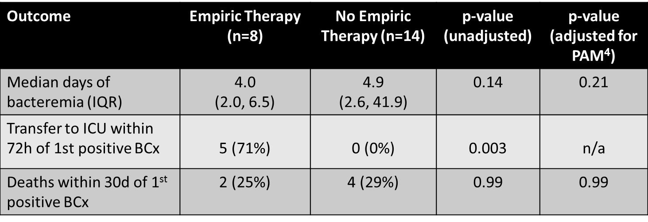

SUPPLEMENTAL TABLE 1. Indications for Vancomycin-Resistant Enterococcus (VRE) Therapy in Nonbacteremic Patients
Indication | Colonized, No. (%) (n=32) | Noncolonized, No. (%) (n=35)
Clinical decline | 24 (75) | 22 (63)
VRE from nonblood siteª | 6 (19) | 1 (3)
Vancomycin alternative^{b} | 0 (0) | 12 (34)
Unknown | 2 (6) | 0 (0)
ª5 from urine, 2 from bronchoalveolar lavage specimens.
^{b}8 cases of daptomycin use were for red man syndrome with vancomycin.

